UNITED STATES
SECURITIES AND EXCHANGE COMMISSION
Washington, D.C. 20549

FORM 10-K

☒ ANNUAL REPORT PURSUANT TO SECTION 13 OR 15(d) OF THE SECURITIES
EXCHANGE ACT OF 1934

For the fiscal year ended December 28, 2025

OR

☐ TRANSITION REPORT PURSUANT TO SECTION 13 OR 15(d) OF THE SECURITIES
EXCHANGE ACT OF 1934

For the transition period from _________ to __________

Commission file number 000-01088

KELLY SERVICES, INC.
(Exact Name of Registrant as specified in its Charter)

Delaware |  |  |  |  |  | 38-1510762
(State or other jurisdiction of incorporation or organization) |  |  |  |  |  | (I.R.S. Employer Identification No.)

999 West Big Beaver Road, Troy, Michigan 48084
(Address of principal executive offices) (Zip Code)

(248) 362-4444
(Registrant’s telephone number, including area code)

Securities registered pursuant to Section 12(b) of the Act:
Title of each class |  |  | Trading Symbols |  |  | Name of each exchange on which registered
Class A Common Stock, $1.00 par value per share |  |  | KELYA |  |  | The Nasdaq Stock Market LLC
Class B Common Stock, $1.00 par value per share |  |  | KELYB |  |  | The Nasdaq Stock Market LLC

Securities registered pursuant to Section 12(g) of the Act: None

Indicate by check mark if the registrant is a well-known seasoned issuer, as defined in Rule 405 of the Securities Act. Yes ☐ No ☒

Indicate by check mark if the registrant is not required to file reports pursuant to Section 13 or Section 15(d) of the Act. Yes ☐ No ☒

Indicate by check mark whether the registrant (1) has filed all reports required to be filed by Section 13 or 15(d) of the Securities Exchange Act of 1934 during the preceding 12 months (or for such shorter period that the registrant was required to file such reports), and (2) has been subject to such filing requirements for the past 90 days. Yes ☒ No ☐

Indicate by check mark whether the registrant has submitted electronically every Interactive Data File required to be submitted pursuant to Rule 405 of Regulation S-T (§232.405 of this chapter) during the preceding 12 months (or for such shorter period that the registrant was required to submit such files). Yes ☒ No ☐

Indicate by check mark whether the registrant is a large accelerated filer, an accelerated filer, a non-accelerated filer, a smaller reporting company or an emerging growth company. See the definitions of “large accelerated filer,” “accelerated filer,” “smaller reporting company” and “emerging growth company” in Rule 12b-2 of the Exchange Act.

Large accelerated filer |  |  | ☐ |  |  | Accelerated filer |  |  | ☒
Non-accelerated filer |  |  | ☐ |  |  | Smaller reporting company |  |  | ☐
Emerging growth company |  |  | ☐

If an emerging growth company, indicate by check mark if the registrant has elected not to use the extended transition period for complying with any new or revised financial accounting standards provided pursuant to Section 13(a) of the Exchange Act. ☐

Indicate by check mark whether the registrant has filed a report on and attestation to its management’s assessment of the effectiveness of its internal control over financial reporting under Section 404(b) of the Sarbanes-Oxley Act (15 U.S.C. 7262(b)) by the registered public accounting firm that prepared or issued its audit report. ☒

If securities are registered pursuant to Section 12(b) of the Act, indicate by check mark whether the financial statements of the registrant included in the filing reflect the correction of an error to previously issued financial statements. ☐

Indicate by check mark whether any of those error corrections are restatements that required a recovery analysis of incentive-based compensation received by any of the registrant’s executive officers during the relevant recovery period pursuant to §240.10D-1(b). ☐

Indicate by check mark whether the registrant is a shell company* (as defined in Rule 12b-2 of the Act). Yes ☐ No ☒

The aggregate market value of the voting and non-voting common equity held by non-affiliates computed by reference to the price at which the common equity was last sold, or the average bid and asked price of such common equity, as of the last business day of the registrant’s most recently completed second fiscal quarter, was approximately $364.0 million.

Registrant had 30,915,587 shares of Class A and 3,295,941 shares of Class B common stock, par value $1.00 per share, outstanding as of February 01, 2026.

Documents Incorporated by Reference

Portions of the proxy statement of the registrant with respect to its 2026 Annual Meeting of Stockholders are incorporated by reference in Part III of this Form 10-K to the extent described herein.

2

KELLY SERVICES, INC.
TABLE OF CONTENTS

PART I |  |  | 4
ITEM 1. BUSINESS |  |  | 4
ITEM 1A. RISK FACTORS |  |  | 9
ITEM 1B. UNRESOLVED STAFF COMMENTS |  |  | 20
ITEM 1C. CYBERSECURITY |  |  | 20
ITEM 2. PROPERTIES |  |  | 22
ITEM 3. LEGAL PROCEEDINGS. |  |  | 22
ITEM 4. MINE SAFETY DISCLOSURES. |  |  | 22
PART II |  |  | 23
ITEM 5. MARKET FOR THE REGISTRANT’S COMMON EQUITY, RELATED STOCKHOLDER MATTERS AND ISSUER PURCHASES OF EQUITY SECURITIES. |  |  | 23
ITEM 6. [RESERVED] |  |  | 25
ITEM 7. MANAGEMENT’S DISCUSSION AND ANALYSIS OF FINANCIAL CONDITION AND RESULTS OF OPERATIONS. |  |  | 26
ITEM 7A. QUANTITATIVE AND QUALITATIVE DISCLOSURES ABOUT MARKET RISK. |  |  | 42
ITEM 8. FINANCIAL STATEMENTS AND SUPPLEMENTARY DATA. |  |  | 43
ITEM 9. CHANGES IN AND DISAGREEMENTS WITH ACCOUNTANTS ON ACCOUNTING AND FINANCIAL DISCLOSURE. |  |  | 43
ITEM 9A. CONTROLS AND PROCEDURES. |  |  | 43
ITEM 9B. OTHER INFORMATION. |  |  | 43
ITEM 9C. DISCLOSURE REGARDING FOREIGN JURISDICTIONS THAT PREVENT INSPECTIONS. |  |  | 43
PART III |  |  | 44
ITEM 10. DIRECTORS, EXECUTIVE OFFICERS AND CORPORATE GOVERNANCE. |  |  | 44
ITEM 11. EXECUTIVE COMPENSATION. |  |  | 44
ITEM 12. SECURITY OWNERSHIP OF CERTAIN BENEFICIAL OWNERS AND MANAGEMENT AND RELATED STOCKHOLDER MATTERS. |  |  | 44
ITEM 13. CERTAIN RELATIONSHIPS AND RELATED TRANSACTIONS AND DIRECTOR INDEPENDENCE. |  |  | 44
ITEM 14. PRINCIPAL ACCOUNTANT FEES AND SERVICES. |  |  | 44
PART IV |  |  | 45
ITEM 15. EXHIBITS, FINANCIAL STATEMENT SCHEDULES. |  |  | 45
INDEX TO FINANCIAL STATEMENTS |  |  | 46
SCHEDULE II - VALUATION RESERVES |  |  | 93
SIGNATURES |  |  | 97

3

PART I

Unless the context otherwise requires, throughout this Annual Report on Form 10-K the words “Kelly,” “Kelly Services,” “the Company,” “we,” “us” and “our” refer to Kelly Services, Inc. and its consolidated subsidiaries.

ITEM 1. BUSINESS.

History and Development of Business

William Russell Kelly pioneered the staffing industry when he founded Kelly® in 1946 and we’ve been reinventing it ever since. Our inception helped usher in and embolden a workforce of women who kept the economy moving forward during World War II, opening doors and creating completely new opportunities. Over the next 79 years, as work evolved, Kelly continued to equip people with the skills to master new technologies as they emerged and the opportunity to put them to work in ways that enriched their lives.

As the world of work has evolved, so have our offerings to reflect the changing needs of employers and talent. In 1996, Kelly established the industry’s first Managed Service Provider (“MSP”) program. Three years later, the Company launched specialized offerings in engineering, information technology and education. After successfully establishing industry-leading positions in each of these attractive markets, Kelly initiated a strategic plan to drive greater value creation by refocusing its portfolio on specialties. In 2020, Kelly launched a new operating model comprising five specialty business units: Kelly Professional & Industrial (“P&I”); Kelly Science, Engineering & Technology (“SET”); Kelly Education; KellyOCG (“Outsourcing & Consulting” or “OCG”); and Kelly International.

To enhance specialization in higher margin, higher growth specialties, Kelly also pursued an aggressive approach to driving inorganic growth in SET, Education and OCG. By monetizing non-core assets (Persol Holdings Co., Ltd. in 2022 and EMEA staffing operations in 2024, among other transactions) and redeploying available capital, Kelly completed several strategic acquisitions over the years, including Teachers On Call; Global Technology Associates (“GTA”); NextGen; Greenwood/Asher & Associates; Softworld; RocketPower; Pediatric Therapeutic Services (“PTS”); Motion Recruitment Partners (“MRP”); and Children’s Therapy Center (“CTC”).

Building on a significant shift in Kelly’s business mix driven by its specialty strategy, the Company took steps to further optimize its operating model and accelerate profitable growth. Beginning in 2023, Kelly implemented a comprehensive business transformation initiative that delivered structural efficiency improvements across the enterprise and significantly improved profitability. In 2024, Kelly completed the sale of its European staffing operations within the Company’s International business unit, further sharpening its focus on specialty outcome-based and staffing services in North America, while maintaining global recruitment process outsourcing (“RPO”) and MSP capabilities. In 2025, Kelly integrated its P&I and OCG specialty areas, responding to a shift in large enterprise demand toward integrated workforce solutions and enabling a more streamlined and efficient go-to-market approach. In addition, the Company launched a multi-year strategic initiative to integrate all of the businesses into one enterprise system. The first phase of integrating the SET business was completed and went live in early 2026.

Today, Kelly remains one of the largest providers of temporary and permanent staffing services, outcome-based solutions, RPO, MSP and payroll process outsourcing (“PPO”). The Company delivers these differentiated offerings through three specialty business units, each a leader in the respective markets on which they are focused: Kelly Education; Kelly Science, Engineering & Technology; and Kelly Enterprise Talent Management.

Business Objectives

We strive to empower organizations and talent to access limitless opportunities by enabling employers to recruit and manage skilled workers and help job seekers find great work. As experts in hiring experts, we ensure our customers have the people they need when and where they’re needed most. We’re also using our position in the middle of the talent supply and demand equation to challenge outdated barriers that hold back far too many people from attaining meaningful work, supporting their families and contributing to the economy. Our Equity@Work initiative seeks to remove barriers to employment and create a labor market that is accessible for more people. While universal change takes time, we continue to make progress with additional outreach, new alliances and partnerships and continued executive commitment.

We believe that delivering on these objectives will result in successful outcomes for customers and talent and drive profitable growth for Kelly.
4

Description of Business Segments and Services

Kelly is a global specialty talent solutions company operating in three specialized business units, which are also our reportable segments. This structure enables the Company to serve the specialized needs of both talent and customers while building deep industry expertise and connections.

•Enterprise Talent Management – delivers temporary staffing, outcome-based and permanent placement services focused on light industrial, contact center and office and clerical specialties in North America across a variety of industries and includes products such as Business Process Outsourcing, KellyConnect and Skilled Professional Solutions offerings. ETM also provides global talent supply chain and workforce talent solutions, including MSP, RPO and PPO solutions to customers on a global basis. RPO includes our RocketPower and Sevenstep brands as well as our proprietary technology platform, Kelly Helix.

•Science, Engineering & Technology – provides highly specialized skills to a variety of industries through temporary staffing, outcome-based and permanent placement services. SET is focused on science and clinical research, engineering, technology and telecommunications specialties predominantly in North America. It includes the MRP, Softworld, NextGen and GTA brands, as well as our statementworX offering.

•Education – delivers high quality education and therapy services talent through temporary staffing, permanent placement and executive search services to Pre-K-12 school districts and education organizations across the U.S. It includes the CTC, PTS, Greenwood/Asher and Teachers On Call brands.

Financial information regarding our reportable segments is included in the Segment Disclosures footnote in the notes to our consolidated financial statements presented in Part II, Item 8 of this report.

Business Operations

Geographic Breadth of Services

Headquartered in the United States, Kelly provides workforce solutions to a diverse group of local, regional and global clients in the Americas, Europe and the Asia-Pacific region across a variety of industries.

In 2025, together with our supplier partners, we placed approximately 375,000 workers with a variety of customers around the globe.

Service Marks

We own numerous service marks registered with the United States Patent and Trademark Office, the European Union Intellectual Property Office and numerous individual country trademark offices.

Seasonality and Economic Cycles

Our operating results have historically been affected by the cyclical response to both economic downturns and upswings. Customers use our services to supplement their existing workforce and generally hire permanent employees when long-term demand is expected to increase. In addition, we generate approximately 1% of our revenue through permanent placement fees, which typically have a higher gross margin than our staffing services. Consequently, we may see improved demand for our services and generate larger increases in our revenue and gross profit from services when the economy grows. During periods of increasing demand, we are generally able to improve our profitability and generate operating leverage. Conversely, our revenue from services and gross profit may see larger decreases when economic activity declines and customer demand for our services decreases. When demand decreases, our operating profit is typically impacted unfavorably as we experience a deleveraging of our selling and administrative expense base, which may not decline at the same pace as revenue. Our business also experiences seasonal fluctuations each year, particularly in our Education operating segment. Revenue in Education is generally lowest in the third quarter, in line with schools’ summer break.

Working Capital

Our working capital requirements are primarily generated from our staffing businesses resulting from employee payroll which is generally paid weekly or monthly and customer accounts receivable which is generally outstanding for longer periods. When we operate as a managed service provider, our payment terms to suppliers are generally in line with payment terms from
5

customers, which does not result in a significant use of working capital. Based on the nature of our business, accounts receivable is our most significant asset with days sales outstanding (“DSO”) of 61 days as of December 28, 2025. Since receipts from customers lag payroll payments to temporary employees, working capital requirements increase and operating cash flows may decrease substantially in periods of growth. Conversely, when economic activity slows, working capital requirements may substantially decrease and operating cash flows increase. Such increases dissipate over time if the economic downturn continues for an extended period.

Customers

Kelly’s client portfolio spans employers of all sizes and sectors, including local and mid-sized businesses, to Fortune 500 enterprises, government agencies and education institutions. In 2025, an estimated 55% of total company revenue was attributed to our largest 100 customers and 24% was attributed to our largest 10 customers. Our largest single customer accounted for approximately six percent of total revenue in 2025. In 2024, an estimated 58% of total company revenue was attributed to our largest 100 customers and 29% was attributed to our largest 10 customers. Our largest single customer accounted for approximately six percent of total revenue in 2024.

Government Contracts

Although we conduct business under various federal, state and local government contracts, no one contract represents more than two percent of total company revenue in 2025.

Competition

The worldwide workforce solutions industry is competitive and highly fragmented. In the United States, we compete with other firms that operate nationally and offer a breadth of service similar to ours and with thousands of smaller regional or specialized companies that compete to varying degrees. Outside the United States, we face similar competition. In 2025, our largest competitors were Randstad, Adecco Group, ManpowerGroup Inc. and Allegis Group.

Key factors that influence our success are quality of service, price and breadth of service.

Quality of service is highly dependent on the availability of qualified talent and our ability to promptly and effectively recruit, screen, retain and manage a pool of employees who match the skills required by our customers. We must balance competitive pricing pressures, which may intensify during an economic downturn, with the need to attract and retain a qualified workforce. Price competition is greater in certain markets in which we serve clients and talent, including education, office clerical and light industrial.

Companies may seek a single supplier to manage all of their demand for contingent talent. To provide the breadth of service required, clients may need us to manage staffing suppliers and independent workers on their behalf. Kelly seeks to address this requirement for our clients, enabling us to deliver talent wherever and whenever they need it around the world.

Artificial Intelligence

The Company employs a range of artificial intelligence (“AI”) technologies to support its talent related solutions. These technologies are integrated into recruiting, applicant tracking, candidate screening and assessment, workforce analytics, and broader talent management processes. The Company leverages both third-party AI solutions and internally developed proprietary tools, including the Company’s Kelly Helix platform, to enhance the efficiency, consistency, and scalability of these activities.

Corporate Sustainability

Kelly is committed to the highest standards of corporate citizenship. Given the worldwide reach of our workers, clients, suppliers and partners, we recognize the global impact of our business practices and the importance of public accountability. We continue to advocate on behalf of the global workforce, improve our workplaces, contribute to the communities we serve and ensure our actions are socially, ethically and environmentally responsible. More information about our corporate sustainability initiatives is available in our Corporate Sustainability Report - Growing with Purpose report in the “About Kelly” section of our website www.kellyservices.com.

6

Regulation

Our services are subject to a variety of complex federal and state laws and regulations in the countries where we operate. We continuously monitor legislation and regulatory changes for their potential effect on our business. We invest in technology and process improvements to implement required changes while minimizing the impact on our operating efficiency and effectiveness. Regulatory cost increases are passed through to our clients to the fullest extent possible. As a service business, we are not materially impacted by federal, state or local laws that regulate the discharge of materials into the environment.

Human Capital

We are a talent solutions company and our employees are critical to our success. We must attract and retain experienced internal employees, as well as talent we put to work for our customers. As part of these efforts, we strive to offer competitive total rewards programs, promote employee development, support a workforce that represents the demographics of communities we serve and allow employees to give back to their communities and make a social impact.

We are committed to the health, safety and wellness of our employees and talent. The success of our business is fundamentally connected to the well-being of our people. Accordingly, we seek to implement policies and practices that align with applicable laws and regulations and are in the best interest of our employees, talent and the communities in which we operate.

Kelly’s purpose is to connect people to work in ways that enrich their lives, while creating opportunities for all people to realize their full potential. We are dedicated to removing barriers to employment, ensuring that anyone who is qualified has access to meaningful employment. Kelly creates pathways allowing talent to thrive. We help our clients find the people they need to succeed, while championing fair and all-encompassing hiring practices. Our commitment is reflected in initiatives like Equity@Work, designed to remove obstacles, open doors and expand opportunities for all talent. Kelly’s impact doesn’t stop there. We are devoted to growing and developing a varied ecosystem of supplier partners, empowering them to make a difference in the industry and the marketplace. We support the success of our clients and contribute to a more vibrant ecosystem by nurturing relationships. Through our efforts, Kelly aims to shape a future where work is accessible to everyone, organizations drive innovation with a holistic talent mindset and our collective progress is fueled by perspectives of people from all backgrounds.

Internal Employees

As of December 28, 2025, we employed approximately 3,600 full-time staff members in the United States and an additional 1,300 in our international locations. Kelly retention rates for high performing and high potential employees align with our comparable benchmark.

Compensation and Benefits. Kelly is committed to providing competitive, fair and fiscally responsible total rewards programs to our employees. Our compensation programs are designed to attract, retain and reward talented individuals with the skills necessary to achieve our strategic goals and create long-term value for our shareholders. We provide employees with competitive compensation opportunities, with strong pay-for-performance linkages that include a mix of base salary, short-term incentives and, in the case of our more senior employees, long-term equity awards. Our programs provide fair and competitive opportunities that align employee and stockholder interests. In addition to cash and equity compensation, we offer employees competitive benefits such as life and health (medical, dental and vision) insurance, paid time off, wellness benefits and defined contribution retirement plans. We review our compensation and benefits programs annually and respond to changes in market practice. For example, recent enhancements to our U.S. benefits program include the addition of a virtual physical therapy program to our medical plans and automatic contribution-escalation in one of our 401(k) Plans. In addition, pay and benefits programs for our international employees align with competitive local practices.

Culture. Since 1947, our founder fought to increase women's access to work and we’ve continued to be an outspoken advocate for the value temporary and independent workers bring to the workplace. We are committed to promoting exceptional talent from all walks of life. We believe that our talent pool creates a workplace that is conducive to producing more creative solutions, results in better, more innovative products and services and presents Kelly as a workplace leader, aiding our ability to attract and retain high-performing talent. We focus on fostering a culture of belonging, where everyone feels welcomed and respected and can thrive as we work together. Kelly promotes employee development and internal career mobility to enable our team to achieve their full potential and to ensure we have the evolving workforce capabilities that the future demands.

Community Involvement. Sustainability is at the heart of our relationships with our global workforce, suppliers, customers, and other stakeholders. Our programs and initiatives are dedicated to enhancing the well-being of our employees,
7

their families, and the communities they call home. Through strategic investments and a focus on shared values, we strive to drive lasting positive change while fostering sustainable development. We capture and track volunteering efforts through various platforms, empowering employees to engage in social impact initiatives and collaborate with colleagues. Our Kelly Hands & Hearts corporate volunteering program, along with a dedicated paid Volunteer Day, provides additional opportunities for employees to support causes that matter most to them, both locally and globally. These efforts are essential to our vision of building inclusive and equitable communities. In 2025, we launched our Global Month of Service, encouraging all employees worldwide to participate in meaningful volunteerism and acts of service. Now a cornerstone of our community engagement, this annual event underscores our dedication to collective impact. Through our Equity@Work initiatives and partnerships with like-minded organizations, policy groups, and institutions, we demonstrate our commitment to expanding access to meaningful work and personal growth for all. These collaborations aim to positively influence how companies hire, advance, and help people thrive.

For more information about our corporate strategy to connect people to meaningful work while contributing to a better society, please see our Corporate Sustainability Report - Growing with Purpose, which is available in the “About Kelly” section of our website, www.kellyservices.com.

Talent

In addition to our internal employees, Kelly recruits talent on behalf of our customers globally. In 2025, we placed approximately 375,000 individuals in positions with our customers. When Kelly remains the employer of record for our employees working at our customer locations, we retain responsibility for all assignments (including ensuring appropriate health and safety protocols in conjunction with our customers), wages, benefits, workers’ compensation insurance and the employer's share of applicable payroll taxes as well as the administration of the employees' share of these taxes. We also offer our Kelly talent access to competitive health and benefit programs while they are working with us.

Foreign Operations

For information regarding sales, earnings from operations and long-lived assets by domestic and foreign operations, please refer to the information presented in the Segment Disclosures footnote in the notes to our consolidated financial statements, presented in Part II, Item 8 of this report.

Access to Company Information

We electronically file our annual report on Form 10-K, quarterly reports on Form 10-Q, current reports on Form 8-K and all amendments to those reports with the Securities and Exchange Commission (“SEC”). The SEC maintains an Internet website at www.sec.gov that contains reports, proxy and information statements and other information regarding issuers that file electronically.

We make available, free of charge, through our website and by responding to requests addressed to our investor relations office, our annual report on Form 10-K, quarterly reports on Form 10-Q, current reports on Form 8-K and all amendments to those reports. These reports are available as soon as reasonably practicable after such material is electronically filed with or furnished to the SEC. Our website address is: www.kellyservices.com. The information contained on our website, or on other websites linked to our website, is not part of this report.

8

ITEM 1A. RISK FACTORS.

Risks Related to Macroeconomic Conditions

Our business is significantly affected by fluctuations in general economic conditions.

Historically, the general level of economic activity and employment in the United States and the other countries in which we operate has significantly affected the demand for staffing services. In periods of economic growth, employers often add temporary employees before hiring full-time employees. However, when economic activity declines, many employers reduce their use of temporary employees before laying off full-time employees. Customer responses to real or perceived economic conditions, including perceptions related to market conditions, labor supply, international trade policy, and inflation, could negatively impact customer behavior. Historically, significant changes in economic activity have disproportionately impacted staffing industry volumes. We may not fully benefit from times of increased economic activity should we experience shortages in the supply of workers. We may also experience more competitive pricing pressure and slower customer payments during periods of economic decline. A substantial portion of our revenues and earnings are generated by our business operations in the United States. Any significant economic downturn in the United States or certain other countries in which we operate could have a material adverse effect on our business, financial condition and results of operations.

Our stock price may be subject to significant volatility and could suffer a decline in value.

The market price of our common stock may be subject to significant volatility. We believe that many factors, including several which are beyond our control, have a significant effect on the market price of our common stock. These include:

•actual or anticipated variations in our quarterly operating results;
•announcements of new services by us or our competitors;
•announcements relating to strategic relationships, acquisitions or divestitures;
•changes in financial estimates by securities analysts;
•changes in general economic conditions;
•actual or anticipated changes in laws and government regulations;
•commencement of, or involvement in, litigation;
•the effects of our dual-class common stock (including the concentration of voting power in our Class B shares);
•any major change in our board or management;
•changes in industry trends or conditions; and
•sales of significant amounts of our common stock or other securities in the market.

In addition, the stock market in general and Nasdaq in particular, often experiences significant price and volume fluctuations that frequently are unrelated or disproportionate to the operating performance of listed companies. These broad market and industry factors may seriously harm the market price of our common stock, regardless of our operating performance. A securities class action suit against us arising out of stock volatility or other investor claims, could result in substantial costs, potential liabilities and the diversion of our management’s attention and resources. Further, our operating results may be below the expectations of securities analysts or investors. In such event, the price of our common stock may decline.

Risks Related to our Industry Segment

We operate in a highly competitive industry with low barriers to entry and may be unable to compete successfully against existing or new competitors.

The worldwide staffing services market is highly competitive with limited barriers to entry. We compete in global, national, regional and local markets with full-service and specialized temporary staffing and consulting companies. Some competitors are considerably larger than we are and have more substantial marketing and financial resources. Additionally, the emergence of online staffing platforms, talent sourcing models, or other forms of disintermediation may pose a competitive threat to our services that operate under a more traditional staffing business model. Price competition in the staffing industry is intense, particularly for the provision of office clerical, light industrial and education personnel. We expect that the level of competition will remain high, which could limit our ability to maintain or increase our market share or profitability.

The number of customers distributing their staffing service purchases among a broader group of competitors continues to increase which, in some cases, may make it more difficult for us to obtain new customers, or to retain or maintain our current share of business, with existing customers. We also face the risk that our current or prospective customers may decide to
9

provide similar services internally. As a result, there can be no assurance that we will not encounter increased competition in the future.

Technological advances, including advances in automation and artificial intelligence, may significantly disrupt the labor market and weaken demand for human capital.

Our success is directly dependent on our customers’ demand for talent. As technology continues to evolve, an increasing number of tasks currently performed by people may be replaced by automation, robotics, machine learning, artificial intelligence (“AI”), and other technology advances outside of our control. These changes could result in a decreased demand for human labor. This trend poses a risk to the staffing industry, particularly in lower-skill job categories and to creative, administrative, customer support and clerical roles vulnerable to advances in artificial intelligence. Artificial intelligence is beginning to perform tasks previously handled by knowledge workers, including data entry, basic coding, document review, financial analysis, customer service, and administrative support. As these technologies become more sophisticated and widely adopted, demand for certain categories of professional and technical staff we provide may decline. While technology may create demand for new types of roles that increase the demand for our services, there is no guarantee that growth in emerging job categories will fully offset potential declines in overall staffing demand. If we are unsuccessful in responding to this potential shift in customer demand due to advancing technology, it could have a material adverse effect on our results of operations and financial condition.

Competition rules arising from government legislation, litigation or regulatory activity may limit how we structure and market our services.

As a leading staffing and recruiting company, we are closely scrutinized by government agencies under U.S. and foreign competition laws. An increasing number of governments are enforcing competition laws and regulations, leading to increased scrutiny. Some jurisdictions also allow competitors or consumers to assert claims of anti-competitive conduct.

The European Commission and its various competition authorities have targeted industry trade associations in which we participate, which could result in the assessment of fines against our business. Although we have safeguards in place to comply with competition laws, there can be no guarantee that such safeguards will be successful. Any government regulatory actions may result in fines and penalties or hamper our ability to provide cost-effective benefits to consumers and businesses, reducing the attractiveness of our services and the revenues that come from them. New competition law actions could be initiated. The outcome of such actions, or steps taken to avoid them, could adversely affect us in a variety of ways, including:

•We may have to choose between withdrawing certain services from certain geographies to avoid fines or designing and developing alternative versions of those services to comply with government rulings, which may entail a delay in a service delivery.
•Adverse rulings may act as precedent in other competition law proceedings.

Our business is subject to extensive government regulation, which may restrict the types of services we are permitted to offer or result in additional tax or licensing requirements, or other costs that reduce our revenues and earnings.

The temporary employment industry is heavily regulated in many of the countries in which we operate. Changes in laws or government regulations may result in prohibition or restriction of certain types of services we can offer, increased delivery and operating complexity costs, or the imposition of new or additional pay, benefit, licensing or tax requirements that could reduce our revenues and earnings. In particular, we are subject to state unemployment taxes in the U.S., which typically increase during periods of increased levels of unemployment. Increased government regulation of the workplace, such as enhanced wage or labor protections, laws or regulations restricting the use of artificial intelligence in the employment lifecycle, or expansion of employee privacy rights, could adversely impact our business. Changes in the immigration policy in the United States could adversely impact our ability to recruit or retain non-citizen workers, including individuals employed by us on work visas, primarily H-1B, or eligible to work under temporary protected status, deferred enforcement decisions, or similar work authorizations. We also receive benefits, such as the work opportunity income tax credit in the U.S., that regularly expire and may not be reinstated. There can be no assurance that we will be able to increase the fees charged to our customers in a timely manner and in a sufficient amount to fully cover increased costs as a result of any changes in laws or government regulations. Any future changes in laws or government regulations, or interpretations or enforcement thereof, including additional laws and regulations enacted at a state or local level may make it more difficult or expensive for us to provide services and could have a material adverse effect on our business, financial condition and results of operations. In addition, as state and local jurisdictions expand their regulation of the workplace, we may be unable to adequately monitor or timely respond to changes in state and local regulations, which could result in significant fines and penalties, criminal sanctions against us, our officers or our employees, prohibitions on the conduct of our business, damage to our reputation and other adverse consequences.
10

Unexpected changes in claim trends on our workers’ compensation, unemployment, disability, medical benefit plans, and other expenses may negatively impact our financial condition.

We self-insure, or otherwise bear financial responsibility for, a significant portion of expected losses under our workers’ compensation program, disability and medical benefits claims. Unexpected changes in claim trends, including the severity and frequency of claims, actuarial estimates and medical cost inflation, could result in costs that are significantly different than initially reported. If future claims-related liabilities increase due to unforeseen circumstances, or if we must make unfavorable adjustments to accruals for prior accident years, our costs could increase significantly. In addition, unemployment insurance costs are dependent on benefit claims experience from employees which may vary from current levels and result in increased costs.

We face exposure to other significant expenses that could materially impact our financial performance, including cybersecurity incident response and remediation costs, regulatory compliance expenses, litigation and settlement costs, costs associated with employee or candidate misconduct, technology infrastructure investments required to maintain competitive service delivery, and expenses related to bad debt or client payment defaults. Additionally, we may incur unexpected costs related to regulatory changes, business integration or restructuring activities, or workforce retention initiatives in tight labor markets. Any of these expense categories could increase materially and unexpectedly.

There can be no assurance that we will be able to increase the fees charged to our customers in a timely manner and in a sufficient amount to cover increased costs as a result of any changes in claims-related liabilities or other unexpected expenses. As customers monitor their third-party relationships for financial risk, such adverse financial changes could result in current customer loss or inability to acquire new customers due to perceived negative financial performance.

We may have additional tax liabilities that exceed our estimates.

We are subject to multiple federal, state, local and foreign taxes in the jurisdictions in which we operate. Our tax expense could be materially impacted by changes in tax laws in these jurisdictions, changes in the valuation of deferred tax assets and liabilities or changes in the mix of income by country. The overall size of our workforce and visibility of our industry may make it more likely we become a target of government investigations and we are regularly subject to audit by tax authorities. Although we believe our tax estimates are reasonable, the final determination of audits and any related litigation could be materially different from our historical tax provisions and accruals. The results of an audit or litigation could materially harm our business.

Risks Related to Strategy and Execution

Our future performance depends on the Company’s effective execution of our business strategy.

The performance of the Company’s business is dependent on our ability to effectively execute our growth strategy. Our strategy includes targeted investments in select specialty areas, focusing on growth platforms and implementation of a cost-effective operating model to bridge our strategy to execution. If we are unsuccessful in executing our strategy, we may not achieve either our stated goal of revenue growth or the intended productivity improvements, which could negatively impact profitability. Even if effectively executed, our strategy may be insufficient considering changes in market conditions, technology, changes in customer buying behavior, competitive pressures or other external factors.

If we fail to successfully improve or develop new service offerings, we may be unable to retain and acquire customers, resulting in a decline in revenues.

The Company’s successful execution of our growth strategy requires that we match evolving customer expectations with evolving service offerings. The development of new or improved service offerings requires accurate anticipation of customer needs and emerging technology and workforce trends. We must make long-term investments in our information technology infrastructure and commit resources to development efforts without certainty that these investments will result in service offerings that achieve customer acceptance and generate the revenues required to provide desired returns. If we fail to accurately anticipate and meet our customers’ needs through the development of new or improved service offerings or do not successfully deliver these service offerings, our competitive position could weaken, causing a material adverse effect on our results of operations and financial condition.

11

A loss of major customers or a change in such customers’ buying behavior or economic strength could have a material adverse effect on our business.

We serve many large corporate customers through high volume service agreements. While we intend to maintain or increase our revenues and earnings from our major corporate customers, we are exposed to risks arising from the possible loss of major customer accounts. A change in labor strategy or labor disruptions, including work stoppages or the deterioration of the financial condition or business prospects of these customers could reduce their need for our services and result in a significant decrease in the revenues and earnings we derive from these customers. Such change could occur due to economic, social, climate, or political factors outside of our customers' control. Inability to meet customer demands in response to these factors could result in the decline in use of our service or outright loss of customers. Our customers are also exposed to third-party risk through their use of vendors and suppliers which, in the event of a third-party incident at a customer, could result in a deterioration in their financial condition. Continuing merger and acquisition activity involving our large corporate customers could put existing business at risk or impose additional pricing pressures. Since receipts from customers generally lag payroll to temporary employees, the bankruptcy of a major customer could have a material adverse impact on our ability to meet our working capital requirements. The expansion of payment terms may extend our working capital requirements and reduce available capital for investment. Additionally, most of our customer contracts can be terminated by the customer on short notice without penalty. This creates uncertainty with respect to the revenues and earnings we may recognize with respect to our customer contracts and the loss of a large customer could have a material impact on revenue.

Our business with large customer accounts reflects a market-driven shift in buying behaviors in which reliance on a small number of staffing partners has shifted to reliance upon a network of talent providers. The movement from single-sourced to competitively sourced staffing contracts may also substantially reduce our future revenues from such customers. While Kelly has sought to address this trend, including providing supplier and vendor management services as a customer’s MSP within our OCG segment, we may not be selected or retained as the MSP by our large customers, or if we are the MSP, we may not be one of the underlying staffing providers. This may result in a material decrease in the revenue we derive from providing staffing services to such customers. In addition, revenues may be materially impacted if we decide to exit customers due to pricing pressure or other business factors.

Our business with the federal government and government contractors presents additional risk considerations. We must comply with laws and regulations relating to the formation, administration and performance of federal government contracts. Failure to meet these obligations could result in civil penalties, fines, suspension of payments, reputational damage, disqualification from doing business with government agencies and other sanctions or adverse consequences. Government procurement practices may change in ways that impose additional costs or risks upon us or pose a competitive disadvantage. Our employees may be unable to obtain or retain the security clearances necessary to conduct business under certain contracts, or we could lose, or be unable to secure or retain, a necessary facility clearance. In the event of a security incident by us or our personnel, we may not be able to conduct future business for certain federal government clients. In addition, government agencies may temporarily or permanently lose funding for awarded contracts, reduce spending, or deprioritize future spending on contracts on which we participate, or there could be delays in the start-up of projects already awarded and funded. This creates uncertainty with respect to the revenues and earnings we may recognize with respect to our government contracts.

We are at risk of damage to our brands, which are important to our success.

Our success depends, in part, on the value associated with our brands. Because we assign employees to work under the direction and supervision of our customer at work locations not under Kelly’s control, we are at risk of our employees engaging in unauthorized or illegal conduct that could harm our reputation. Our Education segment is particularly susceptible to this exposure because it places employees in schools and educational institutions where they work directly with vulnerable populations, including minors. These placements create heightened reputational and legal exposure related to potential misconduct involving students. Even a single incident of inappropriate contact, boundary violations, or prohibited interactions between our employees and students could result in significant harm to our brand, loss of client relationships, regulatory scrutiny, and legal liability. The nature of educational environments—where trust, safety, and duty of care are paramount—means that any allegation of misconduct, regardless of its ultimate validity, can damage our reputation within the education sector and more broadly. We implement screening, background checks, and training protocols that surpass regulatory compliance requirements, but we cannot entirely eliminate the risk that individuals we place may engage in conduct that violates professional boundaries or legal standards governing interactions with minors. The impact of such incidents could include contract terminations, difficulty securing new Education clients, litigation costs, regulatory penalties, and lasting damage to the Kelly brand.

Our brand reputation could also be damaged by the actions of unrelated third parties with diverse or unclear motives. Political activists, social media posts, or traditional news media could reference the Kelly brand as part of a broader communication
12

unrelated to our business, which could result in backlash against our business practices. In addition, undesirable actions by our competitors could adversely impact the reputation of the staffing industry as a whole, negatively impacting our brand. As we increasingly use artificial intelligence in our services, incidents of bias, hallucination, or error by artificial intelligence we use, or ethical objections to our use of artificial intelligence, could negatively impact our brand. Any incident, act or omission that damages Kelly’s reputation could cause the loss of current and future customers, additional regulatory scrutiny and liability to third parties, which could negatively impact profitability.

As we increasingly offer services outside the realm of traditional staffing, including outcome-based services, business process outsourcing, vendor and supplier management and services intended to connect independent talent to independent work, we are exposed to additional risks which could have a material adverse effect on our business.

Our business strategy focuses on driving profitable growth in key specialty areas, including through business process outsourcing arrangements, where we provide operational management of our customers’ non-core functions or departments. We also plan to expand the outcome-based services we provide, which increases our risk associated with product delivery. For outcome-based services, customers may impose specific requirements that limit our flexibility and control over service delivery and can increase operational complexity, introduce compliance and security risks, and which could have a material adverse effect on our business. This could expose us to certain risks unique to that business, including civil liability, product liability, or product recalls. As the nature of work changes, we deliver services that connect independent talent to independent work with our customers which could expose the Company to risks of misclassifying workers, which could result in regulatory audits and penalties. Although we have internal vetting processes intended to control such risks, there is no assurance that these processes will be effective or that we will be able to identify these potential risks in a timely manner. Our specialties also include professional services where errors or omissions by employees or independent contractors can result in substantial injury or damages. We attempt to mitigate and transfer such risks through contractual arrangements with our customers and suppliers; however, these services may give rise to liability claims and litigation. While we maintain insurance in types and amounts we believe are appropriate for the contemplated risks, there is no assurance that such insurance coverage will remain available on reasonable terms or be sufficient in amount or scope.

We are increasingly dependent on third parties for the execution of critical functions and could be liable for their inability to perform or adhere to global compliance standards.

We rely on third parties to support critical functions within our operations, including portions of our technology infrastructure, vendor management, customer relationship management, applicant tracking systems and in-country staffing services. If we are unable to contract with third parties having the specialized skills needed to support our growth strategies or integrate their products and services with our business, or if they fail to meet our performance requirements, the results of operations could be adversely impacted. We also rely on supplier partnerships to deliver certain services to customers. If our suppliers fail to meet our standards and expectations, or are unfavorably regarded by our customers, our ability to discontinue the relationship may be limited, which could result in reputational damage, customer loss and adversely affect our results of operations. The failure or inability to adequately perform on the part of one or more of these critical vendors, suppliers, or partners could cause significant disruptions and increased costs. Moreover, these third parties are often subject to international laws and regulations regarding their conduct, including compliance with anti-bribery, anti-corruption, human trafficking, forced or child labor, trade sanctions, sustainability and other compliance obligations (“Global Compliance Obligations”). While we maintain processes to monitor these third-parties for compliance to these standards, failure of these third-parties to adhere to Global Compliance Obligations could result in significant fines and penalties, criminal sanctions against us, our officers or our employees, prohibitions on the conduct of our business, customer loss, and damage to our reputation.

Our information technology strategy may not yield its intended results.

Our information technology strategy focuses on improvements to our technology stack across the company, including synergies in our applicant onboarding and tracking systems, order management system, financial processes, and enterprise resource planning (“ERP”) system. While we have launched a multi-year strategic initiative to integrate all of our businesses into a single ERP system, full implementation of a unified ERP system is a complex, multi-year undertaking, and we face significant risks associated with completing the remaining phases of this initiative. The implementation of our enterprise-wide ERP system may experience delays, cost overruns, or technical challenges that prevent timely completion. We may encounter difficulties integrating our diverse business units into a single ERP. The complexity of harmonizing workflows, data migration, user adoption, and system customization could result in business disruptions, operational inefficiencies, or data integrity issues during the transition period. Even if successfully implemented, the new ERP system may not deliver the anticipated benefits, including improved productivity, cost savings, enhanced data visibility, or improved customer service capabilities. Although we carefully plan for intelligent integration of our acquisitions with our legacy businesses, there is no assurance that we will
13

adequately resolve the issues presented by operating multiple disparate systems, or that we will successfully integrate technology across the Company.

In addition to our ERP initiative, we are pursuing opportunities to integrate artificial intelligence into our business operations, including in the recruiting, applicant tracking, screening, assessment, workforce analytics, and talent management domains. While these AI tools are intended to improve efficiency and services quality, they depend on data quality, algorithmic accuracy, and ongoing maintenance and refinement. Additionally, the rapid evolution of AI technology may require substantial and ongoing investment to remain competitive, and our competitors or new market entrants may deploy superior AI capabilities that erode our market position. If we are unable to successfully implement AI tools that meet customer expectations, fail to identify and adapt to changing talent or customer market demands related to AI, or face regulatory restrictions on AI use in employment contexts, our financial condition and results of operations could be materially adversely affected.

Some of the initiatives are dependent on the products and services of third-party vendors. If our vendors are unable to provide these services, or fail to meet our standards and expectations, we could experience business interruptions or data loss which could have a material adverse effect on our business, financial condition and results of operations. Any delays in completing, or an inability to successfully complete, these technology initiatives, or an inability to achieve the anticipated efficiencies, could adversely affect our operations, liquidity and financial condition.

Past and future acquisitions may not be successful.

As a part of our growth strategy, we continue to monitor the market for acquisition targets to bolster our inorganic growth aspirations. Acquisitions involve a number of risks, including the diversion of management’s attention from its existing operations, the failure to retain key personnel or customers of an acquired business, the failure to realize anticipated benefits such as cost savings and revenue enhancements, potential substantial transaction costs associated with acquisitions, the assumption of unknown liabilities of the acquired business and the inability to successfully integrate the business into our operations. There can be no assurance that any past or future acquired businesses will generate anticipated revenues or earnings.

Further, acquisitions result in goodwill and intangible assets which have the risk of impairment if the future operating results and cash flows of such acquisitions are lower than our initial estimates. In the event of an impairment determination, we may be required to record a significant non-cash charge to earnings that could adversely affect our results of operations.

Risks Related to Operating a Global Enterprise

We conduct a portion of our operations outside of the United States and we are subject to risks relating to our international business activities, including fluctuations in currency exchange rates and numerous legal and regulatory requirements.

We conduct our business in major markets throughout the world. Our operations outside the United States are subject to risks inherent in international business activities, including:

•fluctuations in currency exchange rates;
•restrictions or limitations on the transfer of funds;
•government intrusions including asset seizures, expropriations or de facto control;
•varying economic and geopolitical conditions;
•differences in cultures and business practices;
•differences in employment and tax laws and regulations;
•differences in accounting and reporting requirements;
•differences in labor and market conditions;
•compliance with trade sanctions;
•changing and, in some cases, complex or ambiguous laws and regulations; and
•litigation, investigations and claims.

Our operations outside the United States are reported in the applicable local currencies and then translated into U.S. dollars at the applicable currency exchange rates for inclusion in our consolidated financial statements. Exchange rates for currencies of these countries may fluctuate in relation to the U.S. dollar and these fluctuations may have an adverse or favorable effect on our operating results when translating foreign currencies into U.S. dollars.

14

Our international operations subject us to potential liability under anti-bribery, anti-corruption, anti-trafficking, supply chain, trade protection and other laws and regulations.

The Foreign Corrupt Practices Act and other anti-bribery and anti-corruption laws and regulations (“Anti-Corruption Laws”) prohibit corrupt payments by our employees, vendors, or agents. Other international laws and compacts hold companies liable for human rights violations that occur within their supply chain and impose obligations on companies to prohibit human trafficking, forced labor and child labor (“Human Rights and Supply Chain Laws”). While we devote substantial resources to our global compliance programs and have implemented policies, training and internal controls designed to reduce the risk of corrupt payments and ensure compliance with human rights standards, our employees, directors, officers, vendors, or agents may violate our policies. Our failure to comply with Anti-Corruption Laws or Human Rights and Supply Chain Laws could result in significant fines and penalties, criminal sanctions against us, our directors, officers, employees, agents, or our vendors, prohibitions on the conduct of our business and damage to our reputation. Operations outside the United States may be affected by changes in trade protection laws, policies and measures and other regulatory requirements affecting trade and investment. As a result, we may be subject to legal liability and reputational damage.

Events such as natural disasters, severe weather, terrorist attacks, war, pandemics and other catastrophic events could decrease demand for our services in impacted areas.

Because we conduct our business in major markets throughout the world, we face risks in those environments that are beyond our control. Natural disasters, severe weather, climate change, disease, pandemics, war, terrorist acts, or other similar unforeseen events could materially adversely affect our operations or financial condition. Even where the event does not directly impact our operations, its impact on regional business could adversely impact our business through decreased customer demand or inability to perform services due to the event. Historically, large-scale events have resulted in a temporary economic downturn in areas impacted by such catastrophic events. Even where we are able to provide services in relief and support operations, there is no assurance that we will be able to offset the adverse impacts of the catastrophic event.

We are subject to substantial pressure to meet external stakeholder’s sustainability requirements.
Influential investors, regulators, customers, and advocacy groups have increasingly focused on evaluating the sustainability commitments of companies in which they invest. While we have made public sustainability commitments, our customers often require us to comply with their requirements as part of their own practices. These enhanced expectations from our customers around sustainability practices can increase operating costs and require incremental resources to satisfy. Our inability to meet customer sustainability requirements could also result in the possible loss of major customer accounts. Although we maintain a sustainability program that we believe currently matches or exceeds our customer demands, there can be no guarantee that our program will be able to adequately meet future regulatory or customer requirements or that we will meet our established commitments.

Risks Related to Human Capital

We depend on our ability to attract, develop and retain qualified permanent full-time employees.

As we aim to expand the number of clients utilizing our higher margin specialty solutions in support of our growth strategy, we are highly reliant on individuals who possess specialized knowledge and skills to lead related specialty solutions and operations. Social, political and financial conditions can negatively impact the availability of qualified personnel. Competition for individuals with proven specialized knowledge and skills is intense and demand for these individuals is expected to remain strong in the foreseeable future. Our success is dependent on our ability to attract, develop and retain these employees.

We depend on the ability of Kelly and third-party talent suppliers to attract and retain qualified personnel to provide our services.

We depend on our and our suppliers' ability to attract qualified personnel who possess the skills and experience necessary to meet the workforce demands of our customers. We must continually evaluate our base of available qualified personnel and suppliers to keep pace with changing customer needs. Competition for individuals with established professional skills is fierce and demand for these individuals is anticipated to remain robust for the foreseeable future. Rapid evolution of technology may widen the skills gap, where the demand for expertise outpaces the availability of suitably skilled professionals. The shifts in workforce demographics, including new generations entering the labor market with different expectations around flexibility, career development, and work-life balance, may make it more difficult to attract and retain qualified talent. Low unemployment, periods of reduced job movement or hiring activity, as well as social, political and financial conditions can negatively impact the amount of qualified personnel available to meet the talent requirements of our customers. There can be no
15

assurance that qualified personnel will continue to be available in sufficient numbers and on terms of employment acceptable to us and our customers.

The proliferation of artificial intelligence-enhanced application materials and fraudulent candidates, including those potentially sponsored by hostile actors, creates operational challenges and exposes us to legal, reputational, and security risks.

The widespread availability of artificial intelligence tools has altered the candidate recruitment and screening landscape, creating operational challenges for our business. AI technologies enable candidates to rapidly generate resumes, cover letters, skills assessment responses, and interview answers that may misrepresent their actual qualifications, experience, and capabilities. The growing use of AI by candidates has made it increasingly difficult and costly to identify qualified candidates and assess true competencies.

Candidates may use AI to optimize their resumes for applicant tracking systems, fabricate work histories, exaggerate technical skills, or perform well in initial screenings despite lacking the actual abilities required for the positions. If we place candidates whose qualifications have been misrepresented through AI assistance, and those individuals fail to perform adequately or cause harm to our clients' operations, we may face damage to client relationships, customer loss, and harm to our reputation.

We also face emerging threats from individuals sponsored or directed by hostile nation-states or criminal organizations. These actors may use stolen identities, deepfake technology for video interviews, AI-generated documentation, and other advanced techniques to secure placement in customer organizations with the intent to steal intellectual property, commit fraud, conduct corporate espionage, facilitate cyberattacks, or generate revenue for sanctioned regimes or criminal enterprises. Government agencies have specifically warned about organized schemes involving nationals from foreign countries seeking remote employment at U.S. and international companies while concealing their true identities and locations.

If we inadvertently place individuals engaged in such schemes, or such individuals are placed by suppliers in our MSPs, we could face severe consequences including violations of international sanctions laws and export control regulations, criminal and civil liability, customer loss, government investigations, substantial fines and penalties, reputational damage, and difficulty obtaining or maintaining government contracts.

While we continue to invest in training, enhanced screening procedures, verification technologies, background checks, and fraud detection capabilities, the sophistication of AI tools and the resources available to criminal enterprises and nation-state actors may exceed our detection capabilities. The rapidly evolving nature of these threats means our countermeasures may not keep pace with emerging tactics. These challenges could materially increase our operating costs, reduce our screening effectiveness, expose us to significant legal and financial liability, and damage our competitive position and brand value.

We may be exposed to employment-related claims and losses, including class action lawsuits and collective actions, which could have a material adverse effect on our business.

We employ and assign personnel in the workplaces of other businesses. The risks of these activities include possible claims relating to:

•discrimination and harassment;
•wrongful termination or retaliation;
•violations of employment rights related to employment screening or privacy issues;
•apportionment between us and our customer of legal obligations as an employer of temporary employees;
•classification of workers as employees or independent contractors;
•employment of unauthorized workers;
•violations of wage and hour requirements;
•entitlement to employee benefits, including health insurance and retroactive benefits;
•failure to comply with leave policy and other labor requirements; and
•errors and omissions by our temporary employees, particularly for the actions of professionals such as engineers, therapists, accountants, doctors, teachers and scientists.

We are also subject to potential risks relating to misuse of customer proprietary information, misappropriation of funds, death or injury to our employees, damage to customer facilities due to negligence of temporary employees, criminal activity and other similar occurrences. We may incur fines and other losses or negative publicity with respect to these risks. In addition, these occurrences may give rise to litigation, which could be time-consuming and expensive. In the U.S. and certain other countries in which we operate, new employment and labor laws and regulations have been proposed or adopted that may increase the
16

potential exposure of employers to employment-related claims and litigation. In addition, such laws and regulations are arising with increasing frequency at the state and local level in the U.S. and the resulting inconsistency in such laws and regulations results in additional complexity. There can be no assurance that the corporate policies and practices we have in place to help reduce our exposure to these risks will be effective or that we will not experience losses as a result of these risks. Although we maintain insurance in types and amounts we believe are appropriate in light of the aforementioned exposures, there can also be no assurance that such insurance policies will remain available on reasonable terms or be sufficient in amount or scope of coverage. Additionally, should we have a material inability to produce records as a consequence of litigation or a government investigation, the cost or consequences of such matters could become much greater.

Risks Related to Cyber Security and Data Privacy

Damage to our data facilities could affect our ability to sustain critical business applications.

Many business processes critical to our continued operation are hosted in outsourced facilities in America, Europe and Asia, hosted at our corporate headquarters or, increasingly, occur in cloud-based computer environments. We rely on key cloud and Software as a Service (“SaaS”) providers to support critical business processes. These critical processes include, but are not limited to, payroll, customer reporting and order management. Although we have taken steps to protect such instances by establishing data backup and disaster recovery capabilities, a security incident, outage, or operational failure affecting these providers, or a misconfiguration or integration issue involving our environments, impair our ability to serve customers and candidates, and create a substantial risk of business interruption which could have a material adverse effect on our business, financial condition and results of operations.

A failure to maintain the privacy of personal data entrusted to us could have significant adverse consequences.

In the normal course of business we control, process, or have access to personal data regarding candidates and persons employed or engaged by us, our customers, certain customer employees and managed suppliers. Information concerning these individuals may also reside in systems controlled by third parties for purposes such as employee benefits, assignment information and payroll administration. The legal and regulatory environment concerning data privacy is becoming more complex and challenging and the potential consequences of non-compliance have become more severe. The European Union’s General Data Protection Regulation, the California Consumer Privacy Act, the Health Insurance Portability and Accountability Act of 1996 (“HIPAA”) and similar laws impose additional compliance requirements related to the collection, use, processing, transfer, disclosure, security and retention of personal or protected health information (“PHI”), which can increase operating costs and resources to accomplish. The further expansion of privacy laws and litigation for violations of those laws, including at a state-level in the United States, could make it more difficult or expensive for us to provide services and could have a material adverse effect on our business, financial condition and results of operations.

Any failure to abide by these regulations or to protect such personal information or PHI from inappropriate access or disclosure, whether through social engineering or by accident or other cause, could have severe consequences including fines, litigation, regulatory sanctions, reputational damage and loss of customers or employees. Although we have a privacy compliance program designed to preserve the privacy and rights of the individuals whose personal data we control or process, as well as personal data that we entrust to third parties, there can be no assurance that our program will meet all current and future regulatory requirements, anticipate all potential methods of unauthorized access, or prevent all inappropriate disclosures. Our insurance coverage may not be sufficient to cover all such costs or consequences and there can be no assurance that any insurance that we now maintain will remain available under acceptable terms.

Cyberattacks, damage or disruption to our technology systems and services, breaches of network or information technology security, or other serious security incidents could have an adverse effect on our systems, services, reputation and financial results.

We rely upon multiple information technology systems and networks, some of which are web-based or managed by third parties or open source, to process, transmit and store electronic information and to manage or support a variety of critical business processes and activities. Our networks and applications are increasingly accessed from locations and by devices not within our physical control and the specifics of our technology systems and networks may vary by geographic region. In the course of ordinary business, we may store or process proprietary or confidential information concerning our business and financial performance and current, past or prospective employees, customers, vendors and managed suppliers. The secure and consistent operation of these systems, networks and processes is critical to our business operations. Moreover, our workers may be exposed to, or have access to, similar information in the course of their customer assignments. We routinely experience cyberattacks, which may include the use or attempted use of malware, ransomware, computer viruses, phishing, social engineering schemes and other means of attempted disruption or unauthorized access. Advanced social engineering and
17

impersonation techniques by criminal organizations and nation-state adversaries for the purposes of espionage, data theft, or system disruption have sought to exploit information technology job opportunities at many companies. Although we have not experienced a material attack of this nature, because our services involve providing talent solutions for information technology roles, we are at increased risk for this advanced type of attack, whether directly or through a supplier in our MSP services.

Additionally, the rapid pace of change in information security and cyber security threats could result in a heightened threat level for us or companies in our industry without notice. The potential risk increases as we expand and publicize new services. In addition to cyberattacks, our systems and services are vulnerable to damage or disruption from technology or software failures, errors by our employees or our vendors, power outages, natural disasters, extreme weather, conflicts, or other unforeseen events, which could disrupt our business operations. Our relationships with third parties, including suppliers we manage, customers and vendors, create potential avenues for malicious actors to initiate a supply chain attack. Even in instances where we are not a target of a malicious actor, we could be exposed to risk due to our relationships and business processes with these third parties.

The actions we take to reduce the risk of impairments to our operations or systems and breaches of confidential or proprietary data may not be sufficient to prevent or repel future cyber events or other impairments of our networks or information technologies, especially as cyberattacks become more sophisticated with advances in artificial intelligence. An event involving the destruction, modification, accidental or unauthorized release, or theft of sensitive information from systems related to our business, or an attack that results in damage to or unavailability of our key technology systems or those of critical vendors (e.g., ransomware), could result in damage to our reputation, fines, regulatory sanctions or interventions, contractual or financial liabilities, additional compliance and remediation costs, loss of employees or customers, loss of payment card network privileges, operational disruptions and other forms of costs, losses or reimbursements, any of which could materially adversely affect our operations or financial condition. Our cyber security and business continuity plans and those of our third parties with whom we do business, may not be effective in anticipating, preventing and effectively responding to all potential cyber risk exposures. Cyberattacks, even if unsuccessful, may damage or disrupt our systems and services or require us to take actions to protect our systems that could have a material adverse effect on our business, financial condition and results of operations. Our insurance coverage may not be sufficient to cover all such costs or consequences and there can be no assurance that any insurance that we now maintain will remain available under acceptable terms.

Risks Related to Our Capital Structure

Our controlling stockholder exercises voting control over our company and has the ability to elect or remove from office all of our directors.

We have a controlling stockholder that beneficially owns 92.2% of our outstanding Class B shares. Our Class B common stock is the only class of our common stock entitled to voting rights. The voting rights of our Class B common stock are perpetual and our Class B common stock is not subject to transfer restrictions or mandatory conversion obligations under our certificate of incorporation or bylaws. Our controlling shareholder therefore, is able to exercise voting control with respect to all matters requiring stockholder approval, including the election or removal from office of all members of the Company’s board of directors.

We are not subject to certain of the listing standards that normally apply to companies whose shares are quoted on the Nasdaq Global Select Market.

Our Class A and Class B common stock are quoted on the Nasdaq Global Select Market. Under the listing standards of the Nasdaq Global Select Market, we are deemed to be a “controlled company” due to our controlling shareholder having voting power with respect to more than fifty percent of our outstanding voting stock. A controlled company is not required to have a majority of its board of directors comprised of independent directors. Director nominees are not required to be selected or recommended for the board’s selection by a majority of independent directors or a nominations committee comprised solely of independent directors, nor do the Nasdaq Global Select Market listing standards require a controlled company to certify the adoption of a formal written charter or board resolution, as applicable, addressing the nominations process. A controlled company is also exempt from the Nasdaq Global Select Market’s requirements regarding the determination of officer compensation by a majority of independent directors or a compensation committee comprised solely of independent directors. A controlled company is required to have an audit committee composed of at least three directors who are independent as defined under the rules of both the SEC and the Nasdaq Global Select Market. The Nasdaq Global Select Market further requires that all members of the audit committee have the ability to read and understand fundamental financial statements and that at least one member of the audit committee possess financial sophistication. The independent directors must also meet at least twice a year in meetings at which only they are present.

18

As a “controlled company” under Nasdaq Global Select Market listing standards, we have elected to rely on the controlled company exemptions from certain corporate governance requirements. As a result, we are not required to (i) have director nominees selected or recommended to our board of directors by independent directors (either through a committee composed entirely of independent directors or by a majority of the independent directors on our board of directors) or (ii) have a compensation committee composed entirely of independent directors. Accordingly, the protections that these requirements are intended to provide may not be available to our stockholders, and our controlling stockholder may be able to exert significant influence over matters such as director nominations and executive compensation. In the future, we may elect to rely on additional controlled company exemptions (including exemptions relating to board and committee independence), to the extent we continue to qualify as a controlled company.

The holders of shares of our Class A common stock are not entitled to voting rights.

Under our certificate of incorporation, the holders of shares of our Class A common stock are not entitled to voting rights, except as otherwise required by Delaware law. Furthermore, pursuant to a Letter Agreement dated January 30, 2026, between the Company and Hunt Equity Opportunities, LLC (“Hunt”), for a period of three years following the closing of Hunt’s purchase of Class B common stock, certain “controlling stockholder transactions” (including “going private transactions”) must be approved by the holders of Class A common stock and Class B common stock voting together as a single class. In these specific and limited circumstances, each holder of Class A common stock is entitled to one vote per share, excluding any stockholders that have a material interest in the transaction or a material relationship with Hunt. As a result, Class A common stockholders do not otherwise have the right to vote for the election of directors or in connection with most other matters submitted for the vote of our stockholders, including most mergers and certain other business combination transactions involving the Company. See Subsequent Events footnote in the notes to our consolidated financial statements for additional details.

Provisions in our certificate of incorporation and bylaws and Delaware law may delay or prevent an acquisition of our Company.

Our certificate of incorporation and bylaws contain provisions that could make it harder for a third party to acquire us without the consent of our board of directors. For example, if a potential acquirer were to make a hostile bid for us, the acquirer would not be able to call a special meeting of stockholders to remove our board of directors or act by written consent without a meeting. The acquirer would also be required to provide advance notice of its proposal to replace directors at any annual meeting and would not be able to cumulate votes at a meeting, which would require the acquirer to hold more shares to gain representation on the board of directors than if cumulative voting were permitted.

Our board of directors also has the ability to issue additional shares of common stock which could significantly dilute the ownership of a hostile acquirer. In addition, Section 203 of the Delaware General Corporation Law limits mergers and other business combination transactions involving 15 percent or greater stockholders of Delaware corporations unless certain board or stockholder approval requirements are satisfied. These provisions and other similar provisions make it more difficult for a third party to acquire us without negotiation.

Our board of directors could choose not to negotiate with an acquirer that it did not believe was in our strategic interests. If an acquirer is discouraged from offering to acquire us or prevented from successfully completing a hostile acquisition by these or other measures, our shareholders could lose the opportunity to sell their shares at a favorable price.

At our 2026 Annual Meeting of Stockholders, we expect to seek stockholder approval of an amendment to our certificate of incorporation that would (i) permit stockholder action by written consent, (ii) allow the Chairman of our Board to call special meetings of stockholders, (iii) allow a majority of the holders of our Class B common stock to call special meetings of stockholders, and (iv) permit stockholders to fill vacancies or newly created directorships. If approved, these changes would reduce certain impediments to stockholder action contained in our current organizational documents and could, depending on the circumstances, either facilitate or deter third-party acquisition efforts.

We may not be able to realize value from, or otherwise preserve and utilize, our tax credit and net operating loss carryforwards.

Provisions in U.S. and foreign tax law could limit the use of tax credit and net operating loss carryforwards in the event of an ownership change. In general, an ownership change occurs under U.S. tax law if there is a change in the corporation’s equity ownership that exceeds 50% over a rolling three-year period. If we experience an ownership change, inclusive of our Class A and Class B common stock, our tax credit and net operating loss carryforwards generated prior to the ownership change may be
19

subject to annual limitations that could reduce, eliminate or defer their utilization. Such limitation could materially impact our financial condition and results of operations.

Failure to maintain specified financial covenants in our bank credit facilities, or credit market events beyond our control, could adversely restrict our financial and operating flexibility and subject us to other risks, including risk of loss of access to capital markets.

Our bank credit facilities contain covenants that require us to maintain specified financial ratios and satisfy other financial conditions. During 2025, we met all of the covenant requirements. Our ability to continue to meet these financial covenants, particularly with respect to interest coverage (see Debt footnote in the notes to our consolidated financial statements), cannot be assured. If we default under this or any other of these requirements, the lenders could declare all outstanding borrowings, accrued interest and fees to be due and payable or significantly increase the cost of the facility. Additionally, our credit facilities contain cross-default provisions. In these circumstances, there can be no assurance that we would have sufficient liquidity to repay or refinance this indebtedness at favorable rates or at all. Events beyond our control could result in the failure of one or more of our banks, reducing our access to liquidity and potentially resulting in reduced financial and operating flexibility. If broader credit markets were to experience dislocation, our potential access to other funding sources would be limited.

ITEM 1B. UNRESOLVED STAFF COMMENTS.

None.

ITEM 1C. CYBERSECURITY.

Cybersecurity Risk Management and Strategy

Management of material risks from cybersecurity threats for Kelly, Kelly subsidiaries, third-party suppliers and vendors occurs as part of the Company’s Enterprise Risk Management (“ERM”) program. The Company’s ERM program provides ongoing risk identification, oversight, guidance and mitigation on various risks, including cybersecurity. The Company has a Chief Information Security Officer (“CISO”) responsible for the evaluation and mitigation of cybersecurity risks in coordination with the Company’s information technology, law, risk and insurance and enterprise risk and compliance groups. These groups work in tandem on cybersecurity and privacy governance and oversee the Company’s approach to information security, privacy, data governance and IT infrastructure, which includes monitoring to proactively identify potential security threats, maintenance of access controls, asset management, response and recovery activities and training and awareness programs.

The Company maintains technical and organizational safeguards, including vulnerability assessments, endpoint monitoring, penetration testing, employee training, incident response capability reviews and exercises, cybersecurity insurance and business continuity mechanisms to protect the Company’s assets and operations. In addition to our internal information security team, we rely on services from various third parties, including a Managed Security Service Provider (“MSSP”) and services from an IT solutions organization. To evaluate the effectiveness of these internal and external efforts, Kelly adopted the National Institute of Standards and Technology Cybersecurity framework (“NIST CSF”) and is assessed against the NIST CSF by a third-party firm at least annually. We use the assessment, reviews and exercises to ensure that the Company’s information security program and processes for managing material cybersecurity risks are responsive to changes in the threat environment.

We rely upon multiple information technology systems and networks, some of which are web-based or managed by third parties, to process, transmit and store electronic information and to manage or support a variety of critical business processes and activities. We actively review the risks associated with all third-party service providers at the inception of our relationship with them and on an ongoing basis as part of our information security program and enterprise risk management third-party risk assessment process. These processes include architecture reviews and contractual clauses related to data protection and compliance, SSAE audits and reviews of vendor System and Organization Controls (“SOC”) 1 and SOC 2 Type II reports for critical vendors and ongoing monitoring and reporting of vendor security by independent third parties.

Cybersecurity Threats

Although we have not experienced a cybersecurity incident that materially affected our results of operations or financial condition, we periodically experience cyberattacks, which may include the use or attempted use of malware, ransomware, computer viruses, phishing, AI-enhanced attacks, deepfake technology, social engineering schemes and other means of attempted disruption or unauthorized access. The increasing sophistication of attacks leveraging artificial intelligence and machine learning enables threat actors to automate and scale their operations, create highly convincing phishing campaigns,
20

bypass traditional security measures, and adapt their tactics in real-time to evade detection. Additionally, the rapid pace of change in information security and cybersecurity threats, including the rapid advancement of AI-driven attack capabilities, could result in cyberattacks with little or no notice. Our relationships with third parties, including suppliers we manage, customers and vendors to whom we outsource or rely on for business processes or software, creates potential avenues for malicious actors to initiate a supply chain attack. Even in instances where we are not the direct target of a malicious actor, we could be exposed to risk due to our relationships and business processes with these third parties.

Despite security measures, unforeseen exploits create an inherent risk of cyberattacks that could materially affect our operations without notice. An event involving the destruction, modification, accidental or unauthorized release, or theft of sensitive information from systems related to our business, or an attack that results in damage to or unavailability of our key technology systems or those of critical vendors (e.g., ransomware), could result in damage to our reputation, fines, regulatory sanctions or interventions, contractual or financial liabilities, additional compliance and remediation costs, loss of employees or customers, loss of payment card network privileges, operational disruptions and other forms of costs, losses or reimbursements, any of which could materially adversely affect our operations or financial condition. Our cyber security and business continuity plans and those of our third parties with whom we do business, may not be effective in anticipating, preventing, or effectively responding to all potential cyber risk exposures. Our insurance coverage may not be sufficient to cover all such costs or consequences and there can be no assurance that any insurance that we now maintain will remain available under acceptable terms. See Part I, Item 1A. Risk Factors under the heading “Risks Related to Cyber Security and Data Privacy” for additional commentary.

Governance

Our board of directors oversees consideration of strategic risks to the Company as well as management’s actions to address and mitigate those risks and delegate oversight of specific risk topics to relevant board committees. The Company’s CISO, Chief Information Officer (“CIO”), Chief Risk and Privacy Officer, General Counsel, Chief Financial Officer (“CFO”), Chief Executive Officer (“CEO”) and other officers review the Company’s cybersecurity metrics on access controls, asset management, response and recovery activities, training and awareness programs, cybersecurity threats and certain incident information quarterly and on an ad hoc basis when necessary. The Company's Chief Risk and Privacy Officer, CISO, Vice President of Internal Audit and certain members of this management team and select members from their teams convene monthly to manage cybersecurity and privacy governance. The Chief Risk and Privacy Officer holds similar quarterly reviews with the Audit Committee Chair of the Company's Board of Directors, each committee chair and other directors including the CEO, CFO and General Counsel. During these reviews, topics include:

•implementation and third-party evaluation of the Company’s cybersecurity program, including applicable policies, procedures, governance and adopted risk management framework;
•the impact of cybersecurity and privacy risks on the Company’s services, employees, customers, suppliers, vendors and the staffing industry; and
•information on global regulatory changes and best practices.

In addition to the reports submitted quarterly by the Company’s Chief Risk and Privacy Officer and CISO, the Vice President of Internal Audit independently assesses the Company’s risk management process and separately reports on the effectiveness of the Company’s risk identification, prioritization and mitigation processes to the Audit Committee. All board members are kept apprised of its committees’ risk oversight activities through reports from the committee chairs presented at regular Board meetings. The Company utilizes a multi-layered approach to prevent and detect cyber threats and has standard operating procedures relating to the identification, incident response and notification and management escalations for security incidents. In line with those procedures, the Company activates an emergency management team (“EMT”), empowered to make decisions and respond to critical events including cyber incident mitigation and remediation activities. Members of the EMT for information security incidents include the CISO, CIO and Chief Risk and Privacy Officer, along with additional representatives from the information technology and ERM teams, as well as the General Counsel Office, Finance, Communications and Business Operations as appropriate. While active, the EMT provides regular reports to the CEO, General Counsel and other members of the senior leadership team.

The Company’s Chief Information Security Officer is responsible for the assessment and management of material risks related to cybersecurity. Our CISO has over 20 years of experience in information security and security engineering at various technology and staffing companies. The CISO reports directly to the CIO, who has over 30 years of experience serving as Chief Information Officer, Director of IT and other roles in corporate information technology at staffing and technology companies. In addition, the Company’s Management Team and Cybersecurity and Privacy Governance Team is composed of individuals with collective decades of experience in information technology, data protection, threat response, emergency management, business continuity and disaster recovery.
21

ITEM 2. PROPERTIES.

Our headquarters is a leased facility located in Troy, Michigan and is available to our corporate, subsidiary and divisional employees. We also conduct business operations in both the U.S. and international locations in additional leased facilities. Since 2020, the majority of our internal employees have also conducted business remotely as part of our flexible work policy.

ITEM 3. LEGAL PROCEEDINGS.

We are continuously engaged in litigation, threatened litigation, claims, audits or investigations arising in the ordinary course of our business, such as matters alleging employment discrimination, wage and hour violations, claims for indemnification or liability, violations of privacy rights, anti-competition regulations, commercial and contractual disputes, and tax-related matters, which could result in a material adverse outcome. We record accruals for loss contingencies when we believe it is probable that a liability has been incurred and the amount of loss can be reasonably estimated. Such accruals are recorded in accounts payable and accrued liabilities and in accrued workers’ compensation and other claims in the consolidated balance sheet. We maintain insurance coverage which may cover certain claims. When claims exceed the applicable policy deductible and realization of recovery of the claim from existing insurance policies is deemed probable, we record receivables from the insurance company for the excess amount, which are included in prepaid expenses and other current assets and other assets in the consolidated balance sheet.

While the outcome of these matters currently pending cannot be predicted with certainty, we believe that the resolution of any such proceedings will not have a material adverse effect on our financial condition, results of operations or cash flows.

ITEM 4. MINE SAFETY DISCLOSURES.

Not applicable.

22

PART II

ITEM 5. MARKET FOR THE REGISTRANT’S COMMON EQUITY, RELATED STOCKHOLDER MATTERS AND ISSUER PURCHASES OF EQUITY SECURITIES.

Market Information and Dividends

Our Class A and Class B common stock is traded on the Nasdaq Global Select Market under the symbols “KELYA” and “KELYB,” respectively. The high and low selling prices for our Class A common stock and Class B common stock as quoted by the Nasdaq Global Select Market and the dividends paid on the common stock for each quarterly period in the last two fiscal years are reported in the table below. Our ability to pay dividends is subject to compliance with certain financial covenants contained in our debt facilities, as described in the Debt footnote in the notes to our consolidated financial statements.

 |  |  | Per share amounts (in dollars)
 |  |  | First  Quarter |  |  | Second  Quarter |  |  | Third  Quarter |  |  | Fourth  Quarter |  |  | Year
2025
Class A common
High |  |  | $ | 15.11 |  | $ | 13.34 |  | $ | 14.94 |  | $ | 13.31 |  | $ | 15.11
Low |  |  | 12.66 |  |  | 10.80 |  |  | 11.38 |  |  | 7.98 |  |  | 7.98
Class B common
High |  |  | $ | 15.15 |  | $ | 12.75 |  | $ | 15.05 |  | $ | 13.47 |  | $ | 15.15
Low |  |  | 12.87 |  |  | 11.04 |  |  | 11.81 |  |  | 8.48 |  |  | 8.48
Dividends |  |  | 0.075 |  |  | 0.075 |  |  | 0.075 |  |  | 0.075 |  |  | 0.300
2024
Class A common
High |  |  | $ | 25.27 |  | $ | 25.02 |  | $ | 23.80 |  | $ | 22.44 |  | $ | 25.27
Low |  |  | 19.74 |  |  | 20.84 |  |  | 19.00 |  |  | 12.68 |  |  | 12.68
Class B common
High |  |  | $ | 25.00 |  | $ | 24.53 |  | $ | 22.98 |  | $ | 21.22 |  | $ | 25.00
Low |  |  | 19.80 |  |  | 21.30 |  |  | 19.70 |  |  | 14.00 |  |  | 14.00
Dividends |  |  | 0.075 |  |  | 0.075 |  |  | 0.075 |  |  | 0.075 |  |  | 0.300

Stockholder Rights Plan

On January 11, 2026, our Board of Directors adopted a stockholder rights plan (the “Rights Plan”) following notification that the Terence E. Adderley Revocable Trust K had entered into a definitive agreement to sell its 92.2% holding of the Company’s voting Class B common stock. In connection with the Rights Plan, the Company declared a dividend of one right per outstanding share of Class A and Class B common stock to stockholders of record as of 5:15 p.m. Eastern Time on January 11, 2026. The rights were initially not exercisable and would have become exercisable upon the occurrence of certain events, including if any person or group acquired beneficial ownership of 75% or more of the outstanding shares of Class B common stock.

23

On January 30, 2026, the Company entered into a letter agreement with Hunt and the Board approved Amendment No. 1 to the Rights Plan. The amendment, among other things, exempted the Hunt purchase from Trust K as a triggering event under the Rights Plan and provided that the Rights Plan would expire immediately prior to the closing of that share transfer. The transfer closed on January 30, 2026, and, accordingly, the Rights Plan is no longer in effect as of that date. Additional information regarding the Rights Plan and the amendment is available in the Company’s Current Reports on Form 8-K filed January 12, 2026 and January 30, 2026.

Holders

The number of holders of record of our Class A and Class B common stock were approximately 12,900 and 500, respectively, as of January 30, 2025.

Recent Sales of Unregistered Securities

None.
Issuer Purchases of Equity Securities

During the fourth quarter of 2025, we reacquired shares of our Class A common stock as follows:
Period |  |  | Total Number  of Shares  (or Units)  Purchased |  |  | Average  Price Paid  per Share  (or Unit) |  |  | Total Number  of Shares (or  Units) Purchased  as Part of Publicly  Announced Plans  or Programs |  |  | Maximum Number  (or Approximate  Dollar Value) of  Shares (or Units)  That May Yet Be  Purchased Under the  Plans or Programs
September 29, 2025 through November 2, 2025 |  |  | 29,590 |  |  | $ | 12.40 |  | — |  |  | $ | 40.0
November 3, 2025 through November 30, 2025 |  |  | 576,444 |  |  | 8.54 |  |  | 576,318 |  |  | $ | 35.1
December 1, 2025 through December 28, 2025 |  |  | 583,757 |  |  | 8.76 |  |  | 582,310 |  |  | $ | 30.0
Total |  |  | 1,189,791 |  |  | $ | 8.74 |  | 1,158,628

On November 26, 2024, the Company's board of directors approved a share repurchase program for the Company to repurchase shares covering up to an aggregate of $50.0 million of the Company's Class A common stock. The share repurchase authorization expires on December 2, 2026. We may also reacquire shares outside of the program in connection with shares sold to cover employee tax withholdings due upon the vesting of restricted stock held by employees. Accordingly, 31,163 shares were reacquired in transactions outside the repurchase program during the Company’s fourth quarter.
24

Performance Graph

The following graph compares the cumulative total return of our Class A common stock with that of the S&P SmallCap 600 Index and the S&P 1500 Human Resources and Employment Services Index for the five years ended December 31, 2025. The graph assumes an investment of $100 on December 31, 2020 and that all dividends were reinvested.

COMPARISON OF FIVE YEAR CUMULATIVE TOTAL RETURN
Assumes Initial Investment of $100
December 31, 2020 – December 31, 2025
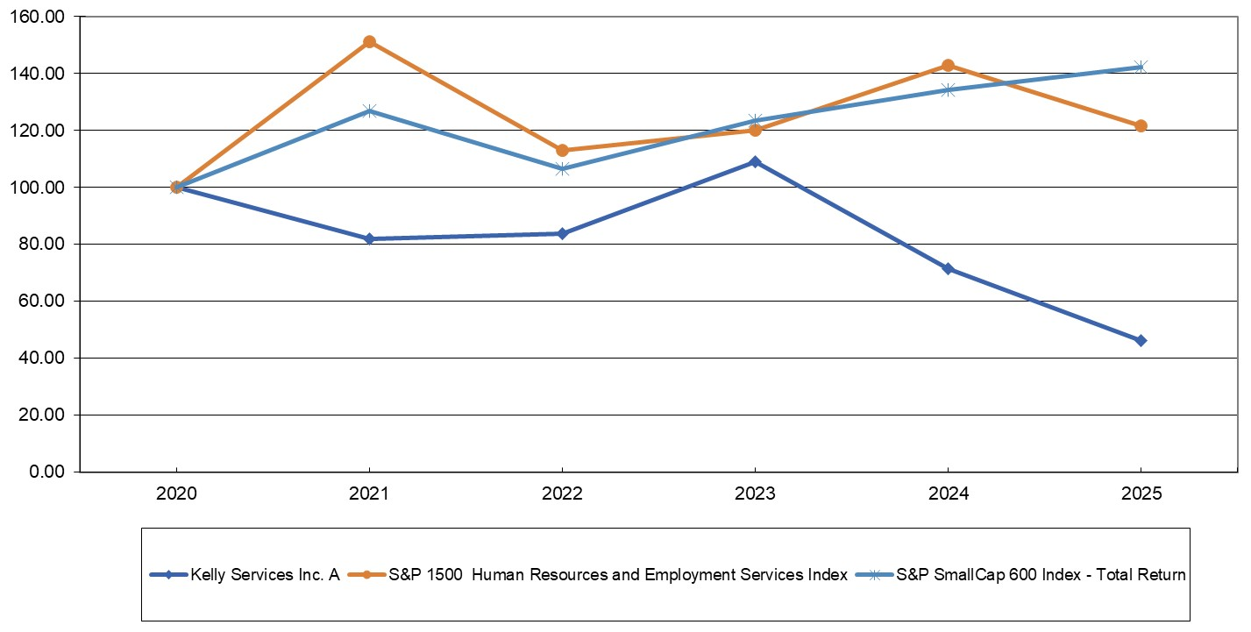
 |  |  | 2020 |  |  | 2021 |  |  | 2022 |  |  | 2023 |  |  | 2024 |  |  | 2025
Kelly Services, Inc. |  |  | $ | 100.00 |  | $ | 81.95 |  | $ | 83.81 |  | $ | 108.96 |  | $ | 71.34 |  | $ | 46.20
S&P SmallCap 600 Index |  |  | $ | 100.00 |  | $ | 126.82 |  | $ | 106.40 |  | $ | 123.48 |  | $ | 134.22 |  | $ | 142.30
S&P 1500 Human Resources and Employment Services Index |  |  | $ | 100.00 |  | $ | 151.14 |  | $ | 112.90 |  | $ | 120.20 |  | $ | 142.72 |  | $ | 121.68

ITEM 6. [RESERVED]

25

ITEM 7. MANAGEMENT’S DISCUSSION AND ANALYSIS OF FINANCIAL CONDITION AND RESULTS OF OPERATIONS.

Executive Overview
In 2025, Kelly continued to advance its multi-year transformation, building on the decisive actions taken in 2023 and 2024 to streamline the portfolio, sharpen strategic focus, and expand into higher-margin, higher-growth specialties. We remained focused on capturing a greater share of growth, converting a higher proportion of revenue into bottom-line performance, and positioning Kelly to benefit from an eventual recovery in the staffing environment.
Kelly entered 2025 with a simplified operating model concentrated on North American staffing, business process outsourcing (“BPO”) and specialty solutions and global Managed Service Provider (“MSP”) and recruitment process outsourcing (“RPO”) offerings, following the 2024 sale of its European staffing operations and the Ayers Group and acquisition of Motion Recruitment Partners (“MRP”) and Children’s Therapy Center (“CTC”). These portfolio actions reflected a deliberate shift toward businesses with more attractive growth profiles, scalable platforms, and improved EBITDA margin potential.
We continued to execute our refreshed go-to-market strategy, designed to deliver the full suite of Kelly solutions to large enterprise customers and capture a greater share of wallet while maintaining high service levels for customers of all sizes. This strategy was supported by ongoing commitment to delivering greater effectiveness and data-driven sales processes and initiatives.
Critical to positioning Kelly for future growth was the hiring of Chris Layden as President and Chief Executive Officer in September 2025. Layden succeeded Peter Quigley, who announced his intention to retire in February 2025. Layden brings dynamic industry leadership and extensive experience leading organizations through periods of significant change, while delivering growth and strengthening competitive positioning. Layden’s hiring underscores Kelly’s commitment to enhancing its operational capabilities and service delivery while transforming its technology processes and platforms.
During 2025, Kelly faced a dynamic macroeconomic environment characterized by sluggish labor market demand and policy shifts which had significant impacts on the industry, including Kelly. In the face of these headwinds, Kelly demonstrated measurable progress in cost discipline and selective market strength. At the same time, we accelerated structural and demand-driven cost optimization initiatives, including technology modernization, acquisition integration and process efficiencies to enhance execution and agility while positioning Kelly to capture market share and improve profitability when staffing market conditions stabilize.
Structural cost actions, operating model simplification, acquisition integration and portfolio reshaping are expected to support continued improvement in Kelly’s growth prospects and financial profile as we move through 2026 and beyond.
Financial Measures

Reported percentage changes are computed based on millions. Prior year percent changes were computed based on actual amounts in thousands. Prior year percent changes have been recast to conform to the new presentation which is calculated based on millions. All dollar amounts are presented in millions except for per share data.

Days sales outstanding (“DSO”) represents the number of days that sales remain unpaid for the period being reported. DSO is calculated by dividing average net sales per day (based on a rolling three-month period) into trade accounts receivable, net of allowances at the period end. Although secondary supplier revenues are recorded on a net basis (net of secondary supplier expense), secondary supplier revenue is included in the daily sales calculation in order to properly reflect the gross revenue amounts billed to the customer.

NM (not meaningful) in the following tables is used in place of percentage changes where: the change is in excess of 500%, the change involves a comparison between earnings and loss amounts, or the comparison amount is zero.

26

Results of Operations
Total Company
(in millions)

 |  |  | 2025 |  |  | 2024 |  |  | % Change
Revenue from services |  |  | $ | 4,250.9 |  | $ | 4,331.8 |  | (1.9)%
Gross profit |  |  | 853.0 |  |  | 882.6 |  |  | (3.4)
SG&A expenses excluding integration, realignment, restructuring charges, and depreciation and amortization |  |  | 747.1 |  |  | 750.8 |  |  | (0.5)
Integration, realignment and restructuring charges |  |  | 27.8 |  |  | 16.1 |  |  | 72.7
Total SG&A expenses excluding depreciation and amortization |  |  | 774.9 |  |  | 766.9 |  |  | 1.0
Depreciation and amortization |  |  | 51.0 |  |  | 51.5 |  |  | (1.0)
Total SG&A expenses |  |  | 825.9 |  |  | 818.4 |  |  | 0.9
Goodwill impairment charge |  |  | 102.0 |  |  | 72.8 |  |  | 40.1
Asset impairment charge |  |  | — |  |  | 13.5 |  |  | NM
Gain on sale of EMEA staffing operations |  |  | (4.1) |  |  | (1.6) |  |  | (156.3)
Gain on sale of assets |  |  | (1.0) |  |  | (5.4) |  |  | 81.5
Earnings (loss) from operations |  |  | (69.8) |  |  | (15.1) |  |  | (362.3)
Other income (expense), net |  |  | (9.0) |  |  | (6.8) |  |  | (32.4)
Earnings (loss) before taxes |  |  | (78.8) |  |  | (21.9) |  |  | (259.8)
Income tax expense (benefit) |  |  | 175.3 |  |  | (21.3) |  |  | NM
Net earnings (loss) |  |  | $ | (254.1) |  | $ | (0.6) |  | NM
Gross profit rate |  |  | 20.1% |  |  | 20.4% |  |  | (0.3) pts.

The total company discussion that follows focuses on 2025 results compared to 2024. For a discussion of total company 2024 results compared to 2023, see “Management's Discussion and Analysis of Financial Condition and Results of Operations” in Part II, Item 7 of our Annual Report on Form 10-K for the fiscal year ended December 29, 2024, filed on February 13, 2025.

In the segment level discussions that follow the total company discussion, the comparative results for 2024 and 2023 have been recast to conform to the new structure. Our operating segments, which also represent our reportable segments, are based on the organizational structure for which financial results are regularly evaluated by our chief operating decision-maker (“CODM”, our CEO) to determine resource allocation and assess performance.

We combined our former P&I and OCG segments into the ETM segment in the first quarter of 2025, responding to a shift in customer demand toward integrated workforce solutions and enabling a more streamlined and efficient go-to-market approach. We also realigned certain customers from the SET segment to the ETM segment to support this integrated strategy. Also in the first quarter of 2025, we moved MRP's Sevenstep business from the SET segment to the ETM segment as part of the broader integration of MRP. The 2024 and 2023 ETM and SET segment information has been recast to conform to the new structure.
Our three reportable segments: (1) Enterprise Talent Management, (2) Science, Engineering & Technology and (3) Education, reflect the specialty services we provide to customers and represent how the business is organized internally.
2025 vs. 2024

Revenue from services decreased 1.9% year-over-year with decreases in the ETM and SET segments, partially offset by an increase in the Education segment and by the acquisition of MRP in May 2024. Excluding the impact from the acquisition, revenue from services decreased 6.2%. Compared to last year and excluding the impact from the acquisition, revenue from staffing services decreased 6.0% and revenue from outcome-based services decreased 9.4% from the prior year. Revenue from talent solutions increased 1.1% and permanent placement revenue decreased 20.9% from the prior year, excluding the impact from the acquisition.

27

Gross profit decreased 3.4% on lower revenue volume, partially offset by the acquisition of MRP. Excluding the impact from the acquisition, gross profit decreased 9.7%. The gross profit rate decreased 30 basis points to 20.1% and was favorably impacted by the acquisition of MRP. Excluding the acquisition, the gross profit rate declined 70 basis points. The decrease is due primarily to changes in business mix, higher employee-related costs and lower permanent placement revenue. Permanent placement revenue has higher gross profit due to very low direct costs of services and thus has a disproportionate impact on gross profit rates. The gross profit rate decreased in the ETM and SET segments and had a slight increase in the Education segment.

Total selling, general and administrative (“SG&A”) expenses increased 0.9%, primarily due to the acquisition of MRP. Excluding the impact of the acquisition, SG&A expenses decreased 4.8%. Included in SG&A expenses in 2025 were $27.8 million of integration and realignment costs related to initiatives to integrate MRP and other prior acquisitions, consolidating operating segments and further aligning processes and technology. Also included in SG&A was $2.7 million of executive transition charges and $0.8 million of transaction costs. Included in SG&A expenses in 2024 were $17.9 million of transaction costs arising from the sale of our EMEA staffing operations and acquisition of MRP, $10.0 million of integration costs related to initiatives to integrate MRP and aligning Company processes and technology, $6.1 million of restructuring and transformation costs and $2.3 million of executive transition charges. Excluding the impact of the acquisition, as well as transaction, integration, restructuring and executive transition charges—and excluding depreciation and amortization—SG&A expenses decreased 4.7% primarily due to momentum on structural and demand-driven expense optimization initiatives and lower variable, performance-based incentive compensation expenses in response to lower revenue volume. Depreciation and amortization represents the total company depreciation and amortization of intangibles, including the amortization of hosted software.

The goodwill impairment charge in 2025 was primarily driven by reduced demand, integration of MRP and Softworld acquisitions and the realignment of reporting units in the SET segment. The goodwill impairment charge in 2024 related to our Softworld reporting unit which delivers technology staffing and workforce services and is included in the SET segment. Changes in internal projections of financial performance due to continued challenging market conditions resulted in a lower estimated fair value for the reporting unit and an impairment charge of $102.0 million and $72.8 million for 2025 and 2024, respectively. The impairment of assets in 2024 represents the impairment of certain right-of-use (“ROU”) assets related to our leased headquarters facility.

Loss from operations in 2025 totaled $69.8 million, compared to a loss from operations of $15.1 million in 2024. The decrease is primarily related to the goodwill impairment charges, increased costs for integration, realignment and restructuring activities, the impact of lower revenue and gross profits and higher SG&A as compared to the prior year.

The change in other income (expense), net is primarily the result of an increase in interest expense related to the long-term debt taken on in 2024 in conjunction with the acquisition of MRP.

Income tax expense was $175.3 million in 2025 compared to an income tax benefit of $21.3 million in 2024. The 2025 expense was impacted by $197.6 million of federal and state valuation allowances established against U.S. general business credit carryforwards and other deferred tax assets, and a $6.2 million impact from a non-tax deductible goodwill impairment charge. This was offset by an $18.4 million benefit from the impairment of tax-deductible goodwill. In 2024, the benefit was driven by an $18.4 million tax benefit from the impairment of tax-deductible goodwill.

28

Operating Results By Segment
(in millions)

 |  |  | 2025 |  |  | 2024 |  |  | 2025 to 2024  % Change |  |  |  | 2023 |  |  |  | 2024 to 2023  % Change
Revenue From Services:
Enterprise Talent Management |  |  | $ | 2,005.5 |  | $ | 2,196.1 |  | (8.7)% |  |  |  | $ | 2,214.4 |  |  | (0.8)%
Science, Engineering & Technology |  |  | 1,240.4 |  |  | 1,165.7 |  |  | 6.4 |  |  |  | 970.6 |  |  |  | 20.1
Education |  |  | 1,010.7 |  |  | 972.3 |  |  | 3.9 |  |  |  | 841.9 |  |  |  | 15.5
International |  |  | — |  |  | — |  |  | NM |  |  |  | 812.1 |  |  |  | NM
Less: Intersegment revenue |  |  | (5.7) |  |  | (2.3) |  |  | (147.8) |  |  |  | (3.3) |  |  |  | 30.3
Consolidated Total |  |  | $ | 4,250.9 |  | $ | 4,331.8 |  | (1.9)% |  |  |  | $ | 4,835.7 |  |  | (10.4)%

2025 vs. 2024

ETM revenue includes the impact from the acquisition of Sevenstep, the MRP talent solutions business. Revenue excluding the acquisition decreased 9.1%. Revenue from staffing services decreased 11.7%, resulting from lower demand primarily at certain large customers and revenue from outcome-based services decreased 12.1%, primarily due to the ramping down of a large contact-center customer that has fully ended as of the third quarter of 2025, which was offset by an increase of 1.1% in talent solutions, excluding the acquisition.

The increase in SET revenue from services was primarily driven by the acquisition of MRP staffing and outcome-based solutions businesses. Excluding the acquisition, revenue from services decreased 9.3%, primarily driven by lower staffing services demand related to U.S. federal government contractors. Excluding the acquisition, revenue in our outcome-based services decreased 5.5%. Permanent placement fees decreased, reflecting continued lower market demand.

The increase in Education revenue from services was driven by the impact of higher fill rates and higher bill rates on stable demand for our services as compared to a year ago, partially offset by the impact of weather-related school closures early in the year.

2024 vs. 2023

The decrease in ETM revenue from services was due primarily to a 3.9% decline in staffing services resulting from lower demand, partially offset by higher bill rates. Revenue from outcome-based services decreased 0.9% due to lower demand for our call-center solutions, partially offset by higher revenue from other specialties.

The increase in SET revenue from services was driven by the acquisition of MRP in May 2024. Excluding the acquisition, revenue from services decreased 6.6%, primarily due to lower demand in our staffing specialties, partially offset by higher bill rates. Excluding the acquisition, revenues from outcome-based services decreased 6.3%.

The increase in Education revenue from services reflects increased demand for our services as compared to a year ago. Increased demand for our services reflects new customer wins and an increased fill rate related to demand of existing customers.

International reflects the sale of our EMEA staffing operations in January 2024 and the transfer of our Mexico operations to our ETM segment.

29

Operating Results By Segment (continued)
(in millions)

 |  |  | 2025 |  |  | 2024 |  |  | 2025 to 2024  % Change |  |  |  | 2023 |  |  |  | 2024 to 2023  % Change
Gross Profit:
Enterprise Talent Management |  |  | $ | 392.8 |  | $ | 444.9 |  | (11.7)% |  |  |  | $ | 465.7 |  |  | (4.5)%
Science, Engineering & Technology |  |  | 313.2 |  |  | 297.9 |  |  | 5.1 |  |  |  | 246.9 |  |  |  | 20.7
Education |  |  | 147.0 |  |  | 139.8 |  |  | 5.2 |  |  |  | 128.7 |  |  |  | 8.6
International |  |  | — |  |  | — |  |  | NM |  |  |  | 120.1 |  |  |  | NM
Consolidated Total |  |  | $ | 853.0 |  | $ | 882.6 |  | (3.4)% |  |  |  | $ | 961.4 |  |  | (8.2)%
Gross Profit Rate:
Enterprise Talent Management |  |  | 19.6 |  | % | 20.3 |  | % | (0.7) pts. |  |  |  | 21.0 |  | % |  | (0.7) pts.
Science, Engineering & Technology |  |  | 25.3 |  |  | 25.6 |  |  | (0.3) |  |  |  | 25.4 |  |  |  | 0.2
Education |  |  | 14.5 |  |  | 14.4 |  |  | 0.1 |  |  |  | 15.3 |  |  |  | (0.9)
International |  |  | — |  |  | — |  |  | — |  |  |  | 14.8 |  |  |  | (14.8)
Consolidated Total |  |  | 20.1 |  | % | 20.4 |  | % | (0.3) pts. |  |  |  | 19.9 |  | % |  | 0.5 pts.

2025 vs. 2024

Gross profit for the ETM segment decreased on lower revenue volume. Factors impacting the gross profit rate included higher employee-related costs and changes in business mix, which reduced the gross profit rate by 70 basis points.

SET gross profit increased primarily due to the acquisition of MRP. The change in the SET gross profit rate was driven by a 50 basis point decrease reflecting the impact of changes in business mix and higher employee-related costs and a 50 basis point decrease as a result of lower permanent placement revenue, partially offset by a 70 basis point increase due to the MRP acquisition, which generates higher gross profit rates.

Gross profit for the Education segment increased on higher revenue volume. The gross profit rate increased 10 basis points due to lower employee-related costs, partially offset by changes in business mix.

2024 vs. 2023

Gross profit for the ETM segment decreased on lower revenue volume. In comparison to the prior year, the gross profit rate decreased 70 basis points primarily due to changes in business mix and lower permanent placement revenue, partially offset by lower employee-related costs.

SET gross profit increased resulting from the acquisition of MRP, partially offset by the decrease in revenue volume in other components of the segment. The gross profit rate increased 80 basis points due to the acquisition of MRP, which generates higher gross profit rates. This impact was partially offset by a 60 basis point decrease in the gross profit rate in other components of SET reflecting changes in business mix and lower permanent placement revenue, partially offset by lower employee-related costs.

Gross profit for the Education segment increased on higher revenue volume. The gross profit rate decreased 90 basis points due primarily to changes in business mix, lower permanent placement revenue and higher employee-related costs.

International reflects the sale of our EMEA staffing operations in January 2024 and the transfer of our Mexico operations to our ETM segment.

30

Operating Results By Segment (continued)
(in millions)

 |  |  | 2025 |  |  | 2024 |  |  | 2025 to 2024  % Change |  |  |  | 2023 |  |  |  | 2024 to 2023  % Change
SG&A Expenses (excluding depreciation and amortization):
Enterprise Talent Management |  |  | $ | 373.0 |  | $ | 385.9 |  | (3.3)% |  |  |  | $ | 432.2 |  |  | (10.7)%
Science, Engineering & Technology |  |  | 247.1 |  |  | 226.7 |  |  | 9.0 |  |  |  | 184.8 |  |  |  | 22.7
Education |  |  | 101.0 |  |  | 95.9 |  |  | 5.3 |  |  |  | 92.4 |  |  |  | 3.8
International |  |  | — |  |  | — |  |  | NM |  |  |  | 122.0 |  |  |  | NM
Corporate expenses |  |  | 53.8 |  |  | 58.4 |  |  | (7.9) |  |  |  | 63.2 |  |  |  | (7.6)
Consolidated Total |  |  | $ | 774.9 |  | $ | 766.9 |  | 1.0% |  |  |  | $ | 894.6 |  |  | (14.3)%

2025 vs. 2024

The decrease in ETM SG&A expenses excluding depreciation and amortization was primarily due to lower salary-related costs and performance-based incentive compensation as a result of operating efficiencies and expense management actions in response to lower revenue volume compared to the prior year, partially offset by the addition of the Sevenstep business and integration and realignment charges. Excluding the acquisition, expenses decreased 4.5% from the prior year.

The increase in SET SG&A expenses excluding depreciation and amortization was primarily related to higher employee-related costs due to the acquisition of MRP. Excluding the acquisition, expenses decreased 6.5% from the prior year due to lower shared service costs which are included in other segment expenses and lower direct salaries reflecting expense management actions in response to lower revenue volume compared to the prior year, partially offset by an increase in integration and realignment charges in 2025 as compared to prior year restructuring and transformation costs.

The increase in Education SG&A expenses excluding depreciation and amortization primarily related to increased costs to support year-over-year revenue growth.

The decrease in Corporate expenses was primarily driven by lower employee-related costs and transaction costs, partially offset by an increase in integration and realignment charges in 2025 as compared to prior year.

2024 vs. 2023

The decrease in total SG&A expenses excluding depreciation and amortization in ETM includes the impact of restructuring and transformation charges and the impact from the addition of the Sevenstep business. Excluding the impact of these items, expenses decreased by 10.5% primarily due to lower direct salaries as a result of cost management in response to lower revenue volume compared to the prior year, as well as the impact of transformation-related actions. Other segment expenses declined primarily due to lower shared service costs for IT, finance, human resources and legal support and lower facilities and equipment-related costs.

The increase in total SG&A expenses excluding depreciation and amortization in SET is due to the MRP acquisition. Excluding the impact from the acquisition, expenses decreased 10.3% from the prior year primarily due to lower shared service costs which are included in other segment expenses and lower direct salaries reflecting the response to lower revenue volume compared to the prior year, as well as the impact of transformation-related actions.

The increase in total SG&A expenses excluding depreciation and amortization in Education is primarily due to increased direct salaries and other segment expenses as revenue levels increased and were partially offset by the impact of transformation-related actions.

International reflects the sale of our EMEA staffing operations in January 2024 and the transfer of our Mexico operations to our ETM segment.

The decrease in Corporate expenses includes the impact of transaction, integration and executive transition costs. Excluding these impacts, expenses decreased 12.6%. This decrease primarily reflects lower legal settlement costs and employee
31

compensation costs. Transaction, integration and executive transition costs were $21.5 million and restructuring and transformation charges were $5.1 million in 2024. Restructuring and transformation charges were $19.9 million and transaction costs were $6.9 million in 2023.

32

Operating Results By Segment (continued)
(in millions)

 |  |  | 2025 |  |  | 2024 |  |  | 2025 to 2024  % Change |  |  |  | 2023 |  |  |  | 2024 to 2023  % Change
Business Unit Profit (Loss)
Enterprise Talent Management |  |  | $ | 19.8 |  | $ | 59.0 |  | (66.4)% |  |  |  | $ | 31.2 |  |  | 89.1%
Science, Engineering & Technology |  |  | (35.9) |  |  | (1.6) |  |  | NM |  |  |  | 62.0 |  |  |  | NM
Education |  |  | 46.0 |  |  | 43.9 |  |  | 4.8 |  |  |  | 36.3 |  |  |  | 20.9
International |  |  | — |  |  | — |  |  | NM |  |  |  | (1.9) |  |  |  | NM
Business Unit Profit (Loss) |  |  | 29.9 |  |  | 101.3 |  |  | (70.5) |  |  |  | 127.6 |  |  |  | (20.6)
Corporate |  |  | (53.8) |  |  | (58.4) |  |  | (7.9) |  |  |  | (63.2) |  |  |  | (7.6)
Asset impairment charge |  |  | — |  |  | (13.5) |  |  | NM |  |  |  | — |  |  |  | NM
Gain on sale of EMEA staffing operations |  |  | 4.1 |  |  | 1.6 |  |  | 156.3 |  |  |  | — |  |  |  | NM
Gain on sale of assets |  |  | 1.0 |  |  | 5.4 |  |  | (81.5) |  |  |  | — |  |  |  | NM
Depreciation and amortization |  |  | (51.0) |  |  | (51.5) |  |  | (1.0) |  |  |  | (40.1) |  |  |  | 28.4
Consolidated Total Earnings (loss) from Operations |  |  | $ | (69.8) |  | $ | (15.1) |  | (362.3)% |  |  |  | $ | 24.3 |  |  | NM

2025 vs. 2024

ETM reported profit decreased versus the prior year primarily due to lower revenue and gross profit with lower demand among certain large customers, partially offset by lower SG&A expenses. These results include the impact from the addition of the Sevenstep business.

SET reported loss includes an increase in goodwill impairment charges and the impact of the 2024 acquisition of MRP. Excluding the goodwill impairment and acquisition impacts, SET business unit loss increased from the prior year due to lower revenue and gross profit, partially offset by lower SG&A expenses.

Education reported profit increased versus the prior year primarily driven by higher revenue and gross profit driven by the impact of higher fill rates and bill rates, partially offset by an increase in SG&A expenses.

Corporate expenses decreased over the prior year primarily driven by lower employee-related costs and transaction costs, partially offset by an increase in integration and realignment charges in 2025.

2024 vs. 2023

ETM reported profit increased versus the prior year due primarily to lower SG&A expenses, partially offset by lower revenue and gross profit. These results include the impact of $1.0 million of business unit profit from the addition of the Sevenstep business.

SET reported profit in 2024 includes a $72.8 million goodwill impairment charge related to Softworld and $11.8 million of business unit profit from the acquisition of MRP. Excluding the goodwill impairment and acquisition impacts, the decrease in profit was essentially flat to prior year.

Education reported profit increased versus the prior year primarily due to higher revenue and gross profit.

International reflects the sale of our EMEA staffing operations in January 2024 and the transfer of our Mexico operations to our ETM segment.

Corporate expenses decreased year-over-year primarily due to lower transformation-related charges, partially offset by higher transaction-related expenses from the sale of our EMEA staffing operations and integration costs related to the acquisition of MRP.

33

Results of Operations
Financial Condition

Historically, we have financed our operations through cash generated by operating activities and access to credit markets. Our working capital requirements are primarily generated from temporary employee payroll, which is generally paid weekly or monthly and customer accounts receivable, which is generally invoiced to customers weekly or monthly and is outstanding for longer periods. Since receipts from customers lag payroll payments to temporary employees, working capital requirements increase and operating cash flows may decrease substantially in periods of growth. Conversely, when economic activity slows, working capital requirements may substantially decrease and operating cash flows increase. Such increases dissipate over time if the economic downturn continues for an extended period.

Cash, Cash Equivalents and Restricted Cash

Cash, cash equivalents and restricted cash totaled $37.7 million at year-end 2025, compared to $45.6 million at year-end 2024. As further described below, during 2025, we generated $122.6 million of cash from operating activities, generated $22.3 million of cash from investing activities and used $161.1 million of cash for financing activities.

Operating Activities

In 2025, we generated $122.6 million of net cash from operating activities, as compared to generating $26.9 million in 2024 and generating $76.7 million in 2023. The increase from prior year is primarily due to decreased working capital requirements.

Trade accounts receivable totaled $1.2 billion at year-end 2025 and $1.3 billion at year-end 2024. Global DSO was 61 days for 2025 and 59 days for 2024.

Deferred tax expense of $168.5 million in 2025 compared to a deferred tax benefit of $27.8 million in 2024 is due to an increase in the valuation allowance on deferred tax assets in 2025. This allowance was principally due to cumulative losses in recent years, which were driven by goodwill impairment charges. Cumulative losses are a significant piece of negative evidence that limits the ability to consider other evidence, such as projections for future growth, when assessing the recoverability of deferred tax assets.

Our working capital position (total current assets less total current liabilities), was $446.5 million at year-end 2025 and $539.0 million for 2024, including the impact of our 2024 acquisition of MRP of $71.2 million. The decrease in working capital is due to lower trade accounts receivable from reduced revenue and the cash collected during the year was used to pay down debt balances. The current ratio (total current assets divided by total current liabilities) was 1.5 at year-end 2025 and 1.7 at year-end 2024.

Investing Activities

In 2025, we generated $22.3 million of net cash for investing activities, compared to using $361.6 million in 2024 and $14.1 million in 2023. Included in cash from investing activities in 2025 is $21.8 million of cash proceeds received in connection with the settlement of the receivable related to the sale of EMEA staffing operations and $6.4 million of cash from the sale of the PersolKelly investment (see Acquisitions and Dispositions footnote). This was partially offset by $8.5 million of cash used for capital expenditures.

Included in cash used for investing activities in 2024 was $431.9 million of cash used for the acquisition of MRP in May 2024 and CTC in November 2024, net of cash received, $11.1 million of cash used for capital expenditures, partially offset by $77.1 million of proceeds from the sale of the EMEA staffing operations, net of cash disposed.

Included in cash used for investing activities in 2023 is $15.3 million of cash used for capital expenditures, partially offset by $2.0 million for the receipt of the final payment in connection with an investment that was sold in 2021.

Capital expenditures in 2025, 2024 and 2023 primarily related to our IT infrastructure and technology programs.

Financing Activities

In 2025, we used $161.1 million of cash for financing activities, as compared to generating $214.8 million in 2024 and using $59.6 million in 2023. The cash used from financing activities is driven by net payments of $137.5 million in 2025 compared to
34

net proceeds of $239.4 million in 2024 on our credit facilities in connection with the acquisition of MRP. The acquisition of MRP represents the primary driver of the change in cash from 2024. The change in cash used for financing activities from 2023 to 2024 was primarily related to a decrease in Class A common stock repurchases. In 2025, we repurchased $10.0 million of our Class A common stock compared to $10.0 million in shares repurchased in 2024 and $42.2 million in 2023.
Dividends paid per common share were $0.30 in 2025, 2024 and 2023. Payments of dividends are restricted by the financial covenants contained in our debt facilities. Details of this restriction are contained in the Debt footnote in the notes to our consolidated financial statements.
Debt-to-total capital (total debt reported in the consolidated balance sheet divided by total debt plus stockholders’ equity) is a common ratio to measure our relative capital structure and leverage. Our ratio of debt-to-total capital was 9.4% at year-end 2025 and 16.2% at year-end 2024.

35

Liquidity

We expect to meet our ongoing short-term and long-term cash requirements principally through cash generated from operations, available cash and equivalents and our credit facilities. Additional funding sources could include additional bank facilities or sale of non-core assets. To meet significant cash requirements related to our nonqualified retirement plan, we may utilize proceeds from Company-owned life insurance policies.

We have historically managed our cash and debt closely to optimize our capital structure. As our cash balances build, we tend to pay down debt as appropriate, unless it is needed for organic or inorganic investments that align with our overall growth strategy. Conversely, when working capital needs grow, we tend to use corporate cash and cash available in the global cash pooling arrangement (the “Cash Pool”) first, and then access our borrowing facilities. We expect our working capital requirements to increase if demand for our services increases.

We assess and monitor our liquidity and capital resources globally. We use the Cash Pool, intercompany loans, dividends, capital contributions, and local lines of credit to meet funding needs and allocate our capital resources among our various subsidiaries. We periodically review our foreign subsidiaries’ cash balances and projected cash needs. As part of those reviews, we may identify cash that we feel should be repatriated to optimize our overall capital structure. As of year-end 2025, these reviews have not resulted in specific plans to repatriate a majority of our international cash balances. We expect much of our international cash will be needed to fund working capital growth in our local operations as working capital needs, primarily trade accounts receivable, increase during periods of growth.

At year-end 2025, we had $150.0 million of available capacity on our $150.0 million revolving credit facility and $105.5 million of available capacity on our $250.0 million securitization facility. The revolving credit facility carried no long-term borrowings on the floating or term benchmark lines of credit. The securitization facility carried $101.9 million of long-term borrowings and $42.6 million of standby letters of credit related to workers’ compensation. The credit facilities also include an accordion feature to increase our combined borrowing capacity by $250.0 million.

Together, the revolving credit and securitization facilities provide us with committed funding capacity that may be used for general corporate purposes subject to financial covenants and restrictions. We believe our cash flow from operations, the availability of liquidity under our credit facilities, including the accordion feature which allows us to increase our borrowing capacity and our ability to access capital from financial markets will be sufficient to meet our anticipated cash requirements, while maintaining sufficient liquidity for normal operating purposes. Throughout 2025 and as of the 2025 year end, we met the debt covenants related to our revolving credit facility and securitization facility.

At year-end 2025, we had additional unsecured, uncommitted short-term local credit facilities totaling $3.2 million, under which we had no borrowings. Details of our debt facilities as of the 2025 year end are contained in the Debt footnote in the notes to our consolidated financial statements.

We repurchased $10.0 million of our Class A common stock in fiscal 2025 pursuant to the $50.0 million share repurchase program, which was approved by our board of directors in November 2024. A total of $30.0 million remains available under the share repurchase program as of year-end 2025.

We monitor the credit ratings of our banking partners on a regular basis and have regular discussions with them. Based on our reviews and communications, we believe the risk of one or more of our banks not being able to honor commitments is insignificant. We also review the ratings and holdings of our money market funds and other investment vehicles regularly to ensure high credit quality and access to our invested cash.

36

Contractual Obligations and Commercial Commitments

In addition to our discussion of liquidity and capital resources, consideration should also be given to the following contractual obligations:

•Long-term debt - We maintain a revolving credit facility and securitization facility as discussed above in Liquidity. Further details regarding these facilities, including terms, rates and conditions, can be found in the Debt footnote in the notes to our consolidated financial statements.

•Leases - We have operating leases for headquarters and field offices and various equipment. Our leases generally have remaining lease terms of one year to 10 years. As of December 28, 2025, we have lease payment obligations of $67.7 million, with $15.1 million payable within the next 12 months. See the Lease footnote in the notes to our consolidated financial statements for further information.

•Accrued workers compensation - We have a combination of insurance and self-insurance contracts in the U.S. under which it bears the first $1.0 million of risk per accident. As of December 28, 2025, the accrual for workers' compensation claims, net of related receivables, was $46.9 million, with $20.9 million payable within the next 12 months. Management utilizes actuarial methods to estimate the future cash payments for these claims, including an allowance for incurred-but-not-reported claims. Further details can be found in the Summary of Significant Accounting Policies footnote in the notes to our consolidated financial statements.

•Accrued retirement benefits - We provide nonqualified retirement plans for officers and certain other employees. As of December 28, 2025, the value of our obligations under these plans are $289.3 million, with $25.6 million payable within the next 12 months. The timing of payments related to the plans vary based on individual elections and specific plan provisions. See the Retirement Benefits footnote in the notes to our consolidated financial statements for further information.

•Purchase obligations - Our purchase obligations represent unconditional commitments relating primarily to technology services and online tools which we expect to utilize generally within the next three fiscal years, in the ordinary course of business. As of December 28, 2025, the value of our non-cancelable purchase obligations is $61.5 million, with $44.0 million expected to be paid within the next 12 months.

37

Critical Accounting Estimates

We prepare our consolidated financial statements in conformity with accounting principles generally accepted in the United States. In this process, it is necessary for us to make certain assumptions and related estimates affecting the amounts reported in the consolidated financial statements and the attached notes. Actual results can differ from assumed and estimated amounts.

Critical accounting estimates are those that we believe require the most difficult, subjective or complex judgments, often as a result of the need to make estimates about the effect of matters that are inherently uncertain. We base our estimates on historical experience and on various other assumptions we believe to be reasonable under the circumstances, the results of which form the basis for making judgments about the carrying value of assets and liabilities that are not readily apparent from other sources. Judgments and uncertainties affecting the application of those estimates may result in materially different amounts being reported under different conditions or using different assumptions. We consider the following estimates to be most critical in understanding the judgments involved in preparing our consolidated financial statements.

Workers’ Compensation

In the U.S., we have a combination of insurance and self-insurance contracts under which we effectively bear the first $1.0 million of risk per single accident. There is no aggregate limitation on our per-accident exposure under these insurance and self-insurance programs. We establish accruals for workers’ compensation utilizing actuarial methods to estimate the undiscounted future cash payments that will be made to satisfy the claims, including an allowance for incurred-but-not-reported claims. We retain an independent consulting actuary to establish ultimate loss forecasts for the current and prior accident years of our insurance and self-insurance programs. The consulting actuary establishes loss development factors and loss rates, based on our historical claims experience as well as industry experience and applies those factors to current claims information to derive an estimate of our ultimate claims liability. In preparing the estimates, the consulting actuary may consider factors such as the nature, frequency and severity of the claims; reserving practices of our third-party claims administrators; performance of our medical cost management and return to work programs; changes in our territory and business line mix; and current legal, economic and regulatory factors such as industry estimates of medical cost trends. Where appropriate, multiple generally accepted actuarial techniques are applied and tested in the course of preparing the loss forecast. We use the ultimate loss forecasts, as developed by the consulting actuary, to establish total expected program costs for each accident year by adding our estimates of non-loss costs such as claims handling fees and excess insurance premiums. When claims exceed the applicable loss limit or self-insured retention and realization of recovery of the claim from existing insurance policies is deemed probable, we record a receivable from the insurance company for the excess amount.

We evaluate the accrual quarterly and make adjustments as needed. The ultimate cost of these claims may be greater than or less than the established accrual. While we believe that the recorded amounts are reasonable, there can be no assurance that changes to our estimates will not occur due to limitations inherent in the estimation process. In the event we determine that a smaller or larger accrual is appropriate, we would record a credit or a charge to cost of services in the period in which we made such a determination. The accrual for workers’ compensation, net of related receivables which are included in prepaid expenses and other current assets and other assets in the consolidated balance sheet, was $46.9 million and $44.4 million at year-end 2025 and 2024, respectively.

Business Combinations

We account for business combinations using the acquisition method of accounting, in which the purchase price is allocated for assets acquired and liabilities assumed and recorded at the estimated fair values at the date of acquisition. Any excess of the purchase price over the estimated fair values of the net assets acquired is recorded as goodwill. Management is required to make significant assumptions and estimates in determining the fair value of the assets acquired, particularly intangible assets. Purchased intangible assets are primarily comprised of acquired trade names and customer relationships that are recorded at fair value at the date of acquisition. We utilize third-party valuation specialists to assist us in the determination of the fair value of the intangibles. The fair value of trade name intangibles is determined using the relief-from-royalty method, which relies on the use of estimates and assumptions about expected future revenue growth rates, royalty rates and discount rates. The fair value of customer relationship intangibles is determined using the multi-period excess earnings method, which relies on the use of estimates and assumptions about expected future revenue growth rates, customer attrition rates, profit margins and discount rates. Determining the useful lives of intangible assets also requires judgment and are inherently uncertain. There is a measurement period of up to one year in which to finalize the fair value determinations and preliminary fair value estimates may be revised if new information is obtained during this period.

38

Income Taxes

Income tax expense is based on expected income and statutory tax rates in the various jurisdictions in which we operate. Judgment is required in determining our income tax expense.

Our effective tax rate includes the impact of accruals and changes to accruals that we consider appropriate, as well as related interest and penalties. A number of years may lapse before a particular matter, for which we have or have not established an accrual, is audited and finally resolved. While it is often difficult to predict the final outcome or the timing of resolution of any particular tax matter, we believe that our accruals are appropriate under generally accepted accounting principles. Favorable or unfavorable adjustments of the accrual for any particular issue would be recognized as an increase or decrease to our income tax expense in the period of a change in facts and circumstances. Our current tax accruals are presented in income and other taxes in the consolidated balance sheet and long-term tax accruals are presented in other long-term liabilities in the consolidated balance sheet.

Tax laws require items to be included in the tax return at different times than the items are reflected in the consolidated financial statements. As a result, the income tax expense reflected in our consolidated financial statements is different than the liability reported in our tax return. Some of these differences are permanent, which are not deductible or taxable on our tax return and some are temporary differences, which give rise to deferred tax assets and liabilities. We establish valuation allowances for our deferred tax assets when the amount of expected future taxable income is not likely to support the use of the deduction or credit. Our net deferred tax asset is recorded using currently enacted tax laws and may need to be adjusted in the event tax laws change.

The U.S. work opportunity credit is allowed for wages earned by employees in certain targeted groups. The actual amount of creditable wages in a particular period is estimated, since the credit is only available once an employee reaches a minimum employment period and the employee’s inclusion in a targeted group is certified by the applicable state. As these events often occur after the period the wages are earned, judgment is required in determining the amount of work opportunity credits accrued for in each period. We evaluate the accrual regularly throughout the year and make adjustments as needed.

Goodwill

We test goodwill for impairment annually and whenever events or circumstances make it more likely than not that an impairment may have occurred. GAAP requires that goodwill be tested for impairment at a reporting unit level. For segments with a goodwill balance, we determine if our reporting units are the same as our operating and reportable segments based on our organizational structure or one level below our operating segments (the component level).

We may first use a qualitative assessment (“step zero”) for the annual impairment test if we have determined that it is more likely than not that the fair value for one or more reporting units is greater than their carrying value. In conducting the qualitative assessment, we assess the totality of relevant events and circumstances that affect the fair value or carrying value of the reporting unit. Such events and circumstances may include macroeconomic conditions, industry and market conditions, cost factors, overall financial performance, entity-specific events and events affecting a reporting unit.

If we elect to forgo the qualitative assessment for a reporting unit, goodwill is tested for impairment by comparing the estimated fair value of a reporting unit to its carrying value (“step one”). If the estimated fair value of a reporting unit exceeds the carrying value of the net assets assigned to a reporting unit, goodwill is not considered impaired and no further testing is required. If the carrying value of the net assets assigned to a reporting unit exceeds the estimated fair value of a reporting unit, goodwill is deemed impaired and is written down to the extent of the difference.

For the step one quantitative test, we utilized a third-party valuation specialist to assist in determining the fair value of our reporting units using the income and market approach. Under the income approach, estimated fair value is determined based on estimated future cash flows discounted by an estimated market participant weighted-average cost of capital, which reflects the overall level of inherent risk of the reporting unit being measured. Estimated future cash flows are based on our internal projection model and reflects management’s outlook for the reporting units. Under the market approach, the use of pricing multiples derived from an analysis of comparable public companies multiplied against historical and/or anticipated financial metrics of each reporting unit was used. Assumptions and estimates about market comparables, future cash flows, discount rates and long-term growth rates are complex and often subjective. They can be affected by a variety of factors, including external factors such as industry and economic trends and internal factors such as changes in our business strategy and our internal forecasts. Our analysis used significant assumptions by reporting unit, including: expected future revenue growth rates, profit margins and discount rates.

39

Although we believe the assumptions and estimates we have made are reasonable and appropriate, different assumptions and estimates could materially impact our reported financial results. Different assumptions of the anticipated future results and growth from our business could result in an impairment charge, which would decrease operating income and result in lower asset values on our consolidated balance sheet.

We completed our annual impairment test for all reporting units with goodwill in the fourth quarter of 2025. Pursuant to the segment changes in first quarter of 2025, the goodwill reporting units were reassessed (see the Segment Disclosures footnote in the notes to our consolidated financial statements). As of year-end 2025, the Company determined that there are three reporting units with assigned goodwill. The three reporting units tested in the fourth quarter of 2025 were SET, Education and RPO. The RPO reporting unit is part of the ETM segment and contains goodwill transferred from Sevenstep, (the RPO business acquired with MRP in 2024). Prior period components related to SET and Education were aggregated into one reporting unit as of year-end 2025. Because the reporting units had been reassessed during the year, and due to the goodwill impairment recognized in the third quarter of 2025, our annual goodwill impairment testing included a step one quantitative analysis for each reporting unit. As a result of the quantitative assessments, we determined that the estimated fair value of the each reporting unit exceeded its carrying value with headroom greater than 10%; therefore goodwill was not impaired as of year-end 2025 (see the Goodwill and Intangible Assets footnote in the notes to our consolidated financial statements). However, if current expectations of future revenue and profit margins are not met, or if market factors outside of our control change significantly, including discount rate, then the goodwill of our reporting units may be impaired in the future, resulting in goodwill impairment charges.

As a measure of sensitivity of the fair value for the three reporting units tested in 2025, while holding all other assumptions constant, an increase in the discount rate of 100 basis points or a decrease of 100 basis points in the revenue growth rate assumptions for each forecasted period used to determine the fair value of the reporting unit would not result in an impairment of goodwill.

We completed our annual impairment test for all reporting units with goodwill in the fourth quarter for the fiscal year ended 2024. For the PTS and Education reporting units, we performed step zero qualitative analyses and have concluded that there are no indications that the fair values of the PTS and Education reporting units are less than their respective carrying values and therefore no further testing was required. For the Softworld and MRP reporting units, our annual goodwill impairment testing included step one quantitative tests. As a result of the quantitative assessment, we determined that the estimated fair value of the MRP reporting unit was more than its carrying value and that the estimated fair value of the Softworld reporting unit no longer exceeded the carrying value. Softworld's 2024 financial performance was lower than internal projections due to continued challenging market conditions. As a result, management’s expectation for near-term financial performance and projected long-term growth rates were revised accordingly. These changes in circumstances were also indicators that the respective long-lived assets may not be recoverable. Softworld has definite-lived intangible assets, consisting of trade names, customer relationships and non-compete agreements, which are amortized over their estimated useful lives. We performed a long-lived asset recoverability test for Softworld and determined that undiscounted future cash flows exceeded the carrying amount of the asset group and were recoverable. Based on the result of our annual goodwill impairment test, we recorded an impairment charge of $72.8 million, which was included in goodwill impairment charge in the consolidated statements of earnings for the year ended 2024, to write-off a portion of Softworld's goodwill balance. Included in the impairment charge was an $18.4 million tax benefit associated with the impairment. The remaining goodwill balance for the Softworld reporting unit was $38.5 million as of year-end 2024.

We completed our annual impairment test for all reporting units with goodwill in the fourth quarter for the fiscal year ended 2023 and as a result of the quantitative and qualitative assessments performed, we determined goodwill was not impaired as of year-end 2023.

At year-end 2025 and 2024, total goodwill amounted to $202.1 million and $304.2 million, respectively. See the Goodwill and Intangible Assets footnote in the notes to our consolidated financial statements for more information.

40

Litigation

Kelly is subject to legal proceedings, investigations and claims arising out of the normal course of business. Kelly routinely assesses the likelihood of any adverse judgments or outcomes to these matters, as well as ranges of probable losses. A determination of the amount of the accruals required, if any, for these contingencies is made after analysis of each known issue. Development of the analysis includes consideration of many factors including: potential exposure, the status of proceedings, negotiations, discussions with our outside counsel and results of similar litigation. The required accruals may change in the future due to new developments in each matter. For further discussion, see the Contingencies footnote in the notes to our consolidated financial statements. At year-end 2025 and 2024, the gross accrual for litigation costs amounted to $2.8 million and $1.5 million, respectively, which is included in accounts payable and accrued liabilities and in accrued workers’ compensation and other claims in the consolidated balance sheet.

NEW ACCOUNTING PRONOUNCEMENTS

See New Accounting Pronouncements footnote in the notes to our consolidated financial statements presented in Part II, Item 8 of this report for a description of new accounting pronouncements.

41

CAUTIONARY NOTE REGARDING FORWARD-LOOKING STATEMENTS

Certain statements contained in this report and in our investor conference call related to these results are “forward-looking” statements within the meaning of the applicable securities laws and regulations. Forward-looking statements include statements which are predictive in nature, which depend upon or refer to future events or conditions, or which include words such as “expects,” “anticipates,” “intends,” “plans,” “believes,” “estimates,” or variations or negatives thereof or by similar or comparable words or phrases. In addition, any statements concerning future financial performance (including future revenues, earnings or growth rates), ongoing business strategies or prospects and possible future actions by us that may be provided by management, including oral statements or other written materials released to the public, are also forward-looking statements. Forward-looking statements are based on current expectations and projections about future events and are subject to risks, uncertainties and assumptions about our Company and economic and market factors in the countries in which we do business, among other things. These statements are not guarantees of future performance and we have no specific intention to update these statements.

Actual events and results may differ materially from those expressed or forecasted in forward-looking statements due to a number of factors. The principal important risk factors that could cause our actual performance and future events and actions to differ materially from such forward-looking statements include, but are not limited to, (i) changing market and economic conditions, (ii) disruption in the labor market and weakened demand for human capital resulting from technological advances, loss of large corporate customers and government contractor requirements, (iii) the impact of laws and regulations (including federal, state and international tax laws), (iv) unexpected changes in claim trends on workers’ compensation, unemployment, disability and medical benefit plans, (v) litigation and other legal liabilities (including tax liabilities) in excess of our estimates, (vi) our ability to achieve our business's anticipated growth strategies, (vii) our future business development, results of operations and financial condition, (viii) damage to our brands, (ix) dependency on third parties for the execution of critical functions, (x) conducting business in foreign countries, including foreign currency fluctuations, (xi) availability of temporary workers with appropriate skills required by customers, (xii) cyberattacks or other breaches of network or information technology security and (xiii) other risks, uncertainties and factors discussed in this report and in our other filings with the Securities and Exchange Commission. Actual results may differ materially from any forward-looking statements contained herein and we undertake no duty to update any forward-looking statement to conform the statement to actual results or changes in our expectations. Certain risk factors are discussed more fully under “Risk Factors” in Part I, Item 1A of this report.

ITEM 7A. QUANTITATIVE AND QUALITATIVE DISCLOSURES ABOUT MARKET RISK.

In the normal course of business, we are exposed to foreign currency exchange rate and interest rate risks that could impact our financial position and results of operations.
Foreign Currency
We are exposed to foreign currency risk primarily related to our foreign subsidiaries. Exchange rates impact the U.S. dollar value of our reported earnings, our investments in and held by subsidiaries, local currency denominated borrowings and intercompany transactions with and between subsidiaries. Our foreign subsidiaries primarily derive revenues and incur expenses within a single country and currency which, as a result, provide a natural hedge against currency risks in connection with normal business operations. Accordingly, changes in foreign currency rates vs. the U.S. dollar and euro generally do not impact local cash flows. Intercompany transactions which create foreign currency risk include services, royalties, loans, contributions and distributions.
Interest Rates
We are exposed to interest rate risks through our use of our credit facilities and other local borrowings, when applicable. Following our acquisition of MRP, we have long-term borrowings on our credit facilities. On July 17, 2024, we entered into a $50.0 million 12-month interest rate swap and a $50.0 million 18-month interest rate swap that effectively locked in the variable SOFR component of our interest rate for a portion of the long-term borrowings on the Securitization Facility at a fixed rate of 4.772% and 4.468% from the effective date through July 17, 2025 and January 17, 2026, respectively. The 12-month interest rate swap was settled early with the final payment made in June 2025. A hypothetical fluctuation of 10% of market interest rates would not have had a material impact on our operating results or cash flows.
We are exposed to market risk as a result of our obligation to pay benefits under our nonqualified deferred compensation plan and our related investments in Company-owned variable universal life insurance policies. The obligation to employees increases and decreases based on movements in the equity and debt markets. The investments in mutual funds, as part of the Company-owned variable universal life insurance policies, are designed to mitigate, but not eliminate, this risk with offsetting gains and losses.

42

ITEM 8. FINANCIAL STATEMENTS AND SUPPLEMENTARY DATA.

The financial statements and supplementary data required by this Item are set forth in the accompanying index on page 46 of this filing and are presented in pages 47-93.

ITEM 9. CHANGES IN AND DISAGREEMENTS WITH ACCOUNTANTS ON ACCOUNTING AND FINANCIAL DISCLOSURE.

None.

ITEM 9A. CONTROLS AND PROCEDURES.

Conclusion Regarding the Effectiveness of Disclosure Controls and Procedures

Based on their evaluation as of the end of the period covered by this report, our Chief Executive Officer and Chief Financial Officer have concluded that our disclosure controls and procedures (as defined in Rules 13a-15(e) and 15d-15(e) under the Securities Exchange Act of 1934) are effective at a reasonable assurance level.

Management’s Report on Internal Control Over Financial Reporting

Management’s report on internal control over financial reporting is presented preceding the consolidated financial statements on page 47 of this report.

Attestation Report of Independent Registered Public Accounting Firm

PricewaterhouseCoopers LLP, independent registered public accounting firm, has audited the effectiveness of our internal control over financial reporting as of December 28, 2025, as stated in their report which appears herein.

Changes in Internal Control Over Financial Reporting

There were no changes in our internal control over financial reporting that occurred during our fourth fiscal quarter that have materially affected, or are reasonably likely to materially affect, our internal control over financial reporting.

ITEM 9B. OTHER INFORMATION.

Securities Trading Plans of Directors and Executive Officers

During the fourth quarter ended December 28, 2025, none of the Company's directors or executive officers adopted, modified or terminated any contract, instruction or written plan for the purchase or sale of Company securities that was intended to satisfy the affirmative defense conditions of Rule 10b5-1(c) or any “non-Rule 10b5-1 trading arrangement.”

ITEM 9C. DISCLOSURE REGARDING FOREIGN JURISDICTIONS THAT PREVENT INSPECTIONS.

Not applicable.

43

PART III

ITEM 10. DIRECTORS, EXECUTIVE OFFICERS AND CORPORATE GOVERNANCE.

Insider Trading Policy

The Company has an insider trading policy governing the purchase, sale and other dispositions of the Company’s securities that applies to all Company personnel, including directors, officers, employees and other covered persons. The Company also follows procedures for the repurchase of its securities. The Company believes that its insider trading policy and repurchase procedures are reasonably designed to promote compliance with insider trading laws, rules and regulations and listing standards applicable to the Company. A copy of the Company’s insider trading policy is filed as Exhibit 19 to this Form 10-K.

Code of Business Conduct and Ethics

We have adopted a Code of Business Conduct and Ethics that applies to our directors, officers and employees, including our principal executive officer, principal financial officer and principal accounting officer or controller or persons performing similar functions. The Code of Business Conduct and Ethics is included as Exhibit 14 to this Form 10-K. We have posted our Code of Business Conduct and Ethics on our website at www.kellyservices.com. We intend to post any changes in or waivers from our Code of Business Conduct and Ethics applicable to any of these officers on our website.

The remaining information required by this Item will be included in the Company's definitive proxy statement to be filed with the SEC within 120 days after December 28, 2025, in connection with the solicitation of proxies for the Company's 2026 Annual Meeting of Stockholders (the “2026 Proxy Statement”) and is incorporated herein by reference.

ITEM 11. EXECUTIVE COMPENSATION.

The information required by this Item will be included in the 2026 Proxy Statement and is incorporated herein by reference.

ITEM 12. SECURITY OWNERSHIP OF CERTAIN BENEFICIAL OWNERS AND MANAGEMENT AND RELATED STOCKHOLDER MATTERS.

The information required by this Item will be included in the 2026 Proxy Statement and is incorporated herein by reference.

ITEM 13. CERTAIN RELATIONSHIPS AND RELATED TRANSACTIONS AND DIRECTOR INDEPENDENCE.

The information required by this Item will be included in the 2026 Proxy Statement and is incorporated herein by reference.

ITEM 14. PRINCIPAL ACCOUNTANT FEES AND SERVICES.

The information required by this Item will be included in the 2026 Proxy Statement and is incorporated herein by reference.

44

PART IV

ITEM 15. EXHIBITS, FINANCIAL STATEMENT SCHEDULES.

(a)The following documents are filed as part of this report:

(i)Financial statements:

Management’s Report on Internal Control Over Financial Reporting

Report of Independent Registered Public Accounting Firm (PCAOB ID 238)

Consolidated Statements of Earnings for the three fiscal years ended December 28, 2025

Consolidated Statements of Comprehensive Income for the three fiscal years ended December 28, 2025

Consolidated Balance Sheets at December 28, 2025 and December 29, 2024

Consolidated Statements of Stockholders’ Equity for the three fiscal years ended December 28, 2025

Consolidated Statements of Cash Flows for the three fiscal years ended December 28, 2025

Notes to Consolidated Financial Statements

(ii)Financial Statement Schedule -

For the three fiscal years ended December 28, 2025:

Schedule II - Valuation Reserves

All other schedules are omitted because they are not applicable or the required information is shown in the financial statements or notes thereto.

(iii)The Exhibits are listed in the Index to Exhibits included beginning at page 94, which is incorporated herein by reference.

(b)The Index to Exhibits and required Exhibits are included following the Financial Statement Schedule beginning at page 94 of this filing.

(c)None.

ITEM 16. FORM 10-K SUMMARY.

None.

45

KELLY SERVICES, INC.

INDEX TO FINANCIAL STATEMENTS AND
SUPPLEMENTAL SCHEDULE
Page Reference
in Report on
Form 10-K
Management’s Report on Internal Control Over Financial Reporting |  |  | 47
Report of Independent Registered Public Accounting Firm |  |  | 48
Consolidated Statements of Earnings for the three fiscal years ended December 28, 2025 |  |  | 51
Consolidated Statements of Comprehensive Income for the three fiscal years ended December 28, 2025 |  |  | 52
Consolidated Balance Sheets at December 28, 2025 and December 29, 2024 |  |  | 53
Consolidated Statements of Stockholders' Equity for the three fiscal years ended December 28, 2025 |  |  | 54
Consolidated Statements of Cash Flows for the three fiscal years ended December 28, 2025 |  |  | 55
Notes to Consolidated Financial Statements |  |  | 57
Financial Statement Schedule - Schedule II - Valuation Reserves at December 28, 2025, December 29, 2024 and December 31, 2023 |  |  | 93

46

Management’s Report on Internal Control Over Financial Reporting

The management of Kelly Services, Inc. (the “Company”), is responsible for establishing and maintaining adequate internal control over financial reporting. Internal control over financial reporting is defined in Rules 13a-15(f) and 15d-15(f) promulgated under the Securities Exchange Act of 1934 as a process designed by, or under the supervision of, the Company’s principal executive and principal financial officers and effected by the Company’s board of directors, management and other personnel, to provide reasonable assurance regarding the reliability of financial reporting and the preparation of financial statements for external purposes in accordance with generally accepted accounting principles and includes those policies and procedures that:

•Pertain to the maintenance of records that in reasonable detail accurately and fairly reflect the transactions and dispositions of the assets of the Company;

•Provide reasonable assurance that transactions are recorded as necessary to permit preparation of financial statements in accordance with generally accepted accounting principles and that receipts and expenditures of the Company are being made only in accordance with authorizations of management and directors of the Company; and

•Provide reasonable assurance regarding prevention or timely detection of unauthorized acquisition, use or disposition of the Company’s assets that could have a material effect on the financial statements.

Because of its inherent limitations, internal control over financial reporting may not prevent or detect misstatements. Also, projections of any evaluation of effectiveness to future periods are subject to the risk that controls may become inadequate because of changes in conditions, or that the degree of compliance with the policies or procedures may change.

The Company’s management assessed the effectiveness of the Company’s internal control over financial reporting as of December 28, 2025. In making this assessment, the Company’s management used the criteria set forth by the Committee of Sponsoring Organizations of the Treadway Commission (“COSO”) in Internal Control-Integrated Framework (2013).

Based on our assessment, management determined that, as of December 28, 2025, the Company’s internal control over financial reporting was effective based on those criteria.

The effectiveness of the Company’s internal control over financial reporting as of December 28, 2025 has been audited by PricewaterhouseCoopers LLP, an independent registered public accounting firm, as stated in their report which appears on pages 48-50.

47

Report of Independent Registered Public Accounting Firm
To the Board of Directors and Stockholders of Kelly Services, Inc.
Opinions on the Financial Statements and Internal Control over Financial Reporting
We have audited the accompanying consolidated balance sheets of Kelly Services, Inc. and its subsidiaries (the "Company") as of December 28, 2025 and December 29, 2024, and the related consolidated statements of earnings, of comprehensive income, of stockholders’ equity and of cash flows for each of the three years in the period ended December 28, 2025, including the related notes and financial statement schedule listed in the accompanying index (collectively referred to as the "consolidated financial statements"). We also have audited the Company's internal control over financial reporting as of December 28, 2025, based on criteria established in Internal Control - Integrated Framework (2013) issued by the Committee of Sponsoring Organizations of the Treadway Commission (COSO).
In our opinion, the consolidated financial statements referred to above present fairly, in all material respects, the financial position of the Company as of December 28, 2025 and December 29, 2024, and the results of its operations and its cash flows for each of the three years in the period ended December 28, 2025 in conformity with accounting principles generally accepted in the United States of America. Also in our opinion, the Company maintained, in all material respects, effective internal control over financial reporting as of December 28, 2025, based on criteria established in Internal Control - Integrated Framework (2013) issued by the COSO.
Basis for Opinions
The Company's management is responsible for these consolidated financial statements, for maintaining effective internal control over financial reporting, and for its assessment of the effectiveness of internal control over financial reporting, included in the accompanying Management’s Report on Internal Control Over Financial Reporting. Our responsibility is to express opinions on the Company’s consolidated financial statements and on the Company's internal control over financial reporting based on our audits. We are a public accounting firm registered with the Public Company Accounting Oversight Board (United States) (PCAOB) and are required to be independent with respect to the Company in accordance with the U.S. federal securities laws and the applicable rules and regulations of the Securities and Exchange Commission and the PCAOB.
We conducted our audits in accordance with the standards of the PCAOB. Those standards require that we plan and perform the audits to obtain reasonable assurance about whether the consolidated financial statements are free of material misstatement, whether due to error or fraud, and whether effective internal control over financial reporting was maintained in all material respects.
Our audits of the consolidated financial statements included performing procedures to assess the risks of material misstatement of the consolidated financial statements, whether due to error or fraud, and performing procedures that respond to those risks. Such procedures included examining, on a test basis, evidence regarding the amounts and disclosures in the consolidated financial statements. Our audits also included evaluating the accounting principles used and significant estimates made by management, as well as evaluating the overall presentation of the consolidated financial statements. Our audit of internal control over financial reporting included obtaining an understanding of internal control over financial reporting, assessing the risk that a material weakness exists, and testing and evaluating the design and operating effectiveness of internal control based on the assessed risk. Our audits also included performing such other procedures as we considered necessary in the circumstances. We believe that our audits provide a reasonable basis for our opinions.
Definition and Limitations of Internal Control over Financial Reporting
A company’s internal control over financial reporting is a process designed to provide reasonable assurance regarding the reliability of financial reporting and the preparation of financial statements for external purposes in accordance with generally accepted accounting principles. A company’s internal control over financial reporting includes those policies and procedures that (i) pertain to the maintenance of records that, in reasonable detail, accurately and fairly reflect the transactions and dispositions of the assets of the company; (ii) provide reasonable assurance that transactions are recorded as necessary to permit preparation of financial statements in accordance with generally accepted accounting principles, and that receipts and expenditures of the company are being made only in accordance with authorizations of management and directors of the company; and (iii) provide reasonable assurance regarding prevention or timely detection of unauthorized acquisition, use, or disposition of the company’s assets that could have a material effect on the financial statements.
48

Because of its inherent limitations, internal control over financial reporting may not prevent or detect misstatements. Also, projections of any evaluation of effectiveness to future periods are subject to the risk that controls may become inadequate because of changes in conditions, or that the degree of compliance with the policies or procedures may deteriorate.
Critical Audit Matters
The critical audit matters communicated below are matters arising from the current period audit of the consolidated financial statements that were communicated or required to be communicated to the audit committee and that (i) relate to accounts or disclosures that are material to the consolidated financial statements and (ii) involved our especially challenging, subjective, or complex judgments. The communication of critical audit matters does not alter in any way our opinion on the consolidated financial statements, taken as a whole, and we are not, by communicating the critical audit matters below, providing separate opinions on the critical audit matters or on the accounts or disclosures to which they relate.
Interim Goodwill Impairment Assessments of the Motion Recruitment Partners and Softworld Reporting Units and the Annual Goodwill Impairment Assessment of the Science, Engineering and Technology Reporting Unit
As described in Notes 1 and 9 to the consolidated financial statements, as of December 28, 2025, the Company’s goodwill balance was $202.1 million, which included $137.1 million related to the Science, Engineering and Technology (SET) reporting unit. Management performs the annual goodwill impairment testing in the fourth quarter each year and regularly assesses whenever events or circumstances make it more likely than not that an impairment may have occurred. During the third quarter of 2025, the Company combined the Motion Recruitment Partners (MRP) and Softworld reporting units with the other legacy SET operations into one SET reporting unit. During the assessment, but before the combination, management concluded that there was a triggering event. Therefore, it was necessary to perform step one quantitative tests utilizing the income approach for both the MRP and Softworld reporting units, resulting in management determining that both MRP and Softworld’s estimated fair value of the reporting units no longer exceeded carrying value. Management recorded an impairment charge of $63.5 million and $38.5 million for MRP and Softworld, respectively. Management completed the annual impairment test for all reporting units with goodwill in the fourth quarter of 2025 primarily using the income approach combined with a market approach. As a result of the quantitative assessment, management determined that the estimated fair value of the SET reporting unit exceeded its carrying value; therefore goodwill was not impaired. Under the income approach, estimated fair value is determined based on estimated future cash flows discounted by an estimated market participant weighted-average cost of capital. Estimated future cash flows for the reporting units used significant assumptions relating to expected future revenue growth rates, profit margins, and discount rates. Under the market approach, the use of pricing multiples derived from an analysis of comparable public companies multiplied against historical and/or anticipated financial metrics of each reporting unit was used.
The principal considerations for our determination that performing procedures relating to the interim goodwill impairment assessments of the MRP and Softworld reporting units and the annual goodwill impairment assessment of the SET reporting unit is a critical audit matter are (i) the significant judgment by management when developing the fair value estimate of the MRP, Softworld and SET reporting units; (ii) a high degree of auditor judgment, subjectivity, and effort in performing procedures and evaluating management’s significant assumptions related to expected future revenue growth rates, profit margins, and discount rates; and (iii) the audit effort involved the use of professionals with specialized skill and knowledge.
Addressing the matter involved performing procedures and evaluating audit evidence in connection with forming our overall opinion on the consolidated financial statements. These procedures included testing the effectiveness of controls relating to management’s interim and annual goodwill impairment assessments, including controls over the valuation of the MRP, Softworld and SET reporting units. These procedures also included, among others (i) testing management’s process for developing the fair value estimate of the MRP, Softworld and SET reporting units; (ii) evaluating the appropriateness of the discounted cash flow models used by management; (iii) testing the completeness and accuracy of underlying data used in the discounted cash flow models; and (iv) evaluating the reasonableness of the significant assumptions used by management related to expected future revenue growth rates, profit margins, and discount rates. Evaluating management’s assumptions related to expected future revenue growth rates and profit margins involved evaluating whether the assumptions used by management were reasonable considering (i) the current and past performance of the MRP, Softworld and SET reporting units; (ii) the consistency with external market and industry data; and (iii) whether the assumptions were consistent with evidence obtained in other areas of the audit. Professionals with specialized skill and knowledge were used to assist in evaluating (i) the appropriateness of the discounted cash flow models and (ii) the reasonableness of the discount rate assumption.
Income Taxes - Valuation of Deferred Tax Assets Related to United States (U.S.) General Business Credit Carryforwards
As described in Notes 1 and 17 to the consolidated financial statements, as of December 28, 2025, the Company’s net deferred tax assets balance was $163.2 million, inclusive of a valuation allowance totaling $230.2 million. The Company accounts for income taxes using the liability method. Under this method, deferred tax assets and liabilities are recognized for the expected
49

tax consequences of temporary differences between the tax bases of assets and liabilities and their reported amounts. Valuation allowances are provided against deferred tax assets when it is more likely than not that some portion or all of the deferred tax asset will not be realized. During 2025, management recorded a charge of $197.6 million to establish a valuation allowance for the Company’s U.S. general business credit carryforwards and to increase the allowance for its foreign tax credit carryforwards, certain state loss carryforwards, and future deductible items. The valuation allowance against the U.S. general business credit carryforwards as of December 28, 2025 was $161.8 million after considering the future deductibility of the credits upon expiration.
The principal considerations for our determination that performing procedures relating to the valuation of deferred tax assets related to U.S. general business credit carryforwards is a critical audit matter are (i) the significant judgment by management when determining whether the deferred tax assets related to U.S. general business credit carryforwards are more likely than not to be realized in the future and (ii) a high degree of auditor judgment, subjectivity, and effort in performing procedures and evaluating audit evidence related to management's assessment of the realizability of deferred tax assets related to U.S. general business credit carryforwards.
Addressing the matter involved performing procedures and evaluating audit evidence in connection with forming our overall opinion on the consolidated financial statements. These procedures included testing the effectiveness of controls relating to management’s assessment of the realizability of deferred tax assets related to U.S. general business credit carryforwards. These procedures also included, among others (i) evaluating the positive and negative evidence available to support management’s assessment of the realizability of deferred tax assets related to U.S. general business credit carryforwards; (ii) testing the completeness and accuracy of underlying data used in management’s assessment; and (iii) evaluating the reasonableness of management’s projections of future profitability by year of the U.S. business. Evaluating the reasonableness of management’s projections of future profitability by year of the U.S. business involved considering (i) the current and past performance of the U.S. business; (ii) the consistency with external market and industry data; (iii) whether tax planning strategies are prudent and feasible; and (iv) the consistency with evidence obtained in other areas of the audit.

/s/ PricewaterhouseCoopers LLP
Detroit, Michigan
February 12, 2026
We have served as the Company’s auditor since 1960.

50

KELLY SERVICES, INC. AND SUBSIDIARIES
CONSOLIDATED STATEMENTS OF EARNINGS
(in millions, except per share data)

 |  |  | 2025 |  |  | 2024 |  |  | 2023
Revenue from services |  |  | $ | 4,250.9 |  | $ | 4,331.8 |  | $ | 4,835.7
Cost of services |  |  | 3,397.9 |  |  | 3,449.2 |  |  | 3,874.3
Gross profit |  |  | 853.0 |  |  | 882.6 |  |  | 961.4
Selling, general and administrative expenses |  |  | 825.9 |  |  | 818.4 |  |  | 934.7
Goodwill impairment charge |  |  | 102.0 |  |  | 72.8 |  |  | —
Asset impairment charge |  |  | — |  |  | 13.5 |  |  | 2.4
Gain on sale of assets |  |  | (1.0) |  |  | (5.4) |  |  | —
Gain on sale of EMEA staffing operations |  |  | (4.1) |  |  | (1.6) |  |  | —
Earnings (loss) from operations |  |  | (69.8) |  |  | (15.1) |  |  | 24.3
Other income (expense), net |  |  | (9.0) |  |  | (6.8) |  |  | 0.6
Earnings (loss) before taxes |  |  | (78.8) |  |  | (21.9) |  |  | 24.9
Income tax expense (benefit) |  |  | 175.3 |  |  | (21.3) |  |  | (11.5)
Net earnings (loss) |  |  | $ | (254.1) |  | $ | (0.6) |  | $ | 36.4
Basic earnings (loss) per share |  |  | $ | (7.24) |  | $ | (0.02) |  | $ | 0.99
Diluted earnings (loss) per share |  |  | $ | (7.24) |  | $ | (0.02) |  | $ | 0.98
Average shares outstanding:
Basic |  |  | 35.1 |  |  | 35.5 |  |  | 35.9
Diluted |  |  | 35.1 |  |  | 35.5 |  |  | 36.3

See accompanying Notes to Consolidated Financial Statements.

51

KELLY SERVICES, INC. AND SUBSIDIARIES
CONSOLIDATED STATEMENTS OF COMPREHENSIVE INCOME
(in millions)

 |  |  | 2025 |  |  | 2024 |  |  | 2023
Net earnings (loss) |  |  | $ | (254.1) |  | $ | (0.6) |  | $ | 36.4
Other comprehensive income (loss), net of tax:
Foreign currency translation adjustments, net of tax expense of $0.5, and net of tax benefits of $0.2 and $0.0, respectively |  |  | 7.2 |  |  | (6.9) |  |  | 8.0
Less: Reclassification adjustments included in net earnings (loss) - equity method investment and other |  |  | — |  |  | (0.6) |  |  | —
Foreign currency translation adjustments |  |  | 7.2 |  |  | (7.5) |  |  | 8.0
Pension liability adjustments, net of tax benefit $0.4 and net of tax expense of $0.2, respectively |  |  | — |  |  | — |  |  | 0.6
Less: Reclassification adjustments included in net earnings |  |  | — |  |  | 0.4 |  |  | 0.1
Pension liability adjustments |  |  | — |  |  | 0.4 |  |  | 0.7
Other comprehensive income (loss) |  |  | 7.2 |  |  | (7.1) |  |  | 8.7
Comprehensive income (loss) |  |  | $ | (246.9) |  | $ | (7.7) |  | $ | 45.1

See accompanying Notes to Consolidated Financial Statements.

52

KELLY SERVICES, INC. AND SUBSIDIARIES
CONSOLIDATED BALANCE SHEETS
(in millions)
 |  |  | 2025 |  |  | 2024
Current Assets
Cash and equivalents |  |  | $ | 33.0 |  | $ | 39.0
Trade accounts receivable, less allowances of $10.0 and $8.4, respectively |  |  | 1,188.7 |  |  | 1,255.5
Prepaid expenses and other current assets |  |  | 46.6 |  |  | 71.0
Total current assets |  |  | 1,268.3 |  |  | 1,365.5
Noncurrent Assets
Property and equipment, net |  |  | 20.5 |  |  | 25.8
Operating lease right-of-use assets |  |  | 42.9 |  |  | 47.0
Deferred taxes |  |  | 163.2 |  |  | 330.1
Retirement plan assets |  |  | 289.7 |  |  | 258.1
Goodwill, net |  |  | 202.1 |  |  | 304.2
Intangibles, net |  |  | 226.2 |  |  | 256.3
Other assets |  |  | 37.7 |  |  | 45.3
Total noncurrent assets |  |  | 982.3 |  |  | 1,266.8
Total Assets |  |  | $ | 2,250.6 |  | $ | 2,632.3
Liabilities and Stockholders' Equity
Current Liabilities
Accounts payable and accrued liabilities |  |  | $ | 631.4 |  | $ | 613.8
Operating lease liabilities |  |  | 12.3 |  |  | 12.3
Accrued payroll and related taxes |  |  | 140.9 |  |  | 163.9
Accrued workers' compensation and other claims |  |  | 20.9 |  |  | 19.0
Income and other taxes |  |  | 16.3 |  |  | 17.5
Total current liabilities |  |  | 821.8 |  |  | 826.5
Noncurrent Liabilities
Long-term debt |  |  | 101.9 |  |  | 239.4
Operating lease liabilities |  |  | 44.9 |  |  | 50.9
Accrued workers' compensation and other claims |  |  | 34.2 |  |  | 33.8
Accrued retirement benefits |  |  | 263.7 |  |  | 239.9
Other long-term liabilities |  |  | 7.6 |  |  | 7.2
Total noncurrent liabilities |  |  | 452.3 |  |  | 571.2
Commitments and contingencies
Stockholders' Equity
Capital stock, $1.00 par value
Class A common stock, 100.0 million shares authorized; 35.2 million shares issued and outstanding at 2025 and 2024 |  |  | 35.2 |  |  | 35.2
Class B common stock, 10.0 million shares authorized; 3.3 million shares issued and outstanding at 2025 and 2024 |  |  | 3.3 |  |  | 3.3
Treasury stock, at cost
Class A common stock, 4.3 million shares at 2025 and 3.6 million shares at 2024 |  |  | (63.1) |  |  | (60.8)
Class B common stock |  |  | (0.6) |  |  | (0.6)
Paid-in capital |  |  | 36.3 |  |  | 34.2
Earnings invested in the business |  |  | 965.1 |  |  | 1,230.2
Accumulated other comprehensive income (loss) |  |  | 0.3 |  |  | (6.9)
Total stockholders' equity |  |  | 976.5 |  |  | 1,234.6
Total Liabilities and Stockholders' Equity |  |  | $ | 2,250.6 |  | $ | 2,632.3

See accompanying Notes to Consolidated Financial Statements.

53

KELLY SERVICES, INC. AND SUBSIDIARIES
CONSOLIDATED STATEMENTS OF STOCKHOLDERS’ EQUITY
(in millions)
 |  |  |  |  |  |  |  |  |  |  |  |  |  |  |  |  |  | Earnings Invested in the Business |  |  | Accumulated Other Comprehensive Income (Loss) |  |  | Total Stockholders’ Equity
 |  |  | Common Stock |  |  |  |  |  | Treasury Stock |  |  |  |  |  | Paid-in Capital
 |  |  | Class A |  |  | Class B |  |  | Class A |  |  | Class B
Balance at January 1, 2023 |  |  | $ | 35.1 |  | $ | 3.4 |  | $ | (19.5) |  | $ | (0.6) |  | $ | 28.0 |  | $ | 1,216.3 |  | $ | (8.5) |  | $ | 1,254.2
Conversion of Class B stock into Class A stock |  |  | 0.1 |  |  | (0.1) |  |  | — |  |  | — |  |  | — |  |  | — |  |  | — |  |  | —
Net issuance of stock awards |  |  | — |  |  | — |  |  | 5.0 |  |  | — |  |  | 2.6 |  |  | — |  |  | — |  |  | 7.6
Purchase of treasury stock |  |  | — |  |  | — |  |  | (42.2) |  |  | — |  |  | — |  |  | — |  |  | — |  |  | (42.2)
Net income (loss) |  |  | — |  |  | — |  |  | — |  |  | — |  |  | — |  |  | 36.4 |  |  | — |  |  | 36.4
Dividends |  |  | — |  |  | — |  |  | — |  |  | — |  |  | — |  |  | (11.0) |  |  | — |  |  | (11.0)
Other comprehensive income (loss), net of tax |  |  | — |  |  | — |  |  | — |  |  | — |  |  | — |  |  | — |  |  | 8.7 |  |  | 8.7
Balance at December 31, 2023 |  |  | 35.2 |  |  | 3.3 |  |  | (56.7) |  |  | (0.6) |  |  | 30.6 |  |  | 1,241.7 |  |  | 0.2 |  |  | 1,253.7
Net issuance of stock awards |  |  | — |  |  | — |  |  | 5.9 |  |  | — |  |  | 3.6 |  |  | — |  |  | — |  |  | 9.5
Purchase of treasury stock |  |  | — |  |  | — |  |  | (10.0) |  |  | — |  |  | — |  |  | — |  |  | — |  |  | (10.0)
Net income (loss) |  |  | — |  |  | — |  |  | — |  |  | — |  |  | — |  |  | (0.6) |  |  | — |  |  | (0.6)
Dividends |  |  | — |  |  | — |  |  | — |  |  | — |  |  | — |  |  | (10.9) |  |  | — |  |  | (10.9)
Other comprehensive income (loss), net of tax |  |  | — |  |  | — |  |  | — |  |  | — |  |  | — |  |  | — |  |  | (7.1) |  |  | (7.1)
Balance at December 29, 2024 |  |  | 35.2 |  |  | 3.3 |  |  | (60.8) |  |  | (0.6) |  |  | 34.2 |  |  | 1,230.2 |  |  | (6.9) |  |  | 1,234.6
Net issuance of stock awards |  |  | — |  |  | — |  |  | 7.7 |  |  | — |  |  | 2.1 |  |  | — |  |  | — |  |  | 9.8
Purchase of treasury stock |  |  | — |  |  | — |  |  | (10.0) |  |  | — |  |  | — |  |  | — |  |  | — |  |  | (10.0)
Net income (loss) |  |  | — |  |  | — |  |  | — |  |  | — |  |  | — |  |  | (254.1) |  |  | — |  |  | (254.1)
Dividends |  |  | — |  |  | — |  |  | — |  |  | — |  |  | — |  |  | (11.0) |  |  | — |  |  | (11.0)
Other comprehensive income (loss), net of tax |  |  | — |  |  | — |  |  | — |  |  | — |  |  | — |  |  | — |  |  | 7.2 |  |  | 7.2
Balance at December 28, 2025 |  |  | $ | 35.2 |  | $ | 3.3 |  | $ | (63.1) |  | $ | (0.6) |  | $ | 36.3 |  | $ | 965.1 |  | $ | 0.3 |  | $ | 976.5

See accompanying Notes to Consolidated Financial Statements.

54

KELLY SERVICES, INC. AND SUBSIDIARIES
CONSOLIDATED STATEMENTS OF CASH FLOWS
(in millions)
 |  |  | 2025 |  |  | 2024 |  |  | 2023
Cash flows from operating activities:
Net earnings (loss) |  |  | $ | (254.1) |  | $ | (0.6) |  | $ | 36.4
Adjustments to reconcile net earnings to net cash from operating activities:
Goodwill impairment charge |  |  | 102.0 |  |  | 72.8 |  |  | —
Asset impairment charge |  |  | — |  |  | 13.5 |  |  | 2.4
Deferred income taxes |  |  | 168.5 |  |  | (27.8) |  |  | (24.9)
Depreciation and amortization |  |  | 42.4 |  |  | 40.2 |  |  | 33.9
Operating lease asset amortization |  |  | 10.9 |  |  | 10.7 |  |  | 16.2
Stock-based compensation |  |  | 12.3 |  |  | 11.8 |  |  | 9.7
Provision for credit losses and sales allowances |  |  | 3.3 |  |  | (0.1) |  |  | 1.6
Gain on sale of EMEA staffing operations |  |  | (4.1) |  |  | (1.6) |  |  | —
Gain on sale of assets |  |  | (1.0) |  |  | (5.4) |  |  | —
Other, net |  |  | 0.3 |  |  | (9.4) |  |  | 3.4
Changes in operating assets and liabilities, net of acquisitions
Accounts receivable |  |  | 94.6 |  |  | (20.9) |  |  | 147.2
Other assets |  |  | 4.9 |  |  | 3.0 |  |  | (12.9)
Accounts payable |  |  | (10.5) |  |  | (31.1) |  |  | (62.5)
Other liabilities |  |  | (46.9) |  |  | (28.2) |  |  | (73.8)
Net cash from (used in) operating activities |  |  | 122.6 |  |  | 26.9 |  |  | 76.7
Cash flows from investing activities:
Capital expenditures |  |  | (8.5) |  |  | (11.1) |  |  | (15.3)
Proceeds from sale of EMEA staffing operations, net of cash disposed |  |  | 21.8 |  |  | 77.1 |  |  | —
Proceeds from sale of PersolKelly investment |  |  | 6.4 |  |  | — |  |  | —
Proceeds from sale of assets |  |  | 1.0 |  |  | 4.3 |  |  | —
Acquisition of companies, net of cash received |  |  | — |  |  | (431.9) |  |  | —
Other investing activities |  |  | 1.6 |  |  | — |  |  | 1.2
Net cash (used in) from investing activities |  |  | 22.3 |  |  | (361.6) |  |  | (14.1)
Cash flows from financing activities:
Net change in short-term borrowings |  |  | — |  |  | — |  |  | (0.7)
Proceeds from long-term debt |  |  | 1,598.0 |  |  | 1,340.2 |  |  | —
Payments on long-term debt |  |  | (1,735.5) |  |  | (1,100.8) |  |  | —
Financing lease payments |  |  | — |  |  | — |  |  | (1.2)
Dividend payments |  |  | (11.0) |  |  | (10.9) |  |  | (11.0)
Payments of tax withholding for stock awards |  |  | (2.3) |  |  | (2.5) |  |  | (1.8)
Purchase of treasury stock |  |  | (10.0) |  |  | (10.0) |  |  | (42.2)
Contingent consideration payments |  |  | — |  |  | — |  |  | (2.5)
Other financing activities |  |  | (0.3) |  |  | (1.2) |  |  | (0.2)
Net cash from (used in) financing activities |  |  | (161.1) |  |  | 214.8 |  |  | (59.6)
Effect of exchange rates on cash, cash equivalents and restricted cash |  |  | 8.3 |  |  | (2.1) |  |  | 2.2
Net change in cash, cash equivalents and restricted cash |  |  | (7.9) |  |  | (122.0) |  |  | 5.2
Cash, cash equivalents and restricted cash at beginning of year |  |  | 45.6 |  |  | 167.6 |  |  | 162.4
Cash, cash equivalents and restricted cash at end of year(1) |  |  | $ | 37.7 |  | $ | 45.6 |  | $ | 167.6
55

KELLY SERVICES, INC. AND SUBSIDIARIES
CONSOLIDATED STATEMENTS OF CASH FLOWS (continued)
(1) The following table provides a reconciliation of cash, cash equivalents and restricted cash to the amounts reported in our consolidated balance sheet:
 |  |  | 2025 |  |  | 2024 |  |  | 2023
Reconciliation of cash, cash equivalents and restricted cash:
Current assets:
Cash and cash equivalents |  |  | $ | 33.0 |  | $ | 39.0 |  | $ | 125.8
Cash included in assets held for sale |  |  | — |  |  | — |  |  | 33.5
Restricted cash included in prepaid expenses and other current assets |  |  | — |  |  | 0.2 |  |  | 0.3
Noncurrent assets:
Restricted cash included in other assets |  |  | 4.7 |  |  | 6.4 |  |  | 8.0
Cash, cash equivalents and restricted cash at end of period |  |  | $ | 37.7 |  | $ | 45.6 |  | $ | 167.6

Supplemental cash flow information |  |  | 2025 |  |  | 2024 |  |  | 2023
Cash paid during the period for:
Interest |  |  | $ | 12.2 |  | $ | 10.0 |  | $ | 2.8
Income taxes, net |  |  | 4.5 |  |  | 10.9 |  |  | 8.9
Non-cash capital accrual |  |  | 0.3 |  |  | 1.6 |  |  | 0.4

See accompanying Notes to Consolidated Financial Statements.

56
KELLY SERVICES, INC.
NOTES TO CONSOLIDATED FINANCIAL STATEMENTS
(In millions, except share and per share data)

1. Summary of Significant Accounting Policies

Nature of Operations Kelly Services, Inc. (the “Company”) is a specialty talent and workforce solutions provider operating throughout the world.

Fiscal Year The Company’s fiscal year ends on the Sunday nearest to December 31. The three most recent years ended on December 28, 2025 (2025), December 29, 2024 (2024) and December 31, 2023 (2023), all of which contained 52 weeks. Period costs included in selling, general and administrative (“SG&A”) expenses are recorded on a calendar-year basis.

Principles of Consolidation The consolidated financial statements include the accounts and operations of the Company and its wholly owned subsidiaries. All intercompany accounts and transactions have been eliminated. Certain prior period amounts have been reclassified to conform to the current presentation. Specifically, as discussed in the Segment Disclosures footnote, the Company has made a change to its reportable segments during the first quarter of 2025.

Foreign Currency Translation All of the Company’s international subsidiaries use their local currency as their functional currency, which is the currency in which they transact the majority of their activities. Revenue and expense accounts of foreign subsidiaries are translated to U.S. dollars at average exchange rates, while assets and liabilities are translated to U.S. dollars at year-end exchange rates. Resulting translation adjustments, net of tax, where applicable, are reported as accumulated foreign currency translation adjustments in stockholders’ equity and are recorded as a component of accumulated other comprehensive income (loss).

Foreign Currency Forward Contracts The Company is exposed to foreign currency fluctuations and enters into foreign currency forward contracts to manage foreign currency risk. Forward contracts may be designated as a fair value hedge, while other forward contracts are not designated as hedging instruments. Both are used to reduce the exposure to variability in certain expected future cash flows. The Company records designated and non-designated derivatives at mark-to-market with gains and losses recognized in earnings according to their designation on the consolidated statements of earnings. See the Fair Value Measurements footnote for further detail on specific forward contracts including each respective line item in which gains and losses are recorded. The Company is permitted to net the fair values of derivative assets and liabilities for financial reporting purposes, if such assets and liabilities are with the same counterparty and subject to a master netting arrangement. Since these conditions have been met, the Company elected to employ net presentation of derivative assets and liabilities.

Interest Rate Swap Contract The Company is exposed to interest rate fluctuation and enters into interest rate swap contracts that are not designated as hedging instruments to manage fluctuations on the Company's securitization facility due to Secured Overnight Financing Rate (“SOFR”) variances (see Fair Value Measurements footnote). The Company records these non-designated derivatives at mark-to-market with gains and losses recognized in other income (expense), net on the consolidated statements of earnings. The Company is permitted to net the fair values of derivative assets and liabilities for financial reporting purposes, if such assets and liabilities are with the same counterparty and subject to a master netting arrangement. Since these conditions have been met, the Company elected to employ net presentation of derivative assets and liabilities.

Revenue Recognition Revenues are recognized when control of the promised services is transferred to the Company's customers, in an amount that reflects the consideration the Company expects to be entitled to in exchange for those services. The Company's revenues are recorded net of any sales, value added, or similar taxes collected from the Company's customers. The Company generates revenue from: the hourly sales of services by the Company's temporary employees to customers (“staffing services” revenue), the recruiting of permanent employees for the Company's customers (“permanent placement” revenue) and through the Company's talent fulfillment and outcome-based activities (“talent solutions” and “outcome-based services” revenue).

The Company records revenues from sales of services and the related direct costs in accordance with the accounting guidance on reporting revenue gross as a principal versus net as an agent. When Kelly is the principal, the Company demonstrates control over the service by being primarily responsible to the Company's customers for fulfilling the contractual promise to provide the service. When Kelly does not demonstrate control over the service, which may be evident through the arrangement of other contingent labor suppliers and/or service providers to perform services for the customer or by Kelly not holding primary responsibility for the fulfillment of the contractual promise to provide services to the customer, the amounts billed to the Company's customers are net of the amounts paid to the secondary suppliers/service providers and the net amount is recorded as revenues.

57
KELLY SERVICES, INC.
NOTES TO CONSOLIDATED FINANCIAL STATEMENTS (continued)
Staffing Services Revenue
Staffing services contracts are generally negotiated and invoiced on a per-hour or per-unit basis as the temporary staffing services are transferred to the customer. Revenue from the majority of the Company's staffing services continues to be recognized over time as the customer simultaneously receives and consumes the services the Company provides. The Company has applied the practical expedient to recognize revenue for these services over the term of the agreement in proportion to the amount the Company has the right to invoice the customer.

Permanent Placement Revenue
Permanent placement revenue is recorded at the point in time the permanent placement candidate begins full-time employment. On the candidate start date, the customer accepts the candidate and can direct the use of the candidate as well as obtains the significant risk and rewards of the candidate. The Company considers this the point the control transfers to the customer.

Outcome-Based Services Revenue
Billings are generally negotiated and invoiced on a measure of time (hours, weeks, months) or per-unit basis for the Company's services performed. The Company recognizes revenue from the majority of the Company's outcome-based services over time as the customer simultaneously receives and consumes the services the Company provides. For the majority of the Company's outcome-based services, the Company has applied the practical expedient to recognize revenue for these services over the term of the agreement in proportion to the amount the Company has the right to invoice the customer.

Talent Solutions Revenue
Talent Solutions services include: overall program management of the Company's customer’s contingent workforce, external vendors and/or independent contractors, end-to-end talent acquisition and payroll outsourcing. Billings are generally negotiated and invoiced as a fee-based commission contingent on the amount of services managed through the program, a monthly management fee, measure of time (hours), or a per-unit basis for the Company's services performed. The Company continues to recognize revenue for talent solution services over time as the customer simultaneously receives and consumes the services the Company provides. The Company has applied the practical expedient to recognize revenue for these services over the term of the agreement in proportion to the amount the Company has the right to invoice the customer.

Variable Consideration
Certain customers may receive cash-based incentives or credits, which are accounted for as a form of variable consideration. The Company estimates these amounts based on the expected or likely amount to be provided to customers and reduce revenues recognized to the extent that it is probable that a significant reversal of such adjustment will not occur. Provisions for sales allowances (billing adjustments related to errors, service issues and compromises on billing disputes), based on historical experience, are recognized at the time the related sale is recognized as a reduction in revenue from services.

Payment Terms
Customer payments are typically due within 60 days of invoicing, but may be shorter or longer depending on contract terms. Management does not assess whether a contract has a significant financing component if the expectation at contract inception is that the period between payment by the customer and the transfer of the services to the customer will be less than one year. The Company does not have any significant financing components or extended payment terms.

Deferred Revenue
Items which are billed to the customer at a point in time, rather than billed over time as the services are delivered to the customer, are assessed for potential revenue deferral. At this time, the balance of the contract liability as well as the amount of revenue recognized in the reporting period that was included in the deferred revenue balance at the beginning of the period is not material.

Deferred Costs
Occasionally, fulfillment costs are incurred after obtaining a contract in order to generate a resource that will be used to provide the Company's services. These costs are considered incremental and recoverable costs to fulfill the Company's contract with the customer. These costs to fulfill a contract are deferred and then amortized on a straight-line basis over a period of benefit that the Company has determined to be the average length of assignment of the employees. The Company determined the period of benefit by taking into consideration the Company's customer contracts, attrition rates and other relevant factors. Amortization expense is included in SG&A expenses in the consolidated statements of earnings.

58
KELLY SERVICES, INC.
NOTES TO CONSOLIDATED FINANCIAL STATEMENTS (continued)
Unsatisfied Performance Obligations
In accordance with the applicable guidance, the Company does not disclose the value of unsatisfied performance obligations for (i) contracts with an original expected length of one year or less and (ii) contracts for which the Company recognizes revenue at the amount to which the Company has the right to invoice for services performed.

Allowance for Credit Losses - Trade Accounts Receivable The Company records an allowance for uncollectible accounts receivable, billed and unbilled, based on historical loss experience, customer payment patterns, current economic trends and reasonable and supportable forecasts, as applicable. The reserve for sales allowances is also included in the allowance for uncollectible accounts receivable. The Company estimates the current expected credit losses by applying internally developed loss rates to all outstanding receivable balances by aging category. Accounts receivable are written-off against the allowance when they are deemed uncollectible. The Company reviews the adequacy of the allowance for uncollectible accounts receivable on a quarterly basis and, if necessary, increases or decreases the balance by recording a charge or credit to SG&A expenses for the portion of the adjustment relating to uncollectible accounts receivable and a charge or credit to revenue from services for the portion of the adjustment relating to sales allowances.

The Company is exposed to credit losses primarily through the Company's sales of workforce solution services to customers. The Company established an allowance for estimated credit losses in the current period resulting from the failure of the Company's customers to make required payments on their trade accounts receivable in future periods. The Company pools such assets by geography and other similar risk characteristics, such as accounts in collection and apply an aging method to estimate future credit losses utilizing inputs such as historical write-off experience, customer payment patterns, current collection data and reasonable and supportable forecasts, as applicable. Credit risk with respect to accounts receivable is limited due to short payment terms. The Company also performs ongoing credit evaluations using applicable credit ratings of its customers to help analyze credit risk. The Company monitors ongoing credit exposure through frequent review of past due accounts (based on the payment terms of the contract) and follow-up with customers, as appropriate. The Company may employ collection agencies and legal counsel to pursue recovery of defaulted receivables.

Allowance for Credit Losses - Other Financial Assets The Company measures expected credit losses on qualified financial assets that do not result from revenue transactions using a probability of default method by type of financing receivable. The estimate of expected credit losses considers credit ratings, financial data, historical write-off experience, current conditions and reasonable and supportable forecasts, as applicable, to estimate the risk of loss.

Cost of Services Cost of services are those costs directly associated with the earning of revenue. The primary examples of these types of costs are temporary employee wages, along with other employee related costs, including associated payroll taxes, temporary employee benefits, such as service bonus and holiday pay and health insurance and workers’ compensation costs. These costs differ fundamentally from SG&A expenses in that they arise specifically from the action of providing the Company's services to customers whereas SG&A costs are incurred regardless of whether or not the Company places temporary employees with the Company's customers.

Advertising Expenses Advertising expenses, which are expensed as incurred and are included in SG&A expenses, were $6.5 million, $9.6 million, and $7.8 million in 2025, 2024 and 2023, respectively.

Use of Estimates The preparation of financial statements in conformity with generally accepted accounting principles requires management to make estimates and assumptions that affect the reported amounts in the consolidated financial statements and accompanying notes. Estimates are used for, but not limited to, the accounting for the allowance for uncollectible accounts receivable and credit losses, workers’ compensation, goodwill and long-lived asset impairment, valuation of acquired intangibles, litigation costs and income taxes. Actual results could differ materially from those estimates.

Cash and Equivalents Cash and equivalents are stated at fair value. The Company considers securities with original maturities of three months or less to be cash and equivalents.

Property and Equipment Property and equipment are stated at cost and are depreciated on a straight-line basis over their estimated useful lives ranging from 5 to 30 years. Leasehold improvements are amortized using the straight-line method over the shorter of their estimated useful lives or their respective lease terms. The Company capitalizes external costs and internal payroll costs directly incurred in the development of software for internal use and amortizes these costs on a straight-line basis over the software’s estimated useful life 3 to 12 years. Upon sale or disposition of property and equipment, the difference between the unamortized cost and the proceeds is recorded as either a gain or a loss and is included in the Company's consolidated statements of earnings. Long-lived assets are evaluated for impairment in accordance with the provisions of the accounting guidance on the impairment or disposal of long-lived assets (see the Property and Equipment footnote).

59
KELLY SERVICES, INC.
NOTES TO CONSOLIDATED FINANCIAL STATEMENTS (continued)
Cloud Computing Arrangements The Company has cloud computing arrangements that are comprised of internal-use software platforms that are accounted for as service contracts. The Company does not have the ability to take possession of the software without significant penalty nor can the Company run the software on its own hardware or contract with another party unrelated to the vendor to host the software. Implementation costs associated with these cloud computing arrangements are capitalized when incurred during the application development phase. Amortization is calculated on a straight-line basis over the life of the contract and is a component of SG&A expenses in the Company's consolidated statements of earnings.

Amortization expense was $9.1 million for 2025, $11.6 million for 2024 and $6.9 million for 2023. The related accumulated amortization totaled $31.0 million in 2025 and $23.5 million in 2024. Capitalized amounts related to such arrangements are recorded within prepaid and other current assets and non-current other assets in the consolidated balance sheet. The Company had $5.2 million as of year-end 2025 and $4.5 million as of year-end 2024 recorded in prepaid expenses and other current assets in the consolidated balance sheet. The Company had $49.5 million as of year-end 2025 and $41.4 million as of year-end 2024 recorded in non-current other assets in the consolidated balance sheet related to capitalized cloud computing arrangements.

Leases Right-of-use (“ROU”) assets represent the Company's right to use an underlying asset for the lease term and lease liabilities represent the Company's obligation to make lease payments arising from the lease. Operating lease ROU assets and liabilities are recognized at commencement date based on the present value of lease payments over the lease term. Since most of the Company’s leases do not have an implicit borrowing rate, the Company uses an incremental borrowing rate based on the information available at commencement date in determining the present value of lease payments. The Company's leases may include options that allow, at the Company's sole discretion, for the lease to be extended or terminated, and when it is reasonably certain that the Company will exercise those options, the Company will include those periods in the lease term. Variable costs, such as payments for insurance and tax payments, are expensed when the obligation for those payments is incurred (see the Leases footnote).

Goodwill and Other Intangible Assets Goodwill represents the excess of the purchase price over the acquisition date fair value of net assets acquired. Purchased intangible assets are primarily comprised of acquired trade names and customer relationships that are recorded at fair value at the date of acquisition. The fair value of trade name intangibles is determined using the relief-from-royalty method, which relies on the use of estimates and assumptions about expected future revenue growth rates, royalty rates and discount rates. The fair value of customer relationship intangibles is determined using the multi-period excess earnings method, which relies on the use of estimates and assumptions about expected future revenue growth rates, customer attrition rates, profit margins and discount rates.

Purchased intangible assets with definite lives are amortized over their respective useful lives (from 5 to 15 years) on a straight-line basis.

Impairment of Long-Lived Assets, Intangible Assets, Goodwill, Equity Method Investments and Equity Securities The Company evaluates long-lived assets and intangible assets with definite lives for impairment whenever events or changes in circumstances indicate that the carrying amount of an asset may not be recoverable. When estimated undiscounted future cash flows will not be sufficient to recover the carrying amount of the asset group, in which the long-lived asset being tested for impairment resides, the asset is written down to its estimated fair value. Assets to be disposed of by sale, if any, are reported at the lower of the carrying amount or estimated fair value less cost to sell.

The Company tests goodwill for impairment annually and whenever events or circumstances make it more likely than not that an impairment may have occurred. Generally accepted accounting principles require that goodwill be tested for impairment at a reporting unit level. For segments with a goodwill balance, the Company has determined that the Company's reporting units are the same as the Company's operating and reportable segments based on the Company's organizational structure or one level below the Company's operating segments (the component level).

The Company may first use a qualitative assessment (“step zero”) for the annual impairment test if the Company has determined that it is more likely than not that the fair value for one or more reporting units is greater than their carrying value. The step zero analysis includes making judgments and assessments to determine whether any events or circumstances have occurred that makes it more likely than not that the fair value of a reporting unit is less than its carrying amount. In conducting the qualitative assessment, the Company assesses the totality of relevant events and circumstances that affect the fair value or carrying value of the reporting unit. Such events and circumstances may include macroeconomic conditions, industry and market conditions, cost factors, overall financial performance, entity-specific events and events affecting a reporting unit.

If the Company elects to forgo the qualitative assessment for a reporting unit, goodwill is tested for impairment by comparing the estimated fair value of a reporting unit to its carrying value (“step one”). If the estimated fair value of a reporting unit exceeds the carrying value of the net assets assigned to a reporting unit, goodwill is not considered impaired and no further
60
KELLY SERVICES, INC.
NOTES TO CONSOLIDATED FINANCIAL STATEMENTS (continued)
testing is required. If the carrying value of the net assets assigned to a reporting unit exceeds the estimated fair value of a reporting unit, goodwill is deemed impaired and is written down to the extent of the difference.

For the step one quantitative test, the Company determines the fair value of the Company's reporting units primarily using the income approach combined with a market approach. Under the income approach, estimated fair value is determined based on estimated future cash flows discounted by an estimated market participant weighted-average cost of capital, which reflects the overall level of inherent risk of the reporting unit being measured. Estimated future cash flows are based on our internal projection model and reflects management’s outlook for the reporting units. Our income approach analysis used significant assumptions by reporting unit, including, expected future revenue growth rates, profit margins and discount rates. Under the market approach, the use of pricing multiples derived from an analysis of comparable public companies multiplied against historical and/or anticipated financial metrics of each reporting unit was used. The assumptions under both the income approach and market approach can be affected by a variety of factors, including external factors such as industry and economic trends and internal factors such as changes in our business strategy and our internal forecasts.

Prior to the sale of the majority of the Company's investment in the Company's equity affiliate, the Company evaluated the Company's equity method investment on a quarterly basis or whenever events or circumstances indicated the carrying amount may be other-than-temporarily impaired. If the Company had concluded that there was an other-than-temporary impairment of the Company's equity method investment, the Company would have adjusted the Company's carrying amount of the Company's investment to the adjusted fair value.

The Company evaluates equity securities measured under the measurement alternative for indicators of impairment on a quarterly basis and whenever observable price changes occur. The measurement alternative represents cost, less impairment, plus or minus observable price changes. Quarterly, the Company also confirm the securities still qualify to be measured in accordance with the measurement alternative. The value of the securities will be adjusted for any increases or decreases as a result of an observable price change.

Accounts Payable Included in accounts payable balances are book overdrafts, which are outstanding checks in excess of funds on deposit. Such amounts totaled $4.6 million and $5.1 million at year-end 2025 and 2024, respectively.

Accrued Payroll and Related Taxes Included in current accrued payroll and related taxes are book overdrafts, which are outstanding checks in excess of funds on deposit. Such amounts totaled $0.6 million and $11.4 million at year-end 2025 and 2024, respectively.

Income Taxes The Company accounts for income taxes using the liability method. Under this method, deferred tax assets and liabilities are recognized for the expected tax consequences of temporary differences between the tax bases of assets and liabilities and their reported amounts. Valuation allowances are provided against deferred tax assets when it is more likely than not that some portion or all of the deferred tax asset will not be realized.

The U.S. work opportunity credit is allowed for wages earned by employees in certain targeted groups. The actual amount of creditable wages in a particular period is estimated, since the credit is only available once an employee reaches a minimum employment period and the employee’s inclusion in a targeted group is certified by the applicable state. As these events often occur after the period the wages are earned, judgment is required in determining the amount of work opportunity credits accrued for in each period. The Company evaluates the accrual regularly throughout the year and make adjustments as needed.

Uncertain tax positions that are taken or expected to be taken in a tax return are recognized in the financial statements when it is more likely than not (i.e., a likelihood of more than fifty percent) that the position would be sustained upon examination by tax authorities that have full knowledge of all relevant information. A recognized tax position is then measured at the largest amount of benefit that is greater than fifty percent likely of being realized upon ultimate settlement.

Interest and penalties related to income taxes are classified as income tax expense. U.S. taxes on global intangible low-taxed income (“GILTI”) are accounted for as incurred.

Stock-Based Compensation The Company may grant restricted stock awards and units (collectively, “restricted stock”) and performance awards of the Company's Class A stock to key employees. The Company utilizes the market price on the date of grant as the fair value for restricted stock and the market price on the date of grant less the present value of the expected dividends not received during the vesting period for performance awards. The value of awards is recognized as expense, net of forfeitures as they occur, over the requisite service periods in SG&A expenses in the Company’s consolidated statements of earnings.

61
KELLY SERVICES, INC.
NOTES TO CONSOLIDATED FINANCIAL STATEMENTS (continued)
Earnings Per Share Restricted stock that entitle their holders to receive nonforfeitable dividends before vesting are considered participating securities and, therefore, are included in the calculation of earnings per share using the two-class method. The two-class method is an earnings allocation formula that determines earnings per share for each class of common stock and participating security according to dividends declared and participation rights in undistributed earnings. Under this method, earnings from continuing operations (or net earnings) is reduced by the amount of dividends declared and the remaining undistributed earnings is allocated to common stock and participating securities based on the proportion of each class’s weighted average shares outstanding to the total weighted average shares outstanding. The calculation of diluted earnings per share includes the effect of potential common shares outstanding in the average weighted shares outstanding.

Workers’ Compensation In the U.S., the Company has a combination of insurance and self-insurance contracts under which the Company effectively bears the first $1.0 million of risk per single accident. The Company establishes accruals for workers’ compensation claims utilizing actuarial methods to estimate the undiscounted future cash payments that will be made to satisfy the claims, including an allowance for incurred-but-not-reported claims. The Company retains an independent consulting actuary to establish loss development factors and loss rates, based on historical claims experience as well as industry experience and applies those factors to current claims information to derive an estimate of the ultimate claims liability.

In preparing the estimates, the consulting actuary considers a number of assumptions and multiple generally accepted actuarial methods in the course of preparing the loss forecast for claims. When claims exceed the applicable loss limit or self-insured retention and realization of recovery of the claim from existing insurance policies is deemed probable, the Company records a receivable from the insurance company for the excess amount. The receivable is included in prepaid expenses and other current assets and other assets in the consolidated balance sheet at year end. The Company evaluates the accrual quarterly throughout the year and makes adjustments as needed and the ultimate cost of these claims may be greater than or less than the established accrual.

62
KELLY SERVICES, INC.
NOTES TO CONSOLIDATED FINANCIAL STATEMENTS (continued)
2. Revenue

Revenue Disaggregated by Service Type

Kelly has three operating segments: Enterprise Talent Management (“ETM”), Science, Engineering & Technology (“SET”) and Education. The ETM segment combines two former reportable segments, Professional & Industrial (“P&I”) and Outsourcing & Consulting Group (“OCG”), along with the transfer of certain customers from the SET segment to better align delivery models and improve go-to-market strategies (see Segment Disclosures footnote). In the first quarter of 2025, the Company also integrated the Sevenstep business—acquired as part of the Motion Recruitment Partners, LLC (“MRP”) acquisition and which had previously been included in the SET segment—into the ETM segment as part of the broader MRP integration strategy. Prior to 2024, the Company also had an International operating segment (see Segment Disclosures footnote). The Company's segments deliver talent through staffing services, permanent placement or outcome-based services. The Company's ETM segment also delivers talent solutions including managed service provider (“MSP”), payroll process outsourcing (“PPO”) and recruitment process outsourcing (“RPO”). The 2023 and 2024 ETM and SET segment information has been recast to conform to the new structure.

The following table presents the Company's segment revenues disaggregated by service type:

 |  |  | December Year-to-Date 2025
 |  |  | Staffing Services |  |  | Outcome-  based  Services |  |  | Talent  Solutions |  |  | Permanent Placement |  |  | Total
Enterprise Talent Management |  |  | $ | 1,038.1 |  | $ | 466.1 |  | $ | 492.4 |  | $ | 8.9 |  | $ | 2,005.5
Science, Engineering & Technology |  |  | 778.7 |  |  | 427.1 |  |  | — |  |  | 34.6 |  |  | 1,240.4
Education |  |  | 1,004.4 |  |  | — |  |  | — |  |  | 6.3 |  |  | 1,010.7
Total Segment Revenue |  |  | $ | 2,821.2 |  | $ | 893.2 |  | $ | 492.4 |  | $ | 49.8 |  | $ | 4,256.6
Intersegment |  |  |  |  |  |  |  |  |  |  |  |  |  |  | (5.7)
Total Revenue from Services |  |  |  |  |  |  |  |  |  |  |  |  |  |  | $ | 4,250.9
 |  |  | December Year-to-Date 2024
 |  |  | Staffing Services |  |  | Outcome-  based  Services |  |  | Talent  Solutions |  |  | Permanent Placement |  |  | Total
Enterprise Talent Management |  |  | $ | 1,175.5 |  | $ | 530.0 |  | $ | 480.8 |  | $ | 9.8 |  | $ | 2,196.1
Science, Engineering & Technology |  |  | 725.0 |  |  | 411.2 |  |  | — |  |  | 29.5 |  |  | 1,165.7
Education |  |  | 966.0 |  |  | — |  |  | — |  |  | 6.3 |  |  | 972.3
Total Segment Revenue |  |  | $ | 2,866.5 |  | $ | 941.2 |  | $ | 480.8 |  | $ | 45.6 |  | $ | 4,334.1
Intersegment |  |  |  |  |  |  |  |  |  |  |  |  |  |  | (2.3)
Total Revenue from Services |  |  |  |  |  |  |  |  |  |  |  |  |  |  | $ | 4,331.8
 |  |  | December Year-to-Date 2023
 |  |  | Staffing Services |  |  | Outcome-  based  Services |  |  | Talent  Solutions |  |  | Permanent Placement |  |  | Total
Enterprise Talent Management |  |  | $ | 1,223.2 |  | $ | 534.6 |  | $ | 442.2 |  | $ | 14.4 |  | $ | 2,214.4
Science, Engineering & Technology |  |  | 580.2 |  |  | 372.6 |  |  | — |  |  | 17.8 |  |  | 970.6
Education |  |  | 834.9 |  |  | — |  |  | — |  |  | 7.0 |  |  | 841.9
International |  |  | 790.0 |  |  | — |  |  | 1.4 |  |  | 20.7 |  |  | 812.1
Total Segment Revenue |  |  | $ | 3,428.3 |  | $ | 907.2 |  | $ | 443.6 |  | $ | 59.9 |  | $ | 4,839.0
Intersegment |  |  |  |  |  |  |  |  |  |  |  |  |  |  | (3.3)
Total Revenue from Services |  |  |  |  |  |  |  |  |  |  |  |  |  |  | $ | 4,835.7
63
KELLY SERVICES, INC.
NOTES TO CONSOLIDATED FINANCIAL STATEMENTS (continued)

Revenue Disaggregated by Geography

The Company's operations are subject to different economic and regulatory environments depending on geographic location. The Company's Education segment operates in the Americas region, the SET segment operates in the Americas and Europe regions and the ETM segment operates in the Americas, Europe and Asia-Pacific regions. In 2023, the Company's International segment included the Company's staffing operations in Europe as well as Mexico, which is included in the Americas region.

The below table presents the Company's revenues disaggregated by geography:
 |  |  | December Year-to-Date
 |  |  | 2025 |  |  | 2024 |  |  | 2023
Americas
United States |  |  | $ | 3,807.9 |  | $ | 3,876.9 |  | $ | 3,555.8
Other |  |  | 332.4 |  |  | 357.3 |  |  | 372.5
Total Americas Region |  |  | 4,140.3 |  |  | 4,234.2 |  |  | 3,928.3
Total Europe Region |  |  | 45.6 |  |  | 41.9 |  |  | 863.7
Total Asia-Pacific Region |  |  | 65.0 |  |  | 55.7 |  |  | 43.7
Total Kelly Services, Inc. |  |  | $ | 4,250.9 |  | $ | 4,331.8 |  | $ | 4,835.7

Deferred Costs

Deferred fulfillment costs, which are included in prepaid expenses and other current assets in the consolidated balance sheet, were zero as of year-end 2025 and $1.8 million as of 2024. Amortization expense for the deferred costs was $1.9 million for 2025, $6.7 million for 2024 and $7.7 million for 2023. As of year-end 2025, there was no impairment loss in relation to the costs capitalized.

3. Credit Losses

The rollforward of the Company's allowance for credit losses related to trade accounts receivable, which is recorded in trade accounts receivable, less allowances in the consolidated balance sheet, is as follows:
 |  |  | December Year-to-Date
 |  |  | 2025 |  |  | 2024 |  |  | 2023
Allowance for credit losses:
Beginning balance |  |  | $ | 4.9 |  | $ | 8.0 |  | $ | 7.7
Current period provision |  |  | 2.5 |  |  | 0.6 |  |  | 2.1
Currency exchange effects |  |  | 0.1 |  |  | (0.3) |  |  | 0.3
Disposition of EMEA staffing operations |  |  | — |  |  | (2.4) |  |  | —
Write-offs |  |  | (1.1) |  |  | (1.0) |  |  | (2.1)
Ending balance |  |  | $ | 6.4 |  | $ | 4.9 |  | $ | 8.0

Write-offs are presented net of recoveries, which were not material, for December year-to-date 2025, 2024 and 2023. As of year-end 2024, the Company had a receivable of $16.4 million related to the sale of the Company's EMEA staffing operations. The receivable was settled in the second quarter of 2025 (see the Acquisitions and Dispositions footnote). There were no long-term customer receivables in 2025, 2024 and 2023. No allowances related to other receivables were material for December year-to-date 2025, 2024 and 2023.

64
KELLY SERVICES, INC.
NOTES TO CONSOLIDATED FINANCIAL STATEMENTS (continued)
4. Acquisitions and Dispositions

Acquisitions

Children's Therapy Center

On November 13, 2024, Kelly Services USA, LLC (“KSU”), a wholly owned subsidiary of the Company, acquired 100% of the issued and outstanding limited liability company interests of Children's Therapy Center (“CTC”). CTC specializes in occupational, physical and speech therapy for children and will expand the Company's growth opportunities in therapeutic services. Under terms of the purchase agreement, the purchase price of $3.3 million was adjusted for cash held by CTC at the closing date and estimated working capital adjustments, resulting in the company paying cash of $3.1 million. In the first quarter of 2025, the Company received a post-close net working capital adjustment of $0.1 million. Goodwill generated from the acquisition of $2.9 million, net of the net working capital adjustment, was primarily attributable to expanding market potential and was assigned to the Education operating segment (see the Goodwill and Intangible Assets footnote). CTC's results of operations are included in the Education segment. As of November 2025, the purchase price allocation for this acquisition is final.
Motion Recruitment Partners

On May 31, 2024, the Company indirectly acquired 100% of the equity interests in Motion Recruitment Partners, LLC (“MRP”) by way of a merger with MRP Merger Sub, Inc. (“Merger Sub”), a newly-formed, wholly owned subsidiary of the Company, with and into MRP Topco (“Topco”), the indirect parent company of MRP and Littlejohn Fund V, L.P. (“Littlejohn”), with Topco surviving the merger (the “Merger”). MRP is a parent company to a group of leading global talent solutions providers and the acquisition is expected to strengthen the scale and capabilities of Kelly's solutions portfolio. Under terms of the merger agreement, the $425.0 million purchase price was adjusted for estimated cash held by MRP at the closing date and estimated working capital adjustments, resulting in the Company paying cash of $440.0 million. The acquisition was funded with cash on hand and available credit facilities (see the Debt footnote). Total consideration included $3.4 million of contingent consideration related to an earnout payment with a maximum potential cash payment of $60.0 million in the event certain financial metrics are met per the terms of the agreement. The earnout period concluded in the first quarter of 2025 and no further liability was recognized. In the fourth quarter of 2024, the Company paid a post-close net working capital adjustment of $1.4 million. The merger agreement contains representations and warranties and covenants customary for a transaction of this nature. The total consideration was as follows:

Cash consideration paid |  |  | $ | 425.0
Estimated cash acquired |  |  | 13.6
Estimated net working capital adjustment |  |  | 1.4
Total cash consideration |  |  | 440.0
Additional consideration payable |  |  | 3.4
Net working capital adjustment |  |  | 1.4
Total consideration |  |  | $ | 444.8

65
KELLY SERVICES, INC.
NOTES TO CONSOLIDATED FINANCIAL STATEMENTS (continued)
As of May 2025, the purchase price allocation for this acquisition is final. The following table summarizes the estimated fair values of the assets acquired and liabilities assumed as of the date of the acquisition:

Cash and equivalents |  |  | $ | 12.6
Trade accounts receivable |  |  | 89.1
Prepaid expenses and other current assets |  |  | 8.5
Net property and equipment |  |  | 3.1
Operating lease right-of-use assets |  |  | 11.9
Goodwill |  |  | 222.9
Intangibles, net |  |  | 145.9
Other assets, noncurrent |  |  | 10.6
Accounts payable and accrued liabilities, current |  |  | (12.1)
Operating lease liabilities, current |  |  | (4.0)
Accrued payroll and related taxes, current |  |  | (15.9)
Income and other taxes, current |  |  | (0.5)
Operating lease liabilities, noncurrent |  |  | (9.0)
Other long-term liabilities |  |  | (18.3)
Total consideration, including working capital adjustments |  |  | $ | 444.8

The fair value of the acquired receivables represents the contractual value net of the allowance for potentially uncollectible accounts. Included in the assets purchased in the MRP acquisition was $145.9 million of intangible assets, made up of $88.1 million in customer relationships, $56.5 million in trade names and $1.3 million for non-compete agreements. The customer relationships are amortized over 15 years with no residual value, the trade names are amortized over 10-15 years with no residual value and the non-compete agreements are amortized over four years with no residual value. Goodwill generated from the acquisition was primarily attributable to expanding market potential and the expected revenue and operational synergies and was assigned to the SET operating segment (see the Goodwill and Intangible Assets footnote). None of the goodwill generated from the acquisition is expected to be deductible for tax purposes.

MRP's results of operations are included in the ETM and SET segments, with MRP’s Sevenstep business included in ETM and the remaining operations in SET. For year-end 2024, the Company's consolidated revenues and net earnings (loss) include $285.8 million and $4.2 million of earnings from MRP, respectively.

Pro Forma Information

The following unaudited pro forma information presents a summary of the operating results as if the MRP acquisition had been completed as of January 2, 2023:
 |  |  |  |  |  |  | 2024 |  |  | 2023
Pro forma revenues |  |  |  |  |  |  | $ | 4,552.2 |  | $ | 5,389.8
Pro forma net earnings (loss) |  |  |  |  |  |  | $ | (4.9) |  | $ | 30.8

The pro forma results for the periods above include adjustments to amortization expense for the intangible assets, reversal of MRP's interest expense on credit facilities that were settled upon completion of the acquisition, interest expense and associated amortization of debt issuance costs for financing the acquisition, reclassification of transaction expenses to the appropriate period and applicable taxes. The unaudited pro forma information presented has been prepared for comparative purposes only and is not necessarily indicative of the results of operations as they would have been had the acquisition occurred on the assumed date, nor is it necessarily an indication of future operating results.

66
KELLY SERVICES, INC.
NOTES TO CONSOLIDATED FINANCIAL STATEMENTS (continued)
Dispositions

Disposition of EMEA Staffing Operations

On January 2, 2024, the Company completed the sale of its EMEA staffing operations (“disposal group”), which was included in the Company's International operating segment, to Gi Group Holdings S.P.A. (“Gi”). Upon closing, the Company received cash proceeds of $110.6 million, or $77.1 million net of cash disposed, which is included in investing activities in the consolidated statements of cash flows. The Company will not receive any proceeds from the contingent consideration opportunity associated with the transaction.

In the first quarter of 2024, the Company recorded a euro-denominated receivable from Gi of $26.9 million representing the adjustments that were determinable and expected to be received. In the second quarter of 2024, the Company recorded negative working capital and other adjustments of $10.1 million, which reduced the net receivable from Gi to $16.8 million. In the second quarter of 2025, the Company received proceeds of $21.8 million in connection with this receivable. The proceeds exceeded the amount previously recorded due to favorable resolution of certain reconciliations under the terms of the purchase agreement. As a result, $4.8 million was recognized in the consolidated statements of earnings in the second quarter of 2025, with $4.0 million recorded in gain on sale of EMEA staffing operations and $0.8 million recorded in other income (expense), net reflecting foreign currency remeasurements up to the date of settlement. The proceeds are included in investing activities in the consolidated statements of cash flows. The receivable from Gi was fully settled and there was no remaining receivable as of the second quarter-end 2025.

The disposal group did not meet the requirements to be classified as discontinued operations as the sale did not have a material effect on the Company's operations and did not represent a strategic shift in the Company's strategy. As of December 31, 2023, the disposal group was classified as held for sale and held at its carrying value. The Company's consolidated earnings from operations in 2023 included earnings of $4.3 million from the EMEA staffing operations.

The major classes of divested assets and liabilities were as follows:

Assets divested
Cash and equivalents |  |  | $ | 33.5
Trade accounts receivable, net |  |  | 202.8
Prepaid expenses and other current assets |  |  | 29.0
Property and equipment, net |  |  | 4.2
Operating lease right-of-use assets |  |  | 14.2
Deferred taxes |  |  | 4.1
Other assets |  |  | 5.4
Assets divested |  |  | 293.2
Liabilities divested
Accounts payable and accrued liabilities |  |  | (24.5)
Operating lease liabilities, current |  |  | (5.7)
Accrued payroll and related taxes |  |  | (91.6)
Income and other taxes |  |  | (32.9)
Operating lease liabilities, noncurrent |  |  | (8.9)
Accrued retirement benefits |  |  | (1.7)
Other long-term liabilities |  |  | (4.6)
Liabilities divested |  |  | (169.9)
Disposal group, net |  |  | $ | 123.3

67
KELLY SERVICES, INC.
NOTES TO CONSOLIDATED FINANCIAL STATEMENTS (continued)
5. Fair Value Measurements

Trade accounts receivable, short-term borrowings, accounts payable, accrued liabilities and accrued payroll and related taxes approximate their fair values due to the short-term maturities of these assets and liabilities. Long-term debt is related to revolving credit agreements and their carrying values approximate fair value as the interest rates are variable and reflect current market rates.

Assets and Liabilities Measured at Fair Value on a Recurring Basis

The following tables present assets and liabilities measured at fair value on a recurring basis as of year-end 2025 and 2024 in the consolidated balance sheet by fair value hierarchy level, as described below.

Level 1 measurements consist of unadjusted quoted prices in active markets for identical assets or liabilities. Level 2 measurements include quoted prices in markets that are not active or model inputs that are observable either directly or indirectly for substantially the full term of the asset or liability. Level 3 measurements include significant unobservable inputs. There were no transfers between Level 1, Level 2 and Level 3 assets or liabilities in 2025 or 2024.
 |  |  | As of Year-End 2025
Description |  |  | Total |  |  | Level 1 |  |  | Level 2 |  |  | Level 3
Assets
Money market funds |  |  | $ | 4.7 |  | $ | 4.7 |  | $ | — |  | $ | —
Total assets at fair value |  |  | $ | 4.7 |  | $ | 4.7 |  | $ | — |  | $ | —
Liabilities
EMEA staffing indemnification |  |  | $ | (1.4) |  | $ | — |  | $ | — |  | $ | (1.4)
Brazil indemnification |  |  | (0.9) |  |  | — |  |  | — |  |  | (0.9)
Total liabilities at fair value |  |  | $ | (2.3) |  | $ | — |  | $ | — |  | $ | (2.3)
 |  |  | As of Year-End 2024
Description |  |  | Total |  |  | Level 1 |  |  | Level 2 |  |  | Level 3
Assets
Money market funds |  |  | $ | 6.4 |  | $ | 6.4 |  | $ | — |  | $ | —
Total assets at fair value |  |  | $ | 6.4 |  | $ | 6.4 |  | $ | — |  | $ | —
Liabilities
Interest rate swaps |  |  | $ | (0.4) |  | $ | — |  | $ | (0.4) |  | $ | —
EMEA staffing indemnification |  |  | (2.0) |  |  | — |  |  | — |  |  | (2.0)
Brazil indemnification |  |  | (1.7) |  |  | — |  |  | — |  |  | (1.7)
Total liabilities at fair value |  |  | $ | (4.1) |  | $ | — |  | $ | (0.4) |  | $ | (3.7)

Money market funds
Money market funds represent investments in money market funds that hold government securities, all of which are restricted as of year-end 2025 and year-end 2024 and are included in other assets in the consolidated balance sheet. These restricted funds represent cash balances that are required to be maintained to fund disability claims in California. The valuations of money market funds are based on quoted market prices of those accounts as of the respective period end.
Forward contracts
In fiscal 2024 and 2023, the Company entered into and settled a €17.0 million and €90.0 million, respectively, foreign currency forward contracts related to the sale of the Company’s EMEA staffing operations. The settlements resulted in a net gain of $1.2 million and net loss of $3.6 million for 2024 and 2023, respectively. There were no forward contracts outstanding as of fiscal year-end 2025.

68
KELLY SERVICES, INC.
NOTES TO CONSOLIDATED FINANCIAL STATEMENTS (continued)
Interest rate swaps
On July 17, 2024, the Company entered into a $50.0 million 12-month interest rate swap and a $50.0 million 18-month interest rate swap to manage interest risk exposure on the Company’s securitization facility. The swaps were not designated as hedges and are marked to market through earnings. The swaps are valued using observable market inputs and are classified as level 2 liabilities. As of year-end 2024, the Company recorded a liability $0.4 million liability in accounts payable and accrued liabilities and recognized a net loss of $0.2 million in other income (expense), net in the consolidated statements of earnings during 2024. The 12-month contract matured in the second quarter of 2025 and the results to the consolidated balance sheet and statements of earnings were not significant. As of year-end 2025, the liability related to the 18-month interest rate swap was not significant.

Indemnification liabilities
As of year-end 2025, the Company recorded indemnification liabilities totaling $2.3 million, consisting of $1.4 million related to the January 2024 sale of the EMEA staffing operations, with $0.1 million in accounts payable and accrued liabilities and $1.3 million in other long-term liabilities, and $0.9 million related to the 2020 sale of the Brazil operations included in other long-term liabilities in the consolidated balance sheet. As of year-end 2024, the indemnification liability totaled $2.0 million for the EMEA staffing operations and $1.7 million for the Brazil sale.

For the EMEA staffing sale, the Company agreed to indemnify the buyer for certain losses and costs for an indefinite term. The maximum exposure is not estimable due to uncertainties in potential outcomes; however, the Company believes the risk of exposure is remote. During 2025, the Company made payments of $0.5 million and recorded a $0.1 million remeasurement adjustment to the liability in gain on sale of EMEA staffing operations in the consolidated statements of earnings. Exchange rate impacts recorded in other income (expense), net in the consolidated statements of earnings were not significant.

For the Brazil sale, indemnification claims may be initiated within six years after closing, with aggregate losses capped at $8.8 million. During 2025, the Company made a $0.9 million payment, with the remaining change in the liability primarily attributable to exchange rate fluctuations recorded in other income (expense), net in the consolidated statements of earnings.

The indemnification liabilities were initially measured at fair value using discounted probability-weighted cash flows and are classified as Level 3 liabilities, remeasured on a recurring basis. Changes in fair value related to reassessments and foreign currency movements are recognized in earnings.

Earnout liabilities
In the second quarter of 2024, the Company recorded an earnout liability relating to the 2024 acquisition of MRP totaling $3.4 million in accounts payable and accrued liabilities in the consolidated balance sheet (see the Acquisitions and Dispositions footnote). The valuation of the earnout liability was initially established using the Monte Carlo simulation model and represented the fair value and is considered a level 3 liability. The maximum total cash payment which may be due related to the earnout liability is $60.0 million. In the fourth quarter 2024, the liability was reassessed and the fair value was determined to be zero. The earnout period concluded in the first quarter of 2025 and no further liability will be recognized.

Equity Investments Without Readily Determinable Fair Value

The Company previously held a 49% ownership interest in PersolKelly Pte. Ltd., which was accounted for under the equity method until the Company sold a majority interest in the first quarter of 2022. The remaining 2.5% interest was subsequently accounted for as an equity investment without readily determinable fair value using the measurement alternative (cost, less impairment, plus or minus observable price changes) in other assets in the consolidated balance sheet. In the first quarter of 2025, the Company sold its remaining interest in PersolKelly Pte. Ltd. for cash proceeds of $6.4 million. The investment had a carrying value of $6.4 million as of year-end 2024 and at the time of the sale, and therefore no gain or loss was recognized.

In 2022, the Company invested in equity securities with an initial investment of $0.4 million, classified in other assets in the consolidated balance sheet and measured using the measurement alternative. In fiscal year 2024, the Company sold a portion of this investment with a carrying value of $0.1 million and recognized a $0.6 million gain in other income (expense), net in the consolidated statements of earnings. The investment was remeasured using the observable prices to $3.5 million, resulting in an unrealized gain of $3.2 million recorded in other income (expense), net in the consolidated statements of earnings. As of year-end 2025, the carrying value of the investment was $3.5 million.

69
KELLY SERVICES, INC.
NOTES TO CONSOLIDATED FINANCIAL STATEMENTS (continued)
Assets Measured at Fair Value on a Nonrecurring Basis

In addition to assets that are recorded at fair value on a recurring basis, annual and interim impairment tests may subject the Company's reporting units with goodwill and long-lived assets to nonrecurring fair value measurement. The Company performs the annual impairment test for goodwill in the fourth quarter of each year and for long-lived assets whenever events or changes in circumstances indicate that the carrying amount of an asset may not be recoverable.

During the third quarter of 2025, the Company concluded that there was a triggering event due to declines in the business performance related to the MRP and Softworld reporting units as a result of dynamic macroeconomic conditions and projected growth rates were revised accordingly. As a result of the MRP and Softworld quantitative assessments, the Company determined that both MRP and Softworld’s estimated fair value of the reporting units no longer exceeded the carrying value. The Company recorded goodwill impairment charges of $102.0 million.

These changes in circumstances were also indicators that the respective long-lived assets may not be recoverable. The Company performed long-lived asset recoverability test for MRP and Softworld and determined that undiscounted future cash flows exceeded the carrying amount of the asset groups and were recoverable.

The various inputs to the fair value models are considered level 3. The Company engaged third-party valuation specialists and used industry accepted valuation models and criteria that were reviewed and approved by various levels of management. Refer to the Summary of Significant Accounting Policies footnote for additional details on the valuation methodologies and inputs used to measure fair value.

Refer to the Goodwill and Intangible Assets footnote for additional details on impairment charges related to years-ended 2025 and 2024 as well as the valuation methodologies and inputs used to measure fair value. There were no goodwill or intangible asset impairment charges recorded in 2023.

6. Integration, Realignment and Restructuring

2025 Actions

In the first quarter of 2025, the Company put in place various initiatives aimed at integrating MRP and other prior acquisitions, combining operating segments and further aligning processes and technology across the Company. The costs incurred related to these integration and realignment initiatives totaled $28.7 million for the year-ended 2025. The integration and realignment costs consisted of $10.1 million of severance, $11.5 million of IT-related charges and $7.1 million of fees and other costs to execute the initiatives. The severance costs incurred as a part of these efforts are primarily accounted for in accordance with ASC 712 Compensation - Nonretirement Postemployment Benefits. The integration and realignment costs are recorded in SG&A expenses in the consolidated statements of earnings.

 |  |  | December Year-to-Date 2025
 |  |  | Severance |  |  | IT-related Charges |  |  | Fees and Other |  |  | Total
Enterprise Talent Management |  |  | $ | 6.9 |  | $ | — |  | $ | 0.7 |  | $ | 7.6
Science, Engineering & Technology |  |  | 2.0 |  |  | 0.9 |  |  | 0.2 |  |  | 3.1
Education |  |  | 0.2 |  |  | — |  |  | 0.1 |  |  | 0.3
Corporate |  |  | 1.0 |  |  | 10.6 |  |  | 6.1 |  |  | 17.7
Total |  |  | $ | 10.1 |  | $ | 11.5 |  | $ | 7.1 |  | $ | 28.7

2024 Actions

Restructuring and transformation charges for the year-ended 2024 were $6.1 million as a continuation of the actions that were announced in the second quarter of 2023 as part of the comprehensive transformation initiative. The transformation activities consisted of $3.0 million of severance charges and $3.1 million of costs to execute the transformation. The severance and transformation costs are recorded in SG&A expenses in the consolidated statements of earnings.

Additionally, in 2024, the Company recognized an impairment charge of $13.5 million primarily for certain ROU assets related to the Company's leased headquarters facility reflecting adjustments as to how the Company is utilizing the building as a part of
70
KELLY SERVICES, INC.
NOTES TO CONSOLIDATED FINANCIAL STATEMENTS (continued)
the Company's ongoing transformation efforts. The impairment charges related to the ROU assets are recorded in the asset impairment charge in the consolidated statements of earnings.

The 2024 table was restated to include integration and realignment costs incurred in 2024 of $10.0 million. These costs are associated with various initiatives aimed at integrating MRP and other prior acquisitions, combining operating segments and further aligning processes and technology across the Company that were initiated in the fourth quarter of 2024.

 |  |  | December Year-to-Date 2024
 |  |  | Severance |  |  | Transformation Costs |  |  | Fees and Other |  |  | Total
Enterprise Talent Management |  |  | $ | 0.7 |  | $ | — |  | $ | — |  | $ | 0.7
Science, Engineering & Technology |  |  | 0.3 |  |  | — |  |  | 0.2 |  |  | 0.5
Corporate |  |  | 2.0 |  |  | 3.1 |  |  | 9.8 |  |  | 14.9
Total |  |  | $ | 3.0 |  | $ | 3.1 |  | $ | 10.0 |  | $ | 16.1

2023 Actions

In 2023, the Company undertook restructuring actions to further the Company's cost management efforts in response to the demand levels and to reflect a repositioning of the Company's ETM staffing business to better capitalize on opportunities in local markets. Restructuring costs incurred in the first quarter of 2023 related to these efforts totaled $5.7 million, which included $4.6 million of severance and $1.1 million of lease termination and other expenses and were recorded in SG&A expenses in the consolidated statements of earnings.

In the second quarter of 2023, the Company announced a comprehensive transformation initiative that included actions to further streamline the Company's operating model to enhance organizational efficiency and effectiveness. The total costs incurred related to these transformation activities in 2023 totaled $32.2 million. The transformation activities included $17.7 million of costs to execute the transformation initiatives through the use of an external consultant, severance of $11.6 million, a $2.4 million impairment charge for ROU assets related to an unoccupied office space lease and $0.5 million of lease termination costs. The impairment charge related to the ROU assets was recorded in the asset impairment charge in the consolidated statements of earnings. The costs to execute, the severance and lease termination costs were recorded in SG&A expenses in the consolidated statements of earnings, as detailed further below.

In connection with the sale of the Company's EMEA staffing operations in the first quarter of 2024 (see the Acquisitions and Dispositions footnote), there was an additional amount of severance costs for $3.1 million incurred in the fourth quarter of 2023 that was related to the sale and recorded in SG&A expenses in the consolidated statements of earnings and included in the table below.

 |  |  | December Year-to-Date 2023
 |  |  | Severance |  |  | Lease Termination Costs, Transformation and Other |  |  |  | Total
Enterprise Talent Management |  |  | $ | 9.0 |  | $ | 0.7 |  |  | $ | 9.7
Science, Engineering & Technology |  |  | 1.3 |  |  | 0.3 |  |  |  | 1.6
Education |  |  | 1.0 |  |  | — |  |  |  | 1.0
International |  |  | 3.3 |  |  | — |  |  |  | 3.3
Corporate |  |  | 4.7 |  |  | 18.3 |  |  |  | 23.0
Total |  |  | $ | 19.3 |  | $ | 19.3 |  |  | $ | 38.6

71
KELLY SERVICES, INC.
NOTES TO CONSOLIDATED FINANCIAL STATEMENTS (continued)
Accrual Summary

A summary of the Company's global restructuring balance sheet accrual, included in accrued payroll and related taxes and accounts payable and accrued liabilities in the consolidated balance sheet, is detailed below:

Balance as of year-end 2023 |  |  | $ | 15.1
Accruals |  |  | 6.6
Reductions for cash payments |  |  | (19.4)
Disposition of EMEA staffing operations |  |  | (1.5)
Accrual adjustments |  |  | (0.5)
Balance as of year-end 2024 |  |  | 0.3
Reductions for cash payments |  |  | (0.3)
Balance as of year-end 2025 |  |  | $ | —

There was no remaining liability for global restructuring and no material adjustments were recorded as of year-end 2025. The balance of $0.3 million as of year-end 2024 primarily represented severance costs which were paid in the first quarter of 2025.

7. Property and Equipment

A summary of property and equipment, at cost, including the related estimated useful lives is as follows:

Category |  |  | 2025 |  |  | 2024 |  |  | Estimated Useful Life
Buildings and improvements |  |  | $ | — |  | $ | 0.4 |  | 30 years
Computer hardware and software |  |  | 110.9 |  |  | 119.9 |  |  | 3 years |  |  | to |  |  | 12 years
Equipment, furniture and fixtures |  |  | 6.5 |  |  | 10.9 |  |  | 5 years
Leasehold improvements(1) |  |  | 6.8 |  |  | 6.5 |  |  | 15 years
Work in process(2) |  |  | 0.9 |  |  | 2.3
Total property and equipment |  |  | 125.1 |  |  | 140.0
Accumulated depreciation |  |  | (104.6) |  |  | (114.2)
Net property and equipment |  |  | $ | 20.5 |  | $ | 25.8
(1) For leasehold improvements within the Company’s headquarters, the estimated useful life is 15 years. The estimated useful life for branches is the lesser of the life of the lease or 5 years.
(2) Work in process represents capitalized costs for internal-use software not yet in service. Depreciation expense was $11.9 million for 2025, $12.5 million for 2024 and $12.4 million for 2023.

72
KELLY SERVICES, INC.
NOTES TO CONSOLIDATED FINANCIAL STATEMENTS (continued)
8. Leases

The Company has operating leases for headquarters and field offices and various equipment. The Company's leases generally have remaining lease terms of one year to 10 years. The Company determines if an arrangement is a lease at inception.

The components of lease expense are recorded in SG&A expenses and were as follows:

 |  |  | December Year-to-Date
Description |  |  | 2025 |  |  | 2024 |  |  | 2023
Operating:
Operating lease cost |  |  | $ | 15.2 |  | $ | 14.6 |  | $ | 21.0
Short-term lease cost |  |  | 0.5 |  |  | 0.6 |  |  | 2.0
Variable lease cost |  |  | 3.5 |  |  | 3.5 |  |  | 6.1
Financing:
Amortization of ROU assets |  |  | — |  |  | 0.3 |  |  | 0.6
Total lease cost |  |  | $ | 19.2 |  | $ | 19.0 |  | $ | 29.7

Supplemental consolidated balance sheet information related to leases is as follows:

Description |  |  | Balance Sheet Location |  |  | As of Year-End 2025 |  |  | As of Year-End 2024
ROU Assets:
Operating |  |  | Operating lease right-of-use assets |  |  | $ | 42.9 |  | $ | 47.0 |  | (1)
Total lease assets |  |  |  |  |  | $ | 42.9 |  | $ | 47.0
ROU Liabilities:
Operating - current |  |  | Operating lease liabilities, current |  |  | $ | 12.3 |  | $ | 12.3
Operating - noncurrent |  |  | Operating lease liabilities, noncurrent |  |  | 44.9 |  |  | 50.9
Total lease liabilities |  |  |  |  |  | $ | 57.2 |  | $ | 63.2

(1)2024 ROU operating assets reflect an impairment charge of $12.1 million, related to the Company's leased headquarters facility reflecting adjustments as to how the Company is utilizing the building as a part of the Company's transformation efforts. The impairment charges related to the ROU assets are recorded in asset impairment charge in the consolidated statements of earnings (see the Integration, Realignment and Restructuring footnote).

Weighted average remaining lease terms and discount rates for operating leases are as follows:

 |  |  | December Year-to-Date
 |  |  | 2025 |  |  | 2024
Weighted average remaining lease term (years): |  |  | 6.4 |  |  | 7.0
Weighted average discount rate: |  |  | 5.7 |  | % | 5.8 |  | %

73
KELLY SERVICES, INC.
NOTES TO CONSOLIDATED FINANCIAL STATEMENTS (continued)
Other information related to leases were as follows:

 |  |  |  | December Year-to-Date
 |  |  |  | 2025 |  |  | 2024 |  |  | 2023
Cash paid for amounts included in the measurement of lease liabilities:
Operating cash flows from operating leases |  |  |  | $ | 16.3 |  | $ | 15.0 |  | $ | 20.6
Financing cash flows from financing leases |  |  |  | — |  |  | — |  |  | 1.2
ROU assets obtained in exchange for new lease obligations:
Operating leases |  |  |  | $ | 6.6 |  | $ | 10.4 |  | $ | 12.6

Maturities of operating lease liabilities as of year-end 2025 are as follows:

2026 |  |  | $ | 15.1
2027 |  |  | 11.1
2028 |  |  | 9.0
2029 |  |  | 7.9
2030 |  |  | 7.1
Thereafter |  |  | 17.5
Total future lease payments |  |  | 67.7
Less: Imputed interest |  |  | 10.5
Total |  |  | $ | 57.2

9. Goodwill and Intangible Assets

Goodwill

The changes in the carrying amount of goodwill by operating segment were as follows:

 |  |  | Science, Engineering & Technology |  |  | Education |  |  | ETM |  |  | Total
Balance as of year-end 2023 |  |  | $ | 111.3 |  | $ | 39.8 |  | $ | — |  | $ | 151.1
Additions |  |  | 222.9 |  |  | 3.0 |  |  | — |  |  | 225.9
Impairment adjustments |  |  | (72.8) |  |  | — |  |  | — |  |  | (72.8)
Balance as of year-end 2024(1) |  |  | 261.4 |  |  | 42.8 |  |  | — |  |  | 304.2
Adjustments |  |  | — |  |  | (0.1) |  |  | — |  |  | (0.1)
Reallocation |  |  | (22.3) |  |  | — |  |  | 22.3 |  |  | —
Impairment adjustments |  |  | (102.0) |  |  | — |  |  | — |  |  | (102.0)
Balance as of year-end 2025(1) |  |  | $ | 137.1 |  | $ | 42.7 |  | $ | 22.3 |  | $ | 202.1

(1) Gross amounts of $376.9 million and $377.0 million are net of impairment losses of $174.8 million and $72.8 million as of year-end of 2025 and 2024, respectively.

Our SET reportable segment contains goodwill from the 2024 acquisition of MRP which has a remaining balance of $137.1 million as of the year ended 2025. During the first quarter 2025 the company reallocated $22.3 million of goodwill related to the Sevenstep business from SET to the ETM reportable segment using a relative fair value approach. The Education reportable segment is comprised of goodwill related to the 2020 acquisition of Greenwood/Asher & Associates, $3.5 million; the 2022 acquisition of Pediatric Therapeutic Services (“PTS”), $36.3 million, and the 2024 acquisition of CTC of $3.0 million.
74
KELLY SERVICES, INC.
NOTES TO CONSOLIDATED FINANCIAL STATEMENTS (continued)

During the third quarter of 2025, the Company assessed the ongoing integration of the MRP and Softworld reporting units, noting that the discrete financial data regularly reviewed by management had changed. As such, the Company combined the MRP and Softworld reporting units with the other legacy SET operations into one SET reporting unit. During the assessment, but before the combination, we concluded that there was a triggering event due to declines in the business performance and revised projected growth rates as a result of dynamic macroeconomic conditions. Therefore, it was necessary to perform step one quantitative tests utilizing the income approach for both the MRP and Softworld reporting units that comprised the total goodwill balance in the SET reportable segment. As a result of the MRP and Softworld quantitative assessments, the Company determined that both MRP and Softworld’s estimated fair value of the reporting units no longer exceeded the carrying value. The Company recorded an impairment charge of $63.5 million and $38.5 million for MRP and Softworld, respectively, for a total goodwill impairment charge of $102.0 million, which was included in goodwill impairment charge in the consolidated statements of earnings at third quarter-end 2025. Included in the impairment charges were $8.6 million and $9.8 million of tax benefits for MRP and Softworld, respectively, associated with the impairment.

The changes in circumstances were also indicators that the respective long-lived assets may not be recoverable. MRP and Softworld have definite-lived intangible assets, consisting of trade names, customer relationships and non-compete agreements, which are amortized over their estimated useful lives. The Company performed long-lived asset recoverability tests for MRP and Softworld and determined that undiscounted future cash flows exceeded the carrying amount of the asset groups and were recoverable. As of the third quarter 2025, following the interim triggering event and post-combination of MRP and Softworld reporting units with the legacy SET operations, the Company performed a step one quantitative test for the combined SET reporting unit and noted no goodwill adjustments were needed as the estimated fair value of the SET reporting unit exceeded the carrying value with a headroom greater than 10%.

The Company performs its annual goodwill impairment testing in the fourth quarter each year and regularly assesses whenever events or circumstances make it more likely than not that an impairment may have occurred. The Company also performs a qualitative review on a quarterly basis of the Company's long-lived assets, comprised of net property and equipment and definite-lived intangible assets, to determine whether events or changes in circumstances indicate that the carrying amount of an asset may not be recoverable.

2025 Goodwill Impairment Assessment

We completed our annual impairment test for all reporting units with goodwill in the fourth quarter of 2025. Pursuant to the segment changes in first quarter of 2025 (see the Segment Disclosures footnote), the goodwill reporting units were reassessed. As of year-end 2025, the Company determined that there are four reporting units for goodwill impairment testing purposes, three of which have associated goodwill. Our annual goodwill impairment testing included a step one quantitative analysis for each reporting unit prepared by a third party valuation specialist. As a result of the quantitative assessments, we determined that the estimated fair value of the each reporting unit exceeded its carrying value with headroom greater than 10%; therefore, goodwill was not impaired as of year-end 2025. If current expectations of future revenue and profit margins are not met, or if market factors outside of the Company's control change significantly, including discount rate, then the goodwill of our reporting units may be impaired in the future, resulting in goodwill impairment charges. As a measure of sensitivity of the fair value for the three reporting units tested in 2025, while holding all other assumptions constant, an increase in the discount rate of 100 basis points or a decrease of 100 basis points in the revenue growth rate assumptions for each forecasted period used to determine the fair value of the reporting unit would not result in an impairment of goodwill.

2024 Goodwill Impairment Assessment

In the fourth quarter of 2024, the Company performed the annual goodwill impairment testing. For the PTS and Education reporting units, the Company performed step zero qualitative analyses and have concluded that there are no indications that the fair values of the PTS and Education reporting units are less than their respective carrying values and therefore no further testing was required. For the Softworld and MRP reporting units, the Company's annual goodwill impairment testing included step one quantitative tests. As a result of the MRP quantitative assessment, the Company determined that the estimated fair value of the MRP reporting unit was more than its carrying value. The estimated fair value of the MRP reporting unit exceeded the carrying value by less than 10%.

As a result of the Softworld quantitative assessment, the Company determined that Softworld's estimated fair value of the reporting unit no longer exceeded the carrying value. Softworld's 2024 financial performance was lower than internal projections due to continued challenging market conditions. As a result, management’s expectation for near-term financial performance and projected long-term growth rates were revised accordingly. These changes in circumstances were also indicators that the respective long-lived assets may not be recoverable. Softworld has definite-lived intangible assets, consisting
75
KELLY SERVICES, INC.
NOTES TO CONSOLIDATED FINANCIAL STATEMENTS (continued)
of trade names, customer relationships and non-compete agreements, which are amortized over their estimated useful lives. The Company performed a long-lived asset recoverability test for Softworld and determined that undiscounted future cash flows exceeded the carrying amount of the asset group and were recoverable. Based on the result of the Company's annual goodwill impairment test, the Company recorded an impairment charge of $72.8 million, which was included in goodwill impairment charge in the consolidated statements of earnings for the year ended 2024, to write-off a portion of Softworld's goodwill balance. Included in the impairment charge was an $18.4 million tax benefit associated with the impairment. The remaining goodwill balance for the Softworld reporting unit was $38.5 million as of year-end 2024.

Intangible Assets

Intangible assets, excluding fully-amortized intangibles, are included in intangibles, net on the Company's consolidated balance sheet and consist of the following:
 |  |  |  |  |  |  | 2025 |  |  |  |  |  |  |  |  | 2024
 |  |  | Useful Lives |  |  |  | Gross Carrying Amount |  |  | Less: Accumulated Amortization |  |  | Net |  |  | Gross Carrying Amount |  |  | Less: Accumulated Amortization |  |  |  | Net
Customer relationships |  |  | 10-15 years |  |  |  | $ | 221.7 |  | $ | 77.1 |  | $ | 144.6 |  | $ | 229.2 |  | $ | 65.9 |  |  | $ | 163.3
Trade names |  |  | 10-15 years |  |  |  | 108.1 |  |  | 30.2 |  |  | 77.9 |  |  | 108.1 |  |  | 20.4 |  |  |  | 87.7
Non-compete agreements |  |  | 5 years |  |  |  | 5.6 |  |  | 3.8 |  |  | 1.8 |  |  | 5.6 |  |  | 2.7 |  |  |  | 2.9
Trademarks |  |  | 10 years |  |  |  | 4.8 |  |  | 2.9 |  |  | 1.9 |  |  | 4.8 |  |  | 2.4 |  |  |  | 2.4
Total |  |  |  |  |  |  | $ | 340.2 |  | $ | 114.0 |  | $ | 226.2 |  | $ | 347.7 |  | $ | 91.4 |  |  | $ | 256.3

Intangible amortization expense, which is included in SG&A expenses in the consolidated statements of earnings, was $30.1 million, $27.3 million and $20.9 million in 2025, 2024 and 2023, respectively. The amortization expense is expected to be $29.4 million in 2026, $28.8 million in 2027, $27.4 million in 2028, $24.8 million in 2029, and $23.3 million in 2030.

10. Debt

Revolving Credit Facility

The Company has a $150.0 million, five-year revolving credit facility (the “Facility”), with a termination date of May 29, 2029. The Facility is available to be used to fund working capital, acquisitions and general corporate needs. The Facility is secured by certain assets of the Company, excluding U.S. trade accounts receivable.

At year-end 2025, there were no long-term borrowings under the Facility and a remaining borrowing capacity of $150.0 million. The rates for the Facility, which vary based on the Company's leverage ratio as defined in the agreement, include either (i) the Prime rate plus the applicable margin for the floating line or (ii) a term Secured Overnight Financing Rate (“SOFR”) for 1-, 3-, or 6-months dependent on the interest election plus a 0.10% margin and the applicable margin for the term benchmark line. At year-end 2024, there were $40.0 million of long-term borrowings on the term benchmark line under the Facility and a remaining borrowing capacity of $110.0 million. To maintain availability of the funds, the Company pays a facility fee on the full amount of the Facility, regardless of usage. The facility fee varies based on the Company’s leverage ratio as defined in the agreement. The Facility, which contains a cross-default clause that could result in termination if defaults occur under the Company's other loan agreements, had a facility fee of 15.0 basis points at year-end 2025 and 20.0 basis points at year-end 2024. The Facility’s financial covenants and restrictions are described below, all of which were met at year-end 2025:

•The Company must maintain a certain minimum interest coverage ratio of earnings before interest, taxes, depreciation, amortization (“EBITDA”) and certain cash and non-cash charges that are non-recurring in nature to interest expense as of the end of any fiscal quarter.

•The Company must maintain a certain maximum ratio of total indebtedness to the sum of net worth and total indebtedness at all times.

•Dividends, stock buybacks and similar transactions are limited to certain maximum amounts.

•The Company must adhere to other operating restrictions relating to the conduct of business, such as certain limitations on asset sales and the type and scope of investments.
76
KELLY SERVICES, INC.
NOTES TO CONSOLIDATED FINANCIAL STATEMENTS (continued)

Securitization Facility

The Company has a Receivables Purchase Agreement with Kelly Receivables Funding, LLC, a wholly owned bankruptcy remote special purpose subsidiary of the Company (the “Receivables Entity”), related to its $250.0 million, three-year, securitization facility (the “Securitization Facility”). The Receivables Purchase Agreement will terminate May 28, 2027, unless terminated earlier pursuant to its terms.

Under the Securitization Facility, the Company will sell certain trade receivables and related rights (“Receivables”), on a revolving basis, to the Receivables Entity. The Receivables Entity may from time to time sell an undivided variable percentage ownership interest in the Receivables. The Securitization Facility, which contains a cross-default clause that could result in termination if defaults occur under the Company's other loan agreements, also allows for the issuance of standby letters of credit (“SBLC”) and contains certain restrictions based on the performance of the Receivables.

At year-end 2025, the Securitization Facility had $101.9 million of long-term borrowings, SBLCs of $42.6 million related to workers’ compensation and a remaining capacity of $105.5 million. The rate for these borrowings includes the adjusted daily SOFR plus a 0.10% margin and a 1.10% utilization rate on the amount of the Company's borrowings. The rate for the SBLCs of 1.10% represents a utilization rate on the outstanding balance. In addition, the Company pays a commitment fee of 40.0 basis points on the unused capacity. At year-end 2024, the Securitization Facility had 199.4 million of long-term borrowings, SBLCs of $46.1 million related to workers’ compensation and a remaining capacity of $4.5 million.

The Receivables Entity’s sole business consists of the purchase or acceptance through capital contributions of trade accounts receivable and related rights from the Company. As described above, the Receivables Entity may retransfer these receivables or grant a security interest in those receivables under the terms and conditions of the Receivables Purchase Agreement. The Receivables Entity is a separate legal entity with its own creditors who would be entitled, if it were ever liquidated, to be satisfied out of its assets prior to any assets or value in the Receivables Entity becoming available to its equity holders, the Company. The assets of the Receivables Entity are not available to pay creditors of the Company or any of its other subsidiaries, until the creditors of the Receivables Entity have been satisfied. The assets and liabilities of the Receivables Entity are included in the consolidated financial statements of the Company.

Local Credit Facilities

The Company had total unsecured, uncommitted short-term local credit facilities of $3.2 million as of year-end 2025. The Company had no borrowings under these lines at year-end 2025 and 2024.

11. Retirement Benefits

U.S. Defined Contribution Plans

The Company provides a qualified defined contribution plan covering substantially all U.S.-based full-time employees, except officers and certain other employees. The plan offers a savings feature with Company matching contributions. Assets of this plan are held by an independent trustee for the sole benefit of participating employees.

A nonqualified plan is provided for officers and certain other employees. This plan includes provisions for salary deferrals and Company matching contributions.

In addition to the plans above, the Company also provides a qualified plan and a nonqualified plan to certain U.S.-based temporary employees.

The liability for the nonqualified plans was $289.3 million and $260.5 million as of year-end 2025 and 2024, respectively, and is included in current accrued payroll and related taxes and noncurrent accrued retirement benefits in the consolidated balance sheet. The cost of participants’ earnings or loss on this liability, which were included in SG&A expenses in the consolidated statements of earnings, was earnings of $36.4 million, $29.8 million, and $32.9 million for fiscal year-end 2025, 2024 and 2023, respectively.

77
KELLY SERVICES, INC.
NOTES TO CONSOLIDATED FINANCIAL STATEMENTS (continued)
In connection with the administration of these plans, the Company has purchased company-owned variable universal life insurance policies insuring the lives of certain current and former officers and key employees. The cash surrender value of these policies, which is based primarily on investments in mutual funds and can only be used for payment of the Company’s obligations related to the nonqualified deferred compensation plan noted above, was $289.7 million and $258.1 million at year-end 2025 and 2024, respectively and is reflected as a discrete line item in the consolidated balance sheet. During 2025, there were proceeds of $2.7 million in connection with these policies. In 2024, there were $1.7 million proceeds in connection with these policies. In 2023, there were no proceeds in connection with these policies. Tax-free earnings or loss on these assets, which were included in SG&A expenses in the consolidated statements of earnings and which offset the related earnings or loss on the liability, were earnings of $35.7 million in 2025, earnings of $30.9 million in 2024 and earnings of $32.2 million in 2023.

The net expense for retirement benefits for the qualified and nonqualified plans, including Company-matching contributions for full-time employees, totaled $10.4 million in 2025, $8.6 million in 2024 and $10.9 million in 2023 and is included in total SG&A expenses in the consolidated statements of earnings. The expense related to retirement plan contributions for temporary employees is included in cost of services in the consolidated statements of earnings.

International Defined Benefit Plans

The Company had several defined benefit pension plans in locations outside of the United States. Total pension expense for these plans was $0.2 million in 2023. These plans are no longer effective following the sale of our EMEA staffing operations in 2024.

12. Stockholders’ Equity

Common Stock

The authorized capital stock of the Company is 100,000,000 shares of Class A common stock and 10,000,000 shares of Class B common stock. Class A shares have no voting rights and are not convertible. Class B shares have voting rights and are convertible by the holder into Class A shares on a share-for-share basis at any time. Both classes of stock have identical rights in the event of liquidation. The voting rights of Class B shares are perpetual and Class B shares are not subject to transfer restrictions or mandatory conversion obligations under the Company's certificate of incorporation or bylaws.

Class A shares and Class B shares are both entitled to receive dividends, subject to the limitation that no cash dividend on the Class B shares may be declared unless the board of directors declares an equal or larger cash dividend on the Class A shares. As a result, a cash dividend may be declared on the Class A shares without declaring a cash dividend on the Class B shares.

Share Repurchase Programs

In November 2024, the Company's board of directors authorized a $50.0 million Class A share repurchase program that expires on December 2, 2026. During 2025 and 2024, the Company repurchased 1,158,628 Class A shares for $10.0 million and 742,163 Class A shares for $10.0 million, respectively. At year-end 2025, $30.0 million of share repurchases remained authorized under the program as compared to $40.0 million at year-end 2024. A total of 1,900,791 shares have been repurchased under the share repurchase program at an average price of $10.54 per share.

In November 2022, the Company's board of directors authorized a $50.0 million Class A share repurchase program, which was completed in August 2023. During 2023 and 2022, the Company repurchased 2,496,827 Class A shares for $42.2 million and 474,644 Class A shares for $7.8 million, respectively. There were no authorized share repurchases remaining as of year-end 2023 as compared to $42.2 million of share repurchases that remained authorized under the program as of year-end 2022. A total of 2,971,471 shares were repurchased under the share repurchase program at an average price of $16.83 per share.

78
KELLY SERVICES, INC.
NOTES TO CONSOLIDATED FINANCIAL STATEMENTS (continued)
Accumulated Other Comprehensive Income (Loss)

The changes in accumulated other comprehensive income (loss) by component, net of tax, during 2025, 2024 and 2023 are included in the table below. Amounts in parentheses indicate debits.
 |  |  | 2025 |  |  | 2024 |  |  | 2023
Foreign currency translation adjustments:
Beginning balance |  |  | $ | (6.9) |  | $ | 0.6 |  | $ | (7.4)
Other comprehensive income (loss) before classifications |  |  | 7.2 |  |  | (6.9) |  |  | 8.0
Amounts reclassified from accumulated other comprehensive income (loss) - equity method investment and other(1) |  |  | — |  |  | (0.6) |  |  | —
Net current-period other comprehensive income (loss) |  |  | 7.2 |  |  | (7.5) |  |  | 8.0
Ending balance |  |  | 0.3 |  |  | (6.9) |  |  | 0.6
Pension liability adjustments:
Beginning balance |  |  | — |  |  | (0.4) |  |  | (1.1)
Other comprehensive income (loss) before classifications |  |  | — |  |  | — |  |  | 0.6
Amounts reclassified from accumulated other comprehensive income(2) |  |  | — |  |  | 0.4 |  |  | 0.1
Net current-period other comprehensive income (loss) |  |  | — |  |  | 0.4 |  |  | 0.7
Ending balance |  |  | — |  |  | — |  |  | (0.4)
Total accumulated other comprehensive income (loss) |  |  | $ | 0.3 |  | $ | (6.9) |  | $ | 0.2
(1) Amount was recorded in other income (expense), net in the consolidated statements of earnings.
(2) Amount was recorded in SG&A expenses in the consolidated statements of earnings.

13. Earnings (Loss) Per Share

The reconciliation of basic earnings (loss) per share on common stock for 2025, 2024 and 2023 follows:

 |  |  | 2025 |  |  | 2024 |  |  | 2023
Net earnings (loss) |  |  | $ | (254.1) |  | $ | (0.6) |  | $ | 36.4
Less: Earnings allocated to participating securities |  |  | — |  |  | — |  |  | (0.7)
Net earnings (loss) available to common shareholders |  |  | $ | (254.1) |  | $ | (0.6) |  | $ | 35.7
Average common shares outstanding (millions):
Basic |  |  | 35.1 |  |  | 35.5 |  |  | 35.9
Dilutive share awards |  |  | — |  |  | — |  |  | 0.4
Diluted |  |  | 35.1 |  |  | 35.5 |  |  | 36.3
Basic earnings (loss) per share |  |  | $ | (7.24) |  | $ | (0.02) |  | $ | 0.99
Diluted earnings (loss) per share |  |  | $ | (7.24) |  | $ | (0.02) |  | $ | 0.98

Due to the Company's net loss in 2025 and 2024, potentially dilutive shares outstanding, primarily related to deferred common stock associated with the non-employee directors deferred compensation plan and performance shares, of 0.5 million shares and 0.4 million shares in 2025 and 2024, respectively, had an anti-dilutive effect on diluted earnings per share and were excluded from the computation. Potentially dilutive shares outstanding for 2023 are primarily related to deferred common stock associated with the non-employee directors deferred compensation plan and performance shares (see Stock-Based Compensation footnote for a description of performance shares).

The Company presents earnings per share for the Company's two classes of common stock on a combined basis. This presentation is consistent with the earnings per share computations that result for each class of common stock utilizing the two-
79
KELLY SERVICES, INC.
NOTES TO CONSOLIDATED FINANCIAL STATEMENTS (continued)
class method, which is an earnings allocation formula that determines earnings per share for each class of common stock according to the dividends declared (or accumulated) and participation rights in the undistributed earnings. In applying the two-class method, the Company has determined that the undistributed earnings should be allocated to each class on a pro rata basis after consideration of all of the participation rights of the Class B shares (including voting and conversion rights) and the Company's history of paying dividends equally to each class of common stock on a per share basis.

The Company’s certificate of incorporation allows the board of directors to declare a cash dividend to Class A shares without declaring equal dividends to the Class B shares. However, the board of directors has historically declared and the Company has historically paid equal per share dividends on both the Class A and Class B shares. Each class has participated equally in all dividends declared since 1987.

Class B shares are the only shares with voting rights and are convertible, at the option of the holder, into Class A shares on a one-for-one basis. Class B shareholders are therefore able to exercise voting control with respect to all matters requiring stockholder approval, including the election of or removal of directors. As a result of Class B shares’ voting and conversion rights, Class B shares can participate equally in any dividends declared on Class A shares by exercising their conversion rights.

Dividends paid per share for Class A and Class B common stock were $0.30 for 2025, 2024 and 2023.

14. Stock-Based Compensation

On May 8, 2025 (the “Effective Date”), the Company’s stockholders approved the Kelly Services, Inc. 2025 Equity Incentive Plan (the “EIP”). Upon approval of the EIP, the Company’s Equity Incentive Plan, as amended and restated February 15, 2017, (the “Prior Plan”) terminated in its entirety and no further awards may be granted under the Prior Plan. All outstanding awards under the Prior Plan as of the Effective Date, shall remain outstanding and shall be administered and settled in accordance with their terms and the provisions of the Prior Plan. Under the EIP, the Company may grant key employees restricted stock and performance awards associated with the Company’s Class A stock. The EIP provides that the maximum number of shares available for grants is 4.0 million, plus 0.8 million shares that were available to be granted under the Prior Plan immediately prior to the Effective Date. Shares available for future grants at year-end 2025 are 4.6 million. The Company issues shares out of treasury stock to satisfy stock-based awards, if available; otherwise new shares of common stock are issued from authorized shares. The Company presently has no intent to repurchase additional shares for the purpose of satisfying stock-based awards.

The Company recognized stock-based compensation cost of $12.3 million in 2025, $11.8 million in 2024 and $9.7 million in 2023, as well as related tax benefits of $2.0 million in 2025, $2.6 million in 2024 and $1.7 million in 2023.

Restricted Stock

Restricted stock, which typically vests pro-rata over three years, is issued to certain key employees and is subject to forfeiture until the end of an established restriction period. The Company utilizes the market price of its Class A stock on the date of grant as the fair value of restricted stock and expenses the fair value on a straight-line basis over the vesting period.

A summary of the status of nonvested restricted stock as of year-end 2025 and changes during this period is presented as follows below (in thousands of shares except per share data):
 |  |  | Restricted Stock
 |  |  | Shares |  |  | Weighted  Average  Grant Date  Fair Value
Nonvested at year-end 2024 |  |  | 1,061 |  |  | $ | 19.79
Granted |  |  | 980 |  |  | 13.50
Vested |  |  | (477) |  |  | 19.62
Forfeited |  |  | (235) |  |  | 16.94
Nonvested at year-end 2025 |  |  | 1,329 |  |  | $ | 15.72

As of year-end 2025, unrecognized compensation cost related to unvested restricted stock totaled $14.1 million. The weighted average period over which this cost is expected to be recognized is approximately 1.5 years. The weighted average grant date fair value per share of restricted stock granted during 2025, 2024 and 2023 was $13.50, $20.70 and $17.33, respectively. The
80
KELLY SERVICES, INC.
NOTES TO CONSOLIDATED FINANCIAL STATEMENTS (continued)
total fair value of restricted stock, which vested during 2025, 2024 and 2023, was $6.4 million, $6.5 million and $3.3 million, respectively.

Performance Shares

During 2025, 2024 and 2023, the Company granted performance awards associated with the Company’s Class A stock to certain senior officers, which are contingent upon achievement of specific revenue growth and EBITDA margin performance goals over a stated period of time (“performance awards”). The maximum number of performance shares that may be earned is 200% of the target shares originally granted. These awards have three one-year performance periods with the payout for each performance period based on separate financial measure goals that are set in February of each of the three performance periods. Earned shares during each performance period will cliff vest in February subsequent to the third performance period, after approval of the financial results by the Compensation Committee, if not forfeited by the recipient. No dividends are paid on these performance shares.

On February 10, 2026, the Compensation Committee approved the actual performance achievement of 54% of target for the 2025 performance period of the annual 2025, 2024 and 2023 annual grants. All of the shares earned for the 2025 performance period will cliff vest in February 2028, 2027 and 2026, respectively, if not forfeited by the recipient.

The 2025, 2024 and 2023 performance awards have a weighted average grant date fair value of $12.59, $17.60 and $16.20, respectively, which was determined by the market price on the date of grant less the present value of the expected dividends not received during the vesting period.

The total nonvested shares related to 2025, 2024 and 2023 performance awards at year-end 2025 is 262,000, 157,000 and 198,000, respectively.

A summary of the status of nonvested performance shares at target as of year-end 2025 and changes during this period is presented as follows below (in thousands of shares except per share data). The vesting adjustment in the table below represents a portion of the 2022 performance shares that did not vest because actual achievement was below the threshold level or was not achieved, and resulted in no payout.

 |  |  | Performance Shares
 |  |  | Shares |  |  | Weighted Average Grant Date Fair Value
Nonvested at year-end 2024 |  |  | 568 |  |  | $ | 18.66
Granted |  |  | 291 |  |  | 12.59
Vested |  |  | (162) |  |  | 20.18
Forfeited |  |  | (53) |  |  | 14.64
Vesting Adjustment |  |  | (28) |  |  | 15.48
Nonvested at year-end 2025 |  |  | 616 |  |  | $ | 15.00

As of year-end 2025, unrecognized compensation cost related to all unvested performance shares totaled $3.2 million. The weighted average period over which the costs are expected to be recognized is approximately 1.3 years for performance shares. The total fair value of performance shares, which vested during 2025, 2024 and 2023, was $1.8 million, $2.6 million and $3.4 million, respectively.

15. Sale of Assets

In December 2025, Kelly Services sold a property, receiving cash proceeds in the fourth quarter and recognizing a gain of $1.0 million on the sale, as the property had an immaterial carrying value. Additionally, on June 10, 2024, the Company sold Ayers Group, a division of its ETM segment, and received cash proceeds, recording a gain of $5.4 million in the 2024 consolidated statements of earnings after final working capital adjustments. Both asset sales were part of Kelly’s ongoing strategy to further optimize its operating model.

81
KELLY SERVICES, INC.
NOTES TO CONSOLIDATED FINANCIAL STATEMENTS (continued)
16. Other Income (Expense), Net

Included in other income (expense), net are the following:
 |  |  | 2025 |  |  | 2024 |  |  | 2023
Interest income |  |  | $ | 3.7 |  | $ | 6.8 |  | $ | 6.7
Interest expense |  |  | (12.4) |  |  | (10.9) |  |  | (3.2)
Other |  |  | (0.3) |  |  | (2.7) |  |  | (2.9)
Other income (expense), net |  |  | $ | (9.0) |  | $ | (6.8) |  | $ | 0.6

Included in interest income is interest from the Company's money market investments of $3.0 million in 2024 and 2023. The increase in interest expense for 2025 and 2024 reflects the increase in the Company's long-term debt (see Debt footnote).

Included in Other for 2024 is $8.6 million of transaction costs primarily related to the acquisition of MRP and net of the $3.4 million MRP earnout liability write-off, partially offset by a $3.8 million gain on equity securities and a $0.7 million reduction in the Brazil indemnification liability (see Fair Value Measurements footnote). Included in Other for 2023 was a gain of $2.0 million for the receipt of final proceeds in connection with the Company's investment in Business Talent Group, LLC that was sold in 2021.

17. Income Taxes
Earnings (loss) before taxes and equity in net earnings of affiliate for the years 2025, 2024 and 2023 were taxed under the following jurisdictions:
 |  |  | 2025 |  |  | 2024 |  |  | 2023
Domestic |  |  | $ | (97.6) |  | $ | (33.2) |  | $ | 29.9
Foreign |  |  | 18.8 |  |  | 11.3 |  |  | (5.0)
Total |  |  | $ | (78.8) |  | $ | (21.9) |  | $ | 24.9
The provision for income taxes was as follows:
Current tax expense: |  |  | 2025 |  |  | 2024 |  |  | 2023
U.S. federal |  |  | $ | (0.6) |  | $ | (0.7) |  | $ | 1.0
U.S. state and local |  |  | 0.8 |  |  | (0.8) |  |  | 2.5
Foreign |  |  | 6.6 |  |  | 8.0 |  |  | 9.9
Total current |  |  | 6.8 |  |  | 6.5 |  |  | 13.4
Deferred tax (benefit) expense:
U.S. federal |  |  | 151.5 |  |  | (24.9) |  |  | (36.8)
U.S. state and local |  |  | 14.9 |  |  | (2.6) |  |  | (3.6)
Foreign |  |  | 2.1 |  |  | (0.3) |  |  | 15.5
Total deferred |  |  | 168.5 |  |  | (27.8) |  |  | (24.9)
Total provision |  |  | $ | 175.3 |  | $ | (21.3) |  | $ | (11.5)
82
KELLY SERVICES, INC.
NOTES TO CONSOLIDATED FINANCIAL STATEMENTS (continued)
Deferred income taxes reflect the temporary differences between the asset and liability basis for financial reporting purposes and the amounts used for income tax purposes, at the relevant tax rate. The deferred tax assets and liabilities are comprised of the following:
 |  |  | 2025 |  |  | 2024
Fixed assets and right-of-use assets |  |  | $ | (12.2) |  | $ | (15.2)
Intangible assets and goodwill |  |  | 15.4 |  |  | 0.1
Employee compensation and benefit plans |  |  | 82.6 |  |  | 77.0
Operating lease liabilities |  |  | 16.0 |  |  | 17.7
Net operating loss carryforwards |  |  | 10.3 |  |  | 10.9
Capital loss carryforward |  |  | 18.2 |  |  | 19.6
Credit carryforwards |  |  | 240.0 |  |  | 230.6
Other, net |  |  | 23.1 |  |  | 23.6
Valuation allowance |  |  | (230.2) |  |  | (34.2)
Net deferred tax assets |  |  | $ | 163.2 |  | $ | 330.1
The Company has U.S. work opportunity credit and other general business credit carryforwards of $207.3 million which will expire from 2034 to 2045, foreign tax credit carryforwards of $32.7 million which will expire from 2026 to 2035 and minimal state and foreign credit carryforwards which are either indefinite or will expire from 2026 to 2043. The net tax effect of federal, state and foreign loss carryforwards at year-end 2025 totaled $28.5 million, comprised of $18.2 million of capital loss carryforwards that expire in 2029 and $10.3 million of net operating loss carryforwards of which $8.3 million have no expiration and $2.0 million expire between 2026 and 2045.

The valuation allowance is determined in accordance with the provisions of ASC 740, “Income Taxes,” which requires an assessment of both positive and negative evidence when measuring the need for a valuation allowance. During 2025, the Company recorded a charge of $197.6 million to establish a valuation allowance for its U.S. general business credit carryforwards and to increase the allowance for its foreign tax credit carryforwards, certain state loss carryforwards, and future deductible items. The allowance on attributes with a limited life was principally due to cumulative losses in recent years, which were driven by goodwill impairment charges. Cumulative losses are a significant piece of negative evidence that limits the ability to consider other evidence, such as projections for future growth. The valuation allowance against U.S. general business credit carryforwards at year-end 2025 is $161.8 million after considering the future deductibility of the credits upon expiration. The foreign tax credit carryforward valuation allowance is $32.7 million at year-end 2025 and $15.0 million at year-end 2024. During 2024, the Company generated a capital loss carryforward as a result of the sale of its EMEA staffing operations. A valuation allowance of $18.2 million is recorded against the capital loss carryforward at year-end 2025 and $19.2 million is recorded at year-end 2024. As of year-end 2024, the Company’s uncertainty in the ability to create future capital gains and its lack of adequate U.S. foreign source income to fully utilize foreign tax credit carryforwards, represented sufficient negative evidence to require a partial valuation allowance under ASC 740. The Company will continue to evaluate the need for valuation allowances against deferred tax assets on a quarterly basis and may adjust the allowance as circumstances change. The Company intends to maintain a valuation allowance until sufficient positive evidence exists to support realization of the deferred tax assets.

83
KELLY SERVICES, INC.
NOTES TO CONSOLIDATED FINANCIAL STATEMENTS (continued)
At year-end 2025, we adopted ASU 2023-09 “Income Taxes (Topic 740): Improvements To Income Tax Disclosures” on a prospective basis. As required by the ASU, the following table presents the differences between income taxes from continuing operations for financial reporting purposes and the U.S. statutory rate of 21% in 2025:

 |  |  | 2025 |  |  | %
Pretax book income |  |  | $ | (78.8) |  | —
U.S. federal statutory tax rate |  |  | (16.5) |  |  | 21.0%
Domestic state and local income taxes, net of federal income tax effect |  |  | 12.4 |  |  | (15.7)
Foreign tax effects |  |  | 4.7 |  |  | (6.0)
Cross-border tax laws |  |  | 0.7 |  |  | (0.9)
Tax credits
Work opportunity credits |  |  | (7.4) |  |  | 9.3
Changes in valuation allowance |  |  | 181.2 |  |  | (229.9)
Nontaxable and nondeductible items
Life insurance cash surrender value (gain) loss |  |  | (7.2) |  |  | 9.1
Goodwill impairment |  |  | 6.2 |  |  | (7.8)
Other |  |  | 1.1 |  |  | (1.4)
Unrecognized tax benefits |  |  | 0.1 |  |  | (0.1)
Total |  |  | $ | 175.3 |  | (222.4)%
For 2025, the majority of the effect of the state and local income tax category was attributable to California, Michigan, New Jersey and Pennsylvania.

The following table presents the required disclosures prior to our adoption of ASU 2023-09 and reconciles the differences between income taxes from continuing operations for financial reporting purposes and the U.S. statutory rate of 21% in 2024 and 2023:
 |  |  |  | 2024 |  |  | 2023
Income tax based on statutory rate |  |  |  | $ | (4.6) |  | $ | 5.2
State income taxes, net of federal benefit |  |  |  | (2.7) |  |  | (0.9)
Foreign tax rate differential |  |  |  | 0.9 |  |  | 4.6
U.S. work opportunity credits |  |  |  | (7.8) |  |  | (8.5)
Life insurance cash surrender value |  |  |  | (6.2) |  |  | (6.5)
Foreign items |  |  |  | 0.3 |  |  | 3.0
Foreign-derived intangible income deduction |  |  |  | (3.0) |  |  | (2.3)
Sale of foreign subsidiaries |  |  |  | 0.4 |  |  | —
Foreign business taxes |  |  |  | — |  |  | 1.1
Change in deferred tax realizability |  |  |  | (0.4) |  |  | 4.4
Non-deductible expenses |  |  |  | 2.1 |  |  | 0.7
Uncertain tax positions |  |  |  | — |  |  | (0.3)
Stock compensation |  |  |  | 0.4 |  |  | 0.7
Outside basis difference |  |  |  | — |  |  | (13.1)
MRP earnout liability revaluation |  |  |  | (0.7) |  |  | —
Other |  |  |  | — |  |  | 0.4
Total |  |  |  | $ | (21.3) |  | $ | (11.5)
The Company's tax benefit or expense is affected by recurring items, such as the amount of pretax income and its mix by jurisdiction, U.S. work opportunity credits and the change in cash surrender value of non-taxable investments in life insurance policies. It is also affected by discrete items that may occur in any given period but are not consistent from period to period, such as tax law changes or changes in judgment regarding the realizability of deferred tax assets.
84
KELLY SERVICES, INC.
NOTES TO CONSOLIDATED FINANCIAL STATEMENTS (continued)
As noted in the rate reconciliation tables above, several items have contributed to the variance in the Company's income tax expense/benefit over the last three years. 2025 was impacted by $197.6 million of federal and state valuation allowances against U.S. general business credit carryforwards and other deferred tax assets, and a $6.2 million impact from a non-tax deductible goodwill impairment charge. This was offset by a pretax loss, which included an $18.4 million benefit from the impairment of tax-deductible goodwill and a $7.2 million benefit from tax-exempt life insurance cash surrender value gains. 2024 benefited from a pretax loss, which included an $18.4 million benefit from the impairment of tax-deductible goodwill and a $6.2 million benefit from tax-exempt life insurance cash surrender value gains. 2023 benefited from recording a $15.0 million federal and state benefit on the outside basis difference in held for sale assets and a $6.5 million benefit from tax-exempt life insurance cash surrender value gains.

In 2024 and 2023, Foreign items include foreign tax credits, foreign non-deductible expenses and non-taxable income. Foreign business taxes include the French business tax and other taxes based on revenue less certain expenses and are classified as income taxes under ASC 740.

A provision has not been made for additional income taxes on foreign subsidiary undistributed earnings which are indefinitely reinvested. If these earnings were to be repatriated, the Company could be subject to foreign withholding tax, federal and state income tax, net of federal benefit and income taxes on foreign exchange gains or losses, of $5.1 million.

The U.S. work opportunity tax credit program is a temporary provision in the U.S. tax law and expires for employees hired after 2025. While the credit has routinely been extended, it is uncertain whether it will again be extended. In the event the program is not renewed, we will continue to receive credits for qualified employees hired prior to 2026.

On July 4, 2025, the One Big Beautiful Bill Act (“OBBBA”) was enacted, introducing multiple changes to the U.S. tax code. The OBBBA did not have any material impact on the Company’s consolidated financial statements and related disclosures.
The new Organization for Economic Cooperation and Development (“OECD”) Pillar Two global minimum tax rules became effective in 2024 in several jurisdictions in which the Company does business. This did not have a material impact to the Company in 2025 or 2024.
The unrecognized tax benefit is $0.5 million in 2025, $0.5 million in 2024 and $0.6 million in 2023 with immaterial additions and reductions during each period. If recognized, they would have a favorable effect of $0.4 million in 2025, $0.4 million in 2024 and $0.5 million in 2023 on income tax expense.
The Company recognizes both interest and penalties as part of the income tax provision. The Company recognized $0.1 million of expense in 2023, no significant expenses or benefits in 2024, and $0.1 million of expense in 2025 for interest and penalties. Accrued interest and penalties were $0.3 million at year-end 2025 and $0.2 million at year-end 2024.
The Company files income tax returns in the U.S. and in various states and foreign countries. The tax periods open to examination by the major taxing jurisdictions to which the Company is subject include the U.S. for fiscal years 2022 forward, Canada for fiscal years 2018 forward, Puerto Rico for fiscal years 2021 forward, Mexico for fiscal years 2020 forward, and Germany for fiscal years 2010 forward.
The Company and its subsidiaries have various income tax returns in the process of examination. The unrecognized tax benefit and related interest and penalty balances include an insignificant amount for 2025, related to tax positions which are reasonably possible to change within the next twelve months due to income tax audits, settlements and statute expirations.
Income taxes paid (net of refunds received) for the years 2025, 2024 and 2023 were $4.5 million, $10.9 million and $8.9 million, respectively. For 2025, the specific cash taxes paid are as follows, with each state, local and foreign jurisdiction being immaterial:
 |  |  | 2025
Federal |  |  | $ | (1.2)
State and local |  |  | 0.6
Foreign |  |  | 5.1
Total income taxes paid |  |  | $ | 4.5

85
KELLY SERVICES, INC.
NOTES TO CONSOLIDATED FINANCIAL STATEMENTS (continued)
18. Contingencies

The Company is continuously engaged in litigation, threatened litigation, claims, audits or investigations arising in the ordinary course of its business, such as matters alleging employment discrimination, wage and hour violations, claims for indemnification or liability, violations of privacy rights, anti-competition regulations, commercial and contractual disputes and tax-related matters which could result in a material adverse outcome.

The Company records accruals for loss contingencies when the Company believes it is probable that a liability has been incurred and the amount of loss can be reasonably estimated. Such accruals are recorded in accounts payable and accrued liabilities and in accrued workers’ compensation and other claims in the consolidated balance sheet. At year-end 2025 and 2024, the gross accrual for litigation costs amounted to $2.8 million and $1.5 million, respectively.

The Company maintains insurance coverage which may cover certain losses. When losses exceed the applicable policy deductible and realization of recovery of the loss from existing insurance policies is deemed probable, the Company records receivables from the insurance company for the excess amount, which are included in prepaid expenses and other current assets and other assets in the consolidated balance sheet. At year-end 2025 and 2024, there were no related insurance receivables.

The Company estimates the aggregate range of reasonably possible losses, in excess of amounts accrued, is zero to $1.8 million. This range includes matters where a liability has been accrued but it is reasonably possible that the ultimate loss may exceed the amount accrued and for matters where a loss is believed to be reasonably possible, but a liability has not been accrued. The aggregate range only represents matters in which the Company is currently able to estimate a range of loss and does not represent the Company's maximum loss exposure. The estimated range is subject to significant judgment and a variety of assumptions and only based upon currently available information. For other matters, the Company is currently not able to estimate the reasonably possible loss or range of loss.

While the ultimate outcome of these matters cannot be predicted with certainty, the Company believes that the resolution of any such proceedings will not have a material adverse effect on the Company's financial condition, results of operations or cash flows.

86
KELLY SERVICES, INC.
NOTES TO CONSOLIDATED FINANCIAL STATEMENTS (continued)
19. Segment Disclosures
The Company’s operating segments, which also represent its reportable segments, are based on the organizational structure for which financial results are regularly evaluated by the Company’s chief operating decision-maker (“CODM”, the Company’s CEO) to determine resource allocation and assess performance. In the first quarter of 2025, the Company modified its reportable segments. The Company’s three reportable segments: (1) ETM, (2) SET and (3) Education, reflect the specialty services the Company provides to customers and represent how the business is organized internally. Intersegment revenue represents revenue earned between the reportable segments and is eliminated from total segment revenue from services.
The Company combined its former P&I and OCG segments into the ETM segment in the first quarter of 2025, responding to a shift in customer demand toward integrated workforce solutions and enabling a more streamlined and efficient go-to-market approach. The Company also realigned certain customers from the SET segment to the ETM segment to support this integrated strategy. Also in the first quarter of 2025, the Company moved MRP's Sevenstep business from the SET segment to the ETM segment as part of the broader integration of MRP. The 2024 and 2023 ETM and SET segment information has been recast to conform to the new structure.
Prior to 2024, the Company also had an International operating segment. Beginning in the first quarter of 2024, the Company's organizational structure no longer includes the International segment following the sale of the EMEA staffing operations in January 2024. The Company's Mexico operations, which were previously in the Company's International segment, were included in P&I before the first quarter of 2025 and are now included in the ETM segment.
ETM delivers staffing, outcome-based and permanent placement services, providing administrative, accounting and finance, light industrial and contact center staffing and other workforce solutions in the U.S. and Canada, including the Company's KellyConnect and Skilled Professional Solutions products. ETM also provides global talent supply chain and workforce solutions, including MSP, RPO, PPO and executive coaching programs to customers on a global basis and includes the Company's RocketPower and Sevenstep brands. SET provides highly specialized skills to a variety of industries through staffing, outcome-based and permanent placement services. SET is focused on science and clinical research, engineering, technology and telecommunications specialties predominantly in the U.S. and Canada and includes MRP, Softworld, NextGen and Global Technology Associates brands. Education delivers high quality education and therapy services talent through staffing, permanent placement and executive search services to Pre-K-12 school districts and education organizations across the U.S. and includes Teachers On Call, Greenwood/Asher and PTS brands.
The Company utilizes a shared services approach for certain enterprise functions including IT, human resources, legal and finance support in the US and Canada. Expenses incurred to directly support the operating units have been allocated to ETM, SET and Education based on work effort, volume or, in the absence of a readily available measurement process, proportionately based on gross profit realized. Certain expenses related to incentive compensation, law and risk management, certain finance and accounting functions, executive management and corporate campus facilities do not directly benefit a specific operating segment and are not included in the segment results. These costs, as well as costs related to acquisition integration and transformation activities and disposition transition expenses, are included in Corporate expenses in the following tables. In addition to the change in the Company's segment structure in the first quarter of 2025, the Company reassessed the allocation of corporate expenses to the operating segments and allocated additional costs which are attributable to the business from corporate.
In the first quarter of 2024, the Company changed the segment profitability measure from earnings from operations to a business unit profit measure that excludes depreciation and amortization. This change provides management with greater visibility into the financial performance of the segments and how they contribute to the Company's overall performance. The CODM leverages the business unit profit measure during the annual budgeting and forecasting processes, as well as to assess segment profitability, guide resource allocation and evaluate the alignment of compensation plans with strategic goals.
The following tables present information about the reported revenue from services of the Company by reportable segment, along with a reconciliation to earnings (loss) before taxes, for 2025, 2024 and 2023. Asset information by reportable segment is not presented, since the Company does not produce such information internally nor does it use such information to manage its business.

87
KELLY SERVICES, INC.
NOTES TO CONSOLIDATED FINANCIAL STATEMENTS (continued)
 |  |  | December Year-to-Date 2025
 |  |  | ETM |  |  | SET |  |  | Education |  |  |  | Inter-Segment |  |  | Total
Revenue from services |  |  | $ | 2,005.5 |  | $ | 1,240.4 |  | $ | 1,010.7 |  |  | $ | (5.7) |  | $ | 4,250.9
Cost of services(1) |  |  | 1,612.7 |  |  | 927.2 |  |  | 863.7 |  |  |  | (5.7) |  |  | 3,397.9
Direct salaries(2) |  |  | 248.8 |  |  | 182.3 |  |  | 60.8
Other segment expenses(3) |  |  | 124.2 |  |  | 64.8 |  |  | 40.2
SG&A expenses |  |  | 373.0 |  |  | 247.1 |  |  | 101.0 |  |  |  |  |  |  | 721.1
Goodwill impairment charge |  |  | — |  |  | 102.0 |  |  | — |  |  |  |  |  |  | 102.0
Business unit profit (loss) |  |  | $ | 19.8 |  | $ | (35.9) |  | $ | 46.0 |  |  |  |  |  | $ | 29.9
Corporate SG&A |  |  |  |  |  |  |  |  |  |  |  |  |  |  |  | (53.8)
Gain on sale of assets |  |  |  |  |  |  |  |  |  |  |  |  |  |  |  | 1.0
Gain on sale of EMEA staffing operations |  |  |  |  |  |  |  |  |  |  |  |  |  |  |  | 4.1
Depreciation and amortization(4) |  |  |  |  |  |  |  |  |  |  |  |  |  |  |  | (51.0)
Consolidated earnings (loss) from operations |  |  |  |  |  |  |  |  |  |  |  |  |  |  |  | (69.8)
Other income (expense), net |  |  |  |  |  |  |  |  |  |  |  |  |  |  |  | (9.0)
Earnings (loss) before taxes |  |  |  |  |  |  |  |  |  |  |  |  |  |  |  | $ | (78.8)

 |  |  | December Year-to-Date 2024
 |  |  | ETM |  |  | SET |  |  | Education |  |  |  | Inter-Segment |  |  | Total
Revenue from services |  |  | $ | 2,196.1 |  | $ | 1,165.7 |  | $ | 972.3 |  |  | $ | (2.3) |  | $ | 4,331.8
Cost of services(1) |  |  | 1,751.2 |  |  | 867.8 |  |  | 832.5 |  |  |  | (2.3) |  |  | 3,449.2
Direct salaries(2) |  |  | 254.5 |  |  | 161.5 |  |  | 60.5
Other segment expenses(3) |  |  | 131.4 |  |  | 65.2 |  |  | 35.4
SG&A expenses |  |  | 385.9 |  |  | 226.7 |  |  | 95.9 |  |  |  |  |  |  | 708.5
Goodwill impairment charge |  |  | — |  |  | 72.8 |  |  | — |  |  |  |  |  |  | 72.8
Business unit profit (loss) |  |  | $ | 59.0 |  | $ | (1.6) |  | $ | 43.9 |  |  |  |  |  | $ | 101.3
Corporate SG&A |  |  |  |  |  |  |  |  |  |  |  |  |  |  |  | (58.4)
Asset impairment charge |  |  |  |  |  |  |  |  |  |  |  |  |  |  |  | (13.5)
Gain on sale of EMEA staffing operations |  |  |  |  |  |  |  |  |  |  |  |  |  |  |  | 1.6
Gain on sale of assets |  |  |  |  |  |  |  |  |  |  |  |  |  |  |  | 5.4
Depreciation and amortization(4) |  |  |  |  |  |  |  |  |  |  |  |  |  |  |  | (51.5)
Consolidated earnings (loss) from operations |  |  |  |  |  |  |  |  |  |  |  |  |  |  |  | (15.1)
Other income (expense), net |  |  |  |  |  |  |  |  |  |  |  |  |  |  |  | (6.8)
Earnings (loss) before taxes |  |  |  |  |  |  |  |  |  |  |  |  |  |  |  | $ | (21.9)
88
KELLY SERVICES, INC.
NOTES TO CONSOLIDATED FINANCIAL STATEMENTS (continued)
 |  |  | December Year-to-Date 2023
 |  |  | ETM |  |  | SET |  |  | Education |  |  | International |  |  | Inter-Segment |  |  | Total
Revenue from services |  |  | $ | 2,214.4 |  | $ | 970.6 |  | $ | 841.9 |  | $ | 812.1 |  | $ | (3.3) |  | $ | 4,835.7
Cost of services(1) |  |  | 1,748.7 |  |  | 723.7 |  |  | 713.2 |  |  | 692.0 |  |  | (3.3) |  |  | 3,874.3
Direct salaries(2) |  |  | 285.3 |  |  | 121.9 |  |  | 59.6 |  |  | 83.6
Other segment expenses(3) |  |  | 146.9 |  |  | 62.9 |  |  | 32.8 |  |  | 38.4
SG&A expenses |  |  | 432.2 |  |  | 184.8 |  |  | 92.4 |  |  | 122.0 |  |  |  |  |  | 831.4
Asset impairment charge |  |  | 2.3 |  |  | 0.1 |  |  | — |  |  | — |  |  |  |  |  | 2.4
Business unit profit (loss) |  |  | $ | 31.2 |  | $ | 62.0 |  | $ | 36.3 |  | $ | (1.9) |  |  |  |  | $ | 127.6
Corporate SG&A |  |  |  |  |  |  |  |  |  |  |  |  |  |  |  |  |  | (63.2)
Depreciation and amortization(4) |  |  |  |  |  |  |  |  |  |  |  |  |  |  |  |  |  | (40.1)
Consolidated earnings from operations |  |  |  |  |  |  |  |  |  |  |  |  |  |  |  |  |  | 24.3
Other income (expense), net |  |  |  |  |  |  |  |  |  |  |  |  |  |  |  |  |  | 0.6
Earnings before taxes |  |  |  |  |  |  |  |  |  |  |  |  |  |  |  |  |  | $ | 24.9
(1) Cost of services are those costs directly associated with the earning of revenue. The primary examples of these types of costs are temporary employee wages, along with other employee related costs, including associated payroll taxes, temporary employee benefits, such as service bonus, holiday pay, health insurance and workers’ compensation costs. These costs differ fundamentally from SG&A expenses in that they arise specifically from the action of providing the Company's services to customers whereas SG&A costs are incurred regardless of whether or not the Company places temporary employees with the Company's customers.
(2) Direct salaries refers to the compensation expenses for employees directly related to the Company’s operations and service delivery. These expenses include salaries, related payroll taxes, various benefits and performance-based incentives and bonuses for these employees. In the International segment, this includes costs related to IT, human resources, legal and finance costs incurred in the foreign subsidiaries.
(3) Other segment expenses includes shared services costs for IT, human resources, legal and finance support, other professional services and overhead expenses, facilities and equipment-related costs and operational software licenses.
(4) Represents total company depreciation and amortization of intangibles, including the amortization of hosted software.
89
KELLY SERVICES, INC.
NOTES TO CONSOLIDATED FINANCIAL STATEMENTS (continued)
Depreciation and amortization expense is included in SG&A expenses in the Company's consolidated statements of earnings. Depreciation and amortization expense amounts below include amortization of hosted software, which are excluded in the presentation of depreciation and amortization in the Company's consolidated statements of cash flows. The depreciation and amortization amounts by segment are as follows:
 |  |  | 2025 |  |  | 2024 |  |  | 2023
Depreciation and amortization:
Enterprise Talent Management |  |  | $ | 11.4 |  | $ | 17.6 |  | $ | 14.3
Science, Engineering & Technology |  |  | 31.2 |  |  | 25.6 |  |  | 15.7
Education |  |  | 8.4 |  |  | 8.3 |  |  | 7.7
International |  |  | — |  |  | — |  |  | 2.4
A summary of revenue from services by geographic area was as follows:
 |  |  | 2025 |  |  | 2024 |  |  | 2023
Revenue from Services:
United States |  |  | $ | 3,807.9 |  | $ | 3,876.9 |  | $ | 3,555.8
Foreign |  |  | 443.0 |  |  | 454.9 |  |  | 1,279.9
Total |  |  | $ | 4,250.9 |  | $ | 4,331.8 |  | $ | 4,835.7

Foreign revenue is based on the country in which the legal subsidiary is domiciled. No single foreign country’s revenue represented more than 10% of the consolidated revenues of the Company. No single customer represented more than 10% of the consolidated revenues of the Company.

A summary of long-lived assets information by geographic area was as follows:
 |  |  | 2025 |  |  | 2024
Long-Lived Assets:
United States |  |  | $ | 60.1 |  | $ | 70.1
Foreign |  |  | 3.3 |  |  | 2.8
Total |  |  | $ | 63.4 |  | $ | 72.9

Long-lived assets represent property and equipment and ROU assets. No single foreign country’s long-lived assets represented more than 10% of the consolidated long-lived assets of the Company.

20. New Accounting Pronouncements
Recently Adopted
In December 2023, the FASB issued ASU 2023-09, Income Taxes (Topic 740): Improvements to Income Tax Disclosures, which includes amendments to enhance income tax disclosures primarily through changes to the rate reconciliation and income taxes paid information. This ASU is effective for annual reporting periods beginning after December 15, 2024, with early adoption permitted. The Company adopted this guidance for fiscal year 2025 and the adoption did not have a material impact to the Company's consolidated financial statements.
Not Yet Adopted
In December 2025, the FASB issued ASU 2025-11, Interim Reporting, which is intended to improve the navigability of the guidance in ASC 270, Interim Reporting, and clarify when it applies. The amendment specifies when an entity is subject to ASC 270, and addresses the form and content of financial statements and interim disclosures requirements. The ASU clarifies that an entity must disclose events since the end of the last annual reporting period that have a material impact. The ASU is effective for interim reporting periods within annual reporting periods beginning after December 15, 2027, and early adoption is permitted. The Company does not expect this update to have a material impact to the Company's consolidated financial statements.
90
KELLY SERVICES, INC.
NOTES TO CONSOLIDATED FINANCIAL STATEMENTS (continued)
In September 2025, the FASB issued ASU 2025-06, Intangibles - Goodwill and Other - Internal-Use Software (Subtopic 350-40). This ASU simplifies and modernizes guidance for internal-use software by clarifying capitalization thresholds, improving comparability and reducing judgment diversity across all software development methodologies. This ASU is effective for annual reporting periods beginning after December 15, 2027, with early adoption permitted. The Company is currently evaluating the impact of the new guidance on its consolidated financial statements and related disclosures.
In July 2025, the FASB issued ASU 2025-05, Financial Instruments - Credit Losses (Topic 326): Measurement of Credit Losses for Accounts Receivable and Contract Assets. This ASU allows for a practical expedient to be used when estimating expected credit losses on current accounts receivable and/or current contract assets arising from transactions under Topic 606. The new guidance will be effective for annual periods beginning after December 15, 2025, with early adoption permitted. This ASU applies to trade accounts receivable and may have an impact on the calculation of the allowance for uncollectible accounts receivable. The Company is currently evaluating the impact of the new guidance on its consolidated financial statements and related disclosures.
In November 2024, the FASB issued ASU 2024-03, Comprehensive income (Topic 220): Disaggregation of Income Statement Expenses. This ASU requires additional information about certain expense categories in the notes to financial statements. The new guidance will be effective for annual reporting periods beginning after December 15, 2026, with early adoption permitted. The Company is currently evaluating the impact of the new guidance on the Company's consolidated financial statements and related disclosures.
In October 2023, the FASB issued ASU 2023-06, Disclosure Improvements: Codification Amendments in Response to the SEC's Disclosure Update and Simplification Initiative, which modifies several disclosure and presentation requirements in the FASB accounting standard codification to align them with the SEC regulations. The effective date for each amendment will be the date on which the SEC's removal of that related disclosure from Regulation S-X or Regulation S-K becomes effective, with early adoption permitted, by June 30, 2027. For any amendments in which the SEC has not yet removed the applicable requirement from their regulations by June 30, 2027, the pending content of the related amendment in the FASB codification will not be effective. The Company does not expect this update to have a material impact to the Company's consolidated financial statements.
Management has evaluated other recently issued accounting pronouncements and does not believe that any of these pronouncements will have a significant impact on the Company's consolidated financial statements and related disclosures.

21. Related Party Transactions

The Terence E. Adderley Revocable Trust K (“Trust K”), which became irrevocable upon the death of Terence E. Adderley (the former Chairman of the Company's board of directors) on October 9, 2018, controls approximately 92.2% of the outstanding shares of Kelly Class B common stock as of December 28, 2025. There were no material transactions between the Company and Trust K or its trustees in 2025, 2024 or 2023.

91
KELLY SERVICES, INC.
NOTES TO CONSOLIDATED FINANCIAL STATEMENTS (continued)
22. Subsequent Event

On January 9, 2026, Trust K notified the Board that it has entered into a definitive share purchase agreement (“Purchase Agreement”) to sell its entire holding, which constitutes 92.2% of the voting Class B common stock, to Hunt Equity Opportunities, LLC (“Hunt Equity”) for a purchase price of $106.0 million. This Purchase Agreement also includes an additional cash payment, by Hunt Equity, of $15.2 million if the Company achieves a market capitalization of at least $1.2 billion within the 48-month period following the closing. The Company's Class B common stock is the only class of stock entitled to voting rights. As of December 28, 2025, Trust K represented voting control of the Company. Upon completion of the transaction, Hunt Equity will acquire voting control of the Company.

On January 11, 2026, the Board of Directors (“Board”) of the Company approved the adoption of a shareholders rights plan (“Rights Plan”). The Rights Plan was adopted to provide the Board sufficient time to evaluate the terms of the proposed transaction and the plans or proposals of the purchaser, and to consider the best interests of all stockholders.

On January 29, 2026, the Board approved Amendment No. 1 to the Rights Plan, effective January 30, 2026. The Amendment, among other things, exempts the Hunt Equity purchase of shares from Trust K as a triggering event under the Rights Plan and provides that the Rights Plan expires immediately prior to the close of the transaction.

On January 30, 2026, the Company entered into a letter agreement (the “Agreement”) with Hunt Equity to provide for the amendment and expiration of the previously announced Rights Plan, and for certain conduct and approval covenants related to Kelly’s governance and transaction evaluation processes. Thereafter, Trust K closed a transaction with Hunt Equity, pursuant to which Hunt Equity acquired 3,039,940 shares of Class B Common Stock of the Company from Trust K, causing Hunt Equity to become the controlling stockholder of the Company with 92.2% of the Class B Common Stock.

Also pursuant to the Agreement, the Company announced changes to the composition of the Board. Effective January 30, 2026, and until the Company’s 2026 Annual Meeting of Stockholders, the Board is composed of four designees from Hunt Equity, Chris Hunt, Angela Brock-Kyle, Edward Escudero, and James K. Hunt; Chris Layden, the Company’s Chief Executive Officer; and three directors serving on the Board as of the Agreement date, Robert S. Cubbin, Amala Duggirala, and Leslie A. Murphy. Chris Hunt serves as Chairman of the Board. In connection with these changes, Terrence B. Larkin, Gerald S. Adolph, George S. Corona, InaMarie F. Johnson, and Peter W. Quigley resigned from the Board, effective January 30, 2026.

In connection with the transaction above, on January 27, 2026, the Company entered into an agreement with its lenders to amend and restate the Facility. Additionally, the Company and the Receivables Entity amended the Receivables Purchase Agreement related to the Securitization Facility. Both amendments modified the credit agreements so that the closing of the transaction pursuant to the Purchase Agreement will not, in and of itself, constitute a Change in Control under the Credit Agreement. Except as expressly modified by the amendments, the terms of the credit agreements remain unchanged and in full force and effect.

On February 10, 2026, the Company’s Board declared a dividend of $0.075 per share. The dividend is payable on March 11, 2026, to stockholders of record as of the close of business on February 25, 2026.

92

KELLY SERVICES, INC. AND SUBSIDIARIES
SCHEDULE II - VALUATION RESERVES

Valuation allowance for deferred tax assets for the years-ended 2025, 2024 and 2023:

 |  |  |  |  |  | Additions
 |  |  | Balance at beginning of year |  |  | Charged to costs and expenses |  |  | Charged to other accounts |  |  | Currency exchange effects |  |  | Deductions from reserves |  |  | Balance at end of year
2025 |  |  | $ | 34.2 |  | $ | 197.0 |  | $ | — |  | $ | — |  | $ | (1.0) |  | $ | 230.2
2024 |  |  | 60.5 |  |  | 0.6 |  |  | (24.4) |  |  | — |  |  | (2.5) |  |  | 34.2
2023 |  |  | 34.0 |  |  | 40.9 |  |  | — |  |  | 0.6 |  |  | (15.0) |  |  | 60.5

93

INDEX TO EXHIBITS
REQUIRED BY ITEM 601
REGULATION S-K
Exhibit No. |  |  | Description
4.1 |  |  | Stockholder Rights Plan, dated as of January 11, 2026, by Kelly Services, Inc. (Reference is made to Exhibit 4.1 to the Form 8-A filed with the Commission on January 12, 2026, which is incorporated herein by reference).
4.1.2 |  |  | Amendment No. 1 to Stockholder Rights Plan, dated as of January 30, 2026, by Kelly Services, Inc. (Reference is made to Exhibit 4.1 to the Form 8-K filed with the Commission on January 30, 2026, which is incorporated herein by reference).
10.1.2 |  |  | Letter Agreement, dated as of January 30, 2026, by and between Kelly Services, Inc. and Hunt Equity Opportunities, LLC (Reference is made to Exhibit 10.1 to the Form 8-K filed with the Commission on January 30, 2026, which is incorporated herein by reference).
10.1.3* |  |  | Severance Agreement and Release between Kelly Services, Inc. and Daniel H. Malan (Reference is made to Exhibit 10.1 to the Form 8-K/A filed with the Commission on December 12, 2025, which is incorporated herein by reference).
10.1.4* |  |  | Separation and Transition Advisory Services Agreement between Kelly Services, Inc. and Peter Quigley (Reference is made to Exhibit 10.1 to the Form 8-K/A filed with the Commission on November 14, 2025, which is incorporated herein by reference).
10.1.5* |  |  | Offer Letter between Kelly Services, Inc. and Christopher Layden (Reference is made to Exhibit 10.1 to the Form 8-K/A filed with the Commission on August 7, 2025, which is incorporated herein by reference).
10.1.6* |  |  | Kelly Services, Inc. 2025 Equity Incentive Plan (Reference is made to Exhibit 10.1 to the Form 8-K filed with the Commission on May 9, 2025, which is incorporated herein by reference).
10.2.1 |  |  | Registration Rights Agreement, dated as of January 30, 2026, by and between Kelly Services, Inc. and Hunt Equity Opportunities, LLC (Reference is made to Exhibit 10.2 to the Form 8-K filed with the Commission on January 30, 2026, which is incorporated herein by reference).
10.3.1 |  |  | Fourth Amendment to Third Amended and Restated Credit Agreement, dated as of January 27, 2026, among Kelly Services, Inc., the Subsidiary Guarantors party thereto, the Lenders party thereto, and JPMorgan Chase Bank, N.A., as Administrative Agent (Reference is made to Exhibit 10.3 to the Form 8-K filed with the Commission on January 30, 2026, which is incorporated herein by reference).
10.4.1 |  |  | First Amended and Restated Receivables Purchase Agreement Amendment No. 5, dated as of January 27, 2026, among Kelly Receivables Funding, LLC, as Seller, Kelly Services, Inc., as Servicer, and PNC Bank, National Association, as Administrator for each Purchaser Group, as Purchaser Agent for the PNC Purchaser Group, as a Related Committed Purchaser, as LC Bank, and as an LC Participant (Reference is made to Exhibit 10.4 to the Form 8-K filed with the Commission on January 30, 2026, which is incorporated herein by reference).
2.1 |  |  | Agreement for the Sale and Purchase of the Entire Issued Share Capital of Kelly Services Management Sarl, dated as of November 2, 2023, by the Company, Gi Group Holdings S.P.A. and Familia S.R.L. (Reference is made to Exhibit 2.1 to the Form 10-K filed with the Commission on February 20, 2024, which is incorporated herein by reference).
2.2 |  |  | Amended and Restated Agreement and Plan of Merger by and among MRP Topco Inc., Kelly Services, Inc., MRP Merger Sub, Inc. and Littlejohn Fund V, L.P., as the securityholders' representative dated as of May 30, 2024 (Reference is made to Exhibit 2.2 to the Form 10-Q filed with the Commission on August 8, 2024, which is incorporated herein by reference).
94

INDEX TO EXHIBITS
REQUIRED BY ITEM 601
REGULATION S-K (continued)
Exhibit No. |  |  | Description
3.1 |  |  | Amended and Restated Certificate of Incorporation, effective May 14, 2024 (Reference is made to Exhibit 3.1 to the Form 8-K filed with the Commission on May 14, 2024, which is incorporated herein by reference).
3.2 |  |  | By-laws, effective November 6, 2018 (Reference is made to Exhibit 3.1 to the Form 8-K/A filed with the Commission on April 17, 2019, which is incorporated herein by reference).
4 |  |  | Description of Securities (Reference is made to Exhibit 4 to the Form 10-K filed with the Commission on February 13, 2020, which is incorporated herein by reference).
10.1* |  |  | Kelly Services, Inc. Short-Term Incentive Plan, as amended and restated January 1, 2020 (Reference is made to Exhibit 10.1 to the Form 10-K filed with the Commission on February 18, 2021, which is incorporated herein by reference).
10.3* |  |  | Kelly Services, Inc. Amended and Restated Senior Executive Severance Plan (Reference is made to Exhibit 10.1 to the Form 8-K filed with the Commission on May 4, 2021, which is incorporated herein by reference).
10.4* |  |  | Kelly Services, Inc. Non-Employee Directors Deferred Compensation Plan (Reference is made to Exhibit 10.4 to the Form 10-K filed with the Commission on February 20, 2018, which is incorporated herein by reference).
10.5* |  |  | First Amendment to the Kelly Services, Inc. Non-Employee Directors Deferred Compensation Plan (Reference is made to Exhibit 10.5 to the Form 10-K filed with the Commission on February 13, 2020, which is incorporated herein by reference).
10.6 |  |  | Third Amendment to Third Amended and Restated Credit Agreement, dated May 29, 2024 (Reference is made to Exhibit 10.6 to the Form 8-K filed with the Commission on June 3, 2024, which is incorporated herein by reference).
10.8* |  |  | Employment Agreement between Kelly Services Management Sarl and Olivier Thirot (Reference is made to Exhibit 10.8 to the Form 10-K filed with the Commission on February 20, 2024, which is incorporated herein by reference).
10.8.1* |  |  | Termination Agreement dated as of September 18, 2024 between Kelly Services Outsourcing and Consulting Group Sàrl and Olivier Thirot (Reference is made to Exhibit 10.1 to the Form 8-K filed with the Commission on September 20, 2024, which is incorporated herein by reference).
10.10* |  |  | Offer Letter between Kelly Services, Inc. and Troy R. Anderson (Reference is made to Exhibit 10.1 to the Form 8-K filed with the Commission on September 12, 2024, which is incorporated herein by reference).
10.12* |  |  | Kelly Services, Inc. Management Retirement Plan as amended and restated January 1, 2020 (Reference is made to Exhibit 10.12 to the Form 10-K filed with the Commission on February 18, 2021, which is incorporated herein by reference).
10.14 |  |  | Amendment to Amended and Restated Pledge and Security Agreement, dated May 29, 2024 (Reference is made to Exhibit 10.14 to the Form 8-K filed with the Commission on June 3, 2024, which is incorporated herein by reference).
10.15 |  |  | First Amended and Restated Receivables Purchase Agreement Amendment No. 4, dated May 29, 2024 (Reference is made to Exhibit 10.15 to the Form 8-K filed with the Commission on June 3, 2024, which is incorporated herein by reference).
14 |  |  | Code of Business Conduct and Ethics, revised August 2025.
95

INDEX TO EXHIBITS
REQUIRED BY ITEM 601
REGULATION S-K (continued)
Exhibit No. |  |  | Description
19 |  |  | Kelly Services, Inc. Insider Trading Compliance Policy & Section 16 Compliance Procedures.
21 |  |  | Subsidiaries of Registrant.
23 |  |  | Consent of Independent Registered Public Accounting Firm.
24 |  |  | Power of Attorney.
31.1 |  |  | Certification Pursuant to Rule 13a-14(a)/15d-14(a) of the Securities Exchange Act, as amended.
31.2 |  |  | Certification Pursuant to Rule 13a-14(a)/15d-14(a) of the Securities Exchange Act, as amended.
32.1 |  |  | Certification Pursuant to 18 U.S.C. Section 1350, as Adopted Pursuant to Section 906 of the Sarbanes-Oxley Act of 2002.
32.2 |  |  | Certification Pursuant to 18 U.S.C. Section 1350, as Adopted Pursuant to Section 906 of the Sarbanes-Oxley Act of 2002.
97 |  |  | Kelly Services, Inc. Incentive Compensation Recovery (“Clawback”) Policy as amended and restated effective as of October 2, 2023 (Reference is made to Exhibit 97 to the Form 10-K filed with the Commission on February 20, 2024, which is incorporated herein by reference).
101.INS |  |  | Inline XBRL Instance Document - the instance document does not appear in the Interactive Data file because its XBRL tags are embedded within the Inline XBRL document.
101.SCH |  |  | Inline XBRL Taxonomy Extension Schema Document.
101.CAL |  |  | Inline XBRL Taxonomy Extension Calculation Linkbase Document.
101.DEF |  |  | Inline XBRL Taxonomy Extension Definition Linkbase Document.
101.LAB |  |  | Inline XBRL Taxonomy Extension Label Linkbase Document.
101.PRE |  |  | Inline XBRL Taxonomy Extension Presentation Linkbase Document.
104 |  |  | Cover Page Interactive Data File (embedded within the Inline XBRL document)
* Indicates a management contract or compensatory plan or arrangement.

96

SIGNATURES

Pursuant to the requirements of Section 13 or 15(d) of the Securities Exchange Act of 1934, registrant has duly caused this report to be signed on its behalf by the undersigned, thereunto duly authorized.

Date: February 12, 2026 |  |  |  |  |  | KELLY SERVICES, INC.
 |  |  |  |  |  | Registrant
 |  |  | By |  |  | /s/ Troy R. Anderson
 |  |  |  |  |  | Troy R. Anderson
 |  |  |  |  |  | Executive Vice President and Chief Financial Officer

Pursuant to the requirements of the Securities Exchange Act of 1934, this report has been signed below by the following persons on behalf of the registrant and in the capacities and on the dates indicated.

Date: February 12, 2026 |  |  | * |  |  | /s/ C. D. Layden
 |  |  |  |  |  | C. D. Layden
 |  |  |  |  |  | President, Chief Executive Officer and Director
 |  |  |  |  |  | (Principal Executive Officer)
Date: February 12, 2026 |  |  | * |  |  | /s/ J. C. Hunt
 |  |  |  |  |  | J. C. Hunt
 |  |  |  |  |  | Chairman of the Board and Director
Date: February 12, 2026 |  |  | * |  |  | /s/ A. Brock-Kyle
 |  |  |  |  |  | A. Brock-Kyle
 |  |  |  |  |  | Director
Date: February 12, 2026 |  |  | * |  |  | /s/ R. S. Cubbin
 |  |  |  |  |  | R. S. Cubbin
 |  |  |  |  |  | Director
Date: February 12, 2026 |  |  | * |  |  | /s/ A. Duggirala
 |  |  |  |  |  | A. Duggirala
 |  |  |  |  |  | Director
Date: February 12, 2026 |  |  | * |  |  | /s/ E. Escudero
 |  |  |  |  |  | E. Escudero
 |  |  |  |  |  | Director
Date: February 12, 2026 |  |  | * |  |  | /s/ J. K. Hunt
 |  |  |  |  |  | J. K. Hunt
 |  |  |  |  |  | Director
Date: February 12, 2026 |  |  | * |  |  | /s/ L. A. Murphy
 |  |  |  |  |  | L. A. Murphy
 |  |  |  |  |  | Director
97

SIGNATURES (continued)

Date: February 12, 2026 |  |  |  |  |  | /s/ T. R. Anderson
 |  |  |  |  |  | T. R. Anderson
 |  |  |  |  |  | Executive Vice President and Chief Financial Officer
 |  |  |  |  |  | (Principal Financial Officer)
Date: February 12, 2026 |  |  |  |  |  | /s/ N. A. Zuhlke
 |  |  |  |  |  | N. A. Zuhlke
 |  |  |  |  |  | Vice President, Corporate Controller and Chief Accounting Officer
 |  |  |  |  |  | (Principal Accounting Officer)
Date: February 12, 2026 |  |  | *By |  |  | /s/ T. R. Anderson
 |  |  |  |  |  | T. R. Anderson
 |  |  |  |  |  | Attorney-in-Fact

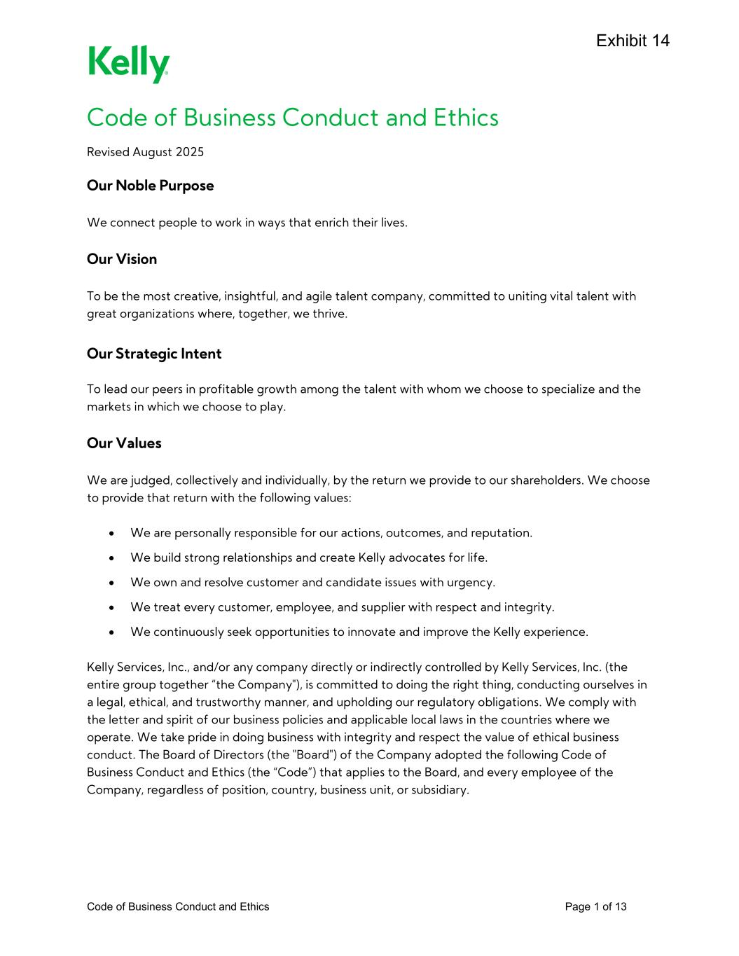
98
Code of Business Conduct and Ethics Page 1 of 13 Code of Business Conduct and Ethics Revised August 2025 Our Noble Purpose We connect people to work in ways that enrich their lives. Our Vision To be the most creative, insightful, and agile talent company, committed to uniting vital talent with great organizations where, together, we thrive. Our Strategic Intent To lead our peers in profitable growth among the talent with whom we choose to specialize and the markets in which we choose to play. Our Values We are judged, collectively and individually, by the return we provide to our shareholders. We choose to provide that return with the following values: • We are personally responsible for our actions, outcomes, and reputation. • We build strong relationships and create Kelly advocates for life. • We own and resolve customer and candidate issues with urgency. • We treat every customer, employee, and supplier with respect and integrity. • We continuously seek opportunities to innovate and improve the Kelly experience. Kelly Services, Inc., and/or any company directly or indirectly controlled by Kelly Services, Inc. (the entire group together “the Company"), is committed to doing the right thing, conducting ourselves in a legal, ethical, and trustworthy manner, and upholding our regulatory obligations. We comply with the letter and spirit of our business policies and applicable local laws in the countries where we operate. We take pride in doing business with integrity and respect the value of ethical business conduct. The Board of Directors (the "Board") of the Company adopted the following Code of Business Conduct and Ethics (the “Code”) that applies to the Board, and every employee of the Company, regardless of position, country, business unit, or subsidiary.

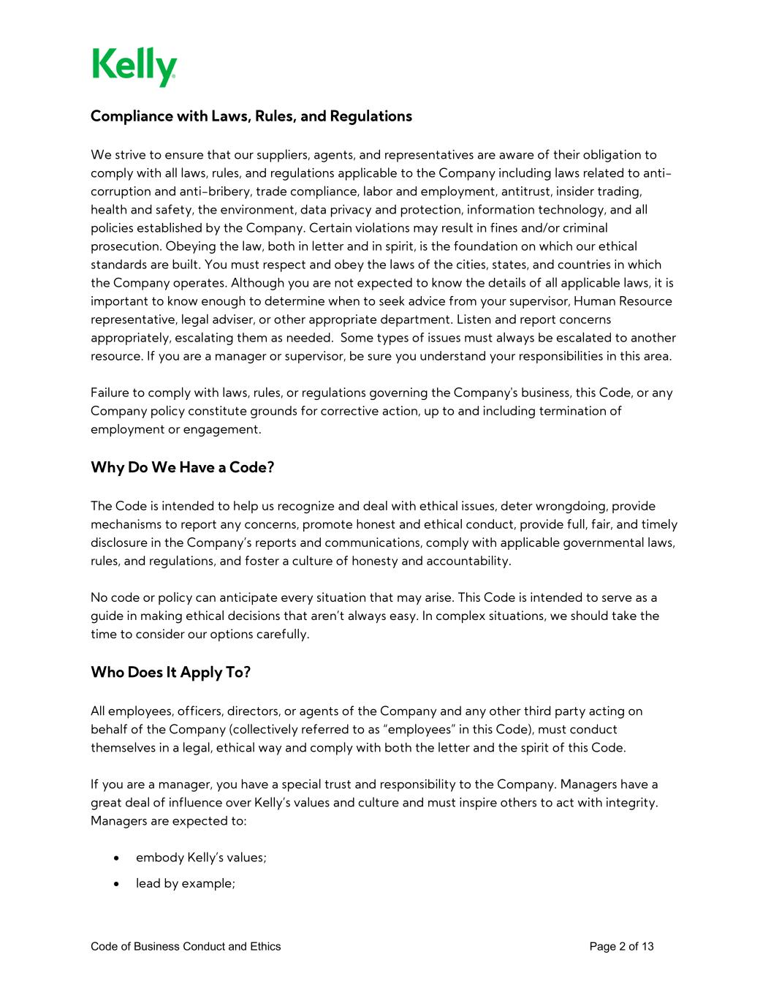
Code of Business Conduct and Ethics Page 2 of 13 Compliance with Laws, Rules, and Regulations We strive to ensure that our suppliers, agents, and representatives are aware of their obligation to comply with all laws, rules, and regulations applicable to the Company including laws related to anti- corruption and anti-bribery, trade compliance, labor and employment, antitrust, insider trading, health and safety, the environment, data privacy and protection, information technology, and all policies established by the Company. Certain violations may result in fines and/or criminal prosecution. Obeying the law, both in letter and in spirit, is the foundation on which our ethical standards are built. You must respect and obey the laws of the cities, states, and countries in which the Company operates. Although you are not expected to know the details of all applicable laws, it is important to know enough to determine when to seek advice from your supervisor, Human Resource representative, legal adviser, or other appropriate department. Listen and report concerns appropriately, escalating them as needed. Some types of issues must always be escalated to another resource. If you are a manager or supervisor, be sure you understand your responsibilities in this area. Failure to comply with laws, rules, or regulations governing the Company's business, this Code, or any Company policy constitute grounds for corrective action, up to and including termination of employment or engagement. Why Do We Have a Code? The Code is intended to help us recognize and deal with ethical issues, deter wrongdoing, provide mechanisms to report any concerns, promote honest and ethical conduct, provide full, fair, and timely disclosure in the Company’s reports and communications, comply with applicable governmental laws, rules, and regulations, and foster a culture of honesty and accountability. No code or policy can anticipate every situation that may arise. This Code is intended to serve as a guide in making ethical decisions that aren’t always easy. In complex situations, we should take the time to consider our options carefully. Who Does It Apply To? All employees, officers, directors, or agents of the Company and any other third party acting on behalf of the Company (collectively referred to as “employees” in this Code), must conduct themselves in a legal, ethical way and comply with both the letter and the spirit of this Code. If you are a manager, you have a special trust and responsibility to the Company. Managers have a great deal of influence over Kelly’s values and culture and must inspire others to act with integrity. Managers are expected to: • embody Kelly’s values; • lead by example;

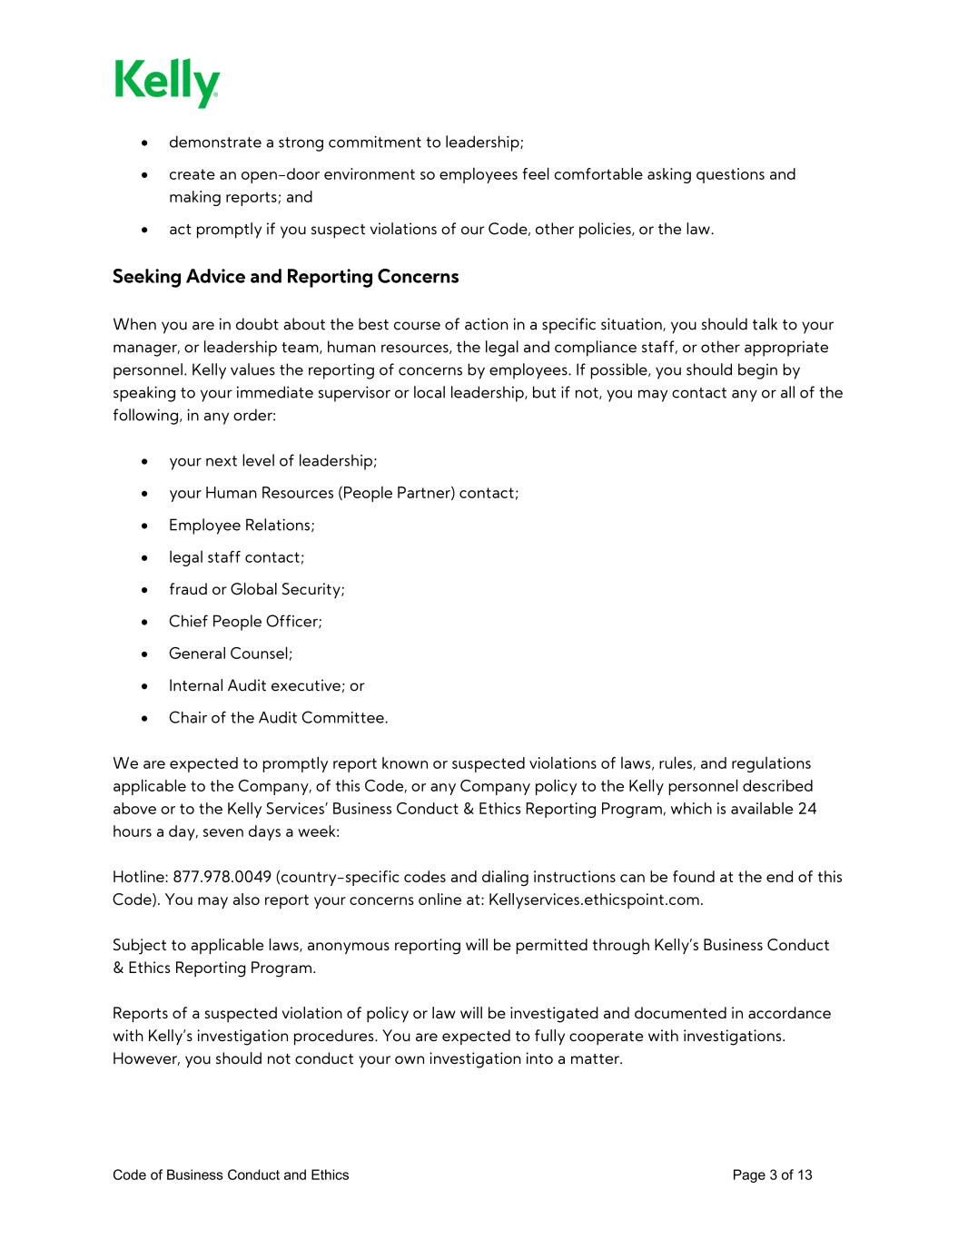
Code of Business Conduct and Ethics Page 3 of 13 • demonstrate a strong commitment to leadership; • create an open-door environment so employees feel comfortable asking questions and making reports; and • act promptly if you suspect violations of our Code, other policies, or the law. Seeking Advice and Reporting Concerns When you are in doubt about the best course of action in a specific situation, you should talk to your manager, or leadership team, human resources, the legal and compliance staff, or other appropriate personnel. Kelly values the reporting of concerns by employees. If possible, you should begin by speaking to your immediate supervisor or local leadership, but if not, you may contact any or all of the following, in any order: • your next level of leadership; • your Human Resources (People Partner) contact; • Employee Relations; • legal staff contact; • fraud or Global Security; • Chief People Officer; • General Counsel; • Internal Audit executive; or • Chair of the Audit Committee. We are expected to promptly report known or suspected violations of laws, rules, and regulations applicable to the Company, of this Code, or any Company policy to the Kelly personnel described above or to the Kelly Services’ Business Conduct & Ethics Reporting Program, which is available 24 hours a day, seven days a week: Hotline: 877.978.0049 (country-specific codes and dialing instructions can be found at the end of this Code). You may also report your concerns online at: Kellyservices.ethicspoint.com. Subject to applicable laws, anonymous reporting will be permitted through Kelly’s Business Conduct & Ethics Reporting Program. Reports of a suspected violation of policy or law will be investigated and documented in accordance with Kelly’s investigation procedures. You are expected to fully cooperate with investigations. However, you should not conduct your own investigation into a matter.

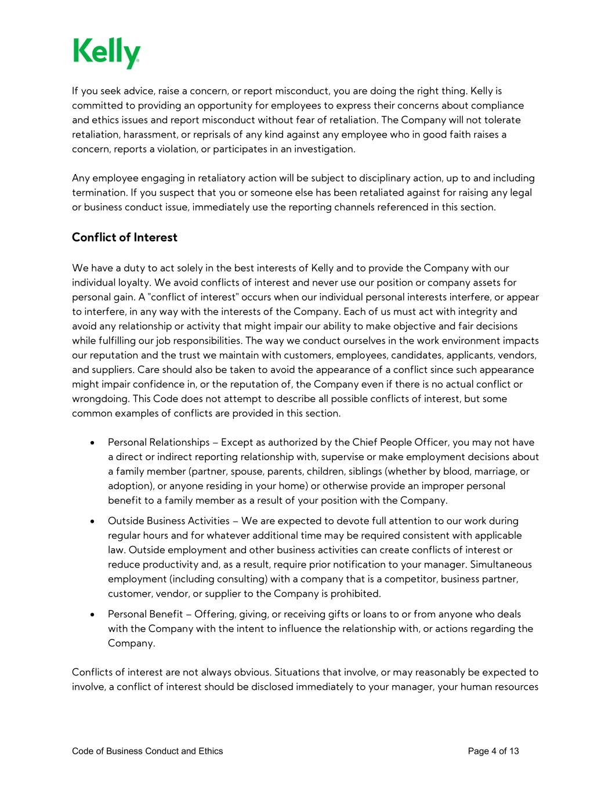
Code of Business Conduct and Ethics Page 4 of 13 If you seek advice, raise a concern, or report misconduct, you are doing the right thing. Kelly is committed to providing an opportunity for employees to express their concerns about compliance and ethics issues and report misconduct without fear of retaliation. The Company will not tolerate retaliation, harassment, or reprisals of any kind against any employee who in good faith raises a concern, reports a violation, or participates in an investigation. Any employee engaging in retaliatory action will be subject to disciplinary action, up to and including termination. If you suspect that you or someone else has been retaliated against for raising any legal or business conduct issue, immediately use the reporting channels referenced in this section. Conflict of Interest We have a duty to act solely in the best interests of Kelly and to provide the Company with our individual loyalty. We avoid conflicts of interest and never use our position or company assets for personal gain. A "conflict of interest" occurs when our individual personal interests interfere, or appear to interfere, in any way with the interests of the Company. Each of us must act with integrity and avoid any relationship or activity that might impair our ability to make objective and fair decisions while fulfilling our job responsibilities. The way we conduct ourselves in the work environment impacts our reputation and the trust we maintain with customers, employees, candidates, applicants, vendors, and suppliers. Care should also be taken to avoid the appearance of a conflict since such appearance might impair confidence in, or the reputation of, the Company even if there is no actual conflict or wrongdoing. This Code does not attempt to describe all possible conflicts of interest, but some common examples of conflicts are provided in this section. • Personal Relationships – Except as authorized by the Chief People Officer, you may not have a direct or indirect reporting relationship with, supervise or make employment decisions about a family member (partner, spouse, parents, children, siblings (whether by blood, marriage, or adoption), or anyone residing in your home) or otherwise provide an improper personal benefit to a family member as a result of your position with the Company. • Outside Business Activities – We are expected to devote full attention to our work during regular hours and for whatever additional time may be required consistent with applicable law. Outside employment and other business activities can create conflicts of interest or reduce productivity and, as a result, require prior notification to your manager. Simultaneous employment (including consulting) with a company that is a competitor, business partner, customer, vendor, or supplier to the Company is prohibited. • Personal Benefit – Offering, giving, or receiving gifts or loans to or from anyone who deals with the Company with the intent to influence the relationship with, or actions regarding the Company. Conflicts of interest are not always obvious. Situations that involve, or may reasonably be expected to involve, a conflict of interest should be disclosed immediately to your manager, your human resources

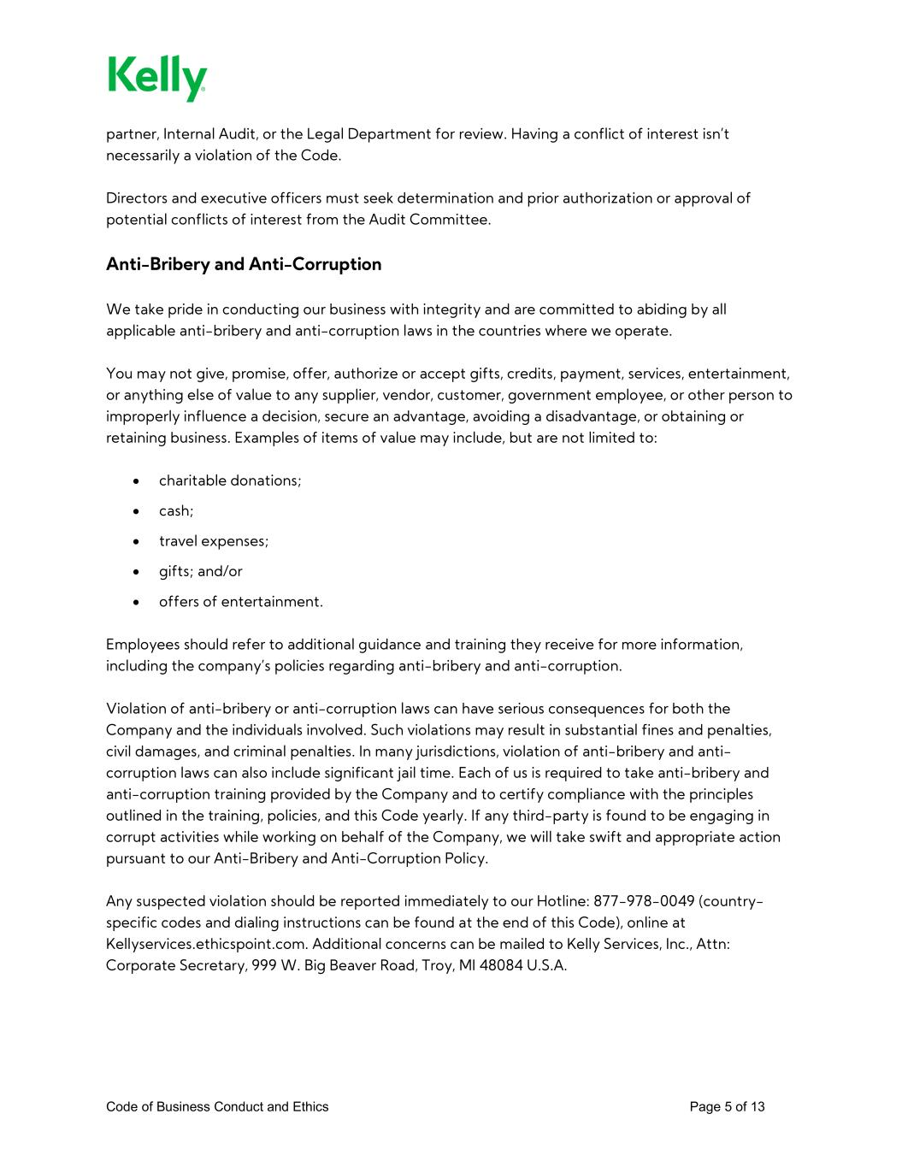
Code of Business Conduct and Ethics Page 5 of 13 partner, Internal Audit, or the Legal Department for review. Having a conflict of interest isn’t necessarily a violation of the Code. Directors and executive officers must seek determination and prior authorization or approval of potential conflicts of interest from the Audit Committee. Anti-Bribery and Anti-Corruption We take pride in conducting our business with integrity and are committed to abiding by all applicable anti-bribery and anti-corruption laws in the countries where we operate. You may not give, promise, offer, authorize or accept gifts, credits, payment, services, entertainment, or anything else of value to any supplier, vendor, customer, government employee, or other person to improperly influence a decision, secure an advantage, avoiding a disadvantage, or obtaining or retaining business. Examples of items of value may include, but are not limited to: • charitable donations; • cash; • travel expenses; • gifts; and/or • offers of entertainment. Employees should refer to additional guidance and training they receive for more information, including the company’s policies regarding anti-bribery and anti-corruption. Violation of anti-bribery or anti-corruption laws can have serious consequences for both the Company and the individuals involved. Such violations may result in substantial fines and penalties, civil damages, and criminal penalties. In many jurisdictions, violation of anti-bribery and anti- corruption laws can also include significant jail time. Each of us is required to take anti-bribery and anti-corruption training provided by the Company and to certify compliance with the principles outlined in the training, policies, and this Code yearly. If any third-party is found to be engaging in corrupt activities while working on behalf of the Company, we will take swift and appropriate action pursuant to our Anti-Bribery and Anti-Corruption Policy. Any suspected violation should be reported immediately to our Hotline: 877-978-0049 (country- specific codes and dialing instructions can be found at the end of this Code), online at Kellyservices.ethicspoint.com. Additional concerns can be mailed to Kelly Services, Inc., Attn: Corporate Secretary, 999 W. Big Beaver Road, Troy, MI 48084 U.S.A.

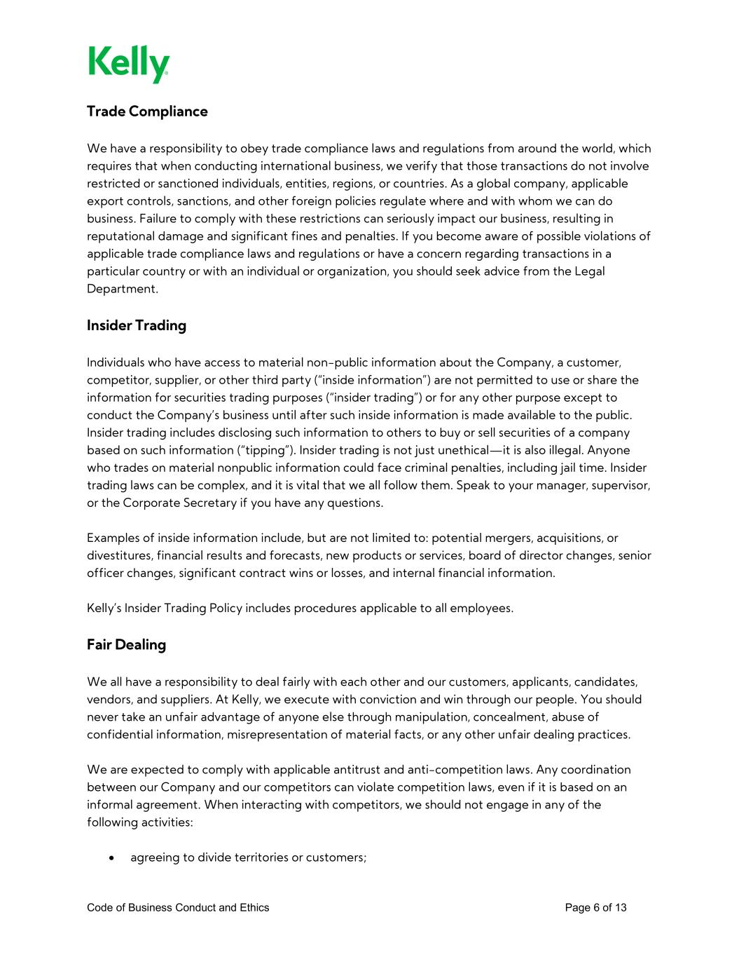
Code of Business Conduct and Ethics Page 6 of 13 Trade Compliance We have a responsibility to obey trade compliance laws and regulations from around the world, which requires that when conducting international business, we verify that those transactions do not involve restricted or sanctioned individuals, entities, regions, or countries. As a global company, applicable export controls, sanctions, and other foreign policies regulate where and with whom we can do business. Failure to comply with these restrictions can seriously impact our business, resulting in reputational damage and significant fines and penalties. If you become aware of possible violations of applicable trade compliance laws and regulations or have a concern regarding transactions in a particular country or with an individual or organization, you should seek advice from the Legal Department. Insider Trading Individuals who have access to material non-public information about the Company, a customer, competitor, supplier, or other third party (“inside information”) are not permitted to use or share the information for securities trading purposes (“insider trading”) or for any other purpose except to conduct the Company’s business until after such inside information is made available to the public. Insider trading includes disclosing such information to others to buy or sell securities of a company based on such information (“tipping”). Insider trading is not just unethical—it is also illegal. Anyone who trades on material nonpublic information could face criminal penalties, including jail time. Insider trading laws can be complex, and it is vital that we all follow them. Speak to your manager, supervisor, or the Corporate Secretary if you have any questions. Examples of inside information include, but are not limited to: potential mergers, acquisitions, or divestitures, financial results and forecasts, new products or services, board of director changes, senior officer changes, significant contract wins or losses, and internal financial information. Kelly’s Insider Trading Policy includes procedures applicable to all employees. Fair Dealing We all have a responsibility to deal fairly with each other and our customers, applicants, candidates, vendors, and suppliers. At Kelly, we execute with conviction and win through our people. You should never take an unfair advantage of anyone else through manipulation, concealment, abuse of confidential information, misrepresentation of material facts, or any other unfair dealing practices. We are expected to comply with applicable antitrust and anti-competition laws. Any coordination between our Company and our competitors can violate competition laws, even if it is based on an informal agreement. When interacting with competitors, we should not engage in any of the following activities: • agreeing to divide territories or customers;

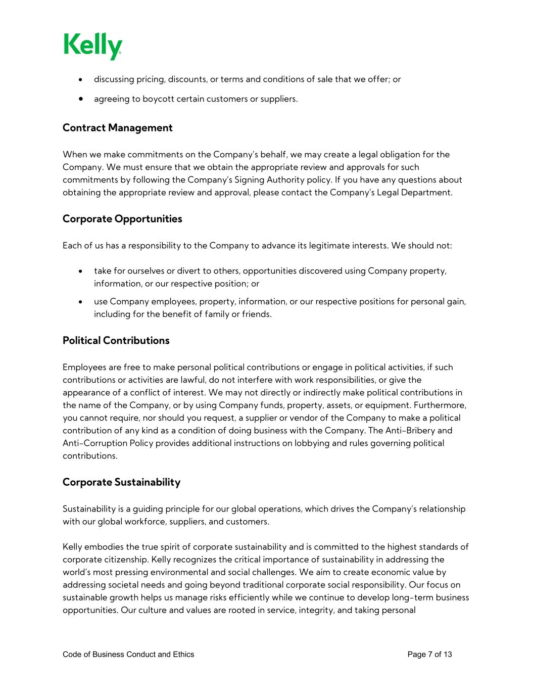
Code of Business Conduct and Ethics Page 7 of 13 • discussing pricing, discounts, or terms and conditions of sale that we offer; or • agreeing to boycott certain customers or suppliers. Contract Management When we make commitments on the Company’s behalf, we may create a legal obligation for the Company. We must ensure that we obtain the appropriate review and approvals for such commitments by following the Company’s Signing Authority policy. If you have any questions about obtaining the appropriate review and approval, please contact the Company’s Legal Department. Corporate Opportunities Each of us has a responsibility to the Company to advance its legitimate interests. We should not: • take for ourselves or divert to others, opportunities discovered using Company property, information, or our respective position; or • use Company employees, property, information, or our respective positions for personal gain, including for the benefit of family or friends. Political Contributions Employees are free to make personal political contributions or engage in political activities, if such contributions or activities are lawful, do not interfere with work responsibilities, or give the appearance of a conflict of interest. We may not directly or indirectly make political contributions in the name of the Company, or by using Company funds, property, assets, or equipment. Furthermore, you cannot require, nor should you request, a supplier or vendor of the Company to make a political contribution of any kind as a condition of doing business with the Company. The Anti-Bribery and Anti-Corruption Policy provides additional instructions on lobbying and rules governing political contributions. Corporate Sustainability Sustainability is a guiding principle for our global operations, which drives the Company’s relationship with our global workforce, suppliers, and customers. Kelly embodies the true spirit of corporate sustainability and is committed to the highest standards of corporate citizenship. Kelly recognizes the critical importance of sustainability in addressing the world’s most pressing environmental and social challenges. We aim to create economic value by addressing societal needs and going beyond traditional corporate social responsibility. Our focus on sustainable growth helps us manage risks efficiently while we continue to develop long-term business opportunities. Our culture and values are rooted in service, integrity, and taking personal

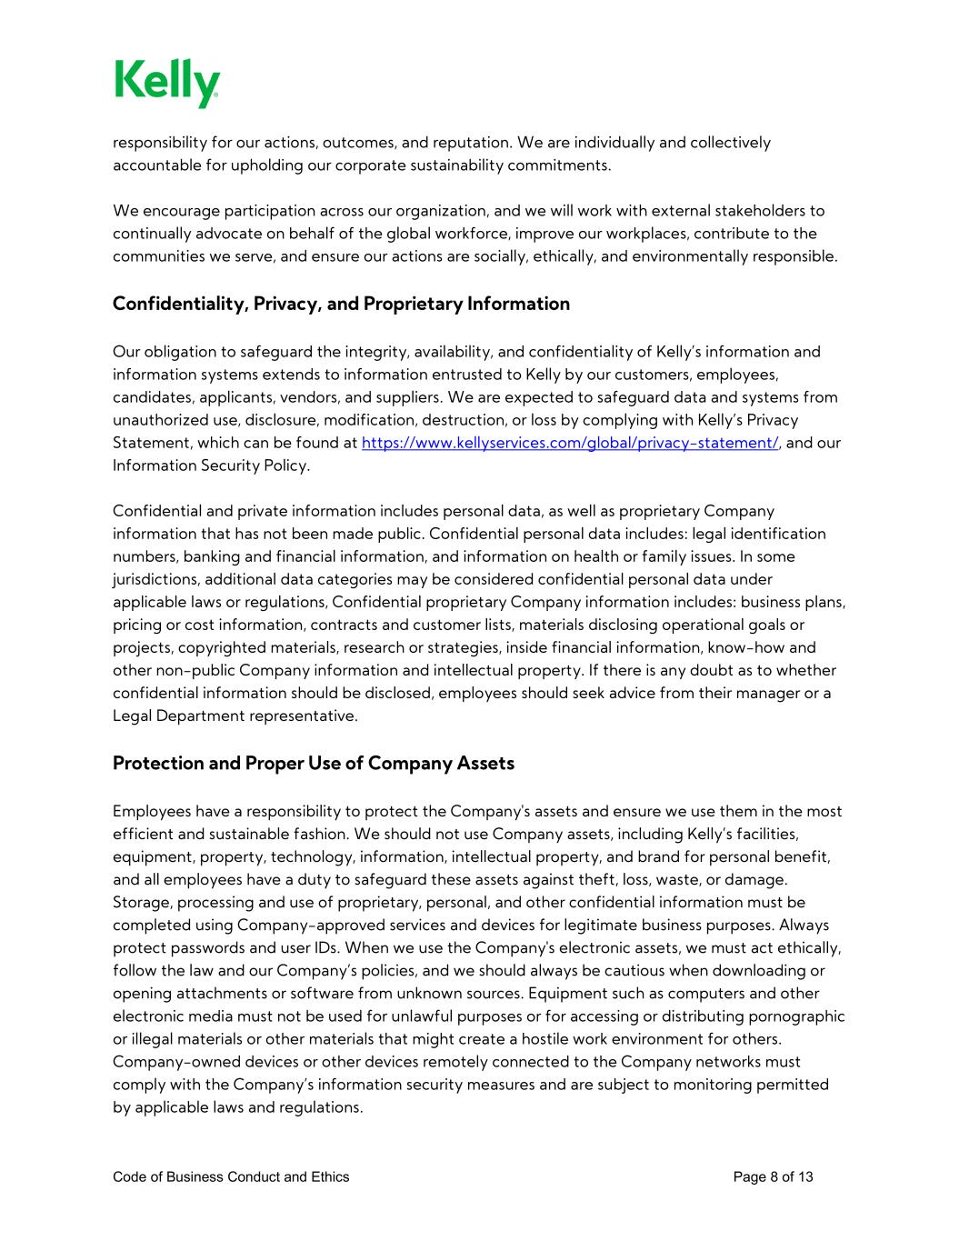
Code of Business Conduct and Ethics Page 8 of 13 responsibility for our actions, outcomes, and reputation. We are individually and collectively accountable for upholding our corporate sustainability commitments. We encourage participation across our organization, and we will work with external stakeholders to continually advocate on behalf of the global workforce, improve our workplaces, contribute to the communities we serve, and ensure our actions are socially, ethically, and environmentally responsible. Confidentiality, Privacy, and Proprietary Information Our obligation to safeguard the integrity, availability, and confidentiality of Kelly’s information and information systems extends to information entrusted to Kelly by our customers, employees, candidates, applicants, vendors, and suppliers. We are expected to safeguard data and systems from unauthorized use, disclosure, modification, destruction, or loss by complying with Kelly’s Privacy Statement, which can be found at https://www.kellyservices.com/global/privacy-statement/, and our Information Security Policy. Confidential and private information includes personal data, as well as proprietary Company information that has not been made public. Confidential personal data includes: legal identification numbers, banking and financial information, and information on health or family issues. In some jurisdictions, additional data categories may be considered confidential personal data under applicable laws or regulations, Confidential proprietary Company information includes: business plans, pricing or cost information, contracts and customer lists, materials disclosing operational goals or projects, copyrighted materials, research or strategies, inside financial information, know-how and other non-public Company information and intellectual property. If there is any doubt as to whether confidential information should be disclosed, employees should seek advice from their manager or a Legal Department representative. Protection and Proper Use of Company Assets Employees have a responsibility to protect the Company's assets and ensure we use them in the most efficient and sustainable fashion. We should not use Company assets, including Kelly’s facilities, equipment, property, technology, information, intellectual property, and brand for personal benefit, and all employees have a duty to safeguard these assets against theft, loss, waste, or damage. Storage, processing and use of proprietary, personal, and other confidential information must be completed using Company-approved services and devices for legitimate business purposes. Always protect passwords and user IDs. When we use the Company's electronic assets, we must act ethically, follow the law and our Company’s policies, and we should always be cautious when downloading or opening attachments or software from unknown sources. Equipment such as computers and other electronic media must not be used for unlawful purposes or for accessing or distributing pornographic or illegal materials or other materials that might create a hostile work environment for others. Company-owned devices or other devices remotely connected to the Company networks must comply with the Company’s information security measures and are subject to monitoring permitted by applicable laws and regulations.

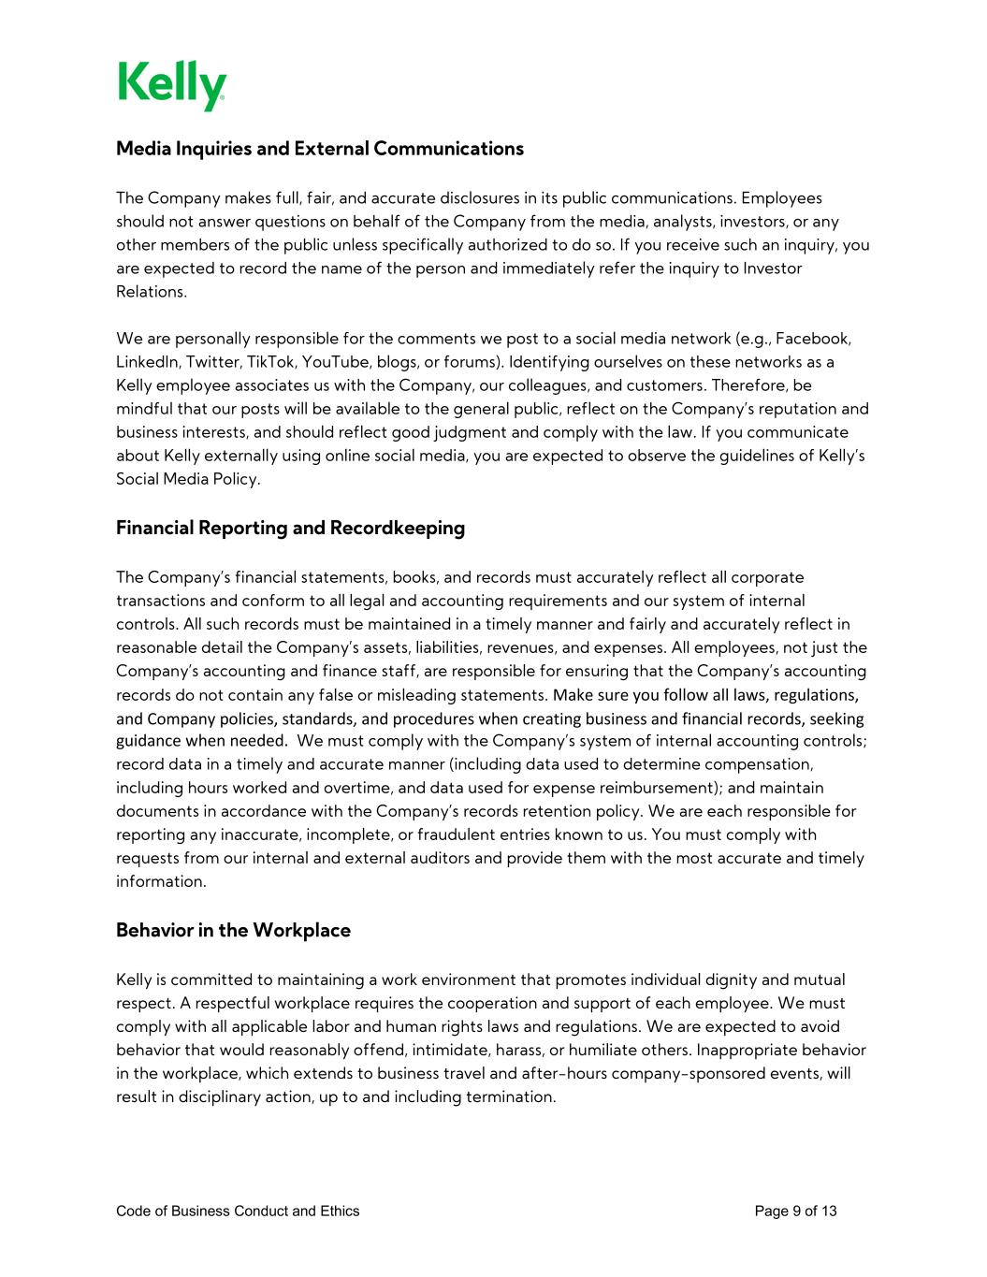
Code of Business Conduct and Ethics Page 9 of 13 Media Inquiries and External Communications The Company makes full, fair, and accurate disclosures in its public communications. Employees should not answer questions on behalf of the Company from the media, analysts, investors, or any other members of the public unless specifically authorized to do so. If you receive such an inquiry, you are expected to record the name of the person and immediately refer the inquiry to Investor Relations. We are personally responsible for the comments we post to a social media network (e.g., Facebook, LinkedIn, Twitter, TikTok, YouTube, blogs, or forums). Identifying ourselves on these networks as a Kelly employee associates us with the Company, our colleagues, and customers. Therefore, be mindful that our posts will be available to the general public, reflect on the Company’s reputation and business interests, and should reflect good judgment and comply with the law. If you communicate about Kelly externally using online social media, you are expected to observe the guidelines of Kelly’s Social Media Policy. Financial Reporting and Recordkeeping The Company’s financial statements, books, and records must accurately reflect all corporate transactions and conform to all legal and accounting requirements and our system of internal controls. All such records must be maintained in a timely manner and fairly and accurately reflect in reasonable detail the Company’s assets, liabilities, revenues, and expenses. All employees, not just the Company’s accounting and finance staff, are responsible for ensuring that the Company’s accounting records do not contain any false or misleading statements. Make sure you follow all laws, regulations, and Company policies, standards, and procedures when creating business and financial records, seeking guidance when needed. We must comply with the Company’s system of internal accounting controls; record data in a timely and accurate manner (including data used to determine compensation, including hours worked and overtime, and data used for expense reimbursement); and maintain documents in accordance with the Company’s records retention policy. We are each responsible for reporting any inaccurate, incomplete, or fraudulent entries known to us. You must comply with requests from our internal and external auditors and provide them with the most accurate and timely information. Behavior in the Workplace Kelly is committed to maintaining a work environment that promotes individual dignity and mutual respect. A respectful workplace requires the cooperation and support of each employee. We must comply with all applicable labor and human rights laws and regulations. We are expected to avoid behavior that would reasonably offend, intimidate, harass, or humiliate others. Inappropriate behavior in the workplace, which extends to business travel and after-hours company-sponsored events, will result in disciplinary action, up to and including termination.

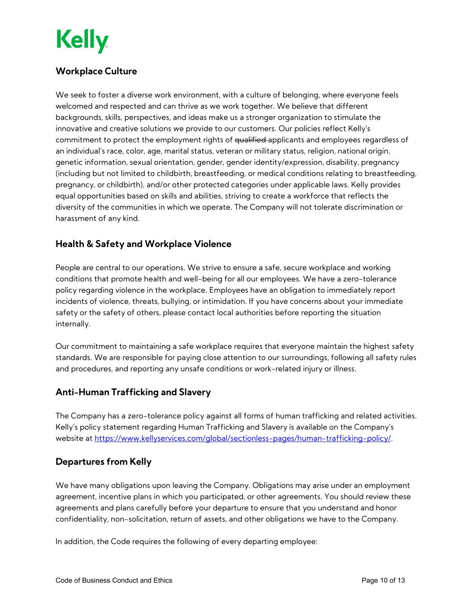
Code of Business Conduct and Ethics Page 10 of 13 Workplace Culture We seek to foster a diverse work environment, with a culture of belonging, where everyone feels welcomed and respected and can thrive as we work together. We believe that different backgrounds, skills, perspectives, and ideas make us a stronger organization to stimulate the innovative and creative solutions we provide to our customers. Our policies reflect Kelly’s commitment to protect the employment rights of qualified applicants and employees regardless of an individual’s race, color, age, marital status, veteran or military status, religion, national origin, genetic information, sexual orientation, gender, gender identity/expression, disability, pregnancy (including but not limited to childbirth, breastfeeding, or medical conditions relating to breastfeeding, pregnancy, or childbirth), and/or other protected categories under applicable laws. Kelly provides equal opportunities based on skills and abilities, striving to create a workforce that reflects the diversity of the communities in which we operate. The Company will not tolerate discrimination or harassment of any kind. Health & Safety and Workplace Violence People are central to our operations. We strive to ensure a safe, secure workplace and working conditions that promote health and well-being for all our employees. We have a zero-tolerance policy regarding violence in the workplace. Employees have an obligation to immediately report incidents of violence, threats, bullying, or intimidation. If you have concerns about your immediate safety or the safety of others, please contact local authorities before reporting the situation internally. Our commitment to maintaining a safe workplace requires that everyone maintain the highest safety standards. We are responsible for paying close attention to our surroundings, following all safety rules and procedures, and reporting any unsafe conditions or work-related injury or illness. Anti-Human Trafficking and Slavery The Company has a zero-tolerance policy against all forms of human trafficking and related activities. Kelly’s policy statement regarding Human Trafficking and Slavery is available on the Company’s website at https://www.kellyservices.com/global/sectionless-pages/human-trafficking-policy/. Departures from Kelly We have many obligations upon leaving the Company. Obligations may arise under an employment agreement, incentive plans in which you participated, or other agreements. You should review these agreements and plans carefully before your departure to ensure that you understand and honor confidentiality, non-solicitation, return of assets, and other obligations we have to the Company. In addition, the Code requires the following of every departing employee:

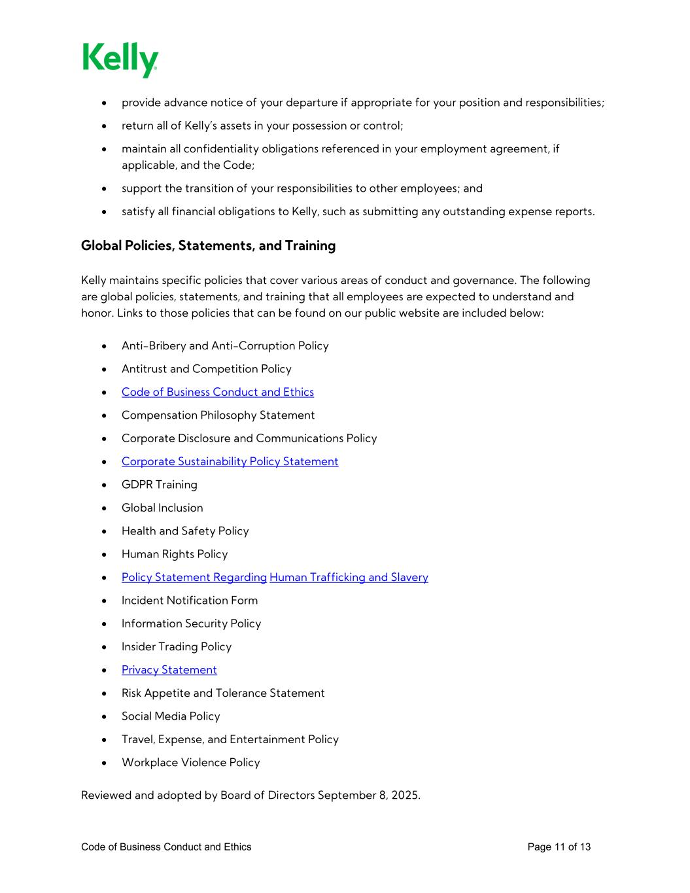
Code of Business Conduct and Ethics Page 11 of 13 • provide advance notice of your departure if appropriate for your position and responsibilities; • return all of Kelly’s assets in your possession or control; • maintain all confidentiality obligations referenced in your employment agreement, if applicable, and the Code; • support the transition of your responsibilities to other employees; and • satisfy all financial obligations to Kelly, such as submitting any outstanding expense reports. Global Policies, Statements, and Training Kelly maintains specific policies that cover various areas of conduct and governance. The following are global policies, statements, and training that all employees are expected to understand and honor. Links to those policies that can be found on our public website are included below: • Anti-Bribery and Anti-Corruption Policy • Antitrust and Competition Policy • Code of Business Conduct and Ethics • Compensation Philosophy Statement • Corporate Disclosure and Communications Policy • Corporate Sustainability Policy Statement • GDPR Training • Global Inclusion • Health and Safety Policy • Human Rights Policy • Policy Statement Regarding Human Trafficking and Slavery • Incident Notification Form • Information Security Policy • Insider Trading Policy • Privacy Statement • Risk Appetite and Tolerance Statement • Social Media Policy • Travel, Expense, and Entertainment Policy • Workplace Violence Policy Reviewed and adopted by Board of Directors September 8, 2025.

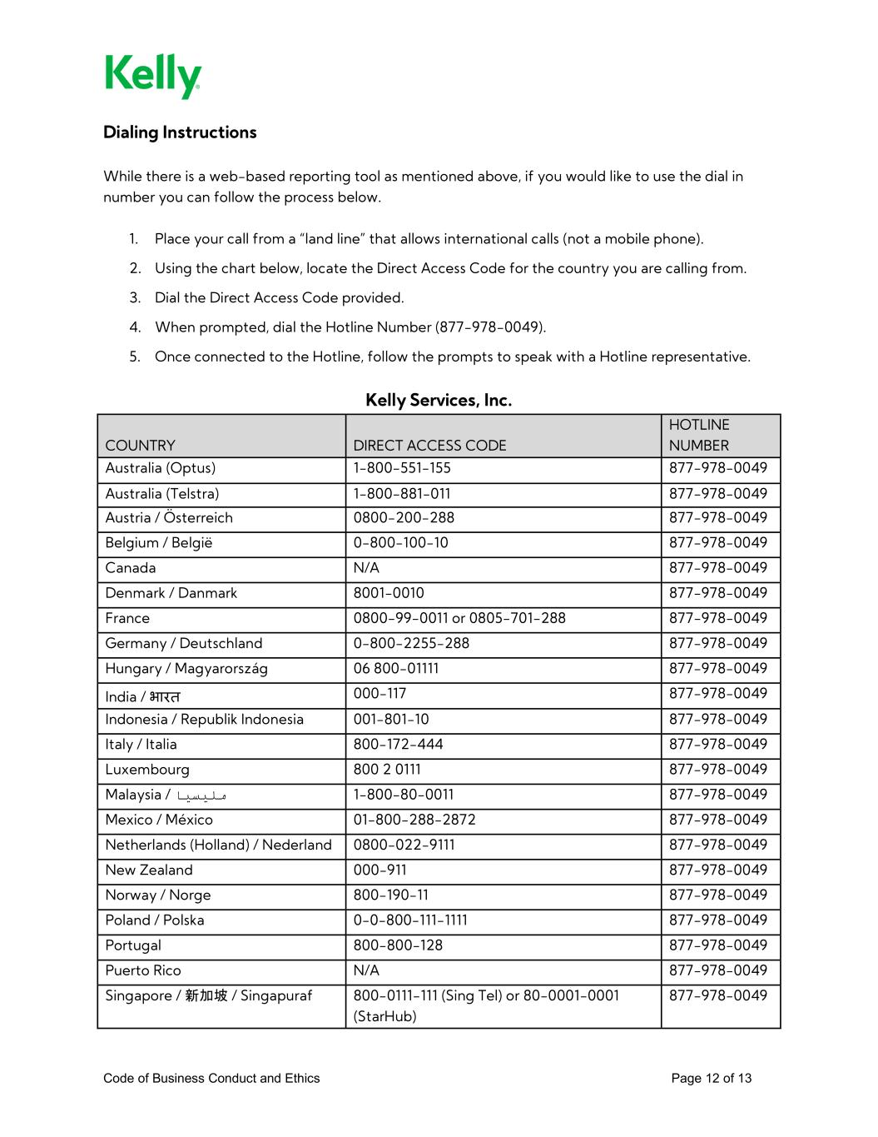
Code of Business Conduct and Ethics Page 12 of 13 Dialing Instructions While there is a web-based reporting tool as mentioned above, if you would like to use the dial in number you can follow the process below. 1. Place your call from a “land line” that allows international calls (not a mobile phone). 2. Using the chart below, locate the Direct Access Code for the country you are calling from. 3. Dial the Direct Access Code provided. 4. When prompted, dial the Hotline Number (877-978-0049). 5. Once connected to the Hotline, follow the prompts to speak with a Hotline representative. Kelly Services, Inc. COUNTRY DIRECT ACCESS CODE HOTLINE NUMBER Australia (Optus) 1-800-551-155 877-978-0049 Australia (Telstra) 1-800-881-011 877-978-0049 Austria / Österreich 0800-200-288 877-978-0049 Belgium / België 0-800-100-10 877-978-0049 Canada N/A 877-978-0049 Denmark / Danmark 8001-0010 877-978-0049 France 0800-99-0011 or 0805-701-288 877-978-0049 Germany / Deutschland 0-800-2255-288 877-978-0049 Hungary / Magyarország 06 800-01111 877-978-0049 India / भारत 000-117 877-978-0049 Indonesia / Republik Indonesia 001-801-10 877-978-0049 Italy / Italia 800-172-444 877-978-0049 Luxembourg 800 2 0111 877-978-0049 Malaysia / 0049-978-877 0011-80-800-1 ملیسیا Mexico / México 01-800-288-2872 877-978-0049 Netherlands (Holland) / Nederland 0800-022-9111 877-978-0049 New Zealand 000-911 877-978-0049 Norway / Norge 800-190-11 877-978-0049 Poland / Polska 0-0-800-111-1111 877-978-0049 Portugal 800-800-128 877-978-0049 Puerto Rico N/A 877-978-0049 Singapore / 新加坡 / Singapuraf 800-0111-111 (Sing Tel) or 80-0001-0001 (StarHub) 877-978-0049

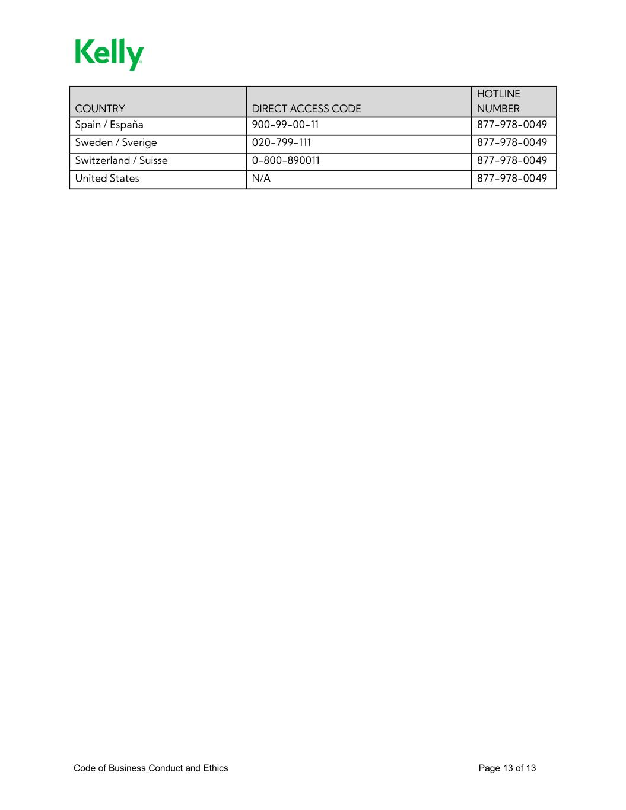
Code of Business Conduct and Ethics Page 13 of 13 COUNTRY DIRECT ACCESS CODE HOTLINE NUMBER Spain / España 900-99-00-11 877-978-0049 Sweden / Sverige 020-799-111 877-978-0049 Switzerland / Suisse 0-800-890011 877-978-0049 United States N/A 877-978-0049

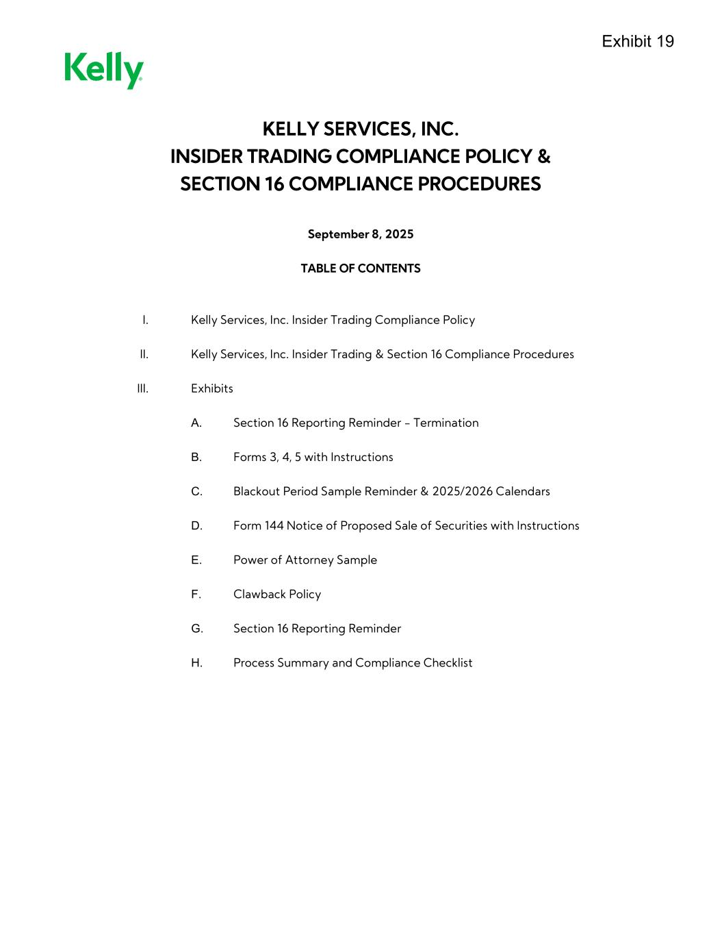
KELLY SERVICES, INC. INSIDER TRADING COMPLIANCE POLICY & SECTION 16 COMPLIANCE PROCEDURES September 8, 2025 TABLE OF CONTENTS I. Kelly Services, Inc. Insider Trading Compliance Policy II. Kelly Services, Inc. Insider Trading & Section 16 Compliance Procedures III. Exhibits A. Section 16 Reporting Reminder - Termination B. Forms 3, 4, 5 with Instructions C. Blackout Period Sample Reminder & 2025/2026 Calendars D. Form 144 Notice of Proposed Sale of Securities with Instructions E. Power of Attorney Sample F. Clawback Policy G. Section 16 Reporting Reminder H. Process Summary and Compliance Checklist

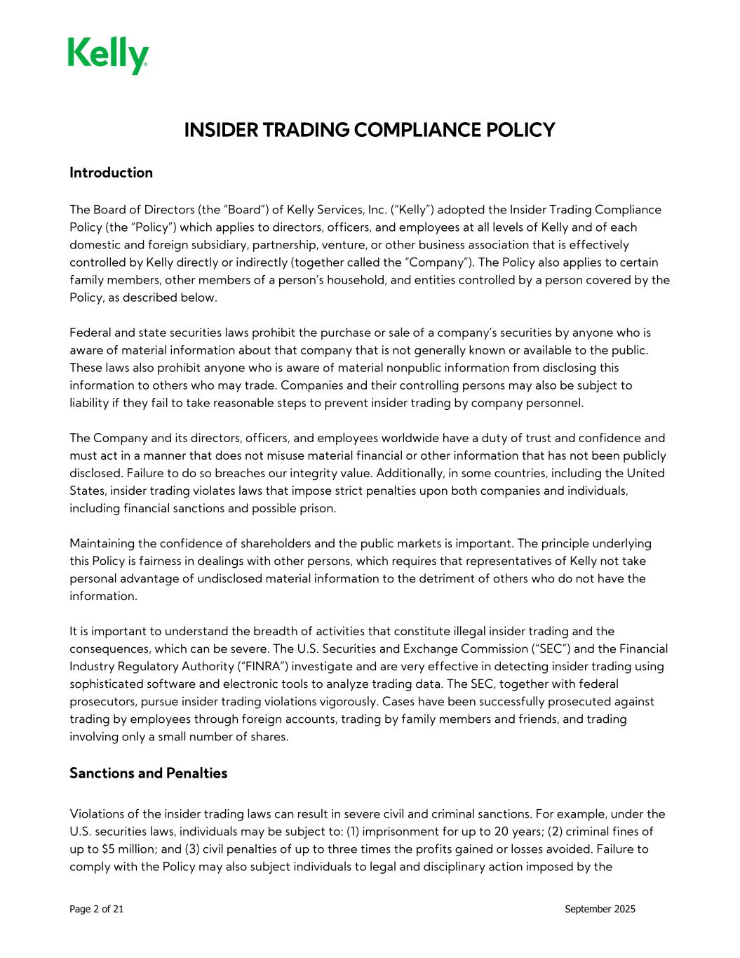
Page 2 of 21 September 2025 INSIDER TRADING COMPLIANCE POLICY Introduction The Board of Directors (the “Board”) of Kelly Services, Inc. (“Kelly”) adopted the Insider Trading Compliance Policy (the “Policy”) which applies to directors, officers, and employees at all levels of Kelly and of each domestic and foreign subsidiary, partnership, venture, or other business association that is effectively controlled by Kelly directly or indirectly (together called the “Company”). The Policy also applies to certain family members, other members of a person’s household, and entities controlled by a person covered by the Policy, as described below. Federal and state securities laws prohibit the purchase or sale of a company’s securities by anyone who is aware of material information about that company that is not generally known or available to the public. These laws also prohibit anyone who is aware of material nonpublic information from disclosing this information to others who may trade. Companies and their controlling persons may also be subject to liability if they fail to take reasonable steps to prevent insider trading by company personnel. The Company and its directors, officers, and employees worldwide have a duty of trust and confidence and must act in a manner that does not misuse material financial or other information that has not been publicly disclosed. Failure to do so breaches our integrity value. Additionally, in some countries, including the United States, insider trading violates laws that impose strict penalties upon both companies and individuals, including financial sanctions and possible prison. Maintaining the confidence of shareholders and the public markets is important. The principle underlying this Policy is fairness in dealings with other persons, which requires that representatives of Kelly not take personal advantage of undisclosed material information to the detriment of others who do not have the information. It is important to understand the breadth of activities that constitute illegal insider trading and the consequences, which can be severe. The U.S. Securities and Exchange Commission (“SEC”) and the Financial Industry Regulatory Authority (“FINRA”) investigate and are very effective in detecting insider trading using sophisticated software and electronic tools to analyze trading data. The SEC, together with federal prosecutors, pursue insider trading violations vigorously. Cases have been successfully prosecuted against trading by employees through foreign accounts, trading by family members and friends, and trading involving only a small number of shares. Sanctions and Penalties Violations of the insider trading laws can result in severe civil and criminal sanctions. For example, under the U.S. securities laws, individuals may be subject to: (1) imprisonment for up to 20 years; (2) criminal fines of up to $5 million; and (3) civil penalties of up to three times the profits gained or losses avoided. Failure to comply with the Policy may also subject individuals to legal and disciplinary action imposed by the

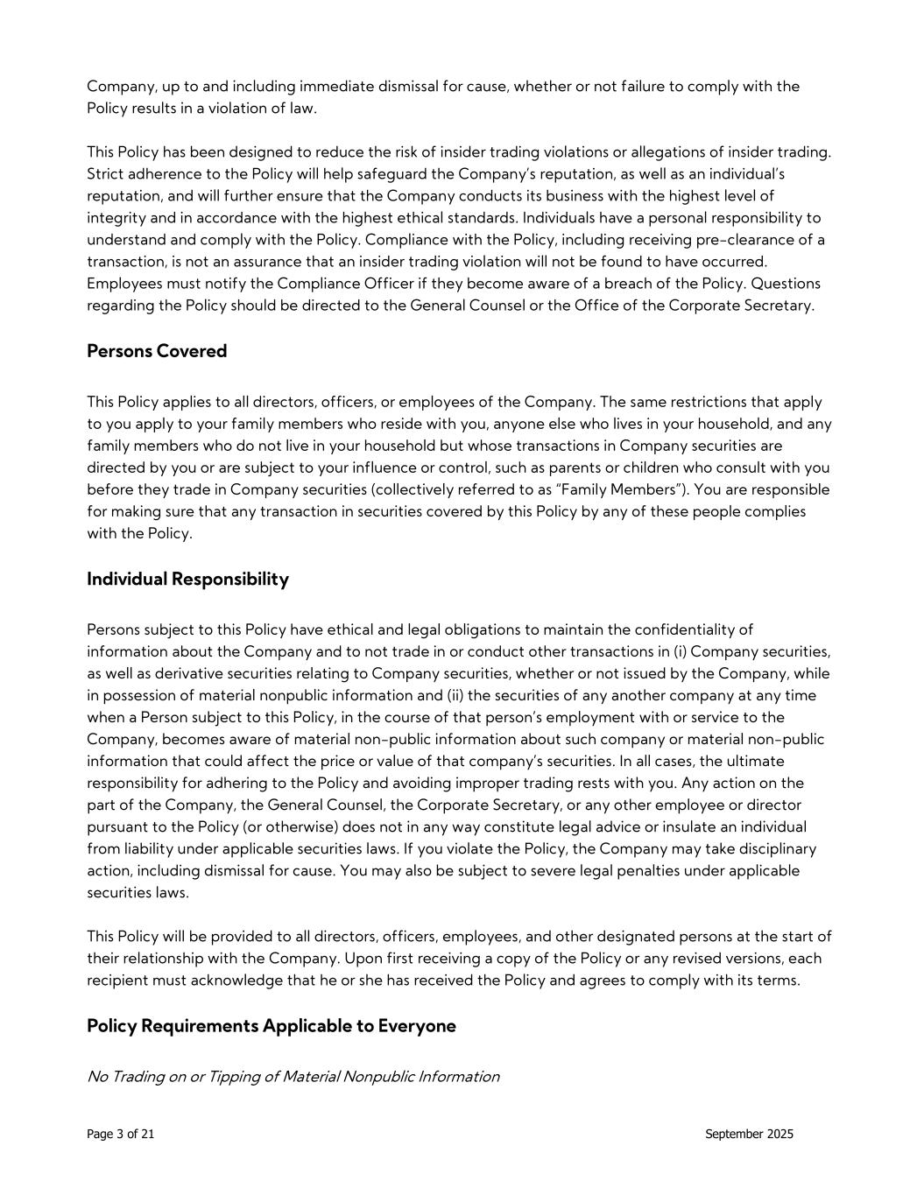
Page 3 of 21 September 2025 Company, up to and including immediate dismissal for cause, whether or not failure to comply with the Policy results in a violation of law. This Policy has been designed to reduce the risk of insider trading violations or allegations of insider trading. Strict adherence to the Policy will help safeguard the Company’s reputation, as well as an individual’s reputation, and will further ensure that the Company conducts its business with the highest level of integrity and in accordance with the highest ethical standards. Individuals have a personal responsibility to understand and comply with the Policy. Compliance with the Policy, including receiving pre-clearance of a transaction, is not an assurance that an insider trading violation will not be found to have occurred. Employees must notify the Compliance Officer if they become aware of a breach of the Policy. Questions regarding the Policy should be directed to the General Counsel or the Office of the Corporate Secretary. Persons Covered This Policy applies to all directors, officers, or employees of the Company. The same restrictions that apply to you apply to your family members who reside with you, anyone else who lives in your household, and any family members who do not live in your household but whose transactions in Company securities are directed by you or are subject to your influence or control, such as parents or children who consult with you before they trade in Company securities (collectively referred to as “Family Members”). You are responsible for making sure that any transaction in securities covered by this Policy by any of these people complies with the Policy. Individual Responsibility Persons subject to this Policy have ethical and legal obligations to maintain the confidentiality of information about the Company and to not trade in or conduct other transactions in (i) Company securities, as well as derivative securities relating to Company securities, whether or not issued by the Company, while in possession of material nonpublic information and (ii) the securities of any another company at any time when a Person subject to this Policy, in the course of that person’s employment with or service to the Company, becomes aware of material non-public information about such company or material non-public information that could affect the price or value of that company’s securities. In all cases, the ultimate responsibility for adhering to the Policy and avoiding improper trading rests with you. Any action on the part of the Company, the General Counsel, the Corporate Secretary, or any other employee or director pursuant to the Policy (or otherwise) does not in any way constitute legal advice or insulate an individual from liability under applicable securities laws. If you violate the Policy, the Company may take disciplinary action, including dismissal for cause. You may also be subject to severe legal penalties under applicable securities laws. This Policy will be provided to all directors, officers, employees, and other designated persons at the start of their relationship with the Company. Upon first receiving a copy of the Policy or any revised versions, each recipient must acknowledge that he or she has received the Policy and agrees to comply with its terms. Policy Requirements Applicable to Everyone No Trading on or Tipping of Material Nonpublic Information

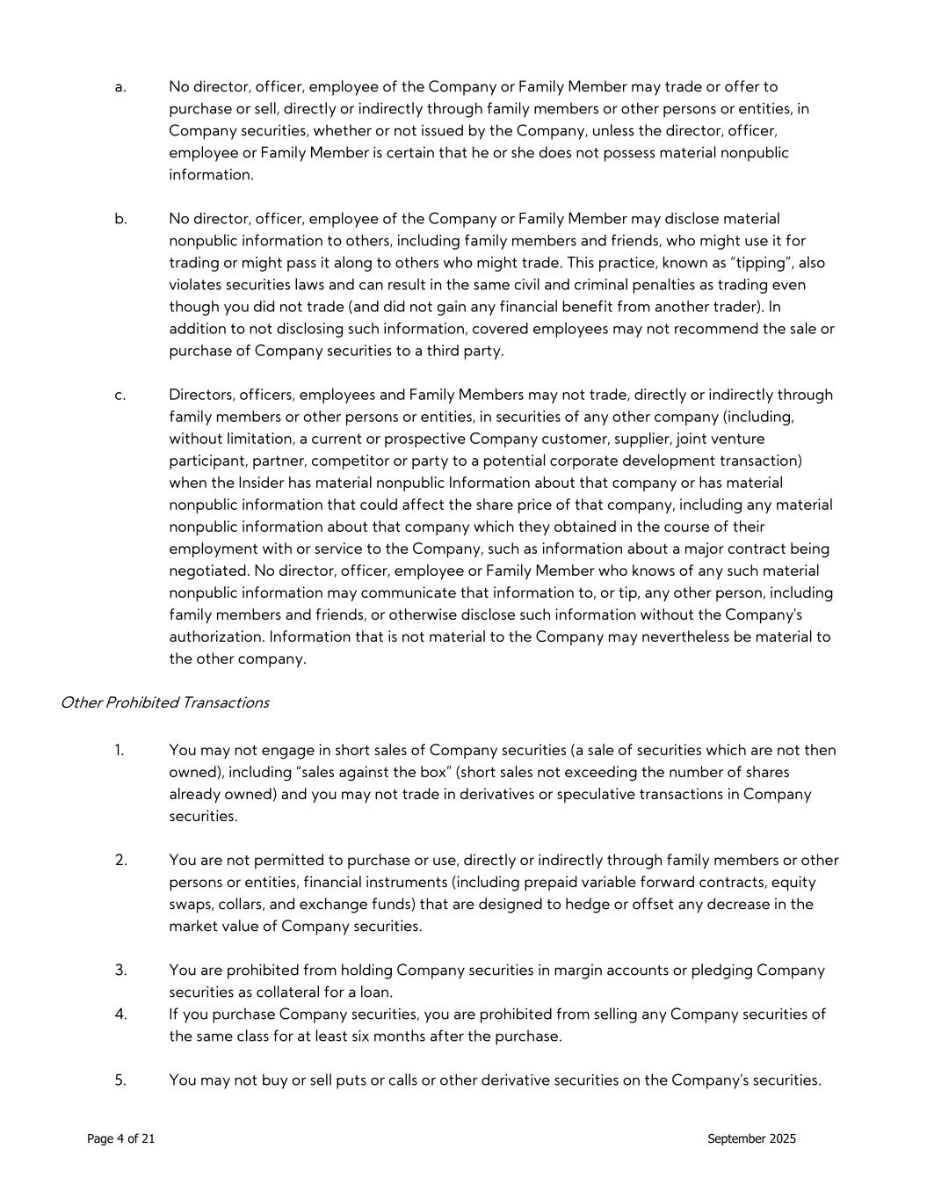
Page 4 of 21 September 2025 a. No director, officer, employee of the Company or Family Member may trade or offer to purchase or sell, directly or indirectly through family members or other persons or entities, in Company securities, whether or not issued by the Company, unless the director, officer, employee or Family Member is certain that he or she does not possess material nonpublic information. b. No director, officer, employee of the Company or Family Member may disclose material nonpublic information to others, including family members and friends, who might use it for trading or might pass it along to others who might trade. This practice, known as “tipping”, also violates securities laws and can result in the same civil and criminal penalties as trading even though you did not trade (and did not gain any financial benefit from another trader). In addition to not disclosing such information, covered employees may not recommend the sale or purchase of Company securities to a third party. c. Directors, officers, employees and Family Members may not trade, directly or indirectly through family members or other persons or entities, in securities of any other company (including, without limitation, a current or prospective Company customer, supplier, joint venture participant, partner, competitor or party to a potential corporate development transaction) when the Insider has material nonpublic Information about that company or has material nonpublic information that could affect the share price of that company, including any material nonpublic information about that company which they obtained in the course of their employment with or service to the Company, such as information about a major contract being negotiated. No director, officer, employee or Family Member who knows of any such material nonpublic information may communicate that information to, or tip, any other person, including family members and friends, or otherwise disclose such information without the Company's authorization. Information that is not material to the Company may nevertheless be material to the other company. Other Prohibited Transactions 1. You may not engage in short sales of Company securities (a sale of securities which are not then owned), including “sales against the box” (short sales not exceeding the number of shares already owned) and you may not trade in derivatives or speculative transactions in Company securities. 2. You are not permitted to purchase or use, directly or indirectly through family members or other persons or entities, financial instruments (including prepaid variable forward contracts, equity swaps, collars, and exchange funds) that are designed to hedge or offset any decrease in the market value of Company securities. 3. You are prohibited from holding Company securities in margin accounts or pledging Company securities as collateral for a loan. 4. If you purchase Company securities, you are prohibited from selling any Company securities of the same class for at least six months after the purchase. 5. You may not buy or sell puts or calls or other derivative securities on the Company's securities.

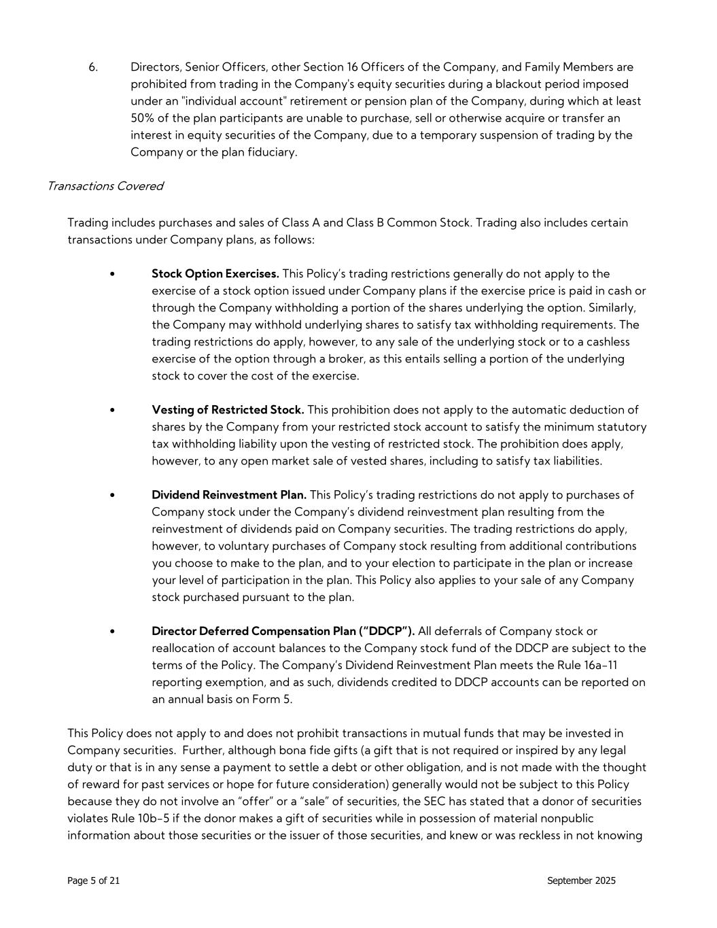
Page 5 of 21 September 2025 6. Directors, Senior Officers, other Section 16 Officers of the Company, and Family Members are prohibited from trading in the Company's equity securities during a blackout period imposed under an "individual account" retirement or pension plan of the Company, during which at least 50% of the plan participants are unable to purchase, sell or otherwise acquire or transfer an interest in equity securities of the Company, due to a temporary suspension of trading by the Company or the plan fiduciary. Transactions Covered Trading includes purchases and sales of Class A and Class B Common Stock. Trading also includes certain transactions under Company plans, as follows: • Stock Option Exercises. This Policy’s trading restrictions generally do not apply to the exercise of a stock option issued under Company plans if the exercise price is paid in cash or through the Company withholding a portion of the shares underlying the option. Similarly, the Company may withhold underlying shares to satisfy tax withholding requirements. The trading restrictions do apply, however, to any sale of the underlying stock or to a cashless exercise of the option through a broker, as this entails selling a portion of the underlying stock to cover the cost of the exercise. • Vesting of Restricted Stock. This prohibition does not apply to the automatic deduction of shares by the Company from your restricted stock account to satisfy the minimum statutory tax withholding liability upon the vesting of restricted stock. The prohibition does apply, however, to any open market sale of vested shares, including to satisfy tax liabilities. • Dividend Reinvestment Plan. This Policy’s trading restrictions do not apply to purchases of Company stock under the Company’s dividend reinvestment plan resulting from the reinvestment of dividends paid on Company securities. The trading restrictions do apply, however, to voluntary purchases of Company stock resulting from additional contributions you choose to make to the plan, and to your election to participate in the plan or increase your level of participation in the plan. This Policy also applies to your sale of any Company stock purchased pursuant to the plan. • Director Deferred Compensation Plan (“DDCP”). All deferrals of Company stock or reallocation of account balances to the Company stock fund of the DDCP are subject to the terms of the Policy. The Company’s Dividend Reinvestment Plan meets the Rule 16a-11 reporting exemption, and as such, dividends credited to DDCP accounts can be reported on an annual basis on Form 5. This Policy does not apply to and does not prohibit transactions in mutual funds that may be invested in Company securities. Further, although bona fide gifts (a gift that is not required or inspired by any legal duty or that is in any sense a payment to settle a debt or other obligation, and is not made with the thought of reward for past services or hope for future consideration) generally would not be subject to this Policy because they do not involve an “offer” or a “sale” of securities, the SEC has stated that a donor of securities violates Rule 10b-5 if the donor makes a gift of securities while in possession of material nonpublic information about those securities or the issuer of those securities, and knew or was reckless in not knowing

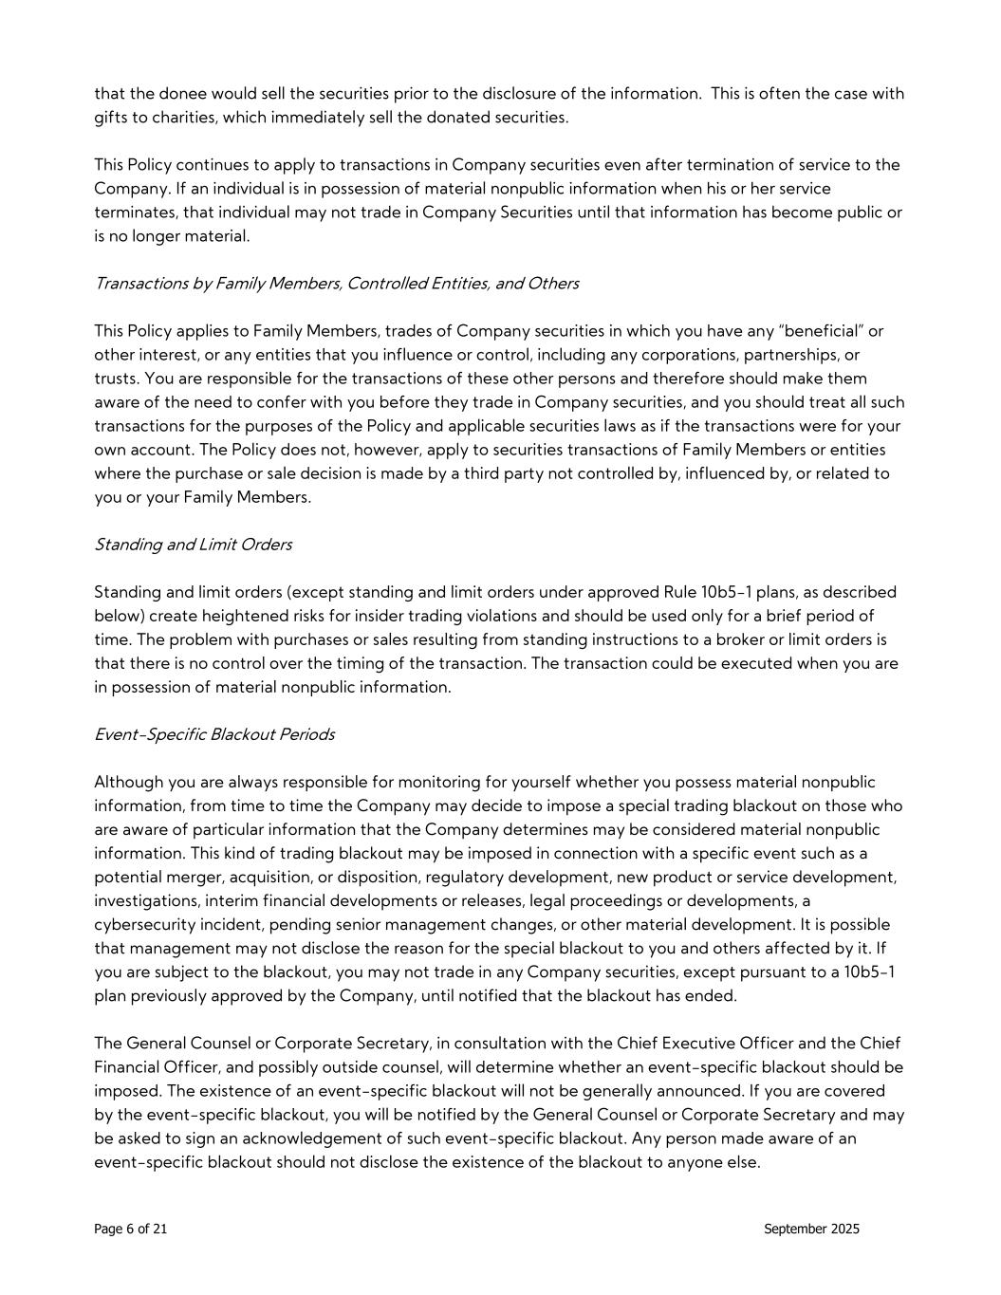
Page 6 of 21 September 2025 that the donee would sell the securities prior to the disclosure of the information. This is often the case with gifts to charities, which immediately sell the donated securities. This Policy continues to apply to transactions in Company securities even after termination of service to the Company. If an individual is in possession of material nonpublic information when his or her service terminates, that individual may not trade in Company Securities until that information has become public or is no longer material. Transactions by Family Members, Controlled Entities, and Others This Policy applies to Family Members, trades of Company securities in which you have any “beneficial” or other interest, or any entities that you influence or control, including any corporations, partnerships, or trusts. You are responsible for the transactions of these other persons and therefore should make them aware of the need to confer with you before they trade in Company securities, and you should treat all such transactions for the purposes of the Policy and applicable securities laws as if the transactions were for your own account. The Policy does not, however, apply to securities transactions of Family Members or entities where the purchase or sale decision is made by a third party not controlled by, influenced by, or related to you or your Family Members. Standing and Limit Orders Standing and limit orders (except standing and limit orders under approved Rule 10b5-1 plans, as described below) create heightened risks for insider trading violations and should be used only for a brief period of time. The problem with purchases or sales resulting from standing instructions to a broker or limit orders is that there is no control over the timing of the transaction. The transaction could be executed when you are in possession of material nonpublic information. Event-Specific Blackout Periods Although you are always responsible for monitoring for yourself whether you possess material nonpublic information, from time to time the Company may decide to impose a special trading blackout on those who are aware of particular information that the Company determines may be considered material nonpublic information. This kind of trading blackout may be imposed in connection with a specific event such as a potential merger, acquisition, or disposition, regulatory development, new product or service development, investigations, interim financial developments or releases, legal proceedings or developments, a cybersecurity incident, pending senior management changes, or other material development. It is possible that management may not disclose the reason for the special blackout to you and others affected by it. If you are subject to the blackout, you may not trade in any Company securities, except pursuant to a 10b5-1 plan previously approved by the Company, until notified that the blackout has ended. The General Counsel or Corporate Secretary, in consultation with the Chief Executive Officer and the Chief Financial Officer, and possibly outside counsel, will determine whether an event-specific blackout should be imposed. The existence of an event-specific blackout will not be generally announced. If you are covered by the event-specific blackout, you will be notified by the General Counsel or Corporate Secretary and may be asked to sign an acknowledgement of such event-specific blackout. Any person made aware of an event-specific blackout should not disclose the existence of the blackout to anyone else.

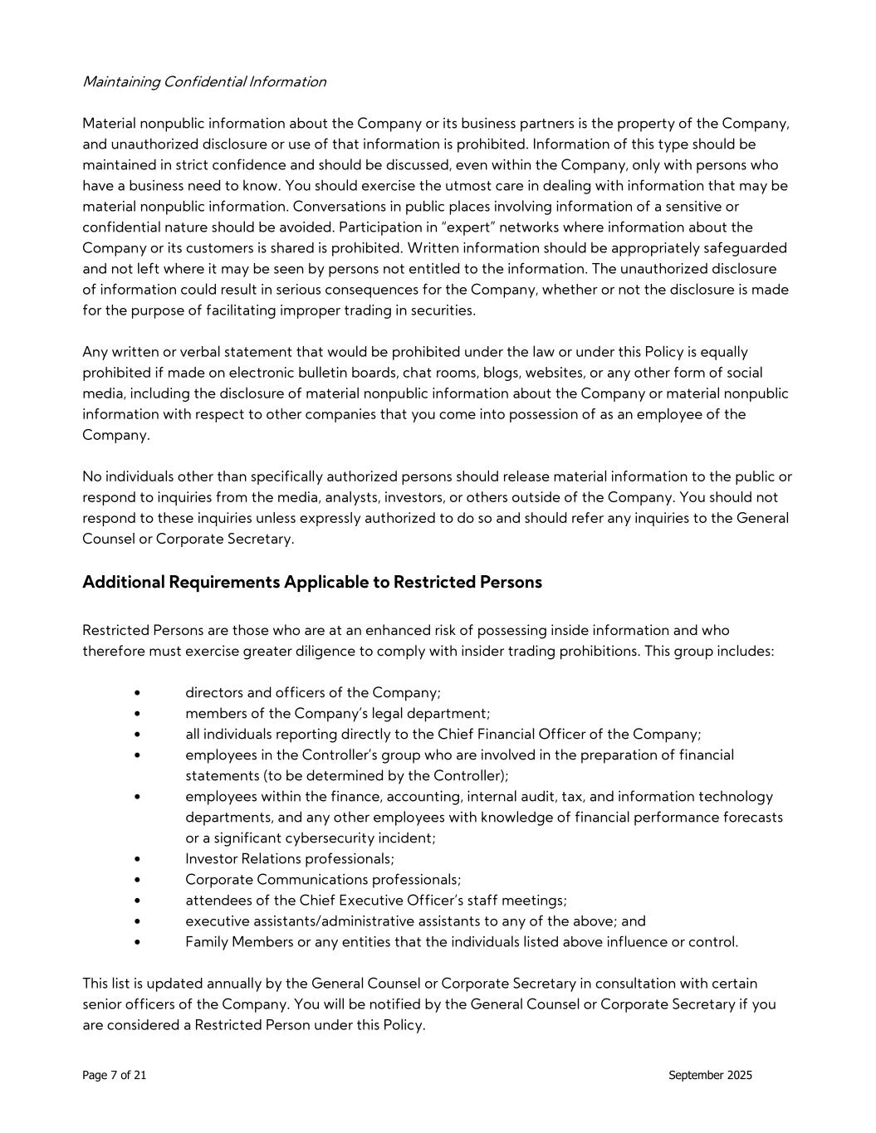
Page 7 of 21 September 2025 Maintaining Confidential Information Material nonpublic information about the Company or its business partners is the property of the Company, and unauthorized disclosure or use of that information is prohibited. Information of this type should be maintained in strict confidence and should be discussed, even within the Company, only with persons who have a business need to know. You should exercise the utmost care in dealing with information that may be material nonpublic information. Conversations in public places involving information of a sensitive or confidential nature should be avoided. Participation in “expert” networks where information about the Company or its customers is shared is prohibited. Written information should be appropriately safeguarded and not left where it may be seen by persons not entitled to the information. The unauthorized disclosure of information could result in serious consequences for the Company, whether or not the disclosure is made for the purpose of facilitating improper trading in securities. Any written or verbal statement that would be prohibited under the law or under this Policy is equally prohibited if made on electronic bulletin boards, chat rooms, blogs, websites, or any other form of social media, including the disclosure of material nonpublic information about the Company or material nonpublic information with respect to other companies that you come into possession of as an employee of the Company. No individuals other than specifically authorized persons should release material information to the public or respond to inquiries from the media, analysts, investors, or others outside of the Company. You should not respond to these inquiries unless expressly authorized to do so and should refer any inquiries to the General Counsel or Corporate Secretary. Additional Requirements Applicable to Restricted Persons Restricted Persons are those who are at an enhanced risk of possessing inside information and who therefore must exercise greater diligence to comply with insider trading prohibitions. This group includes: • directors and officers of the Company; • members of the Company’s legal department; • all individuals reporting directly to the Chief Financial Officer of the Company; • employees in the Controller’s group who are involved in the preparation of financial statements (to be determined by the Controller); • employees within the finance, accounting, internal audit, tax, and information technology departments, and any other employees with knowledge of financial performance forecasts or a significant cybersecurity incident; • Investor Relations professionals; • Corporate Communications professionals; • attendees of the Chief Executive Officer’s staff meetings; • executive assistants/administrative assistants to any of the above; and • Family Members or any entities that the individuals listed above influence or control. This list is updated annually by the General Counsel or Corporate Secretary in consultation with certain senior officers of the Company. You will be notified by the General Counsel or Corporate Secretary if you are considered a Restricted Person under this Policy.

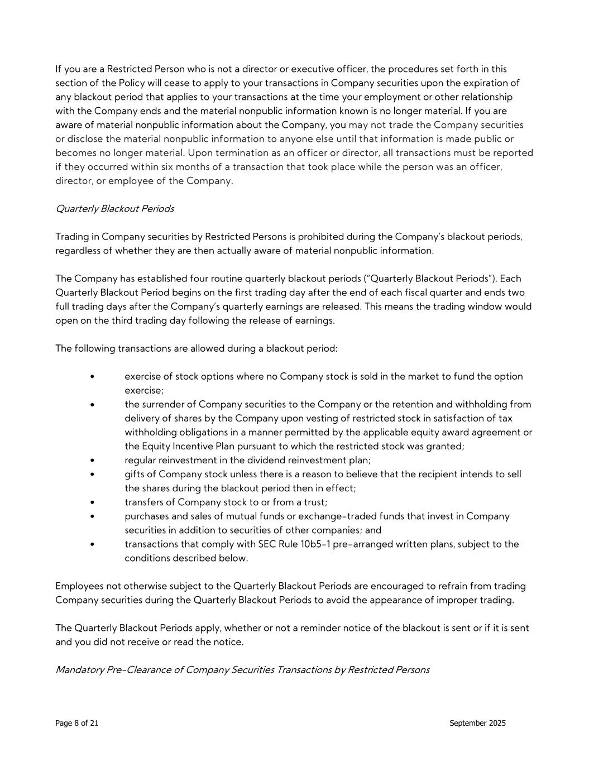
Page 8 of 21 September 2025 If you are a Restricted Person who is not a director or executive officer, the procedures set forth in this section of the Policy will cease to apply to your transactions in Company securities upon the expiration of any blackout period that applies to your transactions at the time your employment or other relationship with the Company ends and the material nonpublic information known is no longer material. If you are aware of material nonpublic information about the Company, you may not trade the Company securities or disclose the material nonpublic information to anyone else until that information is made public or becomes no longer material. Upon termination as an officer or director, all transactions must be reported if they occurred within six months of a transaction that took place while the person was an officer, director, or employee of the Company. Quarterly Blackout Periods Trading in Company securities by Restricted Persons is prohibited during the Company’s blackout periods, regardless of whether they are then actually aware of material nonpublic information. The Company has established four routine quarterly blackout periods (“Quarterly Blackout Periods”). Each Quarterly Blackout Period begins on the first trading day after the end of each fiscal quarter and ends two full trading days after the Company’s quarterly earnings are released. This means the trading window would open on the third trading day following the release of earnings. The following transactions are allowed during a blackout period: • exercise of stock options where no Company stock is sold in the market to fund the option exercise; • the surrender of Company securities to the Company or the retention and withholding from delivery of shares by the Company upon vesting of restricted stock in satisfaction of tax withholding obligations in a manner permitted by the applicable equity award agreement or the Equity Incentive Plan pursuant to which the restricted stock was granted; • regular reinvestment in the dividend reinvestment plan; • gifts of Company stock unless there is a reason to believe that the recipient intends to sell the shares during the blackout period then in effect; • transfers of Company stock to or from a trust; • purchases and sales of mutual funds or exchange-traded funds that invest in Company securities in addition to securities of other companies; and • transactions that comply with SEC Rule 10b5-1 pre-arranged written plans, subject to the conditions described below. Employees not otherwise subject to the Quarterly Blackout Periods are encouraged to refrain from trading Company securities during the Quarterly Blackout Periods to avoid the appearance of improper trading. The Quarterly Blackout Periods apply, whether or not a reminder notice of the blackout is sent or if it is sent and you did not receive or read the notice. Mandatory Pre-Clearance of Company Securities Transactions by Restricted Persons

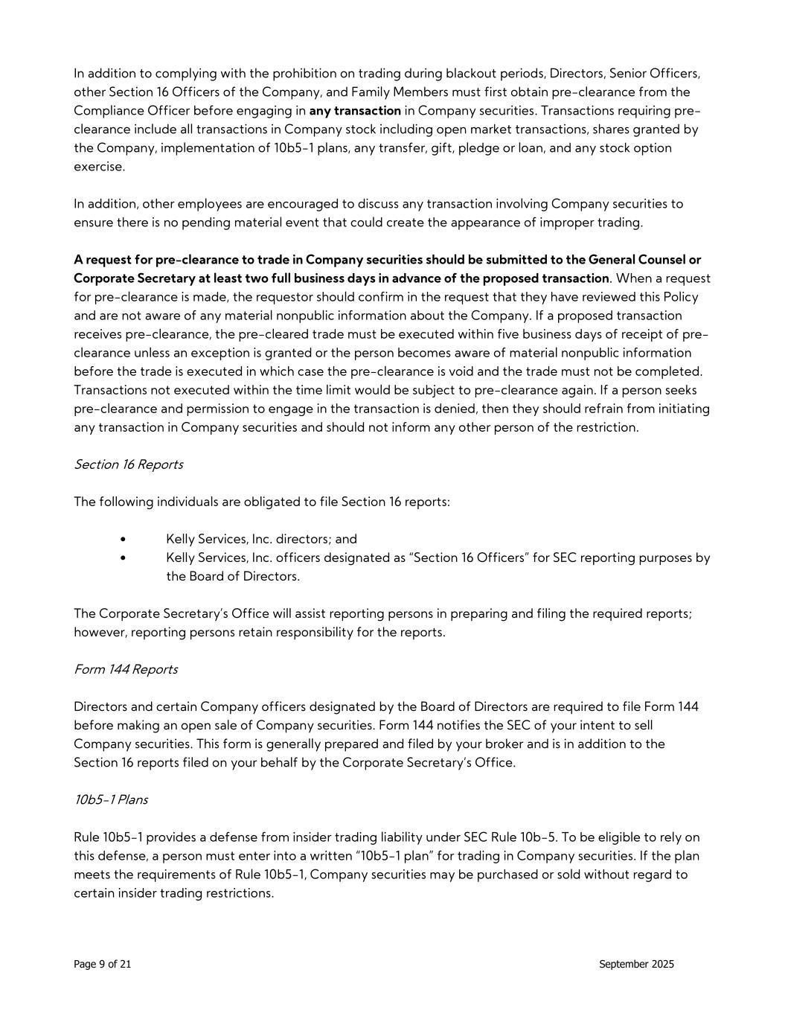
Page 9 of 21 September 2025 In addition to complying with the prohibition on trading during blackout periods, Directors, Senior Officers, other Section 16 Officers of the Company, and Family Members must first obtain pre-clearance from the Compliance Officer before engaging in any transaction in Company securities. Transactions requiring pre- clearance include all transactions in Company stock including open market transactions, shares granted by the Company, implementation of 10b5-1 plans, any transfer, gift, pledge or loan, and any stock option exercise. In addition, other employees are encouraged to discuss any transaction involving Company securities to ensure there is no pending material event that could create the appearance of improper trading. A request for pre-clearance to trade in Company securities should be submitted to the General Counsel or Corporate Secretary at least two full business days in advance of the proposed transaction. When a request for pre-clearance is made, the requestor should confirm in the request that they have reviewed this Policy and are not aware of any material nonpublic information about the Company. If a proposed transaction receives pre-clearance, the pre-cleared trade must be executed within five business days of receipt of pre- clearance unless an exception is granted or the person becomes aware of material nonpublic information before the trade is executed in which case the pre-clearance is void and the trade must not be completed. Transactions not executed within the time limit would be subject to pre-clearance again. If a person seeks pre-clearance and permission to engage in the transaction is denied, then they should refrain from initiating any transaction in Company securities and should not inform any other person of the restriction. Section 16 Reports The following individuals are obligated to file Section 16 reports: • Kelly Services, Inc. directors; and • Kelly Services, Inc. officers designated as “Section 16 Officers” for SEC reporting purposes by the Board of Directors. The Corporate Secretary’s Office will assist reporting persons in preparing and filing the required reports; however, reporting persons retain responsibility for the reports. Form 144 Reports Directors and certain Company officers designated by the Board of Directors are required to file Form 144 before making an open sale of Company securities. Form 144 notifies the SEC of your intent to sell Company securities. This form is generally prepared and filed by your broker and is in addition to the Section 16 reports filed on your behalf by the Corporate Secretary’s Office. 10b5-1 Plans Rule 10b5-1 provides a defense from insider trading liability under SEC Rule 10b-5. To be eligible to rely on this defense, a person must enter into a written “10b5-1 plan” for trading in Company securities. If the plan meets the requirements of Rule 10b5-1, Company securities may be purchased or sold without regard to certain insider trading restrictions.

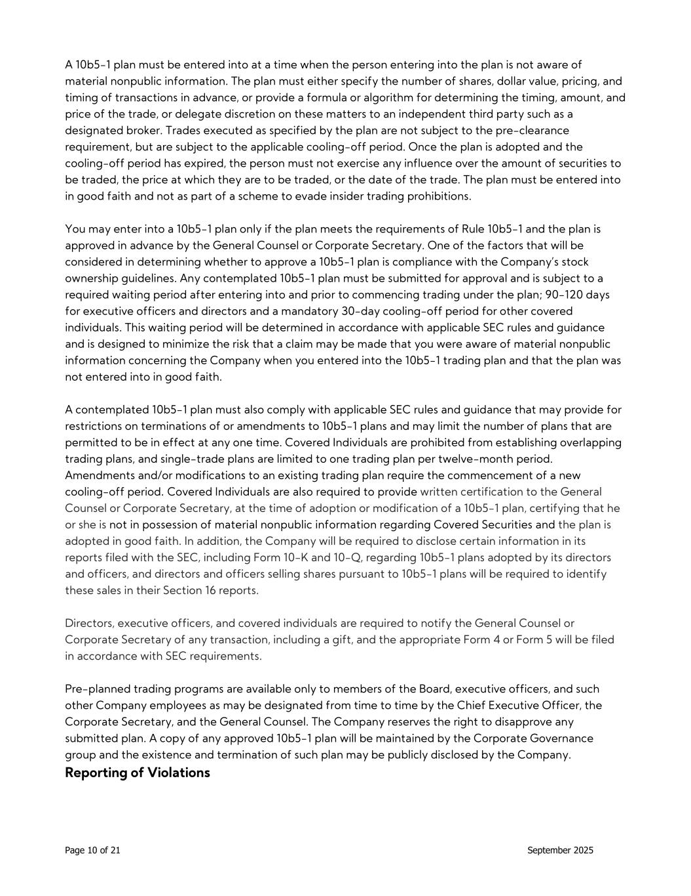
Page 10 of 21 September 2025 A 10b5-1 plan must be entered into at a time when the person entering into the plan is not aware of material nonpublic information. The plan must either specify the number of shares, dollar value, pricing, and timing of transactions in advance, or provide a formula or algorithm for determining the timing, amount, and price of the trade, or delegate discretion on these matters to an independent third party such as a designated broker. Trades executed as specified by the plan are not subject to the pre-clearance requirement, but are subject to the applicable cooling-off period. Once the plan is adopted and the cooling-off period has expired, the person must not exercise any influence over the amount of securities to be traded, the price at which they are to be traded, or the date of the trade. The plan must be entered into in good faith and not as part of a scheme to evade insider trading prohibitions. You may enter into a 10b5-1 plan only if the plan meets the requirements of Rule 10b5-1 and the plan is approved in advance by the General Counsel or Corporate Secretary. One of the factors that will be considered in determining whether to approve a 10b5-1 plan is compliance with the Company’s stock ownership guidelines. Any contemplated 10b5-1 plan must be submitted for approval and is subject to a required waiting period after entering into and prior to commencing trading under the plan; 90-120 days for executive officers and directors and a mandatory 30-day cooling-off period for other covered individuals. This waiting period will be determined in accordance with applicable SEC rules and guidance and is designed to minimize the risk that a claim may be made that you were aware of material nonpublic information concerning the Company when you entered into the 10b5-1 trading plan and that the plan was not entered into in good faith. A contemplated 10b5-1 plan must also comply with applicable SEC rules and guidance that may provide for restrictions on terminations of or amendments to 10b5-1 plans and may limit the number of plans that are permitted to be in effect at any one time. Covered Individuals are prohibited from establishing overlapping trading plans, and single-trade plans are limited to one trading plan per twelve-month period. Amendments and/or modifications to an existing trading plan require the commencement of a new cooling-off period. Covered Individuals are also required to provide written certification to the General Counsel or Corporate Secretary, at the time of adoption or modification of a 10b5-1 plan, certifying that he or she is not in possession of material nonpublic information regarding Covered Securities and the plan is adopted in good faith. In addition, the Company will be required to disclose certain information in its reports filed with the SEC, including Form 10-K and 10-Q, regarding 10b5-1 plans adopted by its directors and officers, and directors and officers selling shares pursuant to 10b5-1 plans will be required to identify these sales in their Section 16 reports. Directors, executive officers, and covered individuals are required to notify the General Counsel or Corporate Secretary of any transaction, including a gift, and the appropriate Form 4 or Form 5 will be filed in accordance with SEC requirements. Pre-planned trading programs are available only to members of the Board, executive officers, and such other Company employees as may be designated from time to time by the Chief Executive Officer, the Corporate Secretary, and the General Counsel. The Company reserves the right to disapprove any submitted plan. A copy of any approved 10b5-1 plan will be maintained by the Corporate Governance group and the existence and termination of such plan may be publicly disclosed by the Company. Reporting of Violations

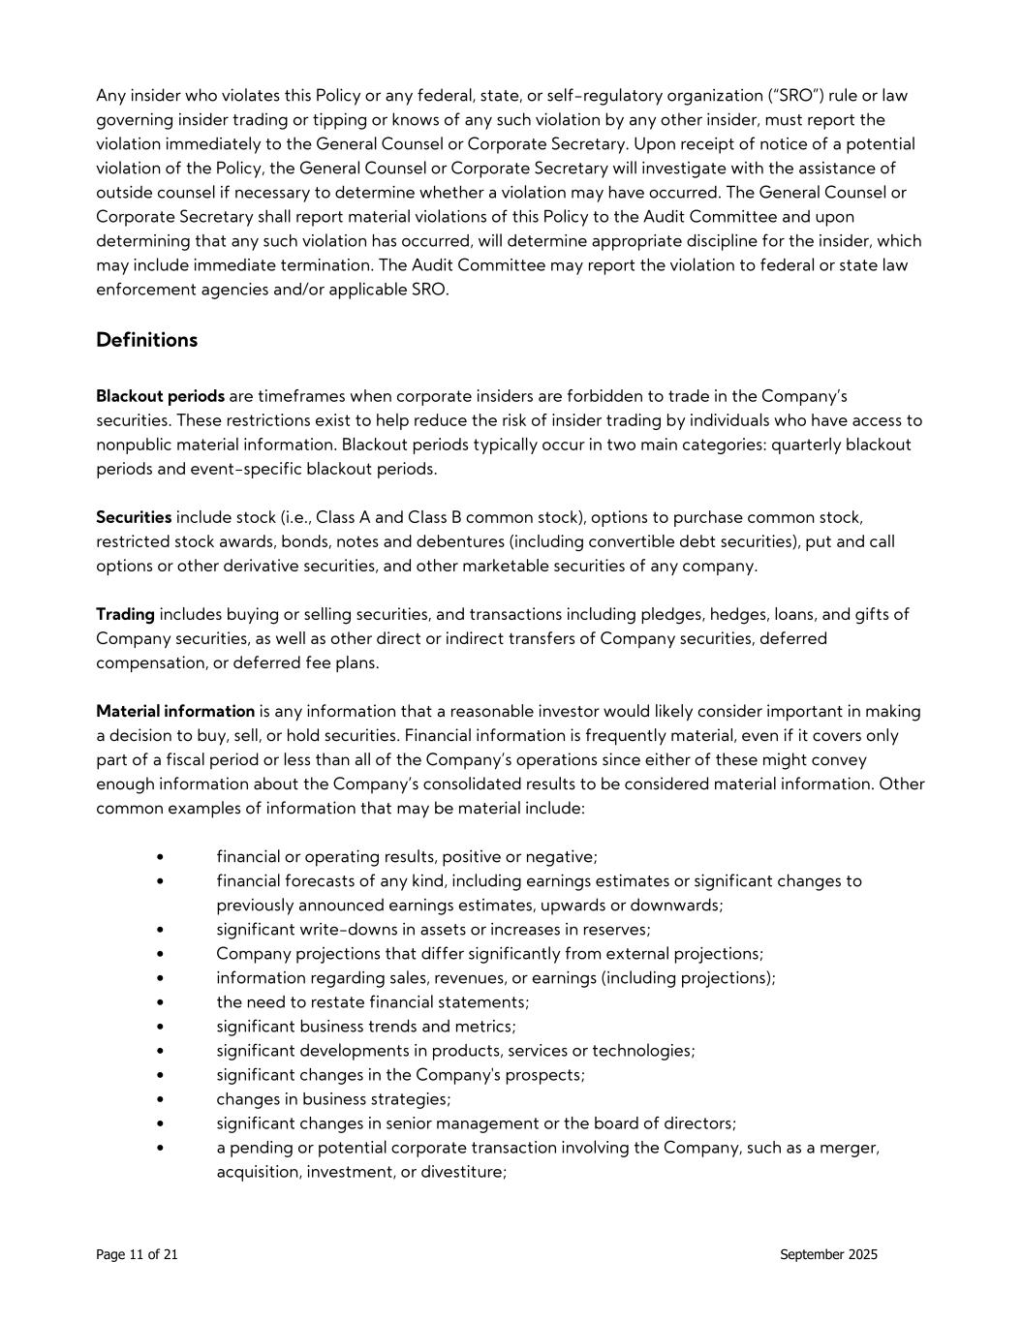
Page 11 of 21 September 2025 Any insider who violates this Policy or any federal, state, or self-regulatory organization (“SRO”) rule or law governing insider trading or tipping or knows of any such violation by any other insider, must report the violation immediately to the General Counsel or Corporate Secretary. Upon receipt of notice of a potential violation of the Policy, the General Counsel or Corporate Secretary will investigate with the assistance of outside counsel if necessary to determine whether a violation may have occurred. The General Counsel or Corporate Secretary shall report material violations of this Policy to the Audit Committee and upon determining that any such violation has occurred, will determine appropriate discipline for the insider, which may include immediate termination. The Audit Committee may report the violation to federal or state law enforcement agencies and/or applicable SRO. Definitions Blackout periods are timeframes when corporate insiders are forbidden to trade in the Company’s securities. These restrictions exist to help reduce the risk of insider trading by individuals who have access to nonpublic material information. Blackout periods typically occur in two main categories: quarterly blackout periods and event-specific blackout periods. Securities include stock (i.e., Class A and Class B common stock), options to purchase common stock, restricted stock awards, bonds, notes and debentures (including convertible debt securities), put and call options or other derivative securities, and other marketable securities of any company. Trading includes buying or selling securities, and transactions including pledges, hedges, loans, and gifts of Company securities, as well as other direct or indirect transfers of Company securities, deferred compensation, or deferred fee plans. Material information is any information that a reasonable investor would likely consider important in making a decision to buy, sell, or hold securities. Financial information is frequently material, even if it covers only part of a fiscal period or less than all of the Company’s operations since either of these might convey enough information about the Company’s consolidated results to be considered material information. Other common examples of information that may be material include: • financial or operating results, positive or negative; • financial forecasts of any kind, including earnings estimates or significant changes to previously announced earnings estimates, upwards or downwards; • significant write-downs in assets or increases in reserves; • Company projections that differ significantly from external projections; • information regarding sales, revenues, or earnings (including projections); • the need to restate financial statements; • significant business trends and metrics; • significant developments in products, services or technologies; • significant changes in the Company's prospects; • changes in business strategies; • significant changes in senior management or the board of directors; • a pending or potential corporate transaction involving the Company, such as a merger, acquisition, investment, or divestiture;

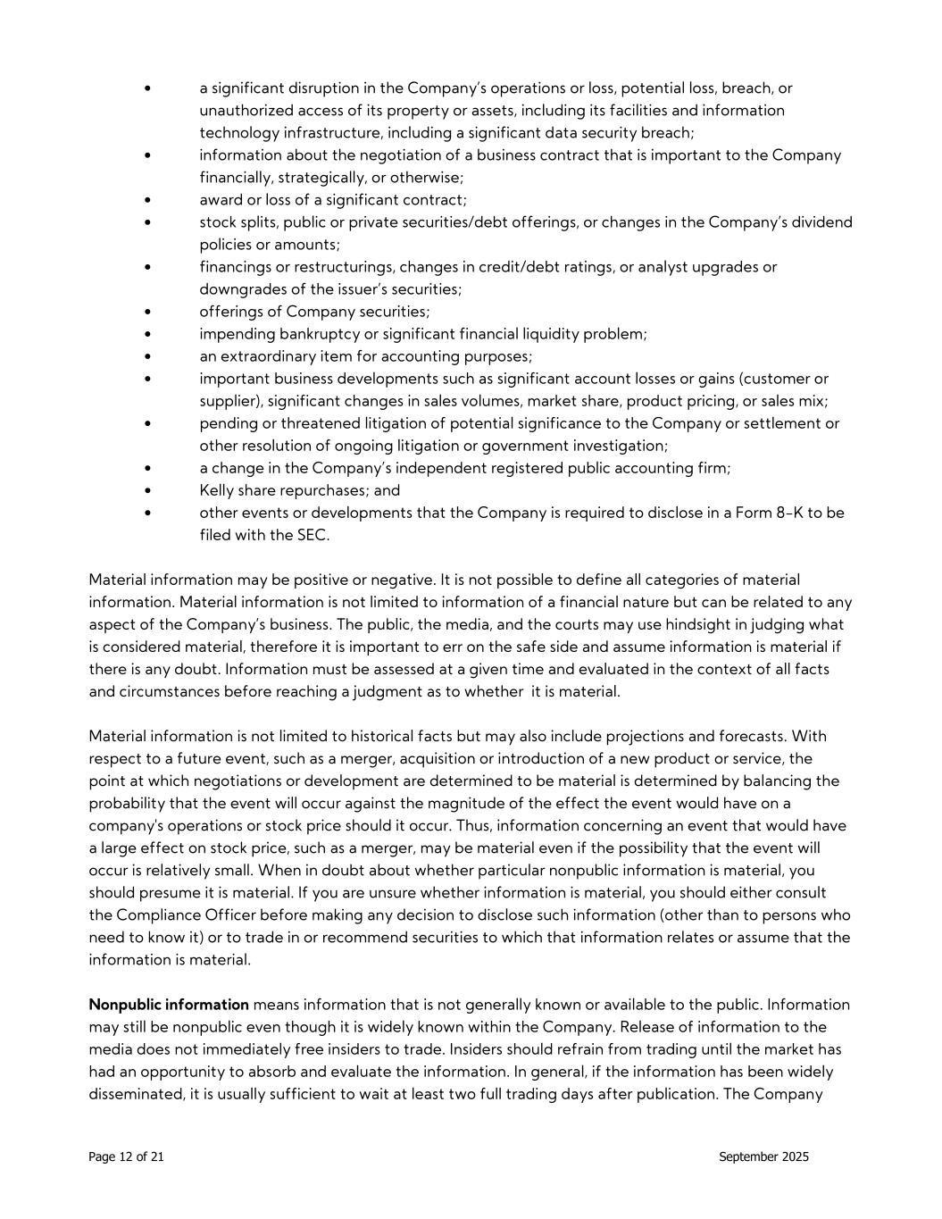
Page 12 of 21 September 2025 • a significant disruption in the Company’s operations or loss, potential loss, breach, or unauthorized access of its property or assets, including its facilities and information technology infrastructure, including a significant data security breach; • information about the negotiation of a business contract that is important to the Company financially, strategically, or otherwise; • award or loss of a significant contract; • stock splits, public or private securities/debt offerings, or changes in the Company’s dividend policies or amounts; • financings or restructurings, changes in credit/debt ratings, or analyst upgrades or downgrades of the issuer’s securities; • offerings of Company securities; • impending bankruptcy or significant financial liquidity problem; • an extraordinary item for accounting purposes; • important business developments such as significant account losses or gains (customer or supplier), significant changes in sales volumes, market share, product pricing, or sales mix; • pending or threatened litigation of potential significance to the Company or settlement or other resolution of ongoing litigation or government investigation; • a change in the Company’s independent registered public accounting firm; • Kelly share repurchases; and • other events or developments that the Company is required to disclose in a Form 8-K to be filed with the SEC. Material information may be positive or negative. It is not possible to define all categories of material information. Material information is not limited to information of a financial nature but can be related to any aspect of the Company’s business. The public, the media, and the courts may use hindsight in judging what is considered material, therefore it is important to err on the safe side and assume information is material if there is any doubt. Information must be assessed at a given time and evaluated in the context of all facts and circumstances before reaching a judgment as to whether it is material. Material information is not limited to historical facts but may also include projections and forecasts. With respect to a future event, such as a merger, acquisition or introduction of a new product or service, the point at which negotiations or development are determined to be material is determined by balancing the probability that the event will occur against the magnitude of the effect the event would have on a company's operations or stock price should it occur. Thus, information concerning an event that would have a large effect on stock price, such as a merger, may be material even if the possibility that the event will occur is relatively small. When in doubt about whether particular nonpublic information is material, you should presume it is material. If you are unsure whether information is material, you should either consult the Compliance Officer before making any decision to disclose such information (other than to persons who need to know it) or to trade in or recommend securities to which that information relates or assume that the information is material. Nonpublic information means information that is not generally known or available to the public. Information may still be nonpublic even though it is widely known within the Company. Release of information to the media does not immediately free insiders to trade. Insiders should refrain from trading until the market has had an opportunity to absorb and evaluate the information. In general, if the information has been widely disseminated, it is usually sufficient to wait at least two full trading days after publication. The Company

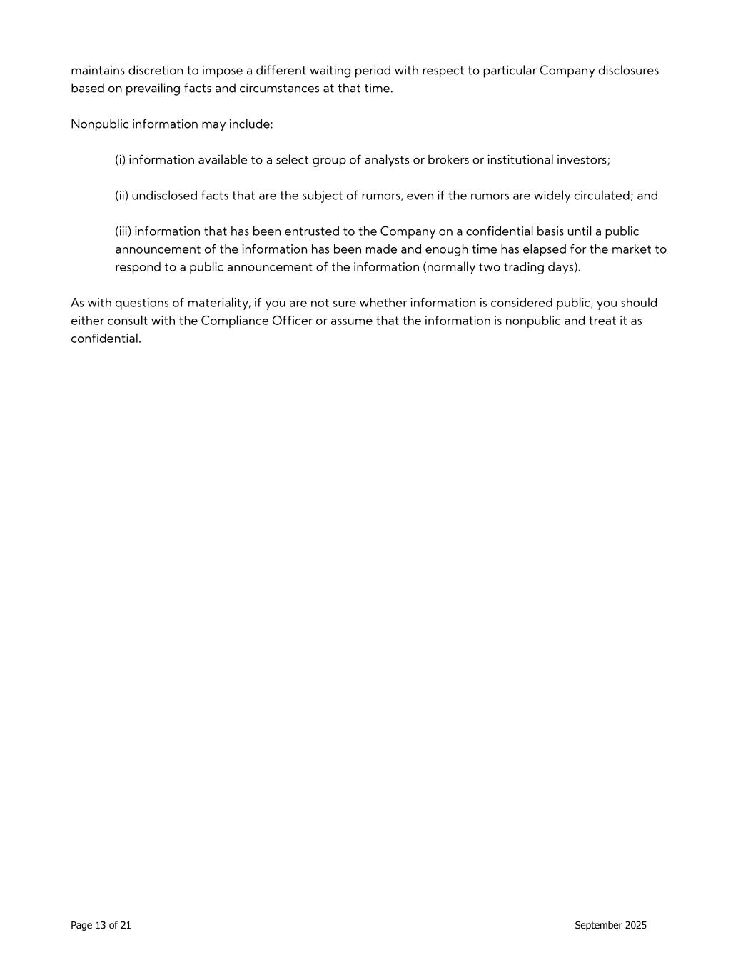
Page 13 of 21 September 2025 maintains discretion to impose a different waiting period with respect to particular Company disclosures based on prevailing facts and circumstances at that time. Nonpublic information may include: (i) information available to a select group of analysts or brokers or institutional investors; (ii) undisclosed facts that are the subject of rumors, even if the rumors are widely circulated; and (iii) information that has been entrusted to the Company on a confidential basis until a public announcement of the information has been made and enough time has elapsed for the market to respond to a public announcement of the information (normally two trading days). As with questions of materiality, if you are not sure whether information is considered public, you should either consult with the Compliance Officer or assume that the information is nonpublic and treat it as confidential.

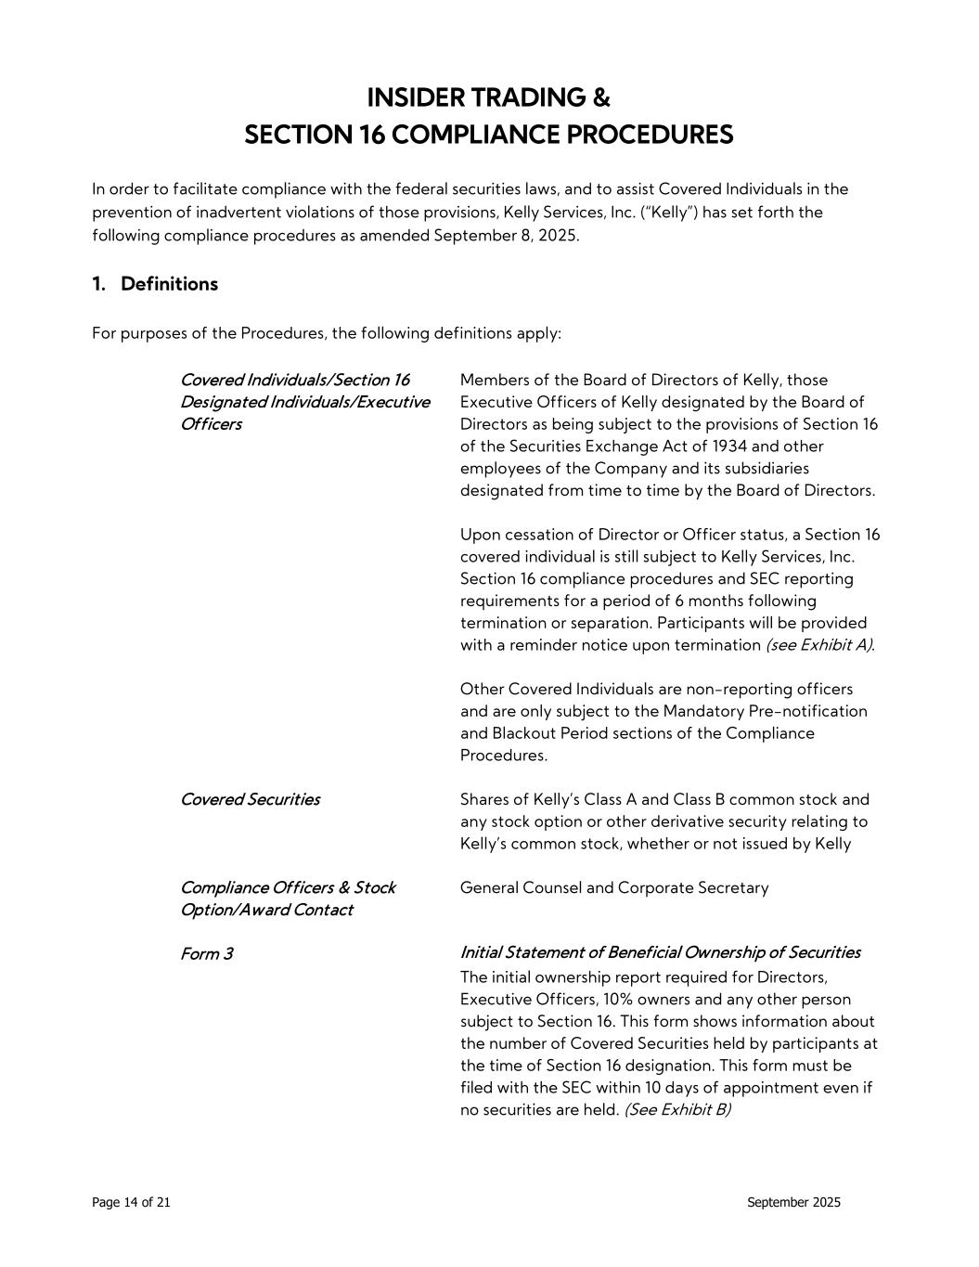
Page 14 of 21 September 2025 INSIDER TRADING & SECTION 16 COMPLIANCE PROCEDURES In order to facilitate compliance with the federal securities laws, and to assist Covered Individuals in the prevention of inadvertent violations of those provisions, Kelly Services, Inc. (“Kelly”) has set forth the following compliance procedures as amended September 8, 2025. 1. Definitions For purposes of the Procedures, the following definitions apply: Covered Individuals/Section 16 Designated Individuals/Executive Officers Members of the Board of Directors of Kelly, those Executive Officers of Kelly designated by the Board of Directors as being subject to the provisions of Section 16 of the Securities Exchange Act of 1934 and other employees of the Company and its subsidiaries designated from time to time by the Board of Directors. Upon cessation of Director or Officer status, a Section 16 covered individual is still subject to Kelly Services, Inc. Section 16 compliance procedures and SEC reporting requirements for a period of 6 months following termination or separation. Participants will be provided with a reminder notice upon termination (see Exhibit A). Other Covered Individuals are non-reporting officers and are only subject to the Mandatory Pre-notification and Blackout Period sections of the Compliance Procedures. Covered Securities Shares of Kelly’s Class A and Class B common stock and any stock option or other derivative security relating to Kelly’s common stock, whether or not issued by Kelly Compliance Officers & Stock Option/Award Contact General Counsel and Corporate Secretary Form 3 Initial Statement of Beneficial Ownership of Securities The initial ownership report required for Directors, Executive Officers, 10% owners and any other person subject to Section 16. This form shows information about the number of Covered Securities held by participants at the time of Section 16 designation. This form must be filed with the SEC within 10 days of appointment even if no securities are held. (See Exhibit B)

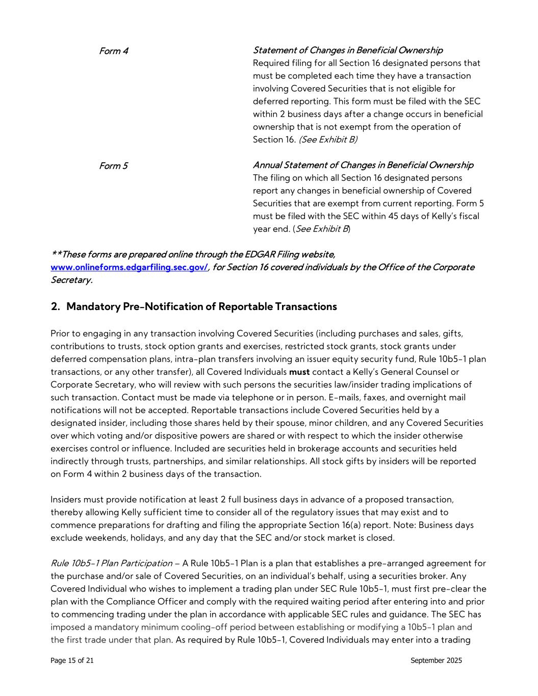
Page 15 of 21 September 2025 Form 4 Statement of Changes in Beneficial Ownership Required filing for all Section 16 designated persons that must be completed each time they have a transaction involving Covered Securities that is not eligible for deferred reporting. This form must be filed with the SEC within 2 business days after a change occurs in beneficial ownership that is not exempt from the operation of Section 16. (See Exhibit B) Form 5 Annual Statement of Changes in Beneficial Ownership The filing on which all Section 16 designated persons report any changes in beneficial ownership of Covered Securities that are exempt from current reporting. Form 5 must be filed with the SEC within 45 days of Kelly’s fiscal year end. (See Exhibit B) **These forms are prepared online through the EDGAR Filing website, www.onlineforms.edgarfiling.sec.gov/, for Section 16 covered individuals by the Office of the Corporate Secretary. 2. Mandatory Pre-Notification of Reportable Transactions Prior to engaging in any transaction involving Covered Securities (including purchases and sales, gifts, contributions to trusts, stock option grants and exercises, restricted stock grants, stock grants under deferred compensation plans, intra-plan transfers involving an issuer equity security fund, Rule 10b5-1 plan transactions, or any other transfer), all Covered Individuals must contact a Kelly’s General Counsel or Corporate Secretary, who will review with such persons the securities law/insider trading implications of such transaction. Contact must be made via telephone or in person. E-mails, faxes, and overnight mail notifications will not be accepted. Reportable transactions include Covered Securities held by a designated insider, including those shares held by their spouse, minor children, and any Covered Securities over which voting and/or dispositive powers are shared or with respect to which the insider otherwise exercises control or influence. Included are securities held in brokerage accounts and securities held indirectly through trusts, partnerships, and similar relationships. All stock gifts by insiders will be reported on Form 4 within 2 business days of the transaction. Insiders must provide notification at least 2 full business days in advance of a proposed transaction, thereby allowing Kelly sufficient time to consider all of the regulatory issues that may exist and to commence preparations for drafting and filing the appropriate Section 16(a) report. Note: Business days exclude weekends, holidays, and any day that the SEC and/or stock market is closed. Rule 10b5-1 Plan Participation – A Rule 10b5-1 Plan is a plan that establishes a pre-arranged agreement for the purchase and/or sale of Covered Securities, on an individual’s behalf, using a securities broker. Any Covered Individual who wishes to implement a trading plan under SEC Rule 10b5-1, must first pre-clear the plan with the Compliance Officer and comply with the required waiting period after entering into and prior to commencing trading under the plan in accordance with applicable SEC rules and guidance. The SEC has imposed a mandatory minimum cooling-off period between establishing or modifying a 10b5-1 plan and the first trade under that plan. As required by Rule 10b5-1, Covered Individuals may enter into a trading

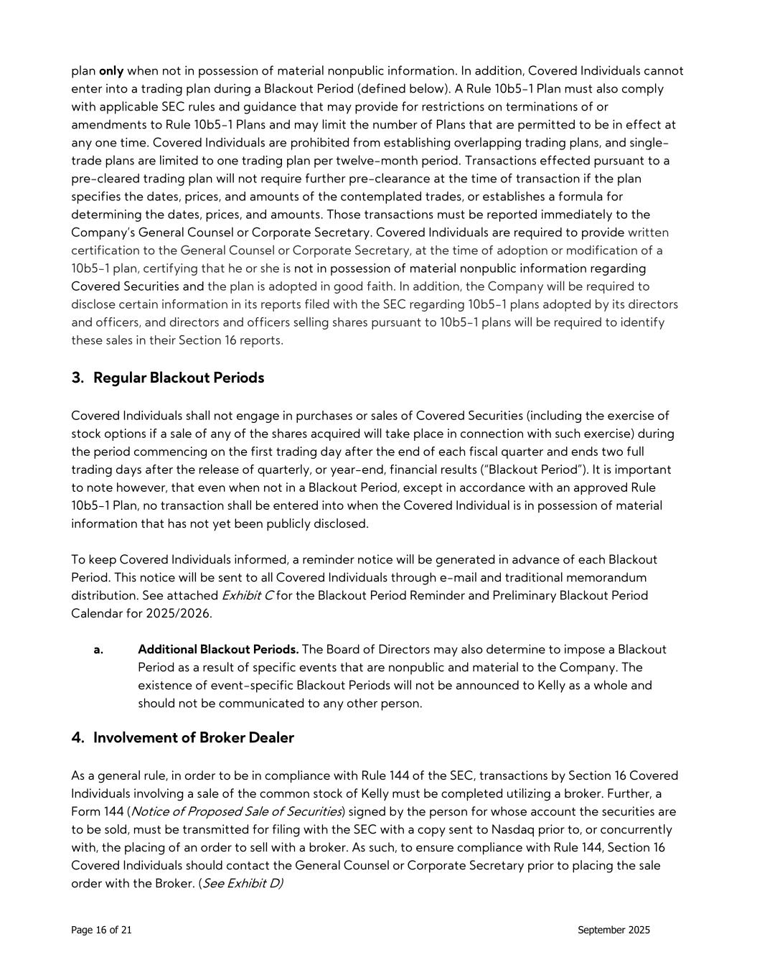
Page 16 of 21 September 2025 plan only when not in possession of material nonpublic information. In addition, Covered Individuals cannot enter into a trading plan during a Blackout Period (defined below). A Rule 10b5-1 Plan must also comply with applicable SEC rules and guidance that may provide for restrictions on terminations of or amendments to Rule 10b5-1 Plans and may limit the number of Plans that are permitted to be in effect at any one time. Covered Individuals are prohibited from establishing overlapping trading plans, and single- trade plans are limited to one trading plan per twelve-month period. Transactions effected pursuant to a pre-cleared trading plan will not require further pre-clearance at the time of transaction if the plan specifies the dates, prices, and amounts of the contemplated trades, or establishes a formula for determining the dates, prices, and amounts. Those transactions must be reported immediately to the Company’s General Counsel or Corporate Secretary. Covered Individuals are required to provide written certification to the General Counsel or Corporate Secretary, at the time of adoption or modification of a 10b5-1 plan, certifying that he or she is not in possession of material nonpublic information regarding Covered Securities and the plan is adopted in good faith. In addition, the Company will be required to disclose certain information in its reports filed with the SEC regarding 10b5-1 plans adopted by its directors and officers, and directors and officers selling shares pursuant to 10b5-1 plans will be required to identify these sales in their Section 16 reports. 3. Regular Blackout Periods Covered Individuals shall not engage in purchases or sales of Covered Securities (including the exercise of stock options if a sale of any of the shares acquired will take place in connection with such exercise) during the period commencing on the first trading day after the end of each fiscal quarter and ends two full trading days after the release of quarterly, or year-end, financial results (“Blackout Period”). It is important to note however, that even when not in a Blackout Period, except in accordance with an approved Rule 10b5-1 Plan, no transaction shall be entered into when the Covered Individual is in possession of material information that has not yet been publicly disclosed. To keep Covered Individuals informed, a reminder notice will be generated in advance of each Blackout Period. This notice will be sent to all Covered Individuals through e-mail and traditional memorandum distribution. See attached Exhibit C for the Blackout Period Reminder and Preliminary Blackout Period Calendar for 2025/2026. a. Additional Blackout Periods. The Board of Directors may also determine to impose a Blackout Period as a result of specific events that are nonpublic and material to the Company. The existence of event-specific Blackout Periods will not be announced to Kelly as a whole and should not be communicated to any other person. 4. Involvement of Broker Dealer As a general rule, in order to be in compliance with Rule 144 of the SEC, transactions by Section 16 Covered Individuals involving a sale of the common stock of Kelly must be completed utilizing a broker. Further, a Form 144 (Notice of Proposed Sale of Securities) signed by the person for whose account the securities are to be sold, must be transmitted for filing with the SEC with a copy sent to Nasdaq prior to, or concurrently with, the placing of an order to sell with a broker. As such, to ensure compliance with Rule 144, Section 16 Covered Individuals should contact the General Counsel or Corporate Secretary prior to placing the sale order with the Broker. (See Exhibit D)

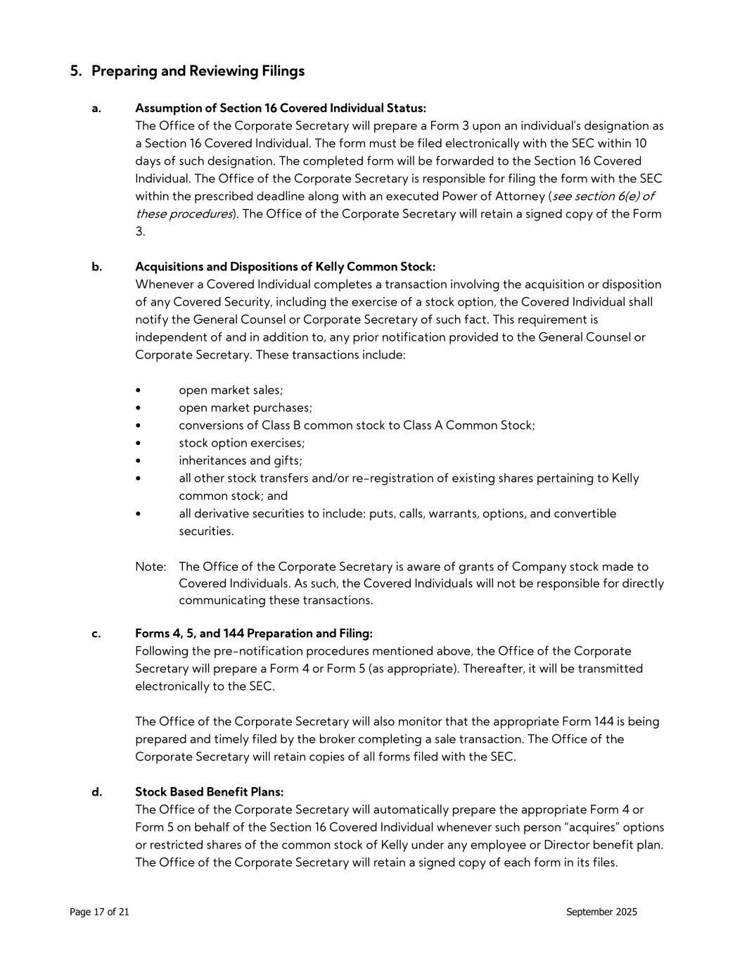
Page 17 of 21 September 2025 5. Preparing and Reviewing Filings a. Assumption of Section 16 Covered Individual Status: The Office of the Corporate Secretary will prepare a Form 3 upon an individual's designation as a Section 16 Covered Individual. The form must be filed electronically with the SEC within 10 days of such designation. The completed form will be forwarded to the Section 16 Covered Individual. The Office of the Corporate Secretary is responsible for filing the form with the SEC within the prescribed deadline along with an executed Power of Attorney (see section 6(e) of these procedures). The Office of the Corporate Secretary will retain a signed copy of the Form 3. b. Acquisitions and Dispositions of Kelly Common Stock: Whenever a Covered Individual completes a transaction involving the acquisition or disposition of any Covered Security, including the exercise of a stock option, the Covered Individual shall notify the General Counsel or Corporate Secretary of such fact. This requirement is independent of and in addition to, any prior notification provided to the General Counsel or Corporate Secretary. These transactions include: • open market sales; • open market purchases; • conversions of Class B common stock to Class A Common Stock; • stock option exercises; • inheritances and gifts; • all other stock transfers and/or re-registration of existing shares pertaining to Kelly common stock; and • all derivative securities to include: puts, calls, warrants, options, and convertible securities. Note: The Office of the Corporate Secretary is aware of grants of Company stock made to Covered Individuals. As such, the Covered Individuals will not be responsible for directly communicating these transactions. c. Forms 4, 5, and 144 Preparation and Filing: Following the pre-notification procedures mentioned above, the Office of the Corporate Secretary will prepare a Form 4 or Form 5 (as appropriate). Thereafter, it will be transmitted electronically to the SEC. The Office of the Corporate Secretary will also monitor that the appropriate Form 144 is being prepared and timely filed by the broker completing a sale transaction. The Office of the Corporate Secretary will retain copies of all forms filed with the SEC. d. Stock Based Benefit Plans: The Office of the Corporate Secretary will automatically prepare the appropriate Form 4 or Form 5 on behalf of the Section 16 Covered Individual whenever such person “acquires” options or restricted shares of the common stock of Kelly under any employee or Director benefit plan. The Office of the Corporate Secretary will retain a signed copy of each form in its files.

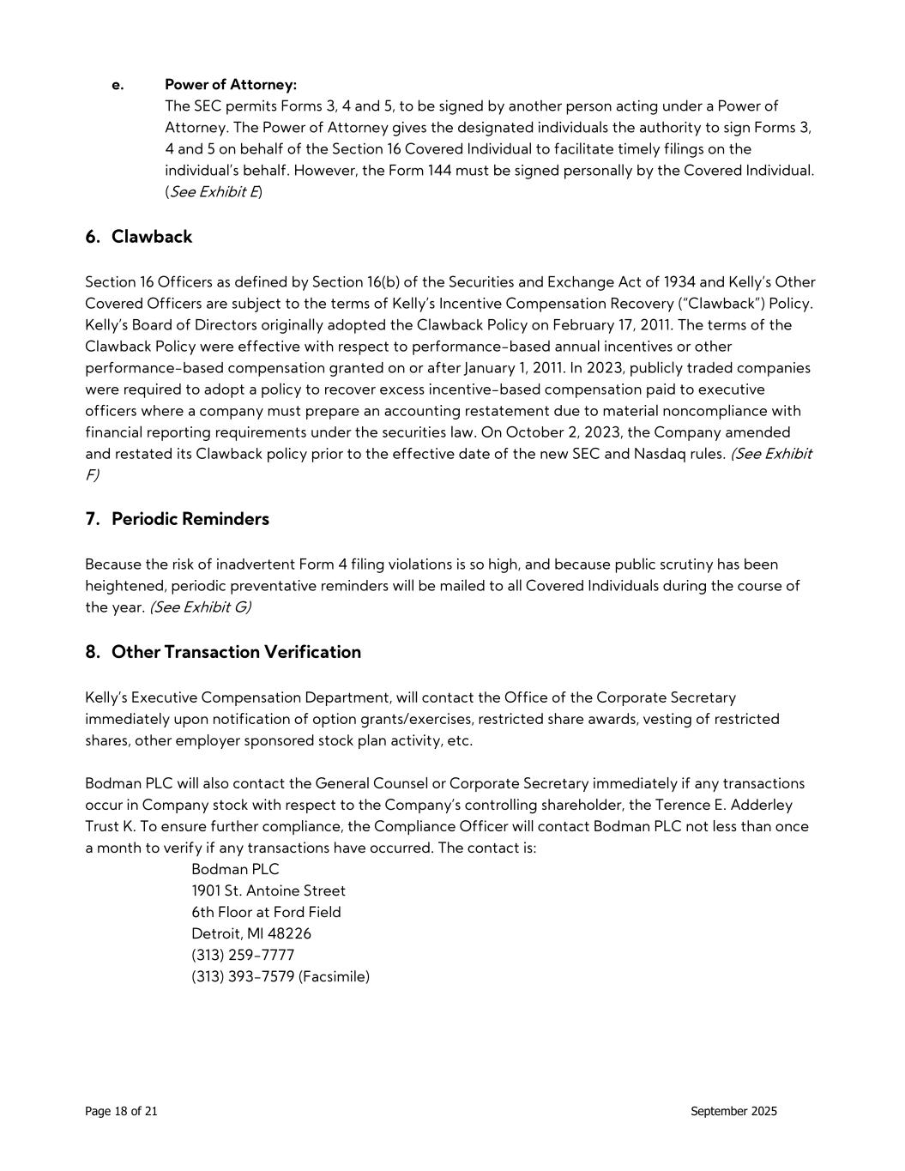
Page 18 of 21 September 2025 e. Power of Attorney: The SEC permits Forms 3, 4 and 5, to be signed by another person acting under a Power of Attorney. The Power of Attorney gives the designated individuals the authority to sign Forms 3, 4 and 5 on behalf of the Section 16 Covered Individual to facilitate timely filings on the individual’s behalf. However, the Form 144 must be signed personally by the Covered Individual. (See Exhibit E) 6. Clawback Section 16 Officers as defined by Section 16(b) of the Securities and Exchange Act of 1934 and Kelly’s Other Covered Officers are subject to the terms of Kelly’s Incentive Compensation Recovery (“Clawback”) Policy. Kelly’s Board of Directors originally adopted the Clawback Policy on February 17, 2011. The terms of the Clawback Policy were effective with respect to performance-based annual incentives or other performance-based compensation granted on or after January 1, 2011. In 2023, publicly traded companies were required to adopt a policy to recover excess incentive-based compensation paid to executive officers where a company must prepare an accounting restatement due to material noncompliance with financial reporting requirements under the securities law. On October 2, 2023, the Company amended and restated its Clawback policy prior to the effective date of the new SEC and Nasdaq rules. (See Exhibit F) 7. Periodic Reminders Because the risk of inadvertent Form 4 filing violations is so high, and because public scrutiny has been heightened, periodic preventative reminders will be mailed to all Covered Individuals during the course of the year. (See Exhibit G) 8. Other Transaction Verification Kelly’s Executive Compensation Department, will contact the Office of the Corporate Secretary immediately upon notification of option grants/exercises, restricted share awards, vesting of restricted shares, other employer sponsored stock plan activity, etc. Bodman PLC will also contact the General Counsel or Corporate Secretary immediately if any transactions occur in Company stock with respect to the Company’s controlling shareholder, the Terence E. Adderley Trust K. To ensure further compliance, the Compliance Officer will contact Bodman PLC not less than once a month to verify if any transactions have occurred. The contact is: Bodman PLC 1901 St. Antoine Street 6th Floor at Ford Field Detroit, MI 48226 (313) 259-7777 (313) 393-7579 (Facsimile)

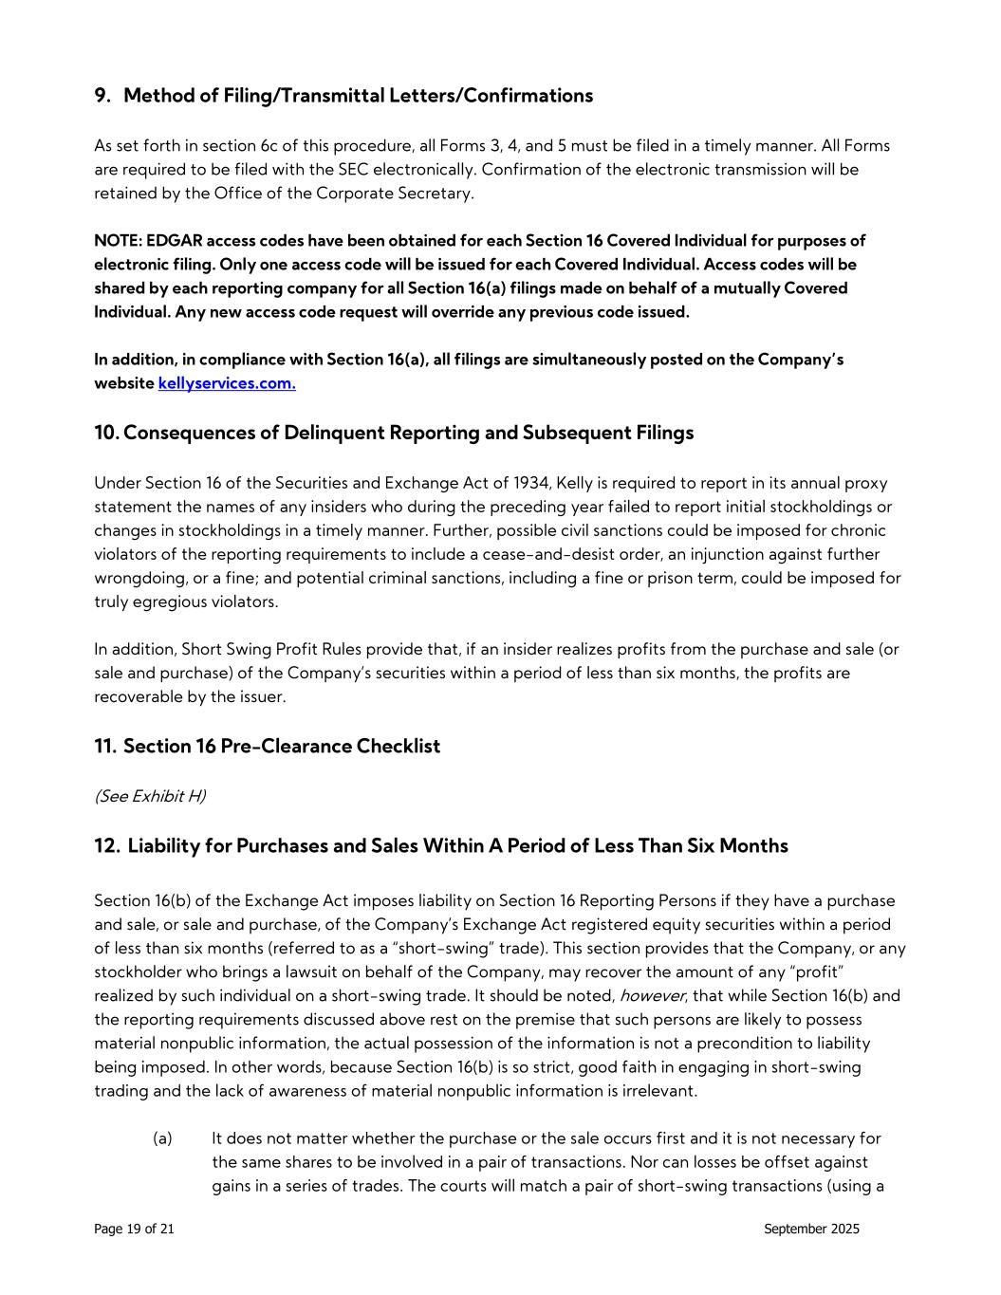
Page 19 of 21 September 2025 9. Method of Filing/Transmittal Letters/Confirmations As set forth in section 6c of this procedure, all Forms 3, 4, and 5 must be filed in a timely manner. All Forms are required to be filed with the SEC electronically. Confirmation of the electronic transmission will be retained by the Office of the Corporate Secretary. NOTE: EDGAR access codes have been obtained for each Section 16 Covered Individual for purposes of electronic filing. Only one access code will be issued for each Covered Individual. Access codes will be shared by each reporting company for all Section 16(a) filings made on behalf of a mutually Covered Individual. Any new access code request will override any previous code issued. In addition, in compliance with Section 16(a), all filings are simultaneously posted on the Company’s website kellyservices.com. 10. Consequences of Delinquent Reporting and Subsequent Filings Under Section 16 of the Securities and Exchange Act of 1934, Kelly is required to report in its annual proxy statement the names of any insiders who during the preceding year failed to report initial stockholdings or changes in stockholdings in a timely manner. Further, possible civil sanctions could be imposed for chronic violators of the reporting requirements to include a cease-and-desist order, an injunction against further wrongdoing, or a fine; and potential criminal sanctions, including a fine or prison term, could be imposed for truly egregious violators. In addition, Short Swing Profit Rules provide that, if an insider realizes profits from the purchase and sale (or sale and purchase) of the Company’s securities within a period of less than six months, the profits are recoverable by the issuer. 11. Section 16 Pre-Clearance Checklist (See Exhibit H) 12. Liability for Purchases and Sales Within A Period of Less Than Six Months Section 16(b) of the Exchange Act imposes liability on Section 16 Reporting Persons if they have a purchase and sale, or sale and purchase, of the Company’s Exchange Act registered equity securities within a period of less than six months (referred to as a “short-swing” trade). This section provides that the Company, or any stockholder who brings a lawsuit on behalf of the Company, may recover the amount of any “profit” realized by such individual on a short-swing trade. It should be noted, however, that while Section 16(b) and the reporting requirements discussed above rest on the premise that such persons are likely to possess material nonpublic information, the actual possession of the information is not a precondition to liability being imposed. In other words, because Section 16(b) is so strict, good faith in engaging in short-swing trading and the lack of awareness of material nonpublic information is irrelevant. (a) It does not matter whether the purchase or the sale occurs first and it is not necessary for the same shares to be involved in a pair of transactions. Nor can losses be offset against gains in a series of trades. The courts will match a pair of short-swing transactions (using a

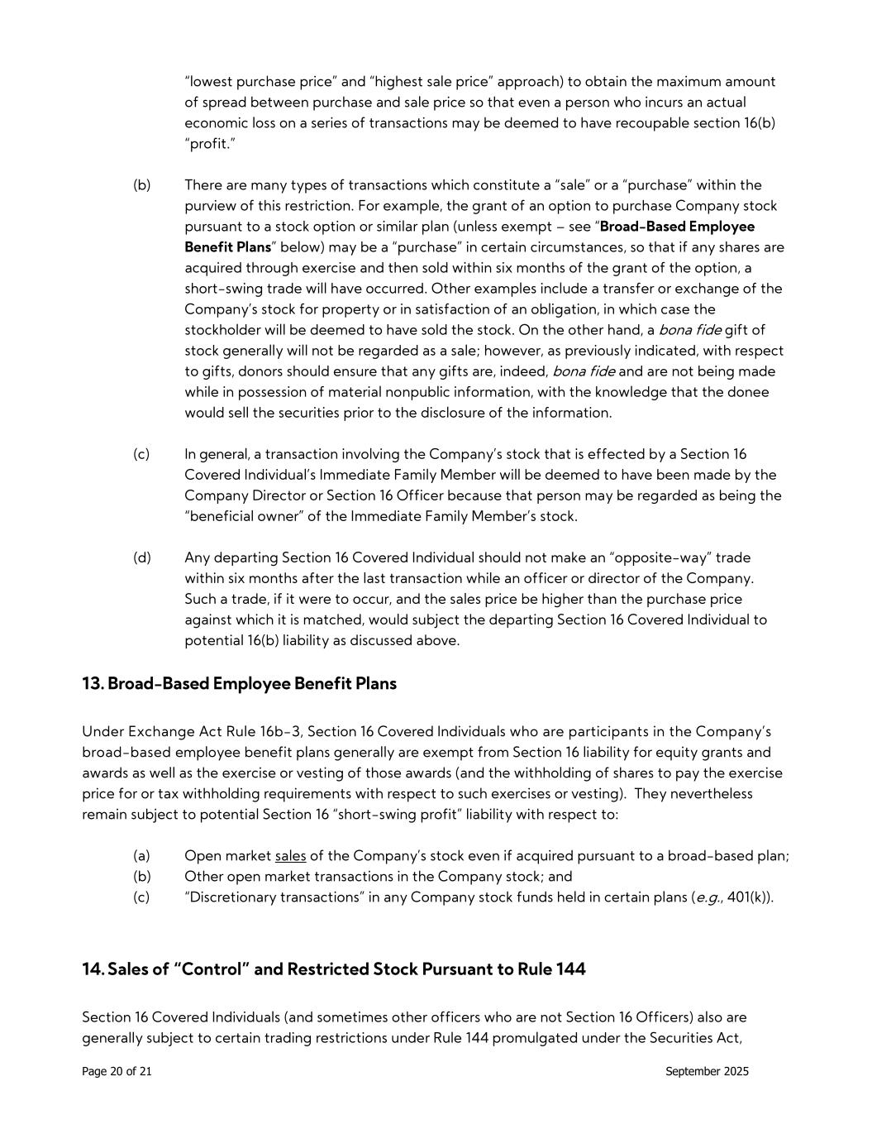
Page 20 of 21 September 2025 “lowest purchase price” and “highest sale price” approach) to obtain the maximum amount of spread between purchase and sale price so that even a person who incurs an actual economic loss on a series of transactions may be deemed to have recoupable section 16(b) “profit.” (b) There are many types of transactions which constitute a “sale” or a “purchase” within the purview of this restriction. For example, the grant of an option to purchase Company stock pursuant to a stock option or similar plan (unless exempt – see “Broad-Based Employee Benefit Plans” below) may be a “purchase” in certain circumstances, so that if any shares are acquired through exercise and then sold within six months of the grant of the option, a short-swing trade will have occurred. Other examples include a transfer or exchange of the Company’s stock for property or in satisfaction of an obligation, in which case the stockholder will be deemed to have sold the stock. On the other hand, a bona fide gift of stock generally will not be regarded as a sale; however, as previously indicated, with respect to gifts, donors should ensure that any gifts are, indeed, bona fide and are not being made while in possession of material nonpublic information, with the knowledge that the donee would sell the securities prior to the disclosure of the information. (c) In general, a transaction involving the Company’s stock that is effected by a Section 16 Covered Individual’s Immediate Family Member will be deemed to have been made by the Company Director or Section 16 Officer because that person may be regarded as being the “beneficial owner” of the Immediate Family Member’s stock. (d) Any departing Section 16 Covered Individual should not make an “opposite-way” trade within six months after the last transaction while an officer or director of the Company. Such a trade, if it were to occur, and the sales price be higher than the purchase price against which it is matched, would subject the departing Section 16 Covered Individual to potential 16(b) liability as discussed above. 13. Broad-Based Employee Benefit Plans Under Exchange Act Rule 16b-3, Section 16 Covered Individuals who are participants in the Company’s broad-based employee benefit plans generally are exempt from Section 16 liability for equity grants and awards as well as the exercise or vesting of those awards (and the withholding of shares to pay the exercise price for or tax withholding requirements with respect to such exercises or vesting). They nevertheless remain subject to potential Section 16 “short-swing profit” liability with respect to: (a) Open market sales of the Company’s stock even if acquired pursuant to a broad-based plan; (b) Other open market transactions in the Company stock; and (c) “Discretionary transactions” in any Company stock funds held in certain plans (e.g., 401(k)). 14. Sales of “Control” and Restricted Stock Pursuant to Rule 144 Section 16 Covered Individuals (and sometimes other officers who are not Section 16 Officers) also are generally subject to certain trading restrictions under Rule 144 promulgated under the Securities Act,


Page 21 of 21 September 2025 including a limit of sales of the Company’s stock to no more than 1% of the outstanding stock during any three-month period and a requirement to file a Form 144. The Company will also assist Section 16 Covered Individuals (and any other affected officers) with the reporting requirements for sales under Rule 144. Questions about Rule 144 should be addressed to the Compliance Officer prior to the consummation of a transaction.

Exhibit 21
SUBSIDIARIES OF REGISTRANT

Kelly Services, Inc.

Subsidiary |  |  | State/Jurisdiction of Incorporation
Kelly Outsourcing and Consulting Group Australia, Ltd. |  |  | Delaware
Kelly Properties, LLC |  |  | Delaware
Kelly Receivables Funding, LLC |  |  | Delaware
Children's Therapy Center, LLC (a subsidiary of Kelly Services USA, LLC) |  |  | Delaware
Motion Recruitment Partners LLC (a subsidiary of MRP Holdco, Inc.) |  |  | Delaware
MRP Holdco, Inc. |  |  | Delaware
SETT Consulting, LLC (a subsidiary of Motion Recruitment Partners LLC) |  |  | Delaware
Matrix Resources LLC (a subsidiary of Motion Recruitment Partners LLC) |  |  | Georgia
Kelly Services Global, LLC |  |  | Michigan
Kelly Services USA, LLC |  |  | Michigan
The Kelly Relief Fund (Non-Profit – subsidiary of Kelly Services, Inc.) |  |  | Michigan
Goal Group, LLC (a subsidiary of Motion Recruitment Partners LLC) |  |  | Virginia
Kelly Outsourcing and Consulting Group (Austria) GmbH, (a subsidiary of Kelly Outsourcing and Consulting Group (Germany), GmbH) |  |  | Austria
Kelly Services Outsourcing and Consulting Group, NV |  |  | Belgium
Kelly Services (Canada), Ltd. |  |  | Canada
MRP Recruiting Inc. (a subsidiary of Motion Recruitment Partners LLC) |  |  | Canada
KellyOCG France SAS |  |  | France
Kelly Outsourcing and Consulting Group (Germany), GmbH |  |  | Germany
Kelly OCG Hungary Kft. |  |  | Hungary
Exhibit 21
1

SUBSIDIARIES OF REGISTRANT (continued)

Kelly Services, Inc.

Subsidiary |  |  | State/Jurisdiction of Incorporation
Kelly Outsourcing and Consulting Group India, Pte. Ltd. (a subsidiary of Kelly Services, Inc. and Kelly Properties, LLC) |  |  | India
Motion Recruitment Limited (a subsidiary of Motion Recruitment Partners LLC) |  |  | Ireland
Agensi Pekerjaan Kelly OCG, Sdn. Bhd. (a subsidiary of Kelly OCG Malaysia Sdn. Bhd.) |  |  | Malaysia
Kelly OCG Malaysia, Sdn. Bhd. (a subsidiary of Kelly OCG Singapore, Pte. Ltd.) |  |  | Malaysia
Kelly Services México, S.A. de C.V. (a subsidiary of Kelly Services, Inc. and Kelly Properties, LLC) |  |  | Mexico
Opciones de Servicio en Mexico, S.A. de C.V. (a subsidiary of Kelly Services México, S.A. de C.V. and Kelly Properties, LLC) |  |  | Mexico
QSM, S.A. de C.V. (a subsidiary of Kelly Services México, S.A. de C.V. and Kelly Properties, LLC) |  |  | Mexico
Kelly Managed Services (Nederland), B.V. |  |  | Netherlands
Kelly OCG Singapore, Pte. Ltd. |  |  | Singapore
KC South Africa |  |  | South Africa
KellyOCG Sweden AB |  |  | Sweden
Kelly Services Outsourcing and Consulting Group, Sarl |  |  | Switzerland
Kelly OCG UK Ltd. |  |  | United Kingdom
Motion Recruitment Partners Ltd. (a subsidiary of Motion Recruitment Partners LLC) |  |  | United Kingdom

2

Exhibit 23

CONSENT OF INDEPENDENT REGISTERED PUBLIC ACCOUNTING FIRM

We hereby consent to the incorporation by reference in the Registration Statements on Form S-3 (No. 333-271834) and Form S-8 (Nos. 333-114837, 333-125091, 333-166798, 333-201165, 333-218039 and 333-287394) of Kelly Services, Inc. of our report dated February 12, 2026 relating to the financial statements, financial statement schedule and the effectiveness of internal control over financial reporting, which appears in this Form 10-K.

/s/ PricewaterhouseCoopers LLP

Detroit, Michigan
February 12, 2026

Exhibit 24

POWER OF ATTORNEY

Each of the undersigned directors of Kelly Services, Inc. does hereby appoint Troy R. Anderson and Vanessa P. Williams, signing singly, his or her true and lawful attorneys, to execute for and on behalf of the undersigned Form 10-K Annual Report pursuant to Section 13 or 15(d) of the Securities Exchange Act of 1934 for the fiscal year ending December 28, 2025, to be filed with the Securities and Exchange Commission in Washington, D.C. under the provisions of the Securities Exchange Act of 1934, as amended, and any and all amendments to said Form 10-K whether said amendments add to, delete from, or otherwise alter the Form 10-K, or add to or withdraw any exhibit or exhibits, schedule or schedules to be filed therewith, and any and all instruments necessary or incidental in connection therewith, hereby granting unto said attorneys and each of them full power and authority to do and perform in the name and on behalf of each of the undersigned, and in any and all capacities, every act and thing whatsoever required or necessary to be done in the exercise of any of the rights and powers herein granted, as fully and to all intents and purposes as each of the undersigned might or could do in person, hereby ratifying and approving the acts of said attorneys and each of them.

IN WITNESS WHEREOF the undersigned have caused this Power of Attorney to be executed as of this 12th day of February, 2026.
/s/ James Christopher Hunt
James Christopher Hunt
/s/ Christopher D. Layden
Christopher D. Layden
/s/ Angela Brock-Kyle
Angela Brock Kyle
/s/ Robert S. Cubbin
Robert S. Cubbin
/s/ Amala Duggirala
Amala Duggirala
/s/ Edward Escudero
Edward Escudero
/s/ James K. Hunt
James K. Hunt
/s/ Leslie A. Murphy
Leslie A. Murphy

Exhibit 31.1

CERTIFICATIONS

I, Christopher D. Layden, certify that:

1.I have reviewed this annual report on Form 10-K of Kelly Services, Inc.;
2.Based on my knowledge, this report does not contain any untrue statement of a material fact or omit to state a material fact necessary to make the statements made, in light of the circumstances under which such statements were made, not misleading with respect to the period covered by this report;
3.Based on my knowledge, the financial statements, and other financial information included in this report, fairly present in all material respects the financial condition, results of operations and cash flows of the registrant as of, and for, the periods presented in this report;
4.The registrant's other certifying officer(s) and I are responsible for establishing and maintaining disclosure controls and procedures (as defined in Exchange Act Rules 13a-15(e) and 15d-15(e)) and internal control over financial reporting (as defined in Exchange Act Rules 13a-15(f) and 15d-15(f)) for the registrant and have:
(a)Designed such disclosure controls and procedures, or caused such disclosure controls and procedures to be designed under our supervision, to ensure that material information relating to the registrant, including its consolidated subsidiaries, is made known to us by others within those entities, particularly during the period in which this report is being prepared;
(b)Designed such internal control over financial reporting, or caused such internal control over financial reporting to be designed under our supervision, to provide reasonable assurance regarding the reliability of financial reporting and the preparation of financial statements for external purposes in accordance with generally accepted accounting principles;
(c)Evaluated the effectiveness of the registrant's disclosure controls and procedures and presented in this report our conclusions about the effectiveness of the disclosure controls and procedures, as of the end of the period covered by this report based on such evaluation; and
(d)Disclosed in this report any change in the registrant’s internal control over financial reporting that occurred during the registrant’s most recent fiscal quarter (the registrant’s fourth fiscal quarter in the case of an annual report) that has materially affected, or is reasonably likely to materially affect, the registrant’s internal control over financial reporting; and
5.The registrant's other certifying officer(s) and I have disclosed, based on our most recent evaluation of internal control over financial reporting, to the registrant's auditors and the audit committee of the registrant's board of directors (or persons performing the equivalent functions):
(a)All significant deficiencies and material weaknesses in the design or operation of internal control over financial reporting which are reasonably likely to adversely affect the registrant's ability to record, process, summarize and report financial information; and
(b)Any fraud, whether or not material, that involves management or other employees who have a significant role in the registrant's internal control over financial reporting.
Date: February 12, 2026
/s/ Christopher D. Layden
Christopher D. Layden
President and
Chief Executive Officer

Exhibit 31.2

CERTIFICATIONS

I, Troy R. Anderson, certify that:

1.I have reviewed this annual report on Form 10-K of Kelly Services, Inc.;
2.Based on my knowledge, this report does not contain any untrue statement of a material fact or omit to state a material fact necessary to make the statements made, in light of the circumstances under which such statements were made, not misleading with respect to the period covered by this report;
3.Based on my knowledge, the financial statements, and other financial information included in this report, fairly present in all material respects the financial condition, results of operations and cash flows of the registrant as of, and for, the periods presented in this report;
4.The registrant's other certifying officer(s) and I are responsible for establishing and maintaining disclosure controls and procedures (as defined in Exchange Act Rules 13a-15(e) and 15d-15(e)) and internal control over financial reporting (as defined in Exchange Act Rules 13a-15(f) and 15d-15(f)) for the registrant and have:
(a)Designed such disclosure controls and procedures, or caused such disclosure controls and procedures to be designed under our supervision, to ensure that material information relating to the registrant, including its consolidated subsidiaries, is made known to us by others within those entities, particularly during the period in which this report is being prepared;
(b)Designed such internal control over financial reporting, or caused such internal control over financial reporting to be designed under our supervision, to provide reasonable assurance regarding the reliability of financial reporting and the preparation of financial statements for external purposes in accordance with generally accepted accounting principles;
(c)Evaluated the effectiveness of the registrant's disclosure controls and procedures and presented in this report our conclusions about the effectiveness of the disclosure controls and procedures, as of the end of the period covered by this report based on such evaluation; and
(d)Disclosed in this report any change in the registrant’s internal control over financial reporting that occurred during the registrant’s most recent fiscal quarter (the registrant’s fourth fiscal quarter in the case of an annual report) that has materially affected, or is reasonably likely to materially affect, the registrant’s internal control over financial reporting; and
5.The registrant's other certifying officer(s) and I have disclosed, based on our most recent evaluation of internal control over financial reporting, to the registrant's auditors and the audit committee of the registrant's board of directors (or persons performing the equivalent functions):
(a)All significant deficiencies and material weaknesses in the design or operation of internal control over financial reporting which are reasonably likely to adversely affect the registrant's ability to record, process, summarize and report financial information; and
(b)Any fraud, whether or not material, that involves management or other employees who have a significant role in the registrant's internal control over financial reporting.
Date: February 12, 2026
/s/ Troy R. Anderson
Troy R. Anderson
Executive Vice President and
Chief Financial Officer

Exhibit 32.1

CERTIFICATION PURSUANT TO 18 U.S.C. SECTION 1350, AS ADOPTED PURSUANT TO
SECTION 906 OF THE SARBANES-OXLEY ACT OF 2002

In connection with the Annual Report of Kelly Services, Inc. (the “Company”) on Form 10-K for the period ended December 28, 2025 as filed with the Securities and Exchange Commission on the date hereof (the “Report”), I, Christopher D. Layden, Chief Executive Officer of the Company, certify, pursuant to 18 U.S.C. Section 1350, as adopted pursuant to Section 906 of the Sarbanes-Oxley Act of 2002, that:
(1)The Report fully complies with the requirements of Section 13(a) or 15(d) of the Securities Exchange Act of 1934; and
(2)The information contained in the Report fairly presents, in all material respects, the financial condition and results of operations of the Company.
Date: February 12, 2026
/s/ Christopher D. Layden
Christopher D. Layden
President and
Chief Executive Officer

A signed original of this written statement required by Section 906 has been provided to Kelly Services, Inc. and will be retained by Kelly Services, Inc. and furnished to the Securities and Exchange Commission or its staff upon request.

Exhibit 32.2

CERTIFICATION PURSUANT TO 18 U.S.C. SECTION 1350, AS ADOPTED PURSUANT TO
SECTION 906 OF THE SARBANES-OXLEY ACT OF 2002

In connection with the Annual Report of Kelly Services, Inc. (the “Company”) on Form 10-K for the period ended December 28, 2025 as filed with the Securities and Exchange Commission on the date hereof (the “Report”), I, Troy R. Anderson, Chief Financial Officer of the Company, certify, pursuant to 18 U.S.C. Section 1350, as adopted pursuant to Section 906 of the Sarbanes-Oxley Act of 2002, that:
(1)The Report fully complies with the requirements of Section 13(a) or 15(d) of the Securities Exchange Act of 1934; and
(2)The information contained in the Report fairly presents, in all material respects, the financial condition and results of operations of the Company.
Date: February 12, 2026
/s/ Troy R. Anderson
Troy R. Anderson
Executive Vice President and
Chief Financial Officer

A signed original of this written statement required by Section 906 has been provided to Kelly Services, Inc. and will be retained by Kelly Services, Inc. and furnished to the Securities and Exchange Commission or its staff upon request.

